**Screen shot 4 on VScode showing the CSS file**

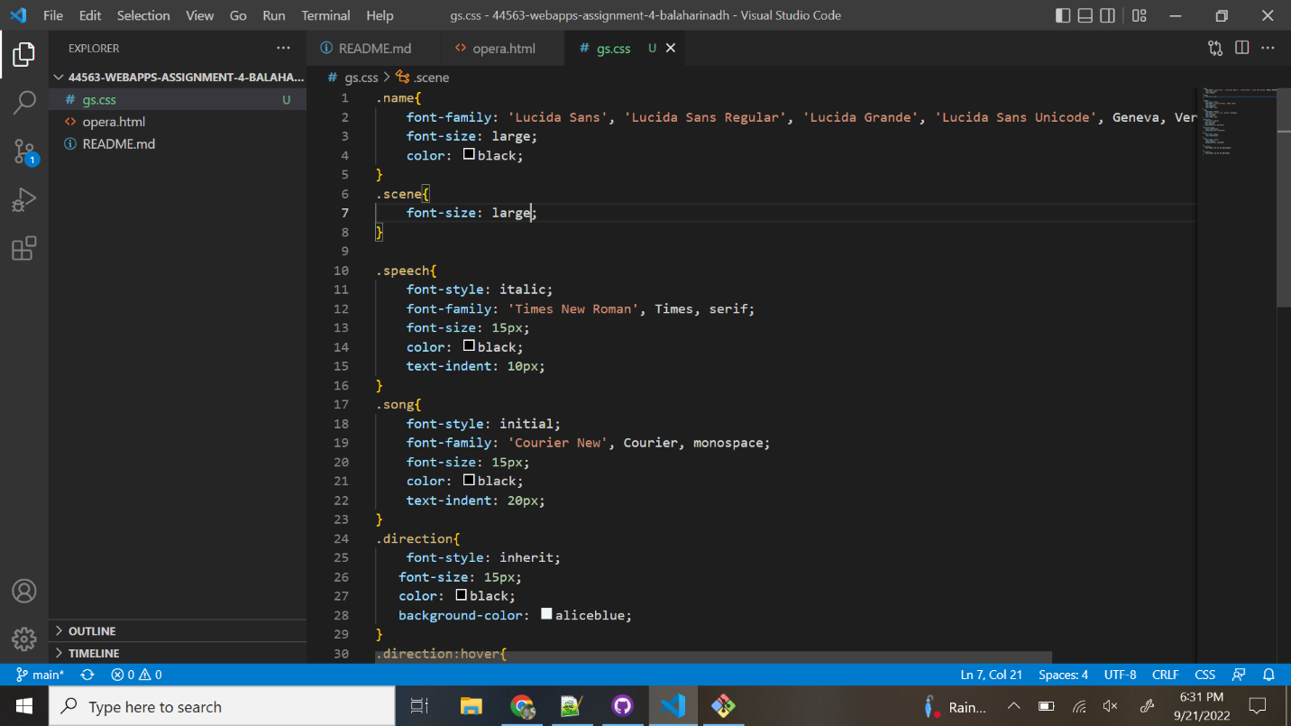

**Screen shot 5 on browser showing the opera page with inspector**

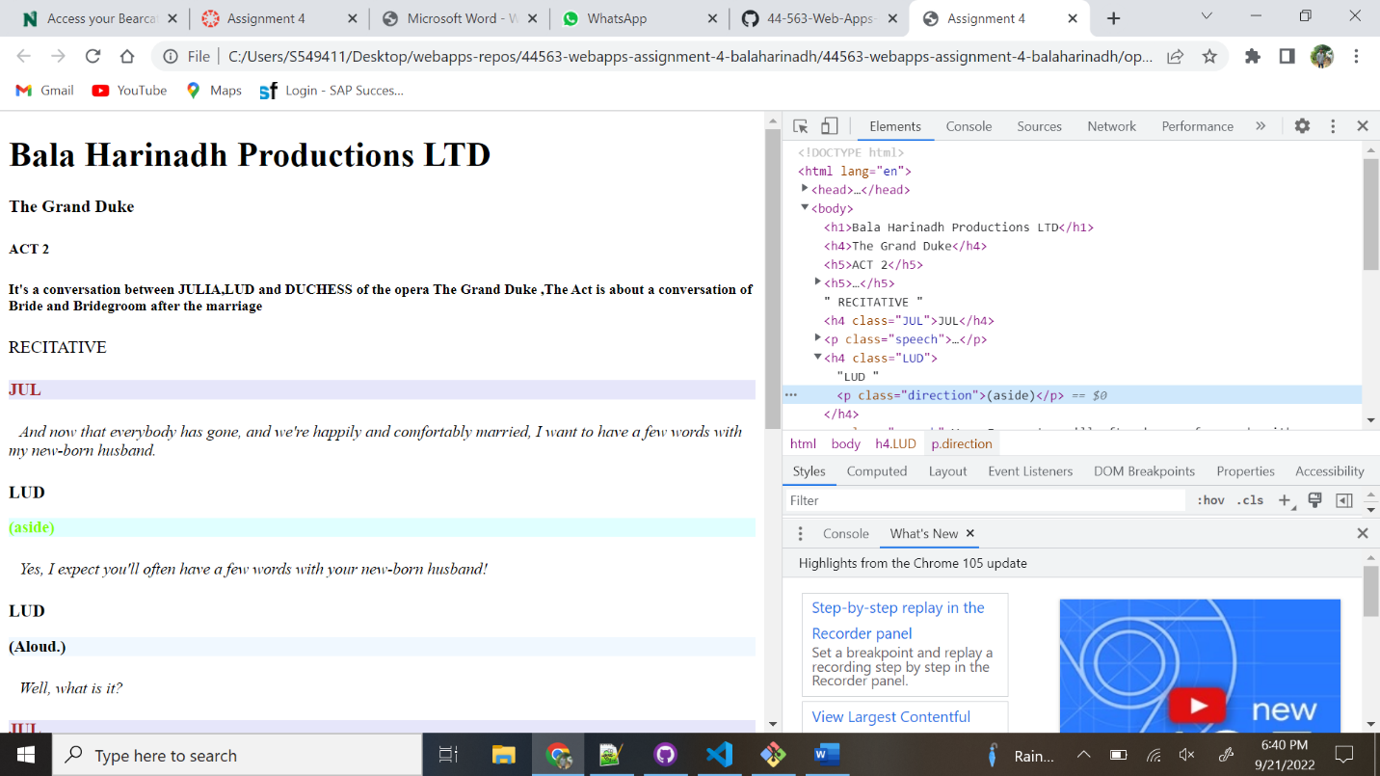

**Screen shot 6 on browser showing table with inspector.**

**Screen shot 7 on browser showing the new page with inspector**

**Screen shot 8 on browser showing opera2.html**

**screen shot(s) on the browser showing the additions.**

