# **Web Apps Assignment 6**

# Screen shot 4 on browser (should see both the guess and image.)

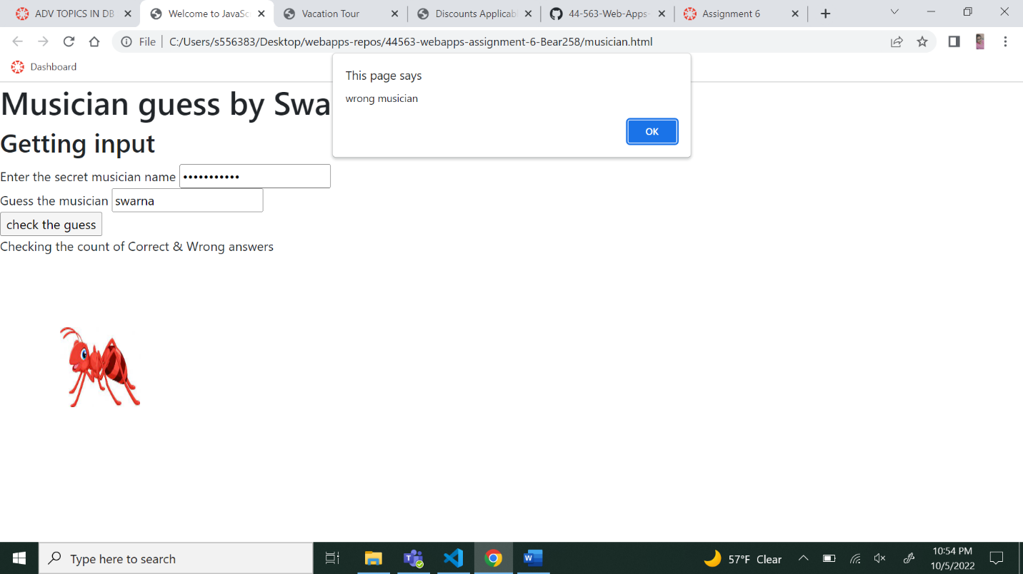

Screen shot 5 on VSCode showing the java script.

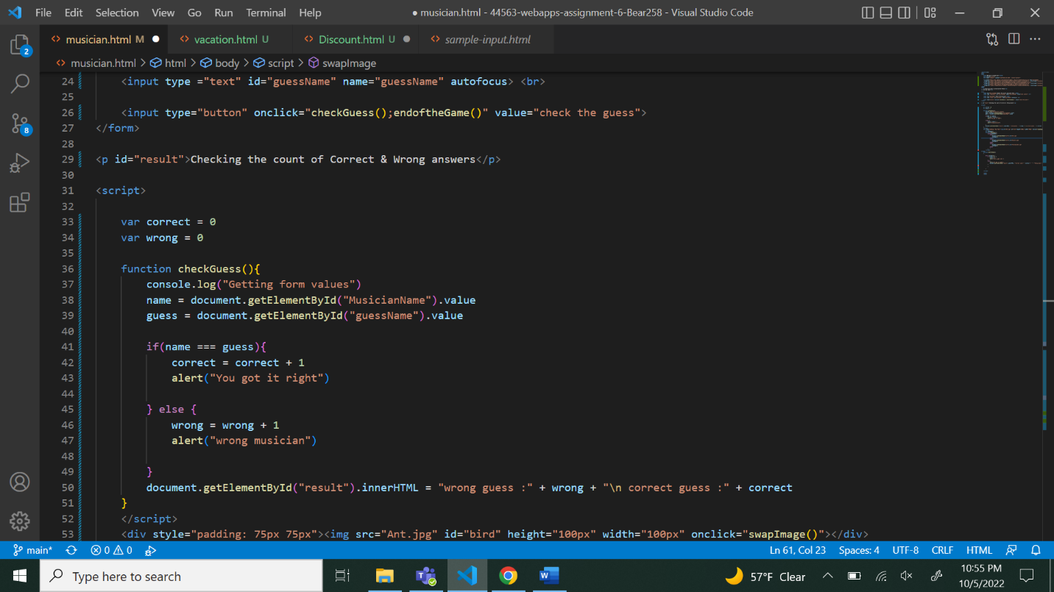

Screen shot 6 on browser (should see both parts.)

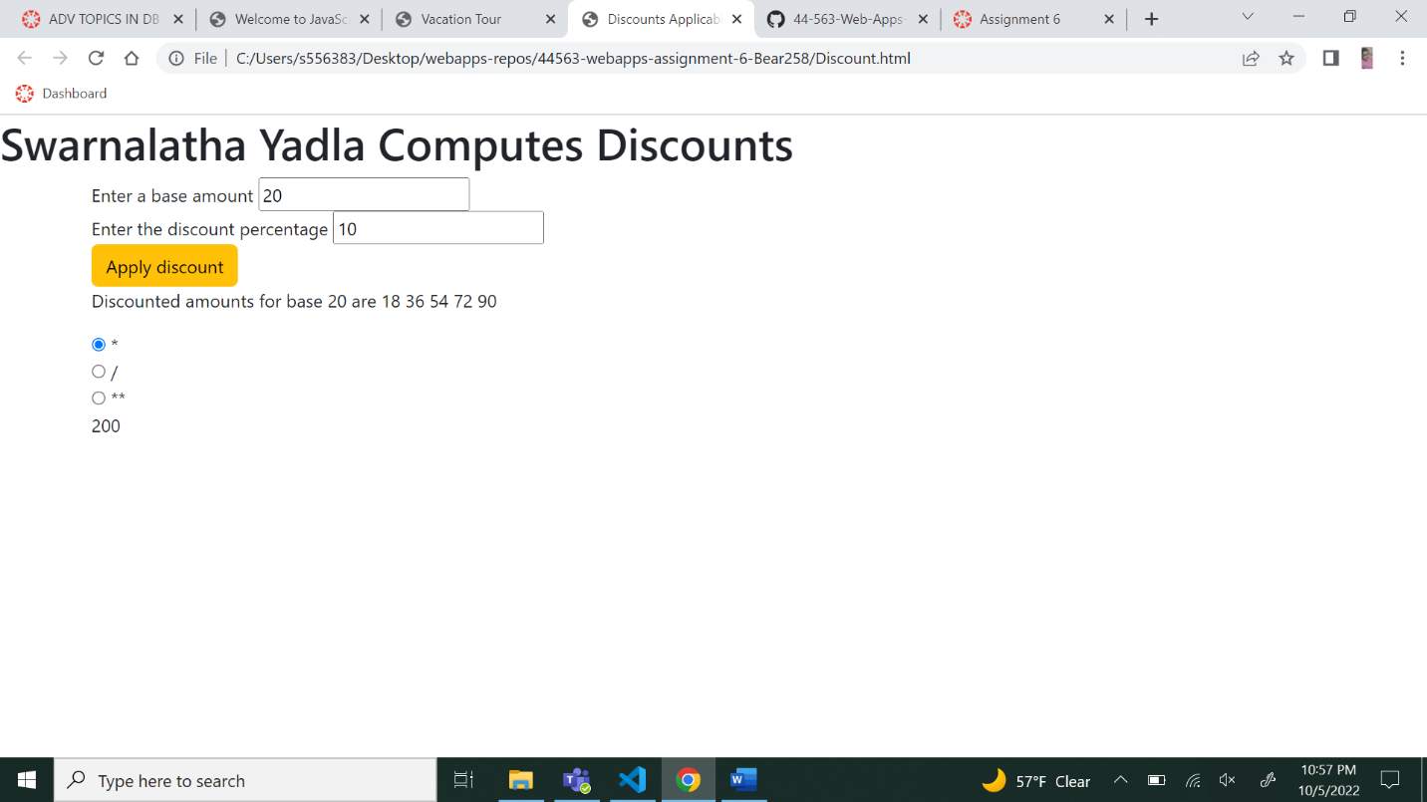

Screen shot 7 on VSCode showing the java script.

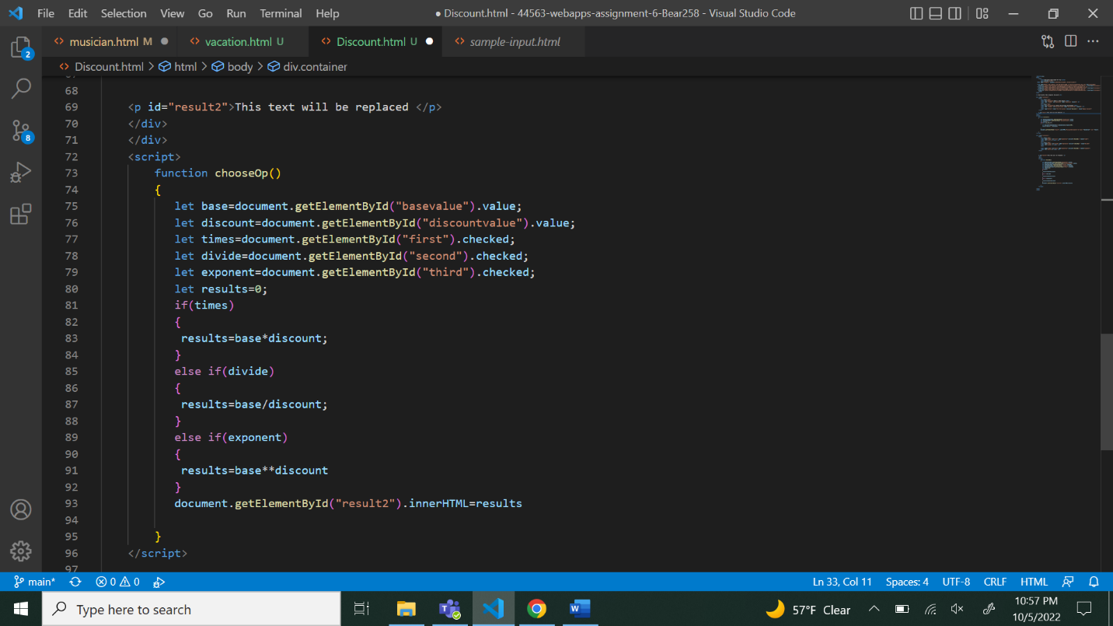

Screen shot 8 on browser.

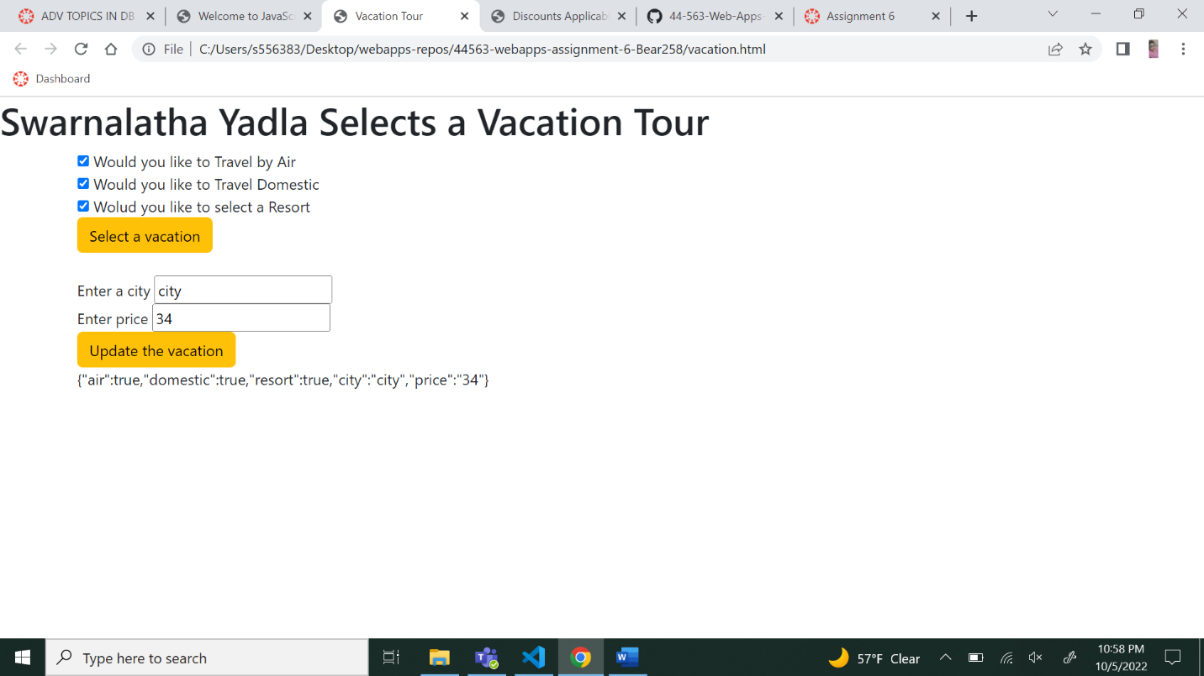

Screen shot 9 on VSCode showing the java script.

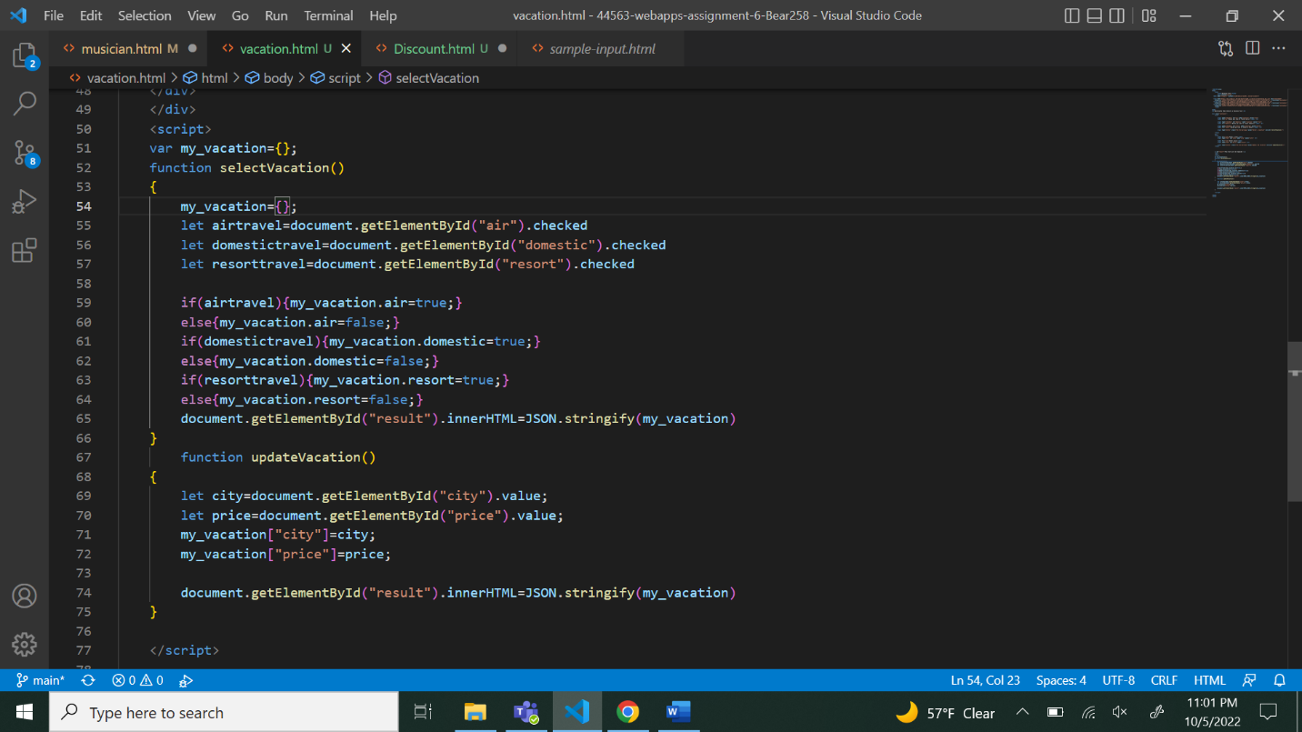

Bonus:

