NAGA MANIKANTA CHIGURUPATI S555681

LAB ASSIGNMENT 06

1.Screen shot 1 of repo on VS Code for submission

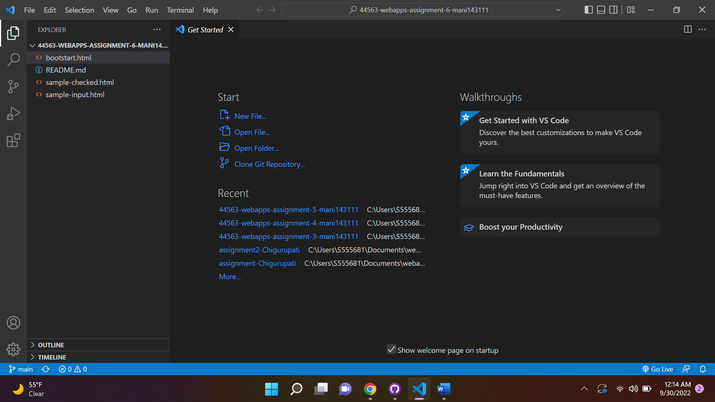

2.Screen shot 2 on your browser of rendered page and the inspector.

3.Screen shot 3 on with form and right/wrong holder visible.

