Screen shot 1 of repo on VS Code for submission

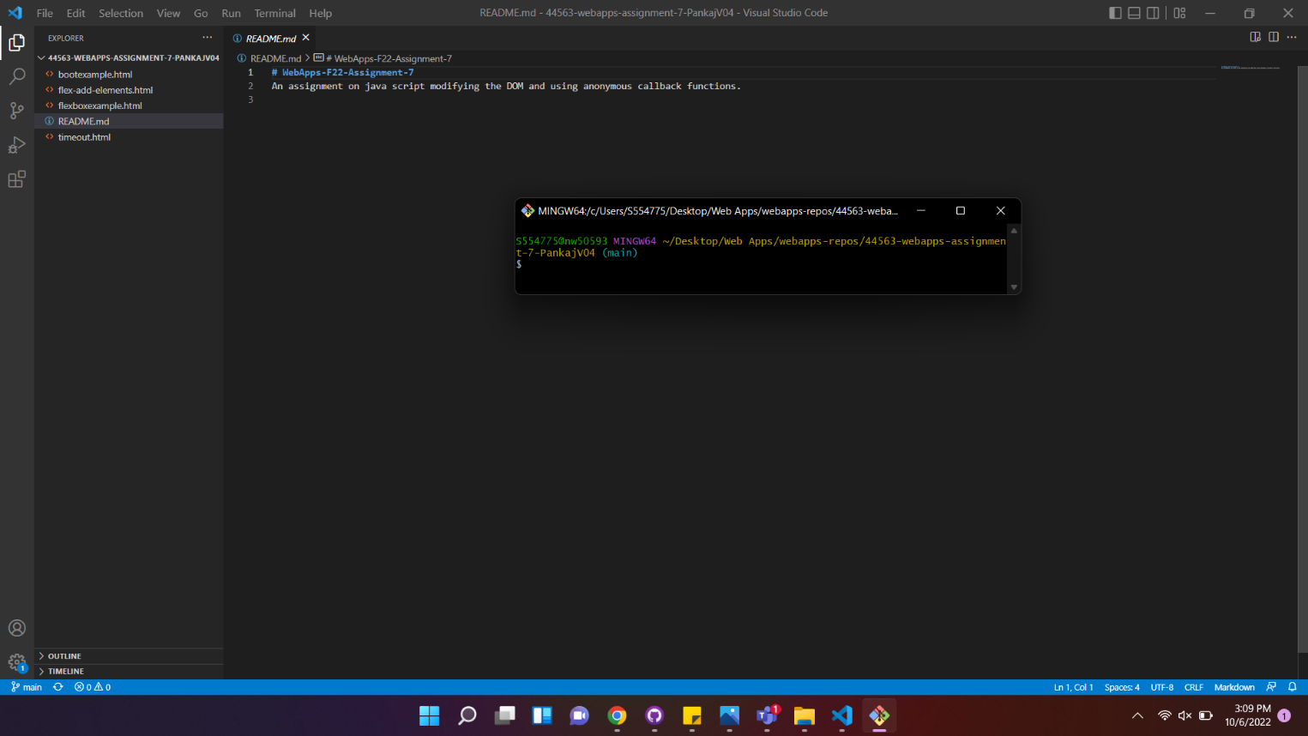

Screen shot 2 on your browser of rendered page and the inspector.

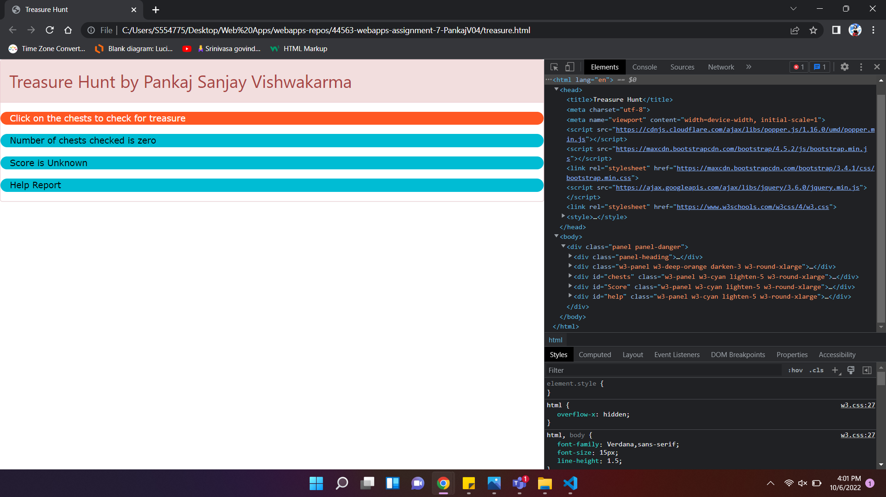

Screen shot 3 on browser (Should see instructions and the 5 by 5 game field.)

