Screen shot 1 of repo on VS Code for submission

Screen shot 2 on your browser of rendered page and the inspector

Screen shot 3 on VS Code of edited play.html.

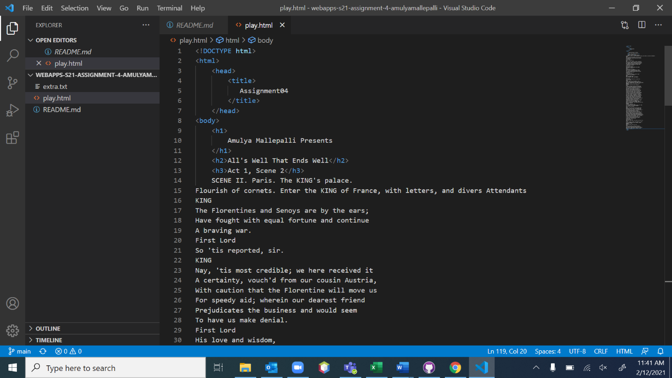

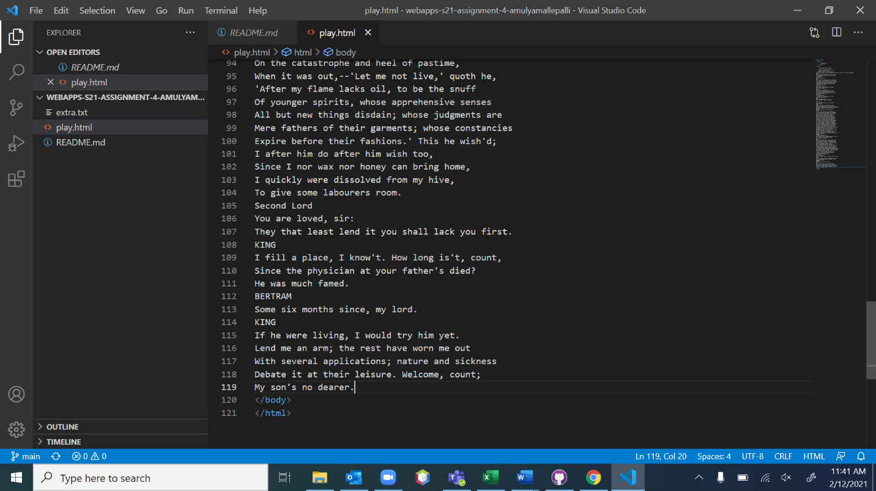

Screen shot 4 on VScode showing the css file.

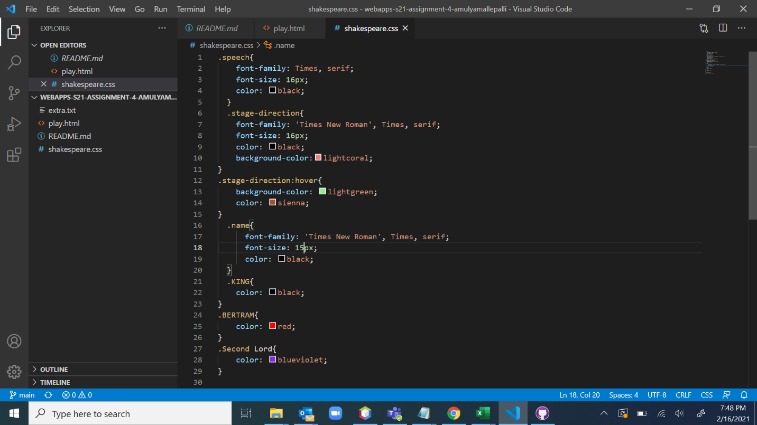

Screen shot 5 on browser showing the play page with inspector.

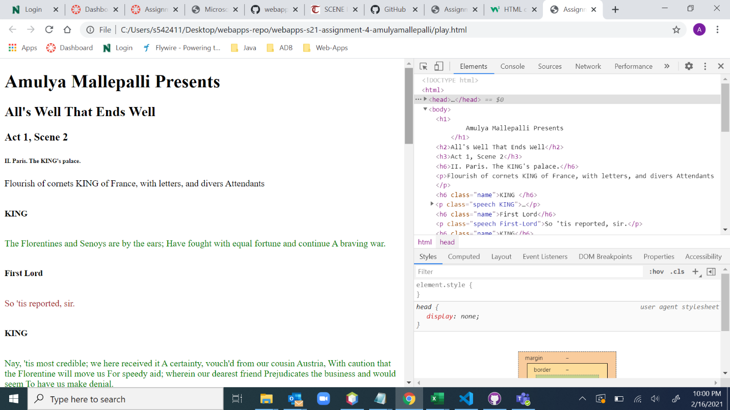

Screen shot 6 on browser showing table with inspector.

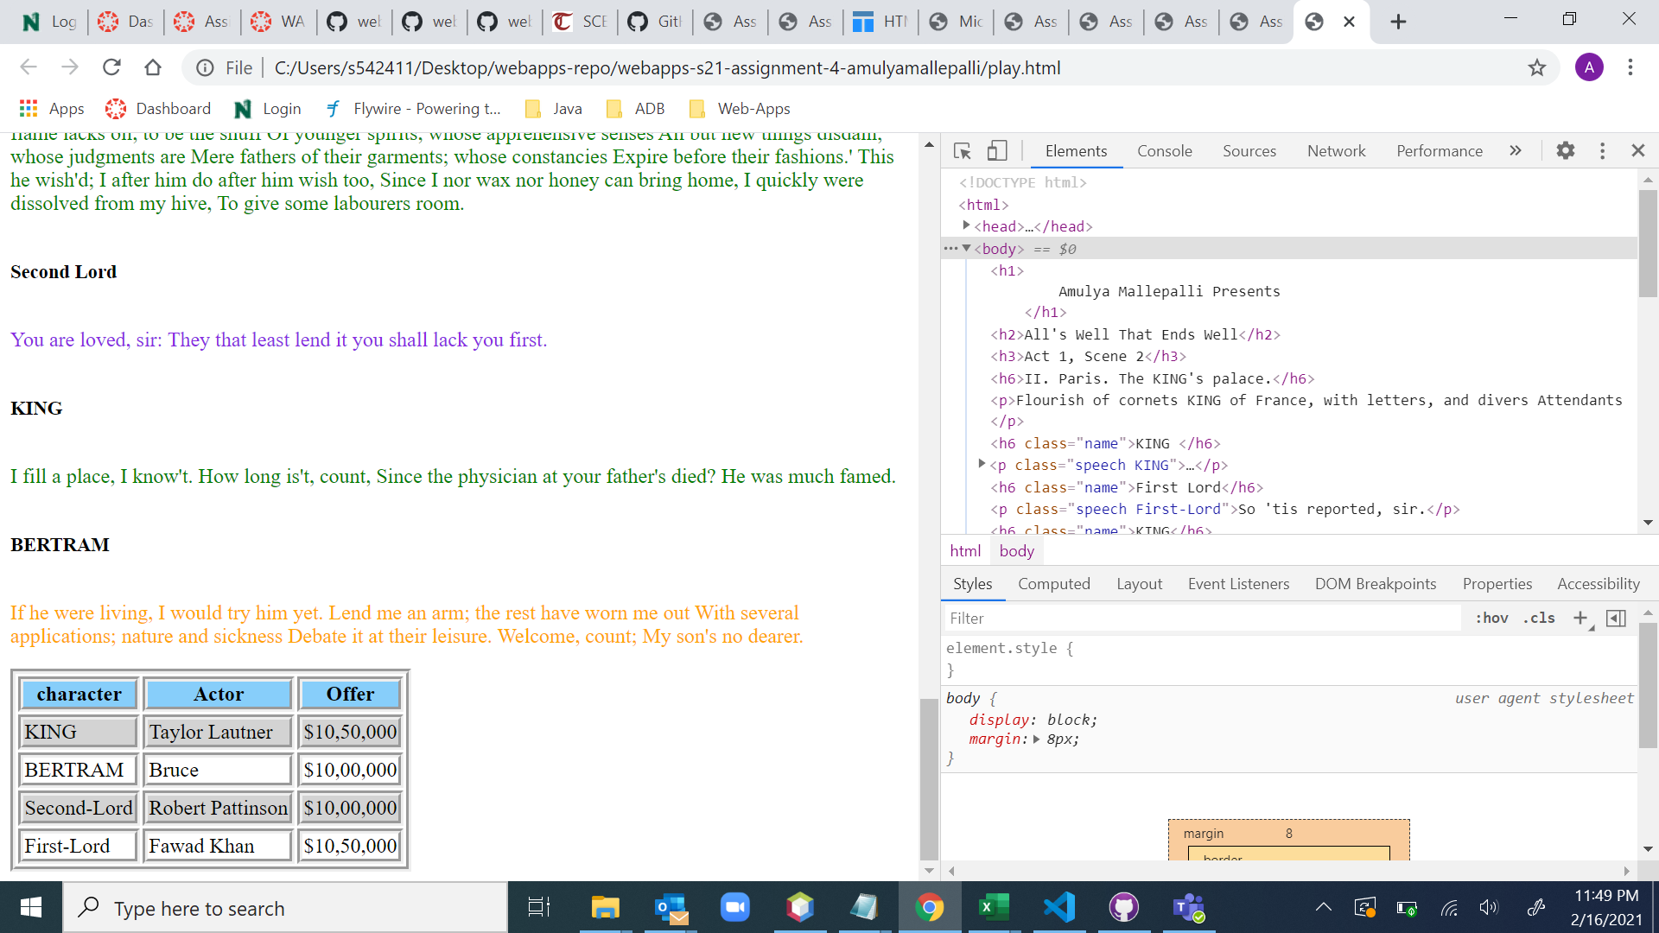

Screen shot 7 on browser showing the new page with inspector.

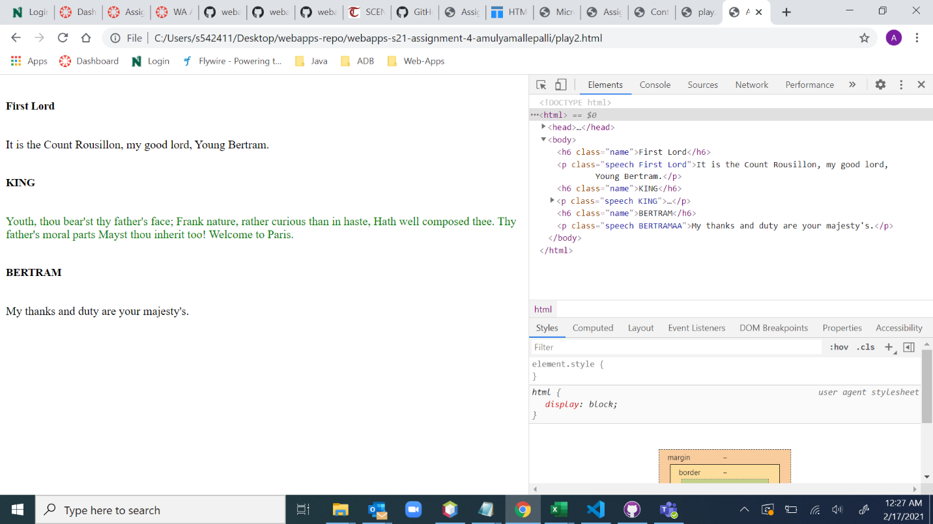

Screen shot 8 on browser showing play2.html hovering over a character name with the inspector.

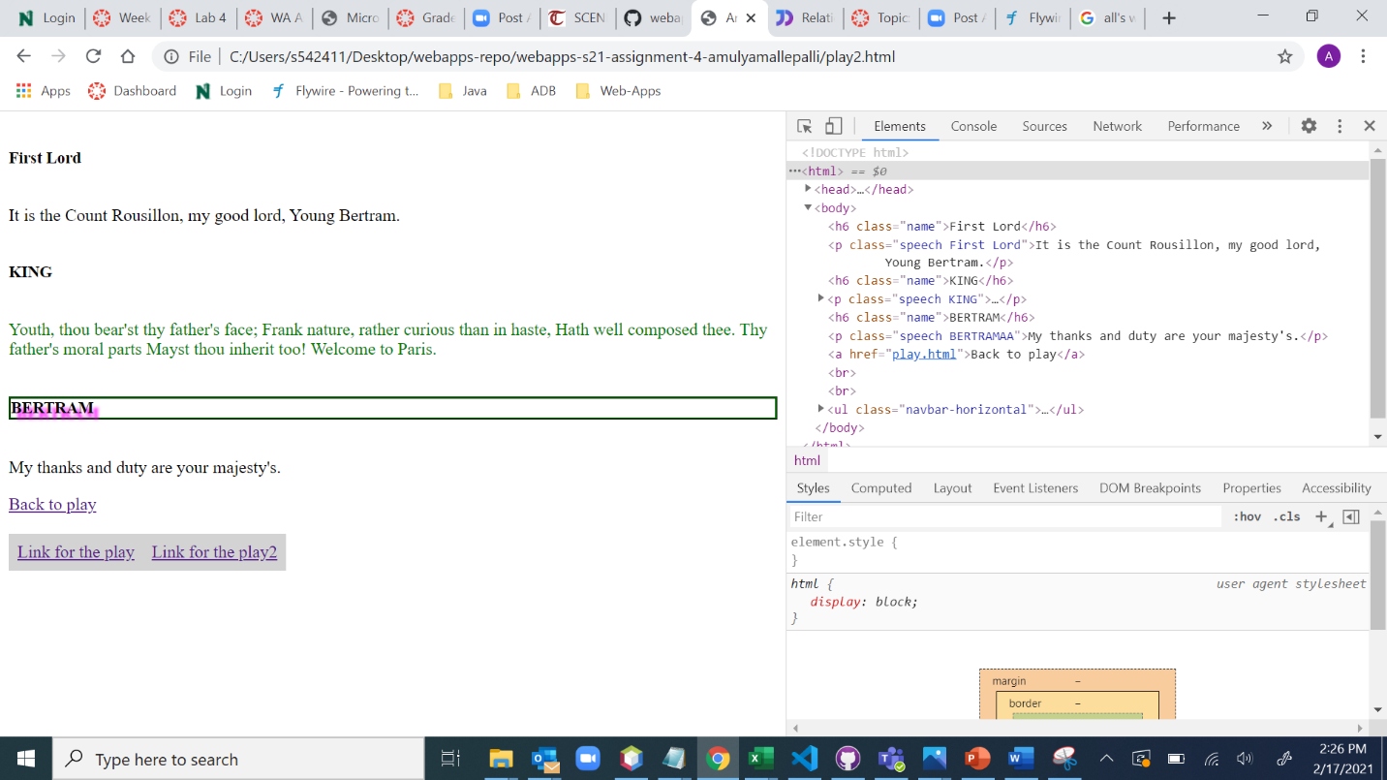

BONUS