Create an azure resource: SQL Database

Download the Dataset: <https://github.com/manojkumarsingh77/Shell2023/blob/main/Session/Drilling_Dataset.csv>

Create a resembling table in the SQL Database:

Create Table Drilling_Dataset

(RigId Integer,

DrillingDepth Integer,

DrillingSpeed Integer,

Location varchar(200),

Created_Date Date);

The given Problem Statement is:

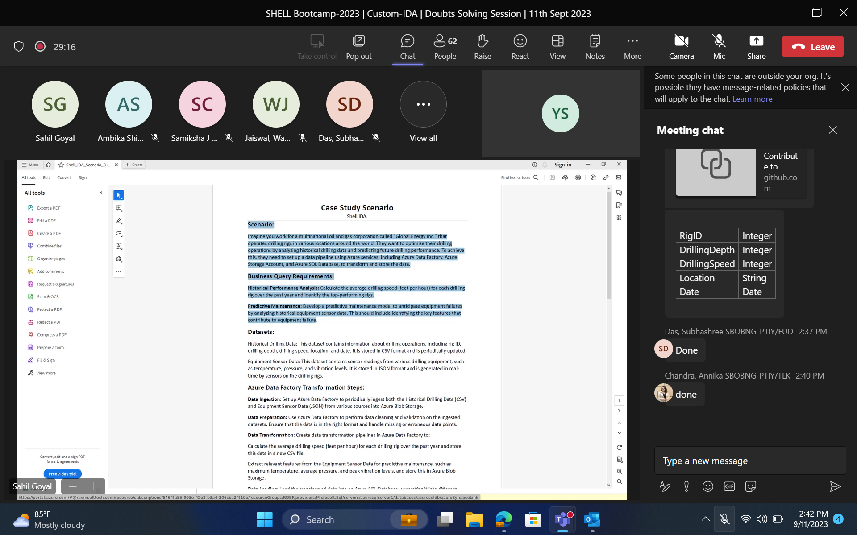

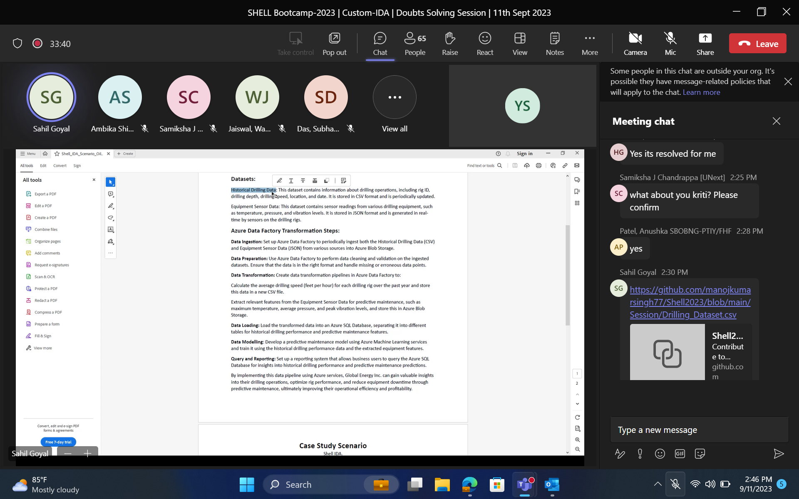

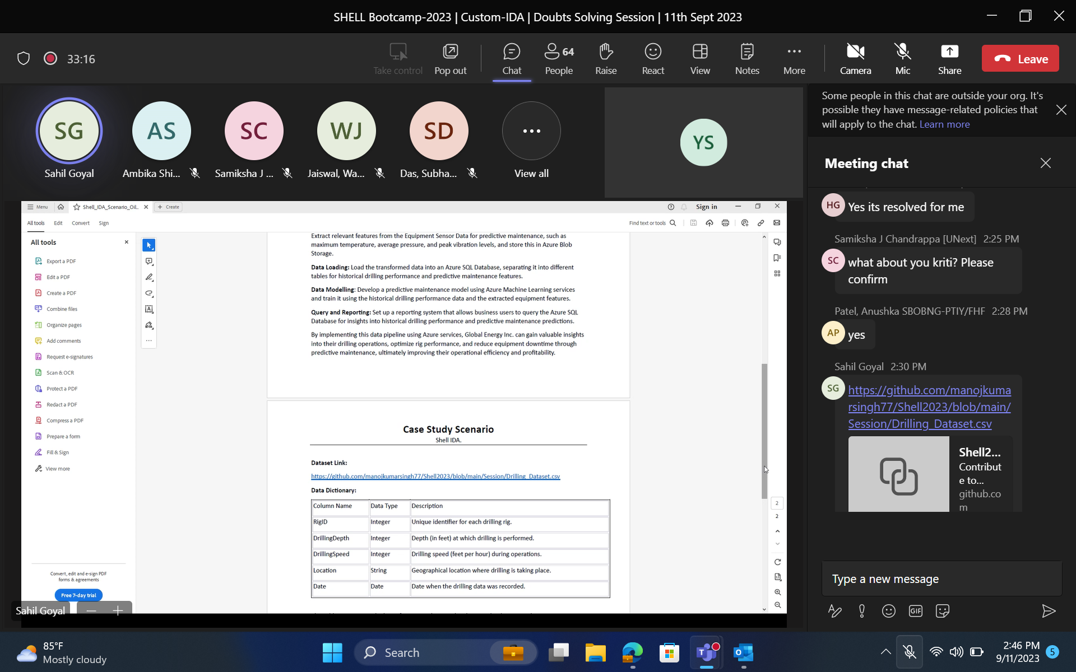

Then Create another azure resource: basic Storage Account

Create a demo container inside the SA

Then Create 3rd azure resource: Data Factory and launch Azure Data Factory Studio

Upload the Data set to the blob storage (no idea about file share… done manually)

Create an LS in the DF for the pipelining the data from SA to DF

// Not this 🡪 Create the Dataset in DF for sink and in pipeline use the Copy Data

In Copy data, set sink to the database created by us at the beginning (will have to create a new LS for this as well)

In Mapping, clearly mention the respective source and sink columns for mapping

Now run and you will be able to see the data in the created Database (use query selector in portal azure)

… (SS for the queries after loading the data to)

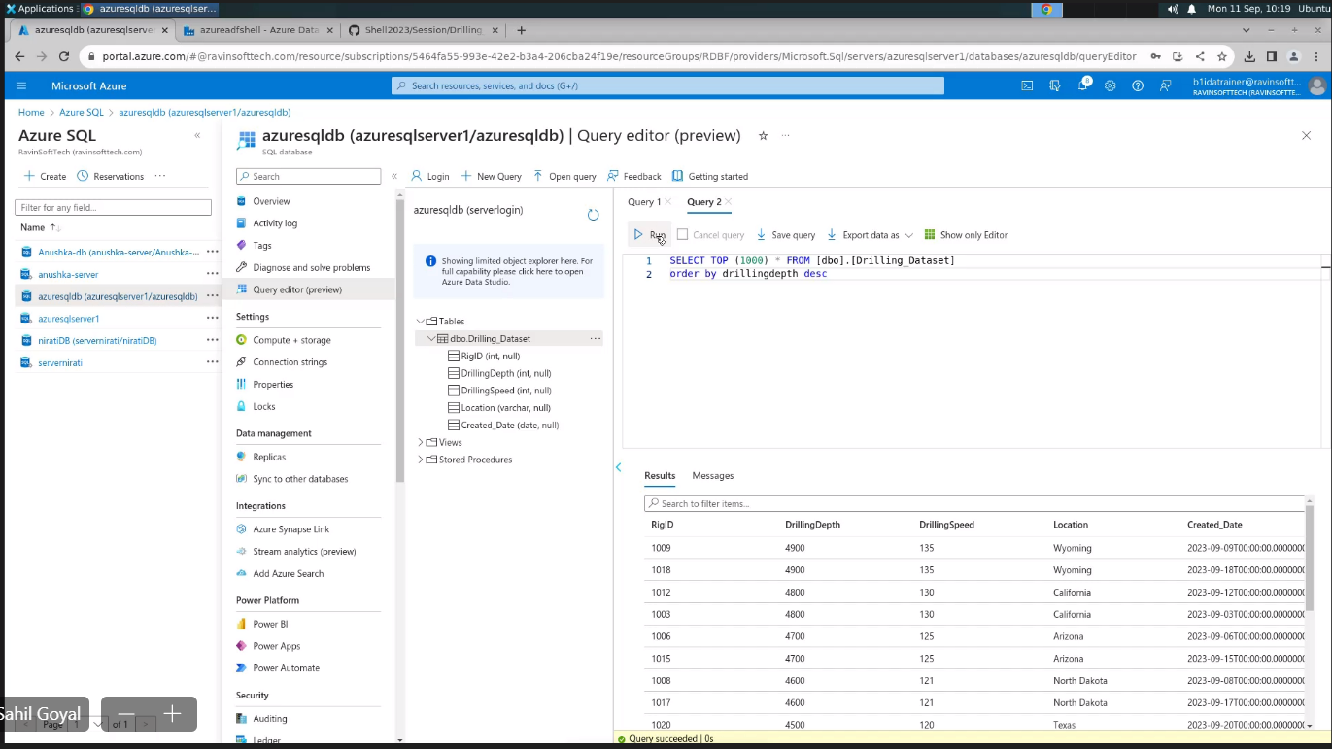

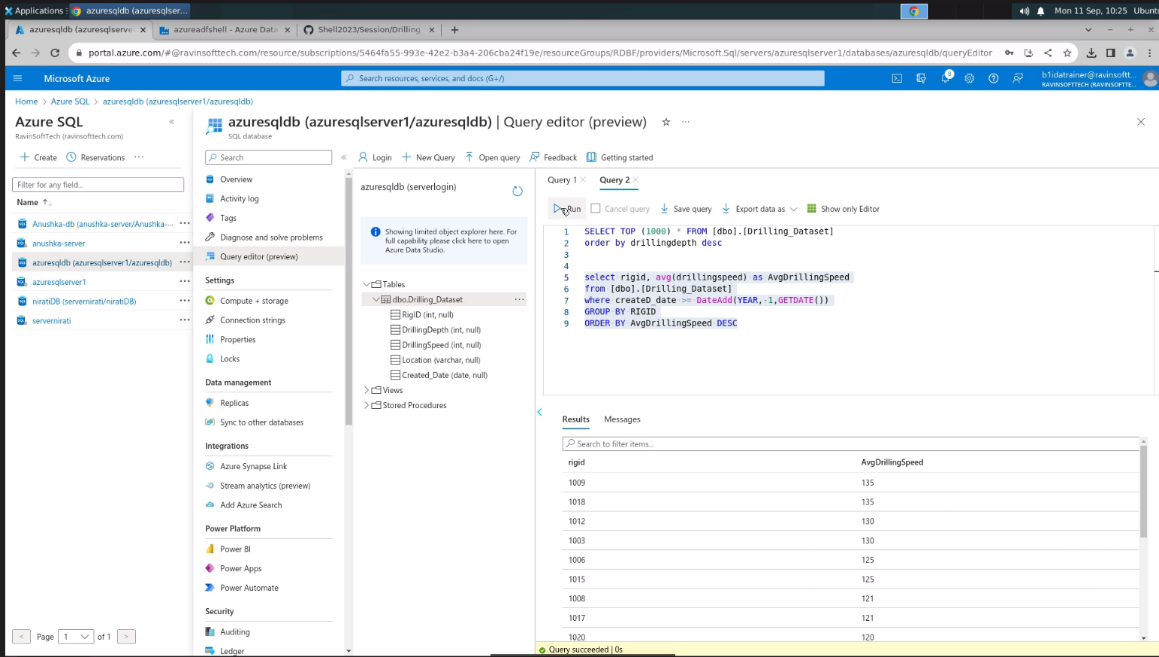

**This whole loading the data thing is also possible using dataflow as well instead of copy data (No idea how it was done tho)

