Mathematics

Core 3

Numerical Methods Coursework

Daniel Easteal

Decimal Search – Newton Raphson - rearrangement

Notes:

value function – cont , equasion - solve

# Introduction

In this assignment I will be going through 3 different numerical methods that are used to solve the root of an equation when one is not simple to find, this can include when the root is irrational or when the x variable if wrapped up inside and outside of a function. The three methods that I will be going through are:

Decimal search

Newton Raphson

Rearrangement

With each of these different methods I will also be showing different cases that they can be used for as well as how the method works to solve the root of the equation as well as when the method fails to find the root. In addition to this I will also be stating the error bounds that the answers that I give will have to ensure that they are only as reliable as I have stated them to be. Furthermore, throughout this piece of course work I will also be used correct mathematical terminology and symbols to ensure that everything is the most accurate that it can be.

# Decimal search

The first type of numerical method that I will be using for this coursework is the Decimal search method, and this is also the simplest method that there is in this list.

The way that this method is completed is by selecting a point that is close to the root that you want to find and from here you then select all the points between that point and the point at the other side of the root. With these 10 points you then get the x co-ordinate for each one and then you find the boundary that the graph changes sign within and from then you will take that section and cut that up into 10 pieces and repeat the method. As this goes on the search will then go through the same steps over and over again and as it does then it will draw closer and closer to the actual root.

For this example, I will be using the equation: y = 4x*sin(cos(x))

And the graph of that looks like this:

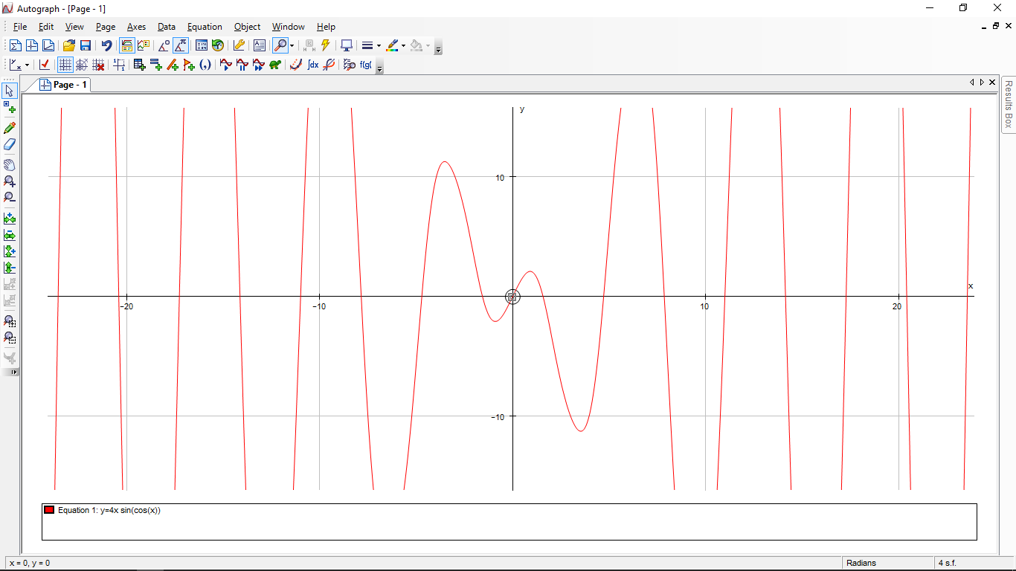

For this graph I will be finding the first root that is above 0 and I will label it alpha (α) so that you know what root I am finding. The root is labelled below on the graph:

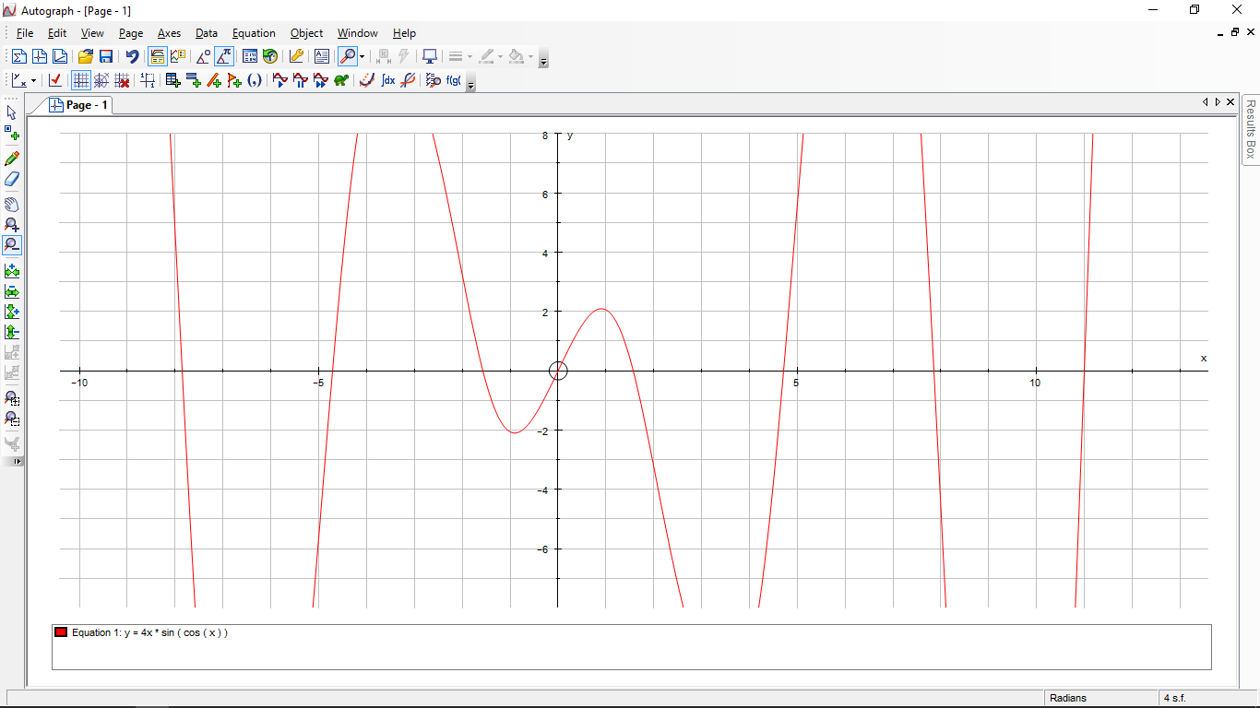

α

y = 4x*sin(cos(x))

As you can see above and in the zoomed in image below the root lies between the value of 1 and 2, as such, this is where we will start the search:

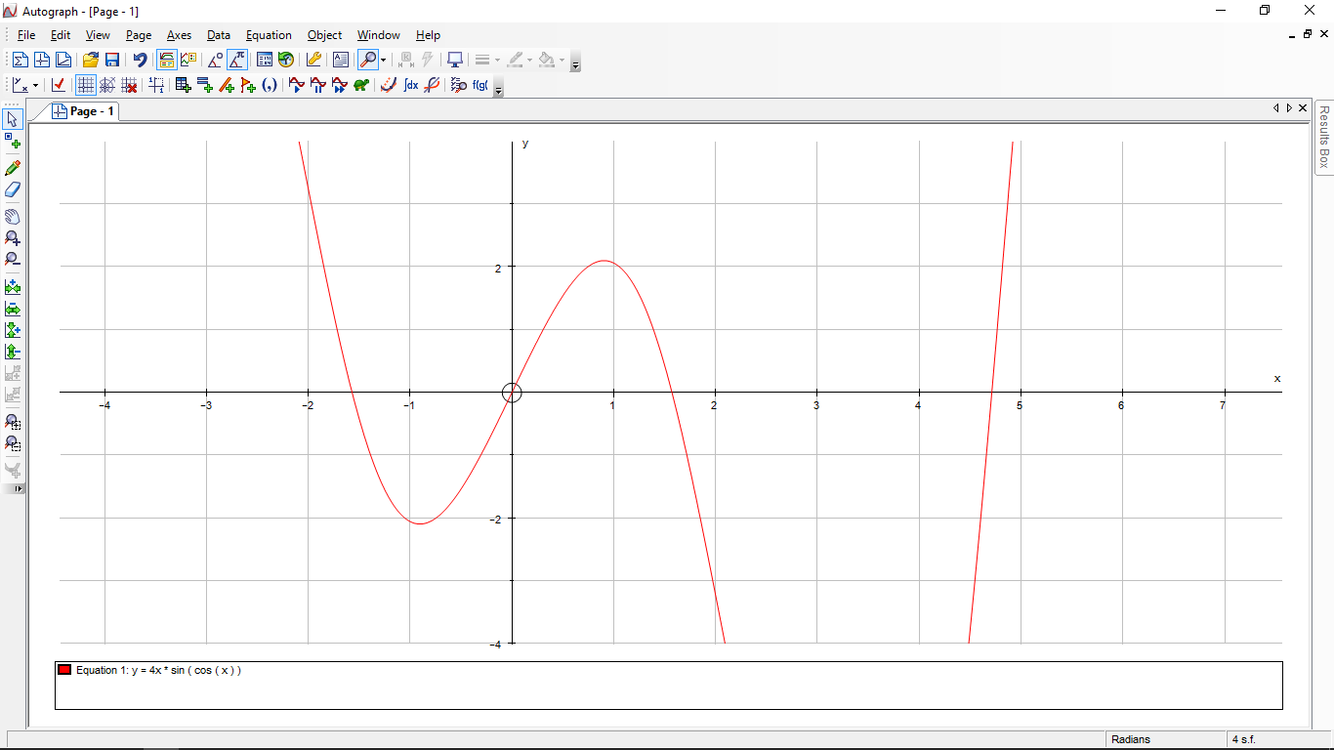

The root lies between the value of 1 and 2

α

In addition to the one above that shows the range the image below will be annotated to show that there is actually a change in sign by overlaying some bars so that one is above zero on one side and below zero on the other. 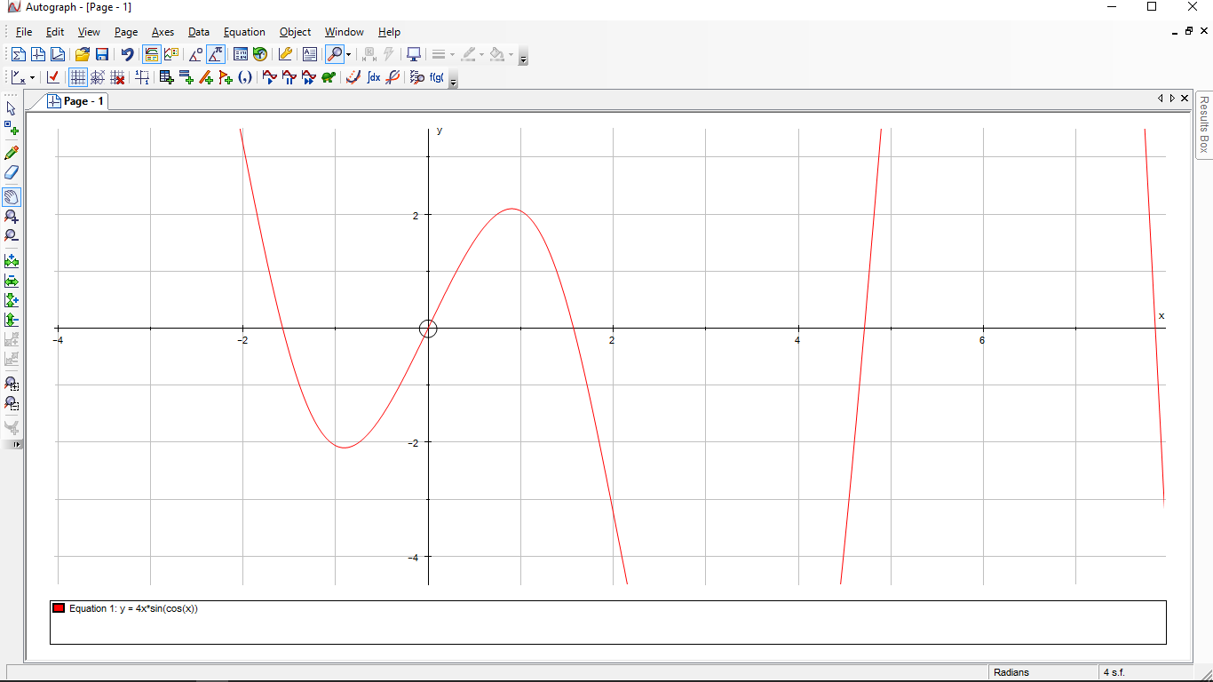

Below zero on this side

Above zero on this side

From here I can then go into a spreadsheet program like Microsoft Excel and input the formula I am using with conditional formatting to show that the sigh does change in that value. To start off with here I will be showing the value of the equation between the values of 1 and 2. This should show that the sigh changes in between these values and as such the formula I have put in works. To show this change of sigh I have made it so that if the value if less than 0 then it will show up as red and if the value is greater than 0 then it will show up as green:

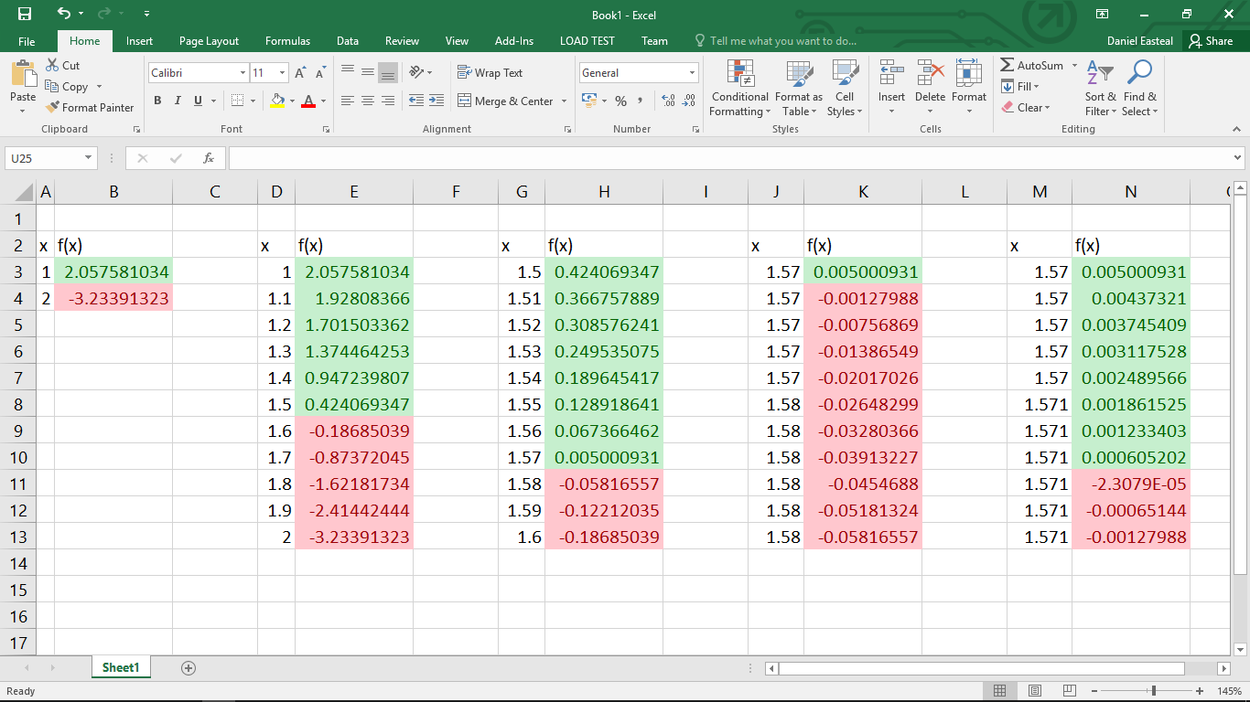 From this image above you can see that I started out with the initial calulation of seeing if the root I wanted to find was inbetween 1 and 2, and from this image above you can see that as in coloums A and B there is a change of sign there. From this point I then took 10 equally paced values between 1 and 2 and then used those to find out where the root changes to a higher definition. And as you can see from the image this occurred between 1.5 and 1.6 as between these values the sign of the anwer changed fom a posivite number (in green) to a negitive number (in red). From herei then did the same thing again over a few times to improve the accuracy of my calculations, This happens as each tim e I repeat the stpes I get a small range that the change of sign is in and from here I then split that small range up into 10 even smaller ranges and see where they change from a positive to a negitive. In the image below you can see the formulas that I used in excel to get the correct answers and the colours are just done by making the answers green if they are greater than 0 and red of they are less than 0:

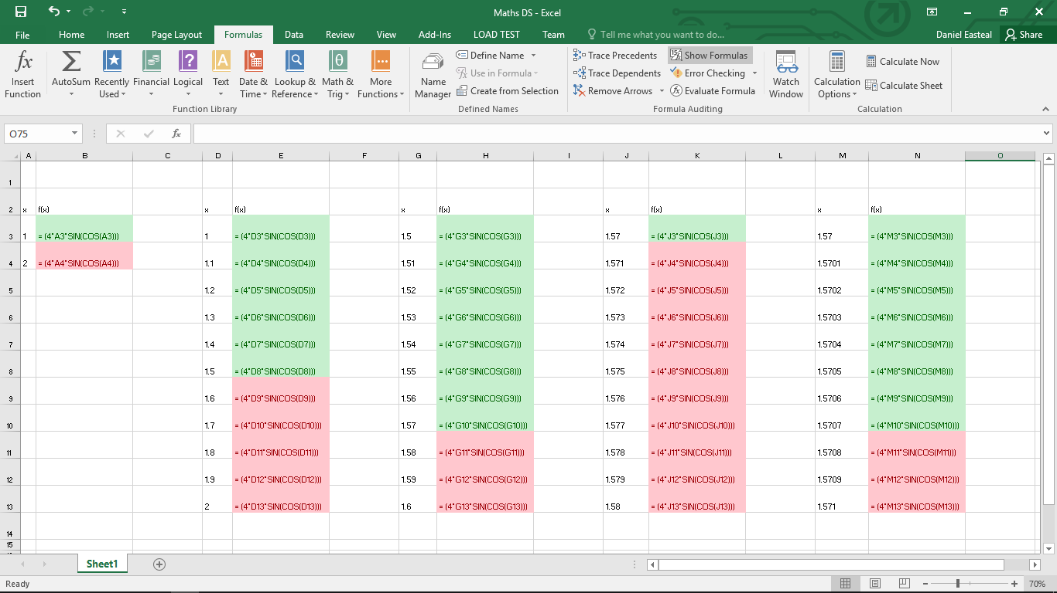from this image here you can see that the formulas are very simple and are just the equasion of the funtion I am trying to solve where the variable x is just the value of the cell to the left. These cells were added in by me as I went through and saw what range the sign changed within.

From this you can see that the x value of the first positive root that satisfies the equasion when x is about equel to 1.571 and this can be stated with an accuracy of $±$ 0.0005 around that numer. This also staes that the x value of the root is 0.57 < x < 0.571, however, I also did an extra run through the algorythm and found out that this value is closer to 0.1571 than 0.1570 so I can state that to three decimal places the answer would round to 0.571.

Therefor with decimal search I can say that the x value for the first positive root of the equasion: y = 4x*sin(cos(x)) that is greater than 0 is equal to 0.571 to 3 decimal places.

# Newton Raphson

# Rearrangement

# Comparison