P3 - Create and populate a database

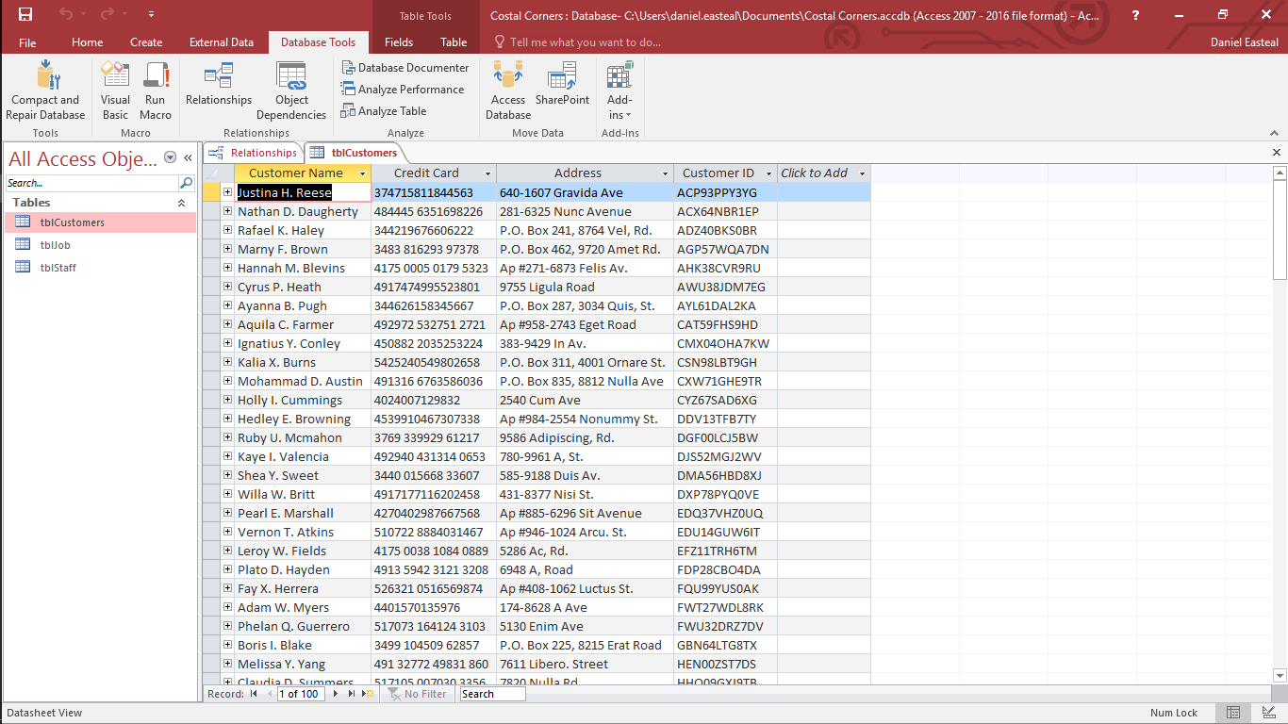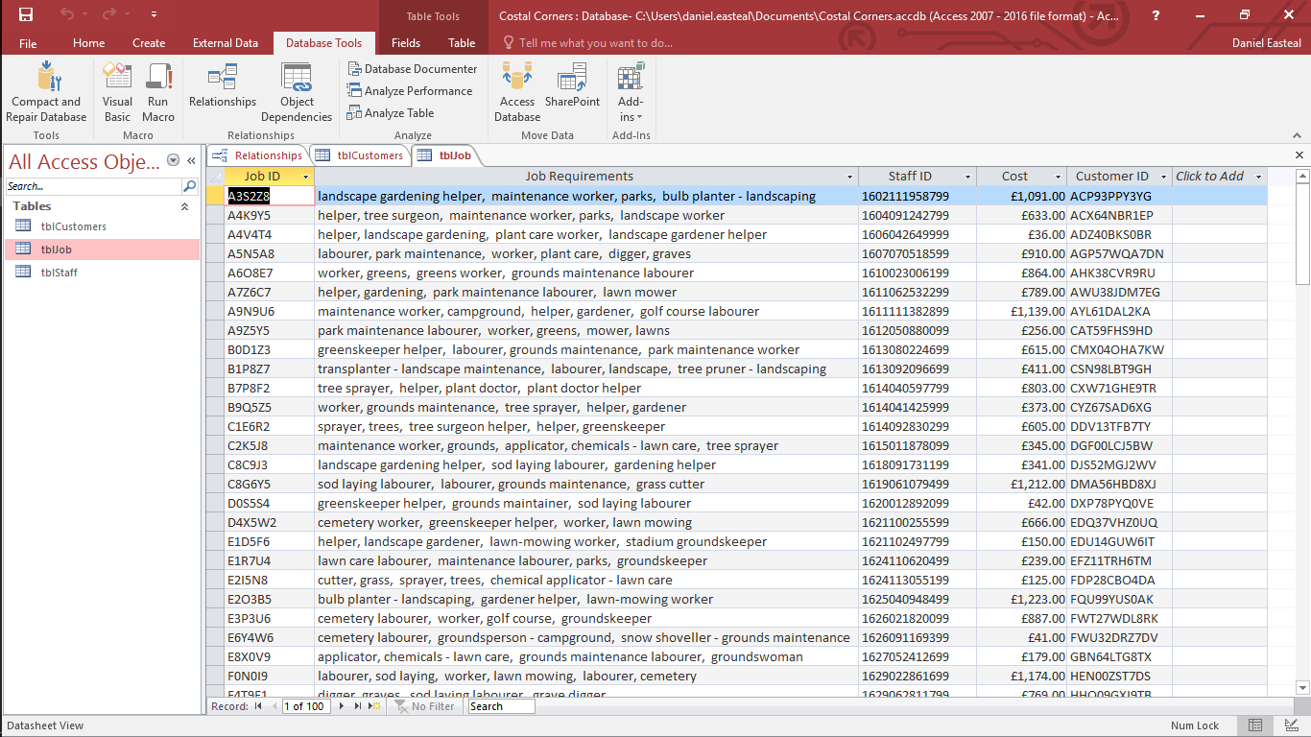For this section I had to create data for a database and fill in 3 tables with more than 10 lines each in them. For this the three tables that I created a customer information table, a staff information table and a job information table. In addition to this I also linked the customer information and the staff information to the job table so that the jobs can be linked to the staff and the customers.

The second table that I created was the job information table, this table would contain all the information about the job that needed to be done. It contains the job ID, the actual work that needs to be done, the assigned staff ID, the total cost and the assigned customer ID.

Here is the first table that I created and it is the table for Customer information, in this table there is information about the customer’s full name, credit card information, address and their unique ID code. These can all be used at different sections of the order and job process so they all need to be kept.

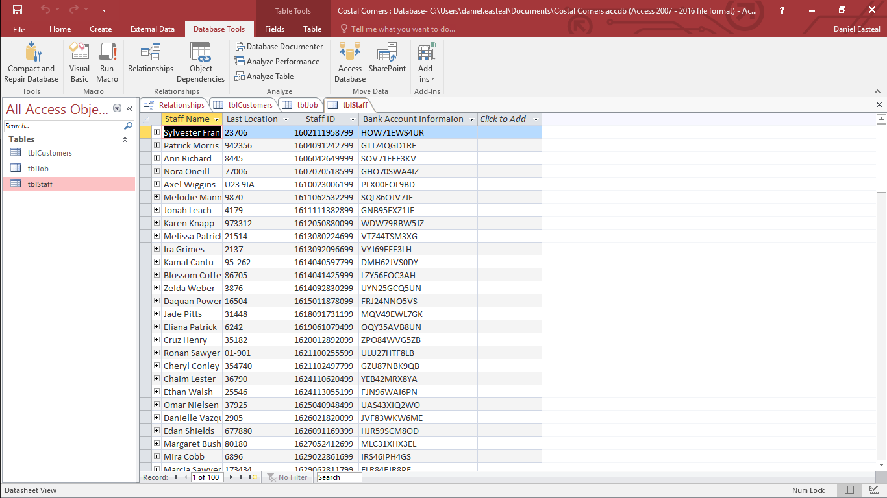

The final table that I created was the Staff table, this contained information about all of the staff that the company would employ. It contains the staff members full name, the last location that they went to do, their unique ID, and their bank account information for getting paid.

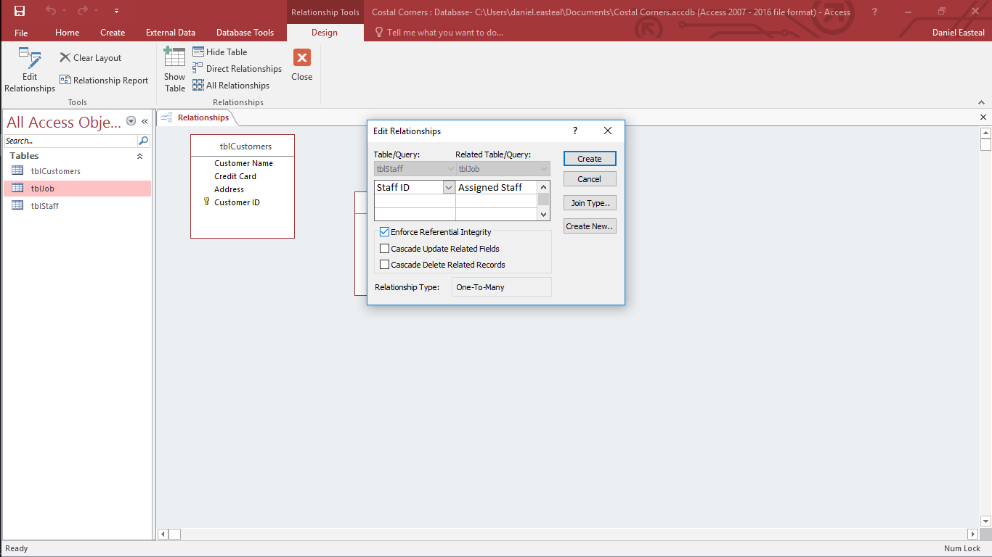

Here you can see me setting up the relationships between the tables. IN this image I am setting the staff ID from the staff table to match up to the assigned staff to the job table. With this link the staff name and information can be accessed from the job table.

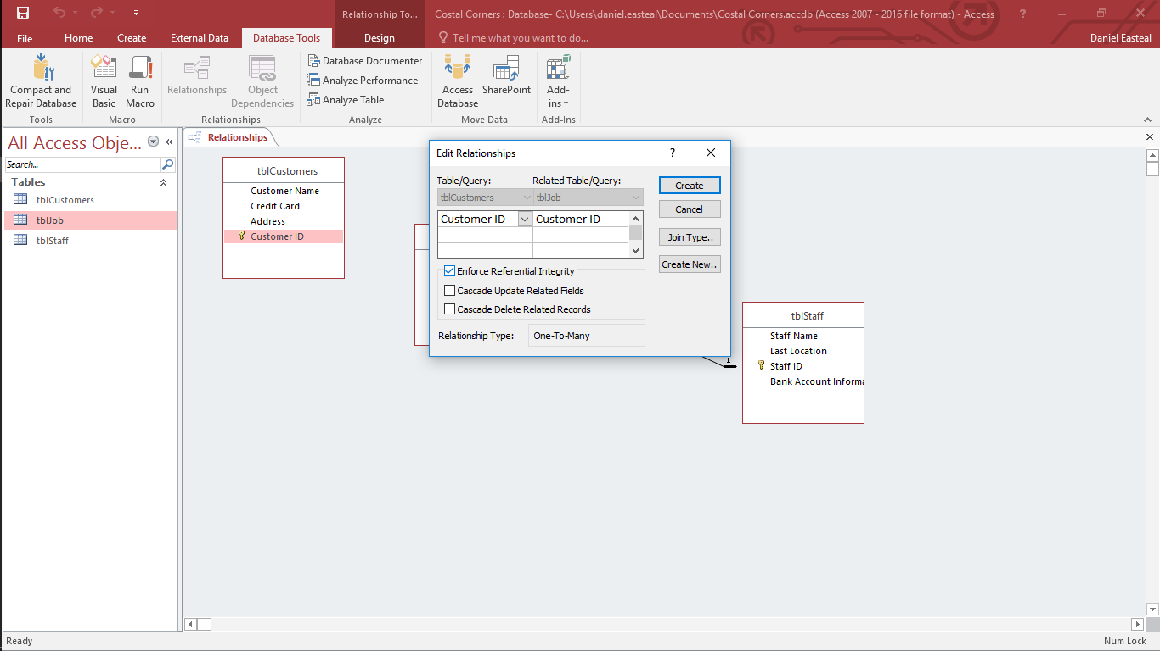 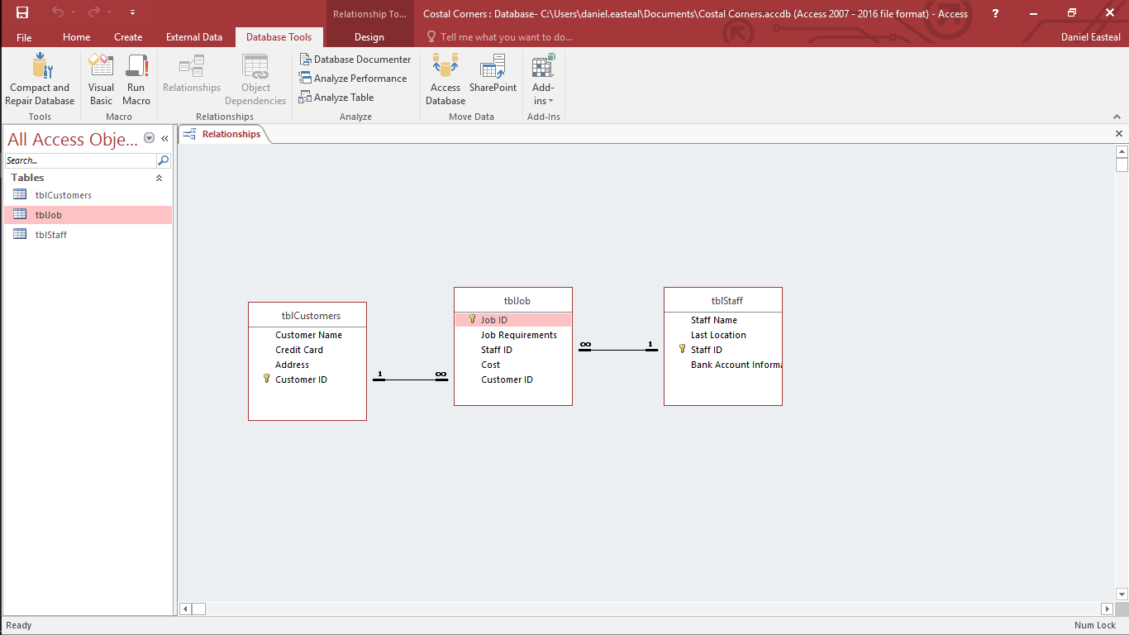

Here is the finished version of the relationship diagram showing what parts from each table are related to the other parts of each other table. This is the relationship that my database has and in addition to this this also shows that the database has referential integrity as that is something that access does automatically when you relate 2 or more tables like this.

Here I am linking the Customer Id from the Customer table to the Customer Id of the customer table. This will allow the customer information to be accessible from the job table which would allow the customer information to be easily related to the work to be done.

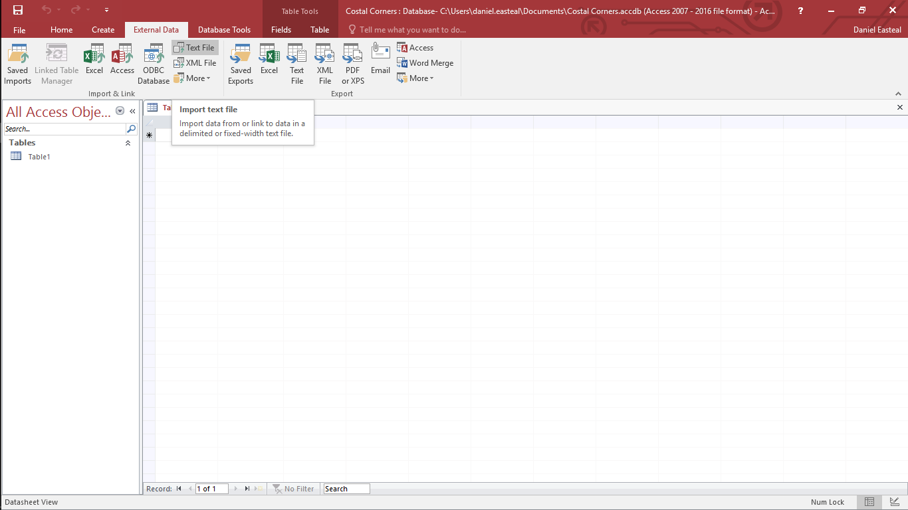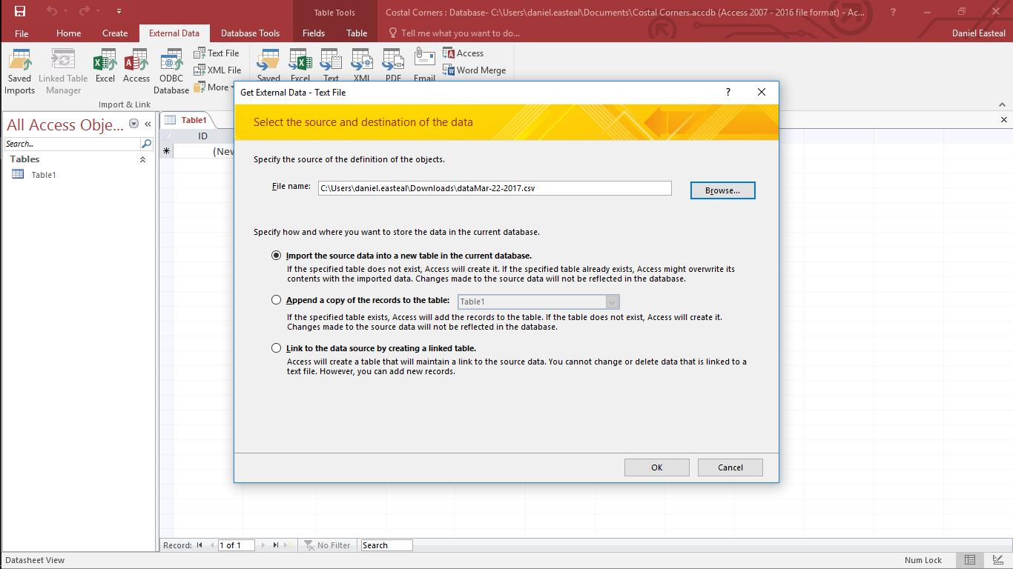M2 - Import data from an external source In this section I will be showing how I import data and information into an access database from 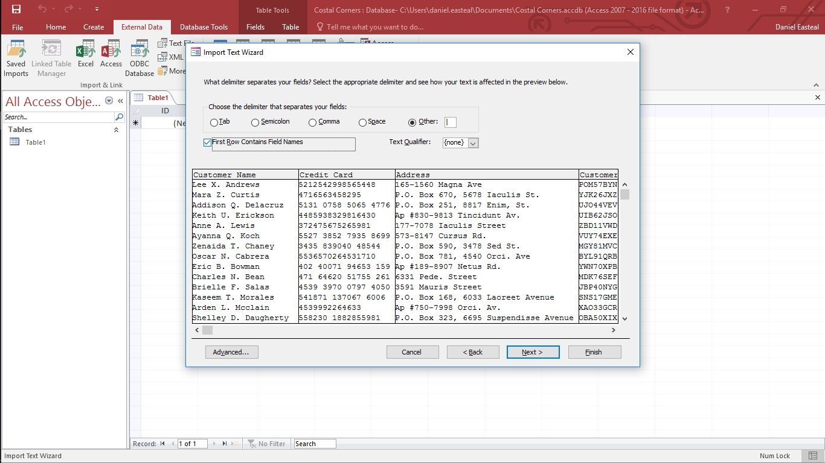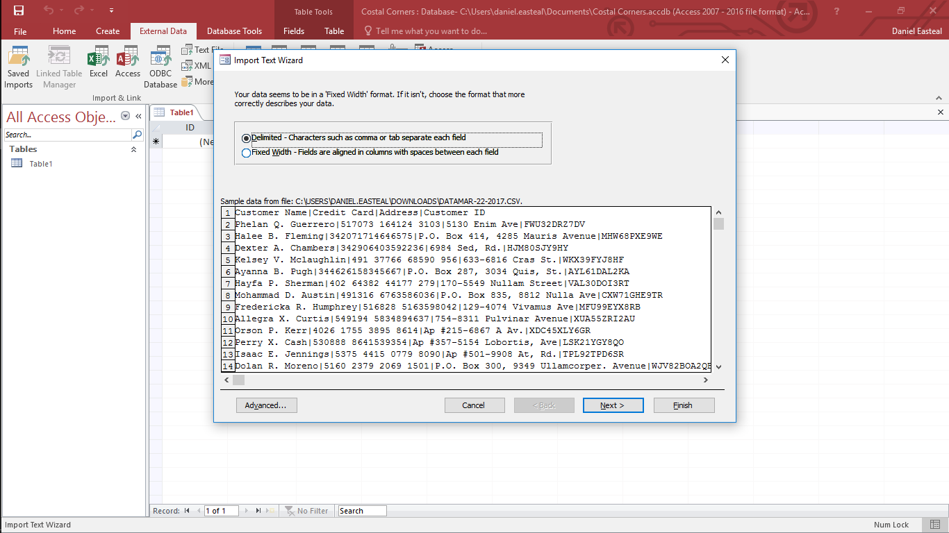

In this section I will be showing how to import data and information from an external source into an access database.

To start a data import you need to go up to the top bar and click on the external data tab and then the type of data that you want to import, in this case it is a text file. I will then click on the text file button to start importing that data.

When you click that text button this window pops up and from here you would actually import the data into the database. Here you need to select the text file that you want to import the data from. You just hit the browse button and find the file and select import as a new table as that is what I want to do in this case.

When you hit next you get to select how the data is specifically separated and in this case pipes “|” are used to separate the sections so I select that. In addition to this I tick the box that makes the first row become the headers for the data that you are importing as in my case that is what it is.

Once you have the file that you want to import the data from you hit next and you get this screen, here you select how the information that you have is actually separated and it will show how it looks. In my case the data is separated by something so I will select that option rather than by fixed size.

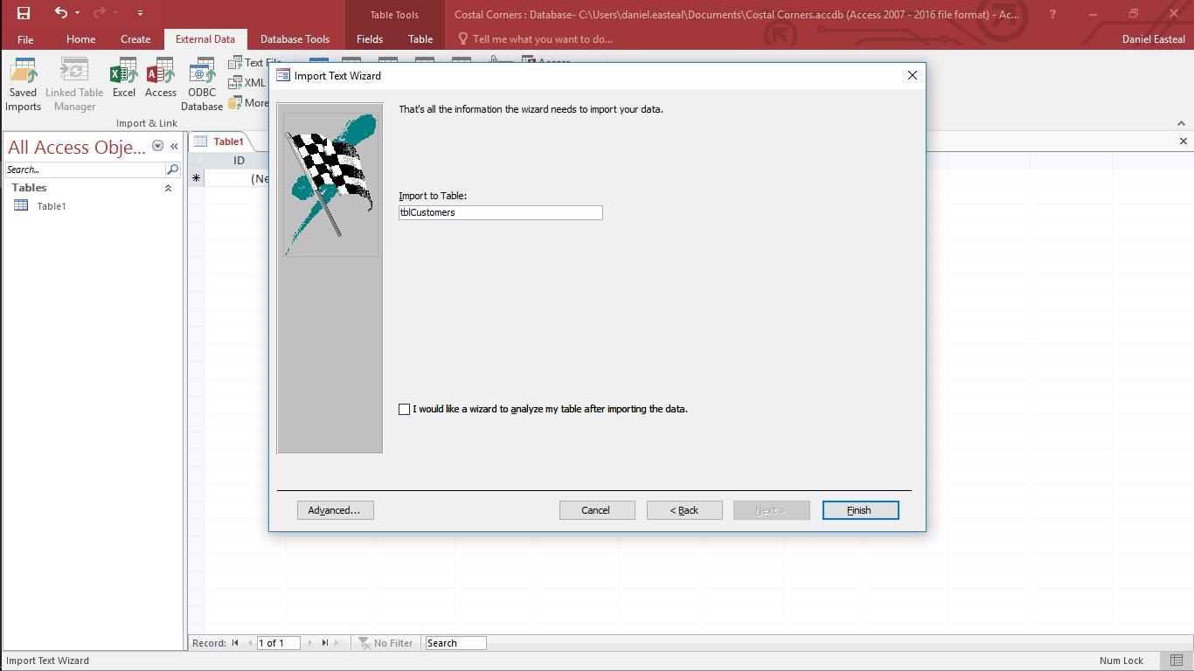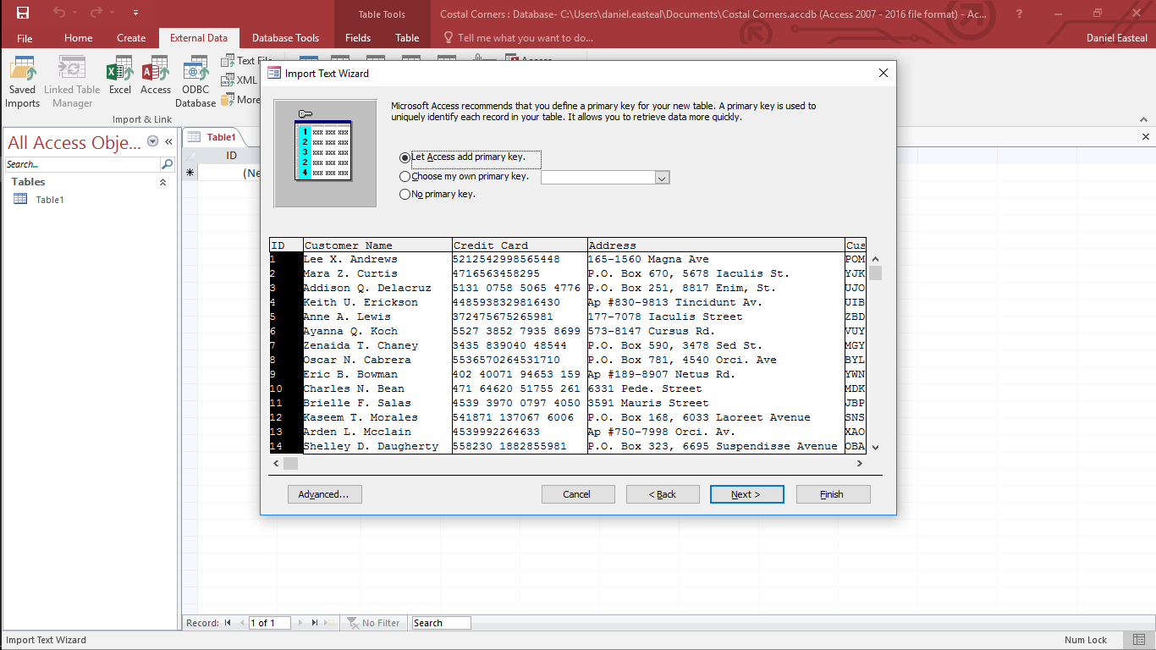

Once you then hot next you have finished the import of the table in the database and so all that is left is to name to table, and in this case I called it “tblCustomers” because it is a table about customer information. And that is that data imported into the table tblCustomers.

From here you will then get to select the primary key for the table that you import, this is a unique field that is used for finding unique records in a table and as such it needs to be unique on each row. Here I would select the Customer ID column as that is unique.

P4 - Create features in data entry forms to ensure validity and integrity of data

In this section I will go through and show you the creation and the features of a form for the database that I have created.

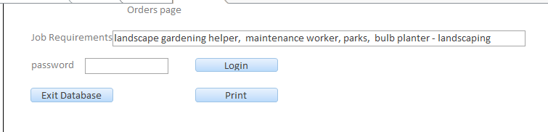

Here is the form that is auto loaded when the database s open. From this the worker can see the information that they need about an order. With the box at the top the worker can add / edit / view the work orders that are available. In addition to tis there is also a password box that is used to access the private area and allow the worker to change the work orders. From this screen the worker can also click the print button to see what the report would look like if they were to print it and then actually print it using the windows print dialog. Finally there is an option to exit the database when they are done.

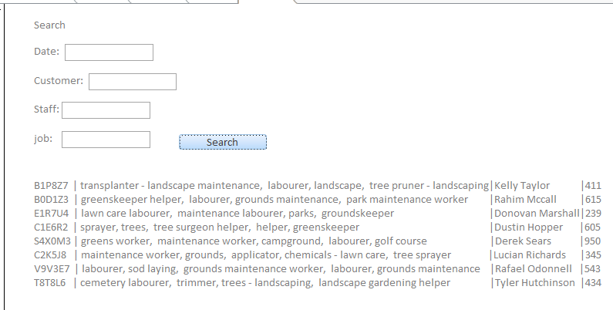

In addition to that previous form there is also a search form that can be accesses from the previous form and above is what it looks like. From this you can search for any result that you have in the database and this will pull information from any of the tables where that data is found. You can search for any information that the database contains. As you can see there are two 4 main boxes that are used for searching and it is obvious that you would need to fill these in to search for something that you want to find.

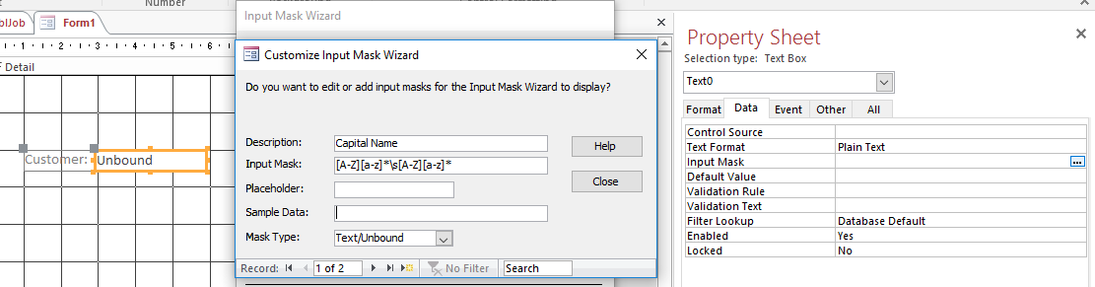

In addition to just being a basic search function, the search boxes are also set to only accept valid input. From this screenshot above you can see that the Customer name section is set up to only accept a name on the form of a capital letter followed by any number of lowercase letters followed by a space, and then a capital letter and the remaining lowercase letters. This will ensure that an input mask to capitalize the initial letter of proper names is actually achieved.



Finally, the section that is used to search for the date has a date picker as the input, this will ensure that the input will actually be a valid date and will work with the database.

P5 - Perform queries using multiple tables and multiple criteria

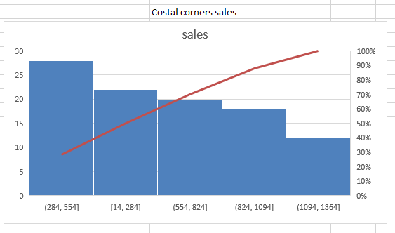In this section I will go through and show you how the order of the business can access the information that he needs about their company in any form that they like from charts to reports and so on.

For the first thing, the owner wanted to be able to see the health of his business in a web dashboard with charts, and above you can see just that. Here we have a very basic web dashboard showing a single chart and in this case it is showing two very important different things. Firstly, the blue chart on the background shows the sales that have been made between each price point and as you can see the most profitable range is between the 250 to 550 price point. In addition to this the red line shows the cumulative frequency of the money that has been made at these different points. From just this simple interface the owner will be able to see the health of the company.

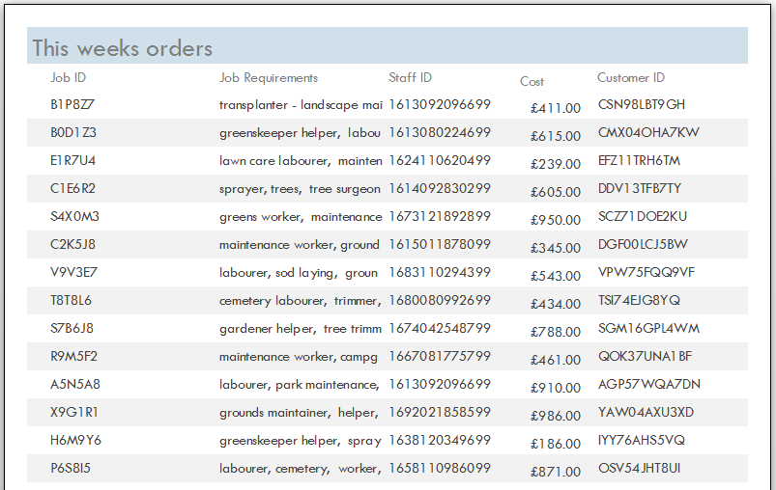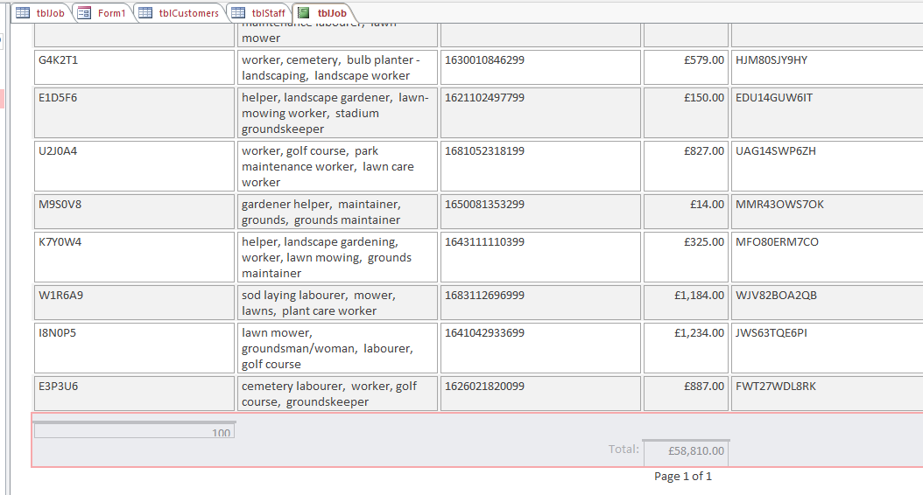

The next thing that the owner would want to see would be the total sales that have been made in this month and the report above is showing that. To do this I simply sorted the data to show only the sales that had been made this month and then generated a report. At the bottom I then added the title of “Total:” and then a box that said “Sum()” and that summed all of the costs in that row which added up to the total cost of all the sales for this month. This information could also be shown in a nicer way like the one below, in this case I made it show the orders for the week.

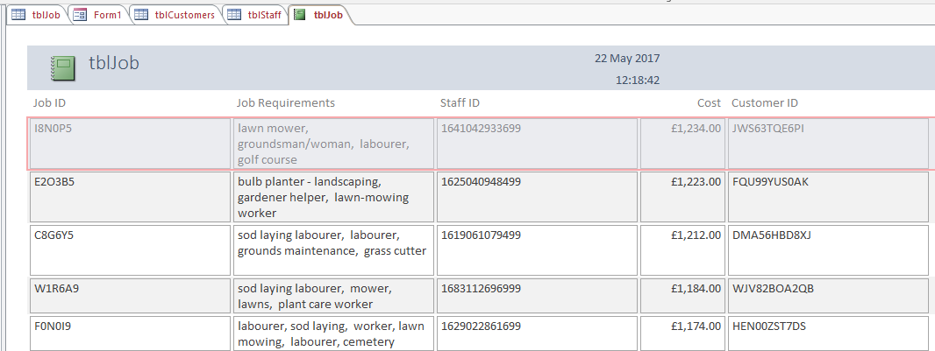

The next thing that the owner may want to see would be the top 5 customers for their business, this is also a simple task as you would sort by customer and then sort by cost, finally you then merge all of the prices for a customer into one value and display only the top 5. And that is exactly what I have done here above. One side effect of this is that the job ID and requirements fields are shown as the top ones when the merge happens, but when you would display this information these would not be shown so that it ok. As you can see here the most that a single customer has paid is £1,234 and after that £1,223.

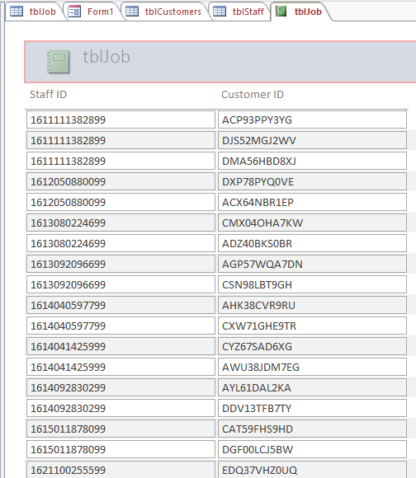

The final thing that the owner might want to see would be the staff and who they actually severed or what customer was assigned to what staff member. In this chart I just sorted by staff and the customers followed suit.

M3 - Export data to an external source

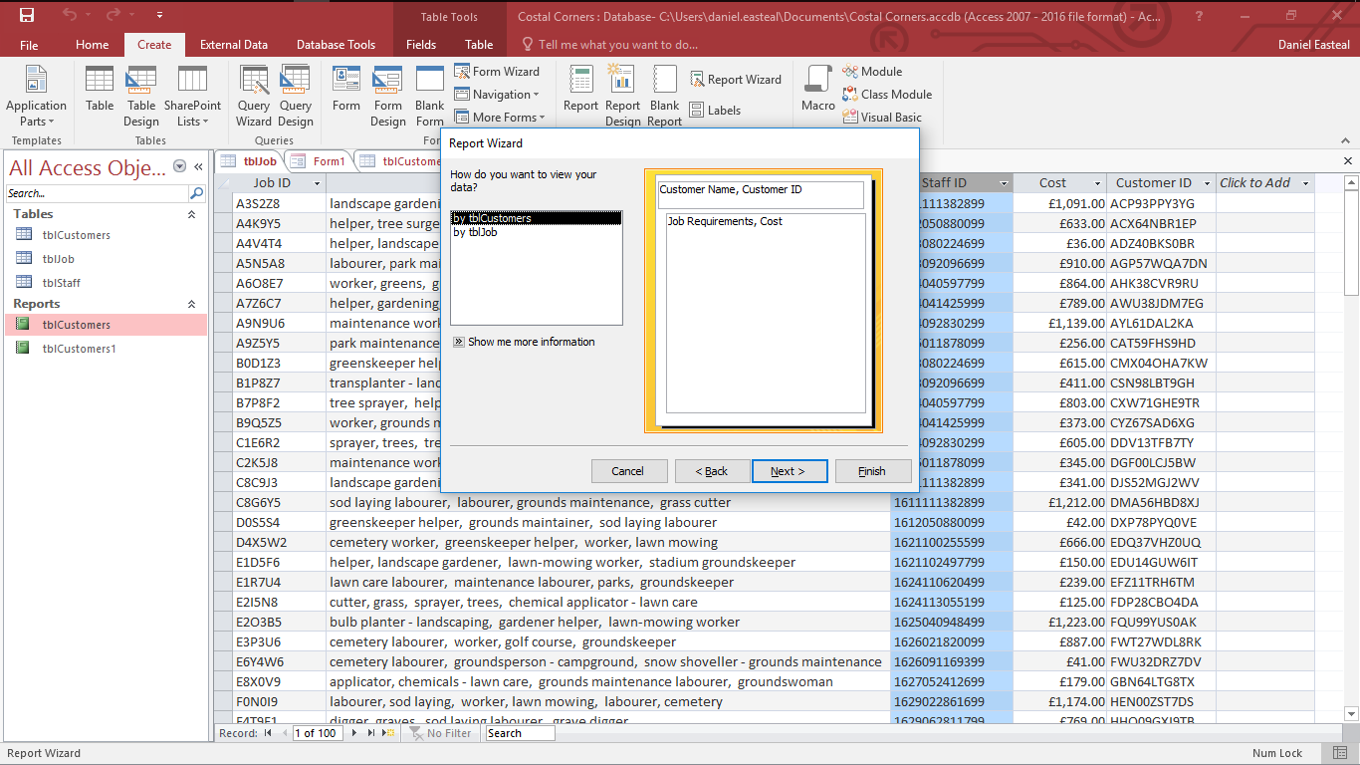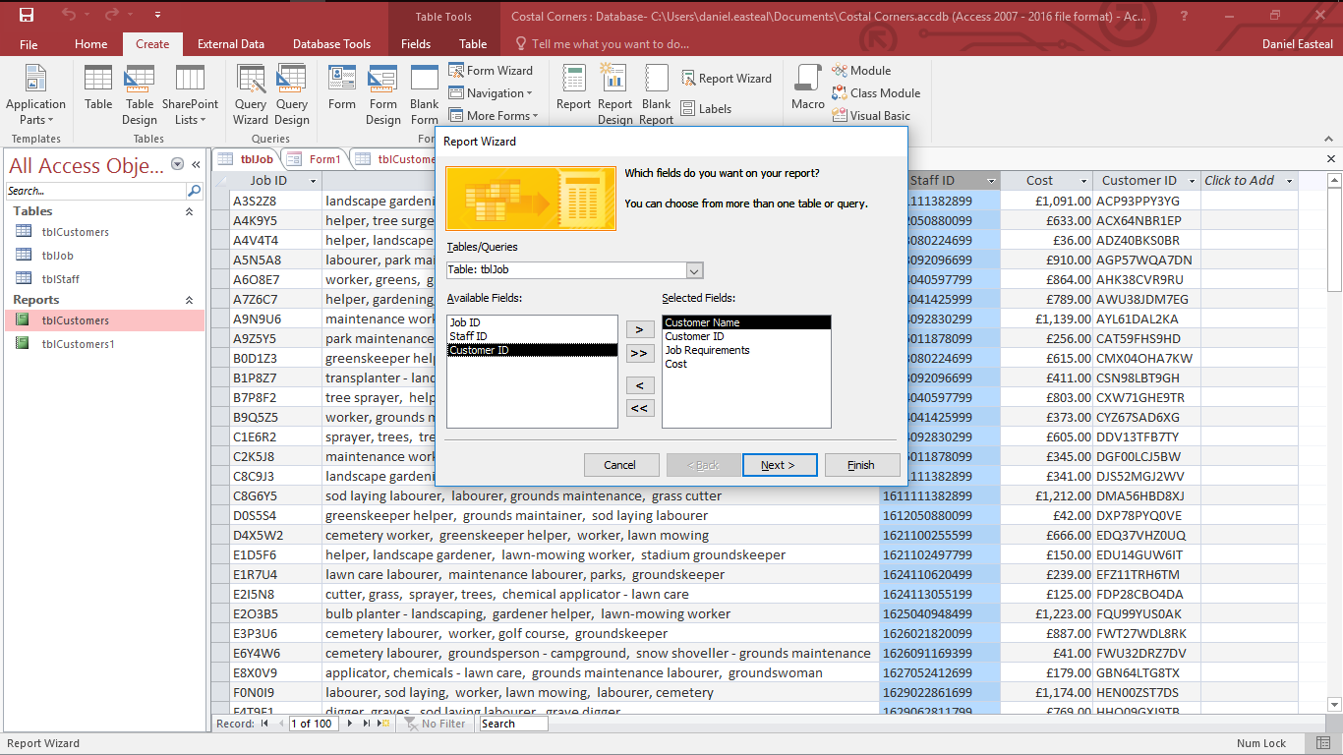In this section I will go through and explain how to export data that you have in an access database. In this example I will go through and show how I would export customer data and information to the customers about orders that they have made

After this it would then ask you what layout you want for the report and I selected a landscape layout due to the fact that the information I will be displaying with the work required is quite long and I want it to fit on one line. After I have selected this I then went to a screen where it asked me about the name of the report and for this I used “order summary” as that it what it is. I then hit finish and that is the report created.

To start off this task you will first need to create a report that will contain the information in a form that the customers can read well and easy. To do this I hit the report wizard button and it presented me with the screen above asking me about what I would like to include. For this report as it is sent to the customer and their order it will include information on their name, their customer ID, the work needed on their order and then the cost. I hot next and it takes me to the screen below where I layout the report as I want it, in my case that would be the customer name and ID up top and then the cost and work after that.

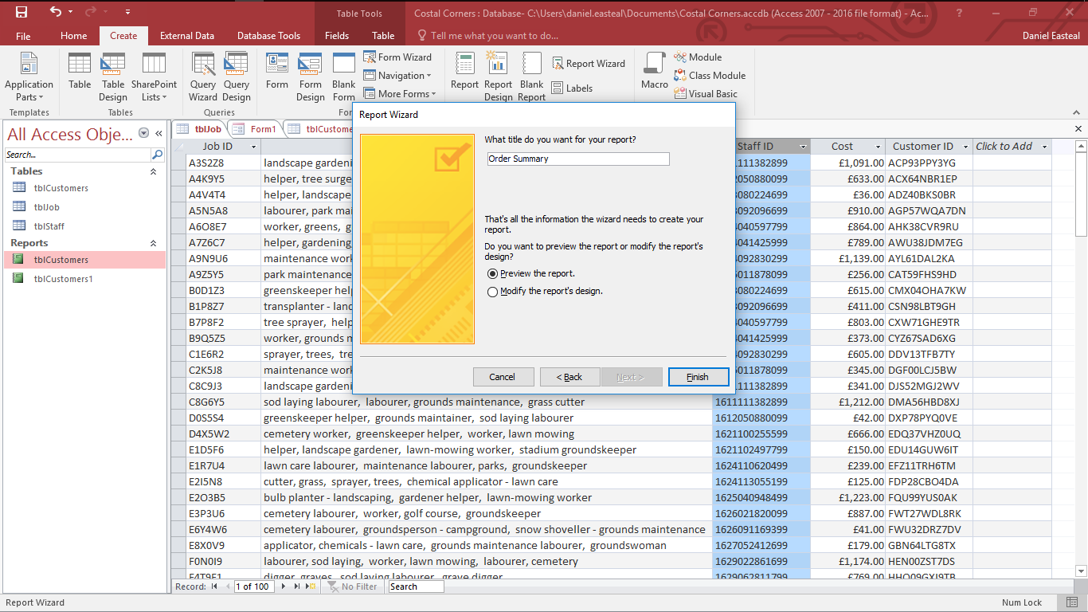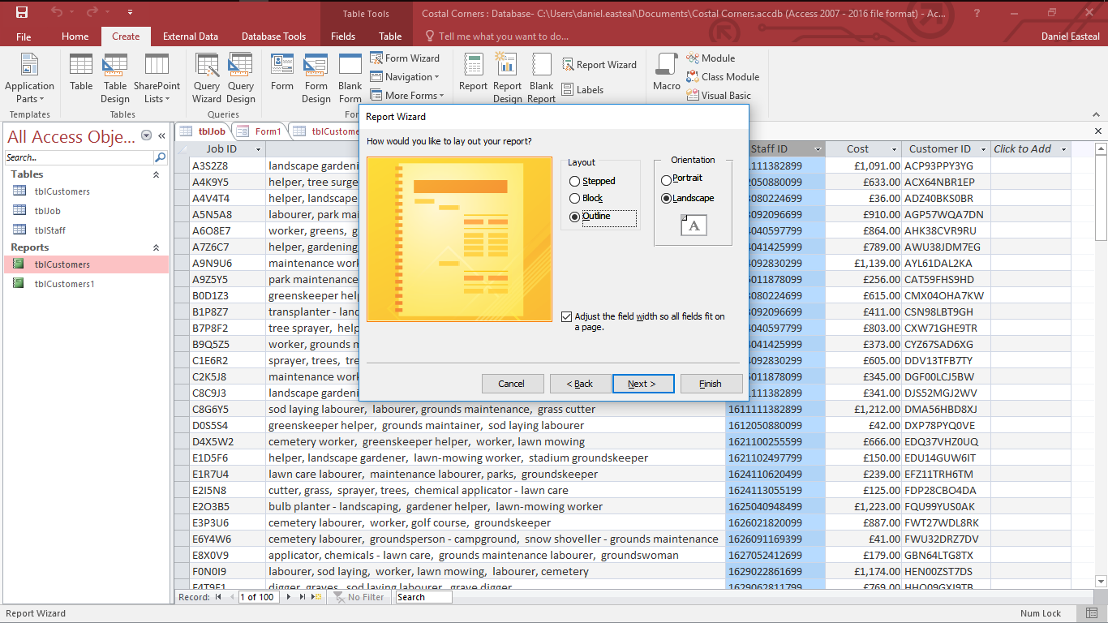

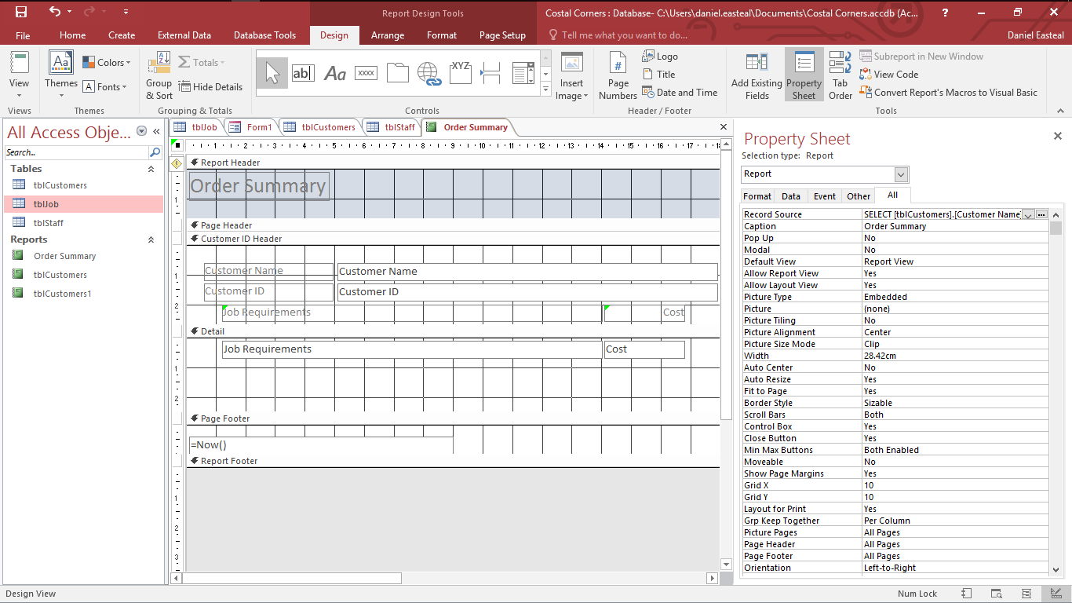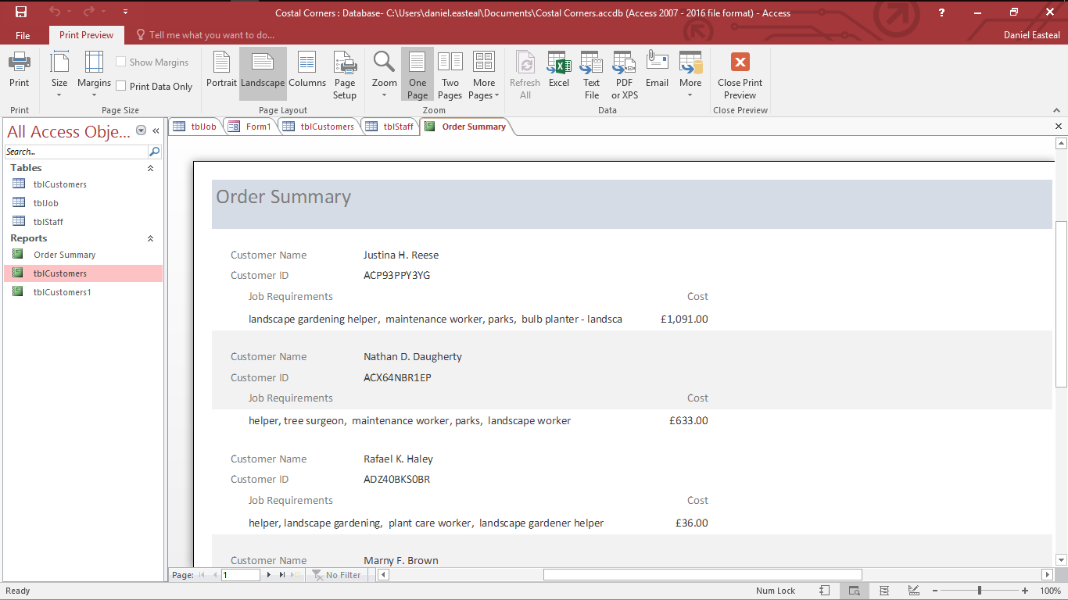

As you can see above the report has been created and it looks exactly how I want it, apart from one thing and that is that that I only want one customer’s information per page. To do this I need to go into design view as you can see below and edit it.

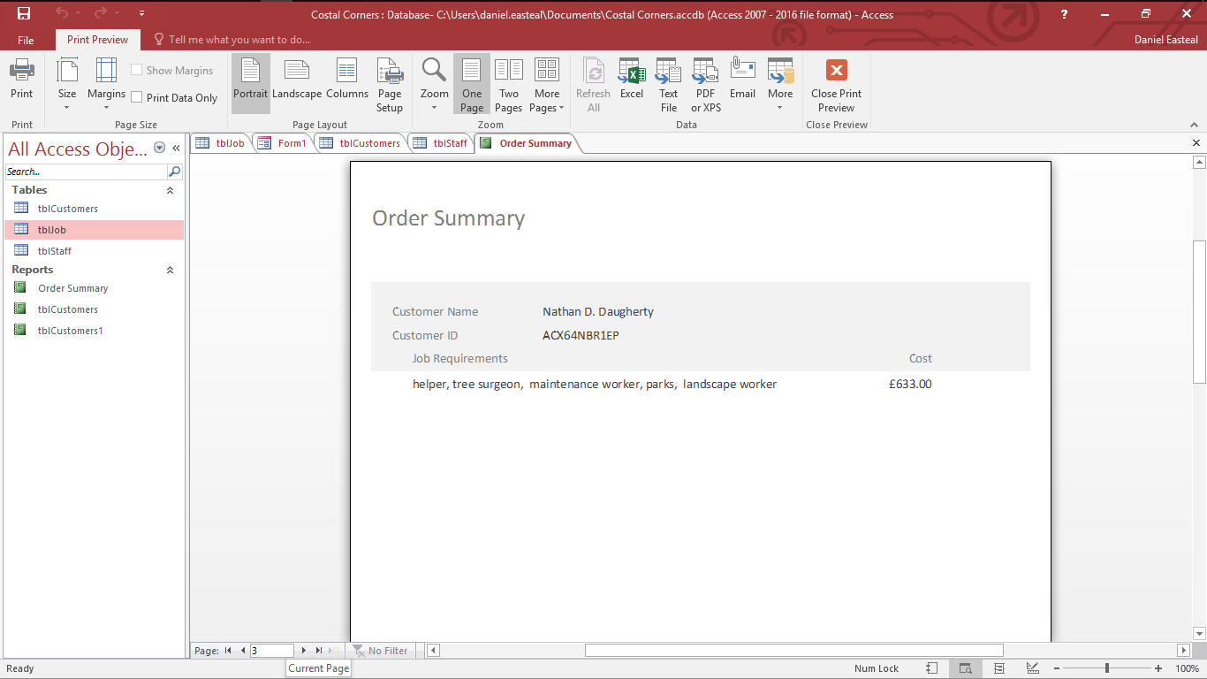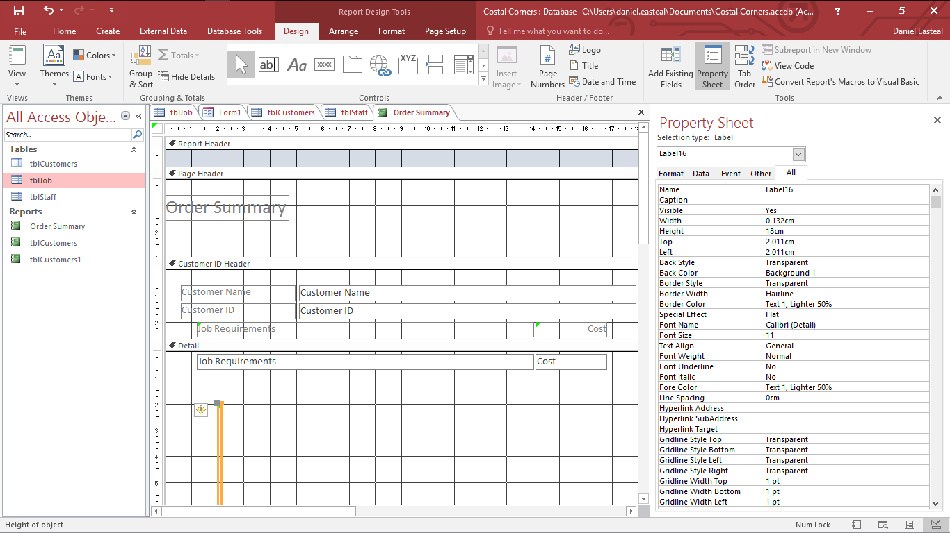

The change that I will need to make is that after every record on the page I will need to add in a page break so that all customer’s information is on a different sheet of paper. The best way that I found to do this was to add in a long text box that would last the width of 2 sides of paper to separate out the results. Now that I have made this you can see that in the image below the report has separated out all results onto one page per customer order. From here all that I would do is send the correct page of this report to the customer that needs it and this can be done easily as they are in the same order as the data in the database.

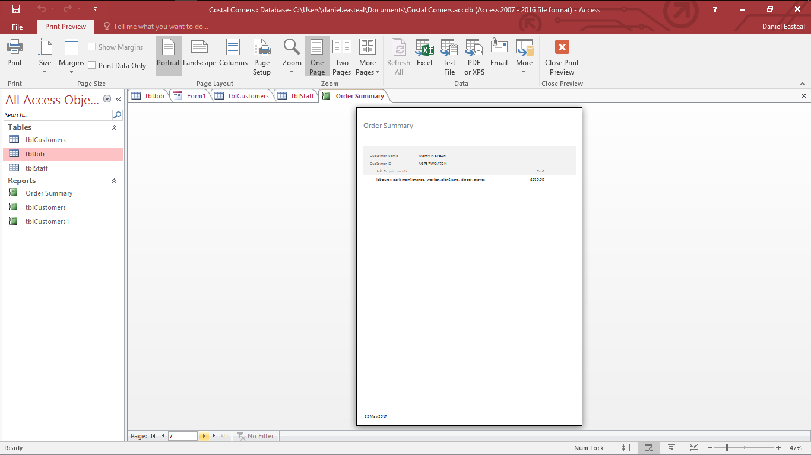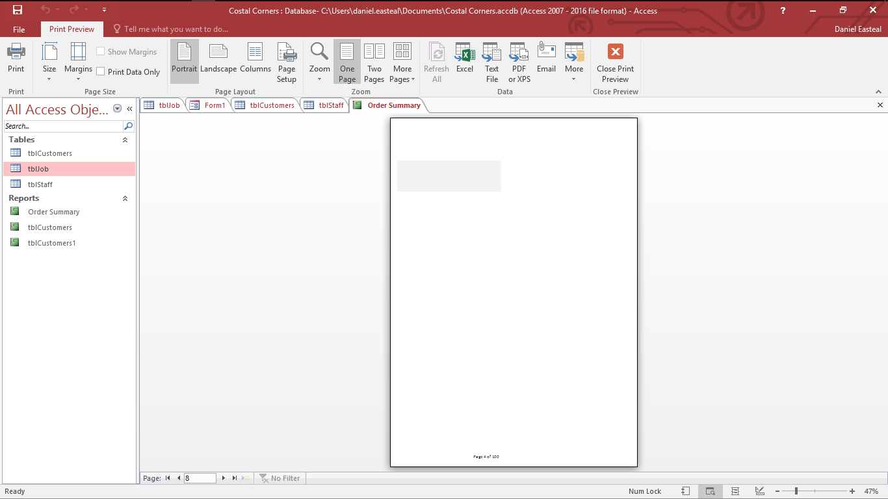

Here is an example of what the customer would receive in their email.

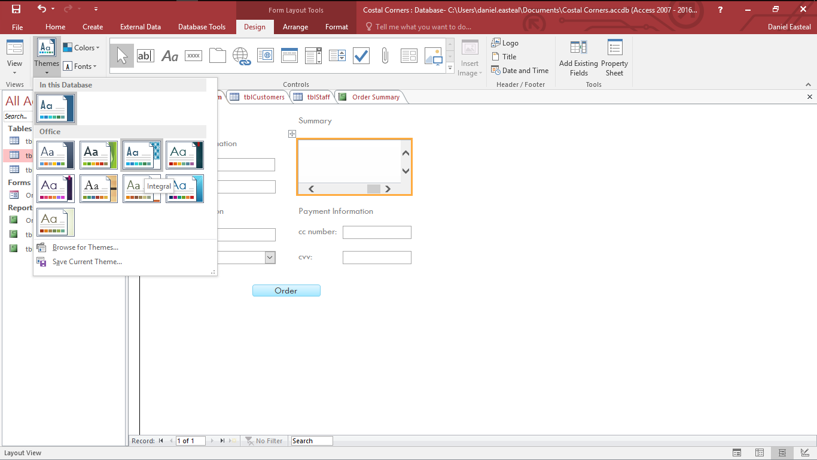P6 – form creation with themes and features.

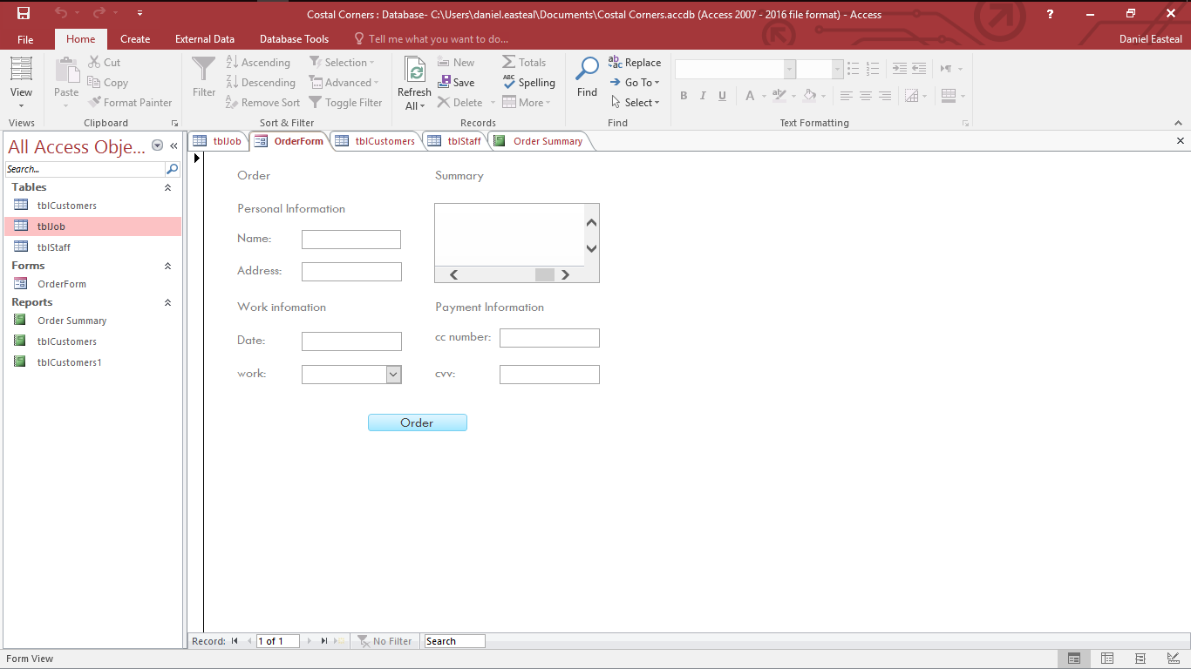In this section I will go through and explain the creation of a form that is used to create an order with the company and how some features of the form work and why they are good.

To start off with, above you can see the basic form that I have created and will be applying all of these features to. As you may be able to see this form already has a custom colour theme applied to it to make the look and feel consistent. To apply the theme all I did was go to the design tab and then on the themes section and clicked on one that would look nice with a few tweaks and that in this case is integral. As you may be able to see this has applied a consistent typeface and colour scheme that goes with the overall design.

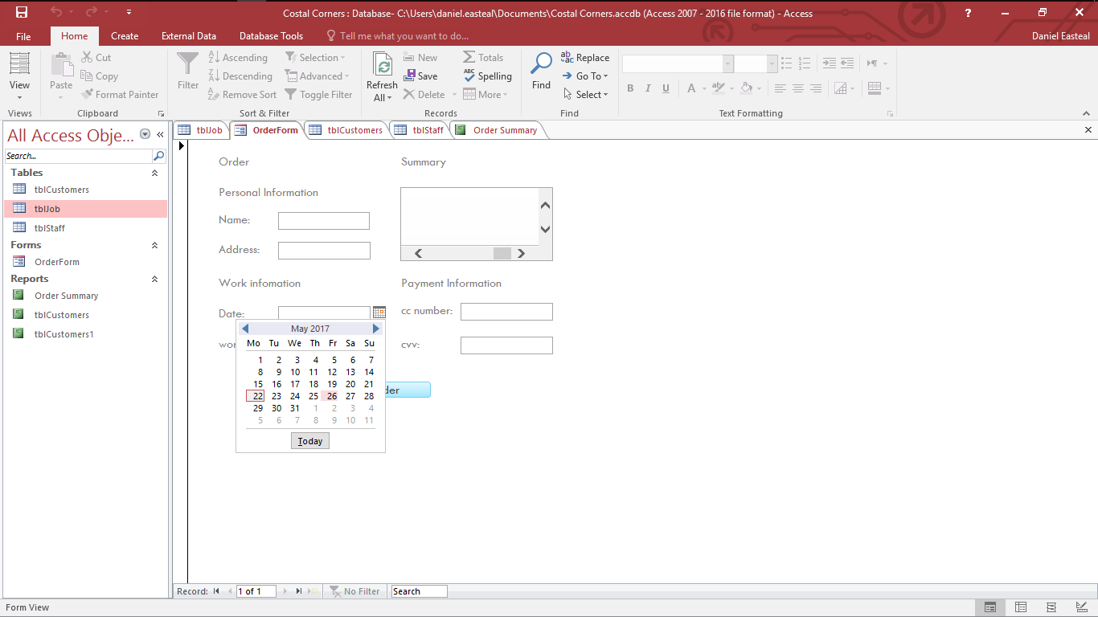

The next future that should be in a form like this would be the date picker for the date entry. With this the user will be able to select the date that they want for the work easily with a nice graphical look at it, additionally it will also always provide a valid input all the time. As you can see in the picture above the date picker has been applied to the date input box and when you click on the calendar this menu pops up allowing you to select a date that you want. In the picture below you can see the result that this would have when you select a date, as you can see it inputs the date for you in a valid format.

Additionally, you can see the navigation object that are in use in this form, although the form is small each section is clearly labelled with the information that the user will have to input at that stage like “order”, “work information”, “summary” and “payment” information this will ensure that the user does not get lost.

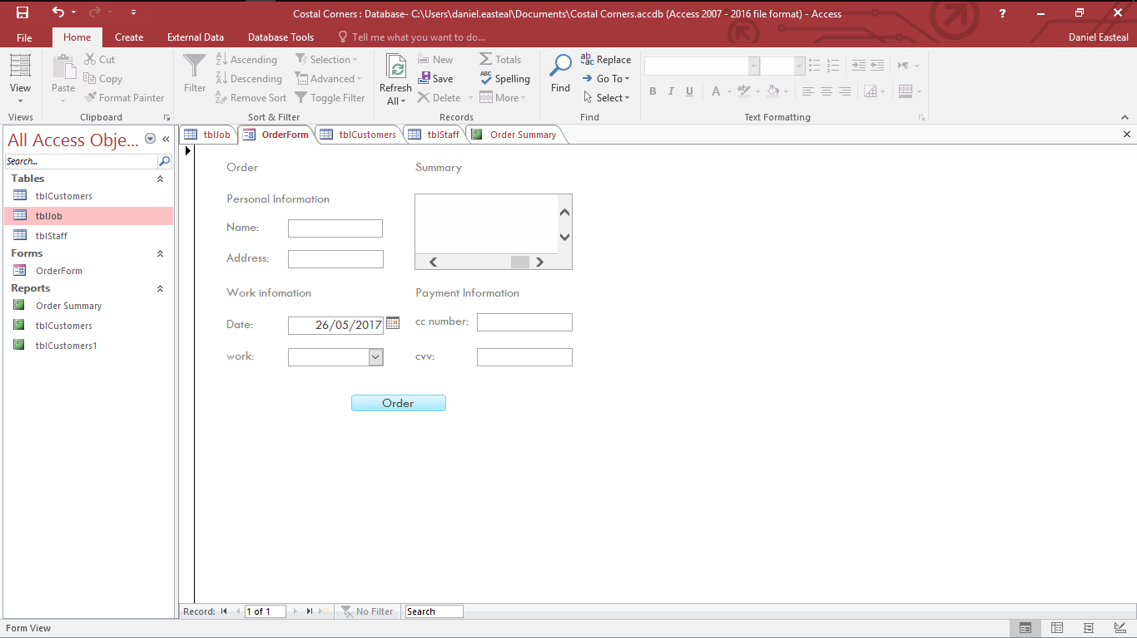

M4 – advanced feature

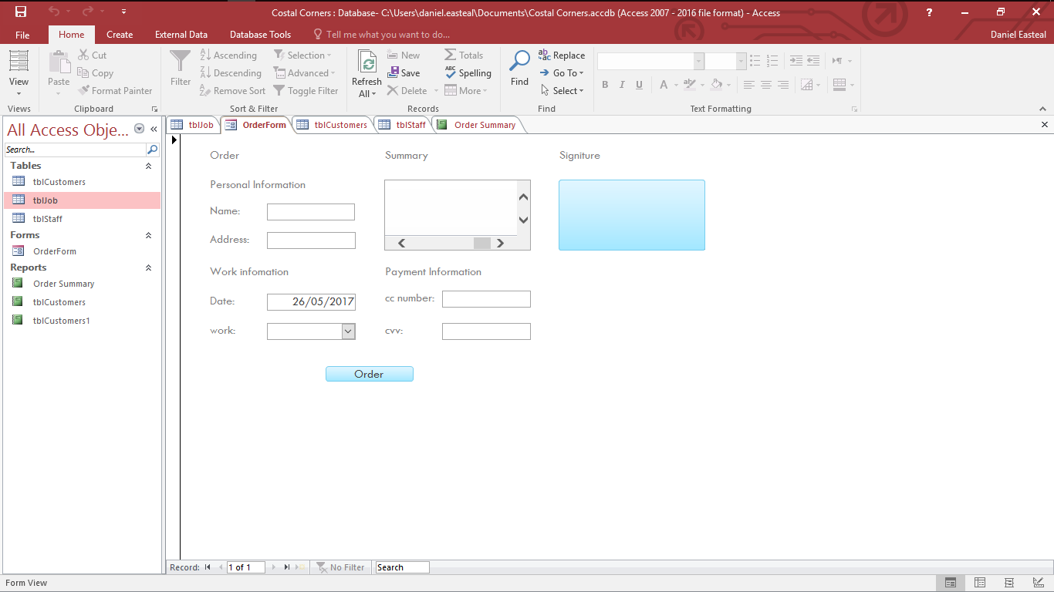In this section I will go through and explain the addition of an advanced feature that I have added to the database, more specifically the user order form.

The advanced feature that I went with in this case was the inclusion of a digital signature input for the customer. This is a great inclusion as it will mean that the customer can sign off on their order when the work is done without the need for more complicated papers and form for them to fill out as the signature they provide can be matched up to the one in the database to confirm. The way that I got this was through a plugin that I found online that offers a digital signature stuff for databases.

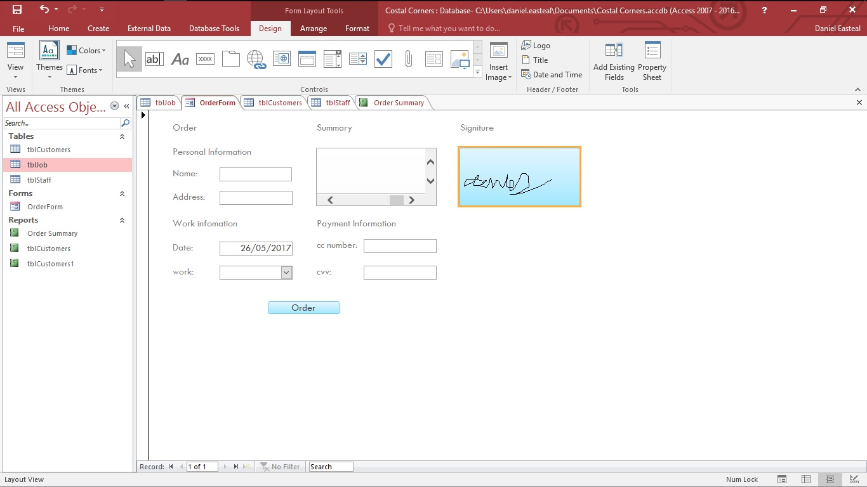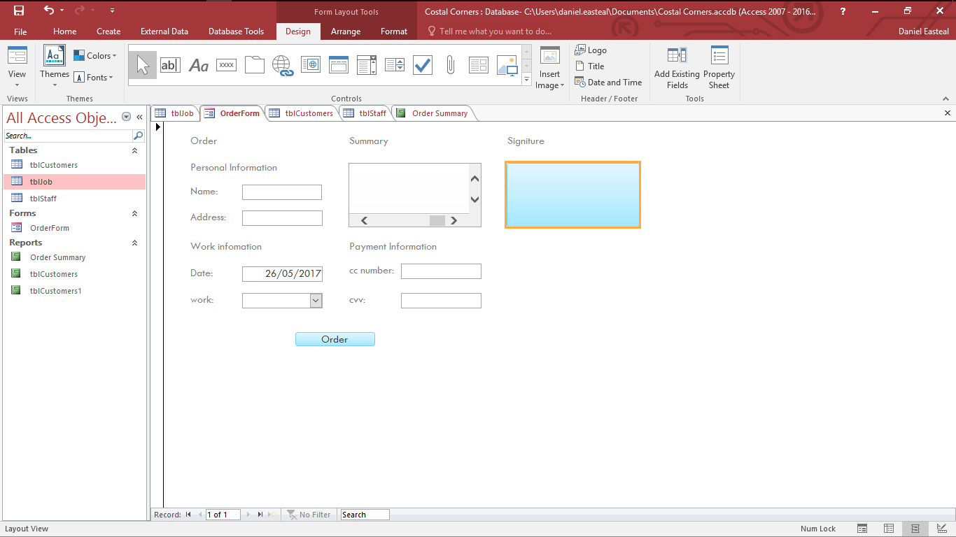

The way that this works is that when you click on the signature input box it will have an orange border around it as you can see in the image above to show you that it is ready to receive input. From here it then catches the input that you provide to the computer through the mouse or trackpad and it then draws out your signature as you type. As you can see in the next image, after I clicked on the box and input my signature it drew it out on the screen and so when I make my order this information will also be saved to the database for later reference.

P7 – test plan

For this section I will demonstrate a test plan for my database that will act on each of the main functions of the database. It will then show all the information about that text that is needed.

|  |  |  |  |  |  |  |
| --- | --- | --- | --- | --- | --- | --- |
| Number | date | checking | details | expected | pass | Problem number |
| 1 | 20/3/17 | Form date input | Adding an order on a certain date to see if it gets added to the database | Date is added to the database | Y | N/A |
| 2 | 20/3/17 | Form work input | Adding an with certain work to see if it gets added to the database | Work is added to the database | Y | N/A |
| 3 | 20/3/17 | Form credit card input | Adding an order with a certain credit card number to see if it gets added to the database and the right table | Credit card number is added | Y | N/A |
| 4 | 20/3/17 | Form customer name input | Adding an order with a certain customer name to see if it gets added to the database | Customer name is added | Y | N/A |
| 5 | 20/3/17 | Form summary generated | Creating an order with certain items to see if they will actually show up in the summary box | Summary is generated | Y | N/A |
| 6 | 20/3/17 | Order summary report generation | Check to see if the generation of the order summary report is as needed with a page for each customer | Report is generated | Y | N/A |
| 7 | 20/3/17 | This month’s orders report | Checking to see if the report that is for this month’s orders generates and provides the correct value at the end of it | Report is generated | Y | N/A |
| 8 | 20/3/17 | Assigned customers report | Checking to see if the report that is for the customers staff generates and provides the correct value at the end of it | Report is generated | Y | N/A |
| 9 | 20/3/17 | Email export | Check to see if the exporting of the database worked correctly and if customers got their email of their order | Email sent and no data lost | Y | N/A |
| 10 | 20/3/17 | Referential integrity | Check to see if the database still has referential integrity and that it has not been lost | Referential integrity is kept | Y | N/A |

D2 - Design a questionnaire to evaluate the user response to your database.

In this section I will go through and create and questionnaire that will go through the database that I have created and I will give this to other students for them to complete and show me what I need to do with my database and what I can improve about it.

Questionnaire:

• how good was the appearance and legibility and what did you think of it:

1 2 3 4 5 6 7 8 9 10

The appearance was simple and concise, it did what it needed to do and it did it well

• how easy can you find the functions that you need

1 2 3 4 5 6 7 8 9 10

Really easily, as they are all on the same screen and it has most things

• Does it provide all the expected features that you would need

1 2 3 4 5 6 7 8 9 10

Yeah, it has everything that could be needed but maybe a few more options

• do you believe that the interface is intuitive

Yes, is really is as you have every thing that you could need right there and labelled

• what is your overall satisfaction

1 2 3 4 5 6 7 8 9 10

• do you have any suggestions for improvement

Only one, maybe add a few more options for ordering the service on the order page, but other than that its good.

In this section I will be explainging how the database that I I have created is fit for purpose and how the it meets the needs of the users of the database

• The features you have incorporated specifically to assist both user types

From looking at the database there are many different features that I have added that are there to specifically assist both types of users for the database, Users and Staff.

Users

The main feature that I have added for the users of the database is the ability to order the service that you need from a form that will then send that information and data into the database ready to be processed. This works by using form that the user can access that they can then input the information for their order. This is actually safe as well as it keeps all the information masked that goes into the database so that the information is not of the incorrect format and doesn’t crash the program when they input it. The main form is made of a few masked input boxes as well as a fully working summary screen and integrated customer signature box online and date selector. This is suited for the user as it allows then to input the information that they need quickly.

Staff

For the staff there is a search feature that will allow the staff member to search for record in the database based on the information in any of the records that are held. In addition to this there is an integrated edit function that is protected by a password so that only some of the people in the business can edit the customer records. The way that this is done is through a few input boxes, one for each record type, a search button a password box and a summary window. The summary window will show all the results of the filtered results based on the search pattern that you input onto the boxes. Tis suits the needs of the staff as it enables them to see any record that they want with the ability to search for what they want easily, with the ability to change some records for administration purposes.

• How they will complete tasks using the database

From the screenshots that you can see, that they can do anything that they need to do with the database due to the fact that all of the features have been implemented in some way. From the user side they have the ability to create the order that they want by imputing the work that they need done and when it should be done as well as the payment information for the service. Additionally, they also have the ability to write down their own signature and preauthorise the payment and make the pipework a lot easier at the end of the process. For the staff side they have the ability to search for any of the recorded in the database to see what needs to be done so that they can prepare for this, additionally they have the ability to generate and send reports to users based on things that they order. Finally they have the ability to change and edit orders.

• the strengths and weaknesses of your solutions

The main strength with the solution that I have provided is that the software works really well with what the customer needs and it has the ability to get the users signature during the ordering process. The reason that this is such a good strength compared to other ordering systems is due to the fact that this will save on paperwork that the customer would have to deal with later on in the process. As they signature is already done, when paying for the work after it has been done the signature can be used automatically to sign for the documents so that for the user it is a seamless process.

One weakness that I would say exists is that the I have not yet automated a system to automatically generate reports because some human intervention is required to make sure that it works ok. This would be quite simple thing to actually set up but in its current state this is potentially an issue and therefore a weakness of the database.

• Any issues raised and what you would do about them

One issue that was raised was the fact that on the order form there could have been more options for what the users want, even though the basic minimum is there. For example, one way that I would improve this is that I would include the ability to add in images as to what your garden currently looks like and then a reference image so that the staff have an idea of what you want the site to look like afterwards. This would not be too hard to implement as it would just be storing information about an image in a database, but at the moment it is not a feature. This would be a really good thing to have due to the fact that it would increase customer satisfaction with the system as they can get it looking exactly how they want It to. With a higher customer satisfaction there would be a higher rate of customers into the business and it would grow well.

• How you could have avoided these issues

As mentioned, I would add in some additional features into the database so that it has additional functionality fir the user .While the image uploading is one idea, another one might be to send is special request messages so that even more specific things can be uploaded to the database and this would increase customer satisfaction a lot more. The way that this would work is that the customer would attach a note saying how they want certain things to be, like that they only want half the garden done, this way the staff at the company know that they only need to do half the work they are planning and so they can save on resources, making them more money and maybe moving some of these to the customer as this would improve customer satisfaction a lot as well, bringing in more money.

• How you could improve the database

One way that I could improve the database would be to add in the ability to export different types of data automatically rather than having to manually generating a report all of the time that you want to see something in a nice way. This would be a good thing to improve as it would save a lot of time when you are trying to do export data and it would increase the productivity of the database.