**Smart Hydroponic Farming Using Internet of Things**

Saivivek Reddy Kusukuntla, Nithin Reddy Kumbham, Vamsidhar Reddy, Jawahar Reddy Nomula, Abhinav Bellamkonda, Gopi Krishna Kandimalla, Dr. Ratan Lal, Northwest Missouri State University, Maryville, Missouri.

**Abstract:**

Natural sunlight is widely recognized as the best source for plant growth and development. When the winter months hit, some plants may not receive enough light and die due to lack of maintenance. To promote faster or balanced growth**.** We wish to use the hydroponics method, which enables us to provide plants the necessary nutrients in an artificial environment utilizing red and blue LED lights that facilitate photosynthesis in plants. These techniques were interfaced with IoT for controlling the system via the internet. The proposed system includes a variety of sensors such as pH sensor to monitor the pH level inside the water, DHT11 Temperature sensor to detect the temperature and Humidity of the Environment, DS18B20 to detect the water temperature. This system also consists of the relay which is used for controlling the water pump to maintain water level inside the tank and HCSR04 sensor to detect the water level inside the tank. The microcontroller that serves as the heart of the system is ESP32. To monitor and control the sensor readings Blynk IoT application is used.

**Introduction:**

There are many reasons that plants die that may include lack of sunlight or maintenance. Growing plants in soil uses harmful pesticides, fertilizers, and other toxic farm chemicals to grow the crop as quickly as possible and get a higher yield than was expected. It is also possible to contaminate fresh water, marine habitats, air, and soil if we proceed in this manner.

Using Hydroponic Farming we can eliminate all the possibilities that plants may die. So, we provide artificial sunlight by deploying LED’s and avoid contamination of soil as we are not using any soil in Hydroponic Farming. Plants are directly dumped in the water. The main objective of this project is to maintain the plants in their natural state by monitoring the factors that increase plant life.

The above picture describes that there are several factors that plants die due to some inappropriate weather conditions, lack of maintenance and limited water supply. As the plant grows in the soil the roots of the plants may not absorb proper nutrients. But using Hydroponic farming the plant roots are directly dipped in the water as roots absorb sufficient nutrients, we can expect the faster and stable growth of the plant. Using Hydroponics technique integrated with IoT we can continuously monitor and track the status of the environment variables of the plants and automate the system to maintain the proper environment conditions of the plant

**Literature review:**

In extreme weather conditions some of the plants cannot survive, low amount of water supply leads to plant death [1].Moreover,Poor farming practices might result in low production yield [2]. Several studies showed that hydroponics and aeroponics as modern farming technique. But in hydroponic farming manual monitoring of environmental conditions of a plant is a trivial task [3]. So we developed a system using IoT to continuously monitor and track the status of the environment variables of the plants. And using hydroponic farming, we can ignore the unwanted plants growing together with the crop [4] and expect no pesticide attack.

In [Md Ashifuddin Mondal](https://ieeexplore.ieee.org/author/37086444563) and  [Zeenat Rehena](https://ieeexplore.ieee.org/author/37855924200) proposed methodology LM35 was used as a temperature sensor [5] but in this proposed system, DHT11 is used to measure both temperature and humidity [6, 7] of the environment. To measure the PH level in the nutrient tank solution, a pH sensor is added [8]. A single wire temperature sensor called the DS18B20 can measure the temperature in water [9, 10]. So, whenever the environment variables values exceed the threshold value the system notifies the user.

The ultrasonic sensor is used to monitor water level in tanks [11]. ESP32 alerts the Water Pump to turn ON when there is low level of water in the tank and supply the water. We can reuse the same water supply as there is no wastage of water in this project [12] because we circulate the same water supply from the storage. Whenever there is a fire accident or Anonymous gases releasing inside the tank, we notify user using MQ135 gas sensor. As LED’s facilitate the photosynthesis [13] we can turn ON/OFF the lights using a switch in Bynk platform.

In Jeremy Maxey-Vesperman proposed methodology SMTP based communication is used [14]. which is slower in sending message notifications but in this proposed system as we send notifications via internet through the Blynk IoT which is faster in processing and sending notification alerts. In the existed work, User can analyze the output in the Thing Speak that has only web application [15]. But in our proposed System we used Blynk IOT that has web application as well as mobile application to analyze the sensor data.

**Proposed Method:**

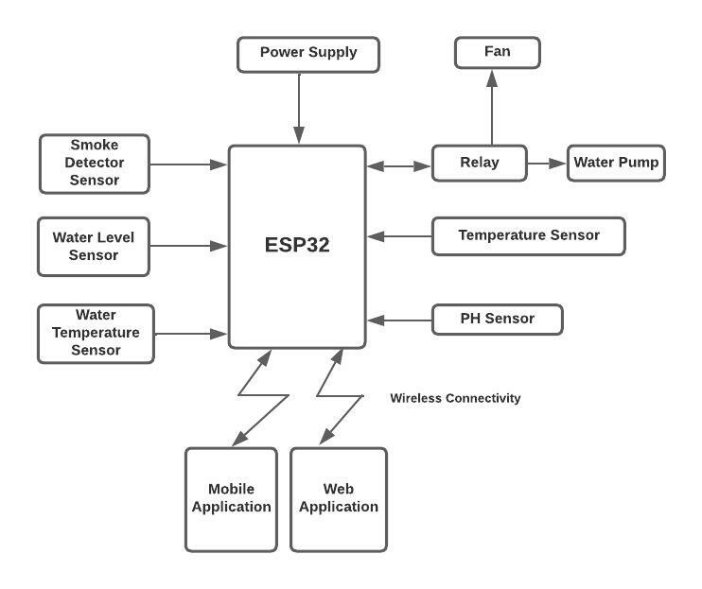

The proposed system includes a variety of sensors such as pH sensor to monitor the

pH level inside the water, DHT11 Temperature sensor to detect the temperature and Humidity of the Environment, DS18B20 to detect the water temperature. This system also consists of the relay which is used for controlling the water pump to maintain water level inside the tank and HCSR04 sensor to detect the water level inside the tank. The microcontroller that serves as the heart of the system is ESP32. To monitor and control the sensor readings Blynk IoT application is used. Block diagram of the proposed system is shown in Fig.3.

**Flow Chart:**

Figure 3 depicts the proposed system's entire operational procedure. The device is initially turned on by the user, at which point the system begins to read the pH, temperature, liquid solution temperature, and tank water level readings. When the threshold value is exceeded, Blynk IoT sends the user a notification alert or displays the data. According to the input of pH, water temperature, and water level inside the tank, the rules are set to manage the motor condition.

**Results and Discussion:**

The application is designed using the Blynk server. There is some visual monitoring in this application, namely gauge for pH, water temperature, Gas sensor value, temperature and humidity and switch to turn LED’s ON/OFF. Switch for turning motor and fan. Diagram

**Conclusion:**

The Esp32 microcontroller and internet of things are the base of the suggested method for smart hydroponic farming. It gives users up-to-date statistics on hydroponic environmental parameters so they can properly care for their plants. Environmental parameters include pH, water temperature, water level, temperature, and relative humidity. The outcomes are given through a mobile application as well as Blynk IoT web. The user receives notification alerts whenever the threshold value is exceeded. Esp32 and the Blynk program both require internet connectivity to display and send notification alerts. This strategy can address the gardening issues that metropolitan regions have due to a lack of gardeners. As a result, users or gardeners may easily take better care of their plants by remotely monitoring and adjusting various factors. In future, fertilization features will be added for automation.

**References:**

[1] Pravin, A., Prem Jacob, T., & Asha, P. (2018). Enhancement of plant monitoring using iot. *International Journal of Engineering &amp; Technology*, *7*(3.27), 53. <https://doi.org/10.14419/ijet.v7i3.27.17653>

[2] Boonsit Yimwadsana; Antika Pornvechamnuay Pichamon Chanthapeth; Chanyanuch Lertthanyaphan; (2018, November 8). *An iot controlled system for plant growth*. IEEE Xplore. <https://ieeexplore.ieee.org/abstract/document/8523886>

[3] D. Saraswathi, P. Manibharathy, R. Gokulnath, E. Sureshkumar, & K. Karthikeyan. (2018a, November 22). *Automation of Hydroponics Green House Farming using IOT*. IEEE Xplore. https://ieeexplore.ieee.org/abstract/document/8541251

[4] R. Vidhya, & K. Valarmathi. (2019b, May 30). *Survey on automatic monitoring of hydroponics farms using iot*. IEEE Xplore.

[5] Md AshifuddinMondal, & Zeenat Rehena. (2018, August 23). *IoT based intelligent agriculture field monitoring system*. IEEE Xplore. <https://ieeexplore.ieee.org/document/8442535>

[6] Ram Krishna Jha, Santosh Kumar, Kireet Joshi, & Rajneesh Pandey. (2018b, April 23). *Field monitoring using IoT in agriculture*. IEEE Xplore. <https://ieeexplore.ieee.org/document/8342777>

[7] V, S. (2021). Internet of Things (IoT) based Smart Agriculture in India: An Overview.*Journal of ISMAC*, *3*(1), 1–15. https://doi.org/10.36548/jismac.2021.1.001

[8] Somchoke Ruengittinun, Sitthidech Phongsamsuan, & Phasawut Sureeratanakorn. (2017b, October 19). *Applied internet of thing for smart hydroponic farming ecosystem (HFE)*. IEEE Xplore. <https://ieeexplore.ieee.org/abstract/document/8074148>

[9] Ali, M., Kanwal, N., Hussain, A., & Qamar, M. (2020, June 6). *IoT Based Smart Garden Monitoring System using NodeMCU Microcontroller*. Unknown.

[10] Padma Nyoman Crisnapati, I Nyoman Kusuma Wardana, I Komang Agus Ady Aryanto , & Agus Hermawan. (2017, October 30). *Hommons: Hydroponic management and monitoring system for an IOT based NFT farm using web technology*. IEEE Xplore. https://ieeexplore.ieee.org/abstract/document/8089268

[11] P Rajalakshmi, & S. Devi Mahalakshmi. (2016, November 3). *IOT based crop-field monitoring and irrigation automation*. IEEE Xplore. <https://ieeexplore.ieee.org/document/7726900>

[12] [Mahesh S. Gour](https://ieeexplore.ieee.org/author/37088440020); [Vittal Reddy](https://ieeexplore.ieee.org/author/37088440552); [Vamsi M.](https://ieeexplore.ieee.org/author/37088439967); [Sridhar N.](https://ieeexplore.ieee.org/author/37088438850); [Vishuvardhan](https://ieeexplore.ieee.org/author/37088440379); [V. Tarak Ram](https://ieeexplore.ieee.org/author/37088439757). *IoT based Farming Techniques in Indoor Environment: A Brief Survey*. (n.d.). IEEE Xplore. Retrieved September 7, 2022, from https://ieeexplore.ieee.org/abstract/document/9137950

[13] Sambath, M., Prasant, M., Bhargav Raghava, N., & Jagadeesh, S. (2019). Iot based garden monitoring system. *Journal of Physics: Conference Series*, *1362*(1), 012069. <https://doi.org/10.1088/1742-6596/1362/1/012069>

[14] Vesperman, S. P. L. M. S. J. M. (2019, November). *Smart plant life monitoring system*. IEEE Xplore. <https://ieeexplore.ieee.org/abstract/document/8907989>

[15] Shruti A Jaishetty, & Rekha Patil. (2016b). Iot sensor network based approach for agricultural field monitoring and control. *International Journal of Research in Engineering and Technology*, *05*(06), 45–48.