Testing Table

Test Series and Number | Purpose | Description | Test Data | Test Data Type | Expected Result | Actual Result | Evidence in Appendix
1.01 | Test the "Team Sheet" button on the main menu functions correctly | Test the "Team Sheet" button links to the "Team Sheet" window and closes the Main Menu window | Click the "Team Sheet" button | Normal | Team Sheet window opens and main menu closes. | Team Sheet window opens and main menu closes. | 1,2
1.02 | Test the "Squad" button on the main menu functions correctly | Test the "Squad" button links to the "Squad" window and closes the Main Menu window | Click the "Squad" button | Normal | Squad window opens and main menu closes. | Squad window opens and main menu closes. | 1,3
1.03 | Test the "Match" button,on the main menu functions correctly | Test the "Match" button links to the "Match" window and closes the Main Menu window | Click the "Match" button | Normal | Match window opens and main menu closes. | Match window opens and main menu closes. | 1,6
1.04 | Test the "Goals" button,on the main menu functions correctly | Test the "Goals" button links to the "Goals" window and closes the Main Menu window | Click the "Goals button | Normal | Goals window opens and main menu closes. | Goals window opens and main menu closes. | 1,8
1.05 | Test the "Exit" button,on the main menu functions correctly | Test the "Exit" button exits the program and closes the Main Menu window | Click the "Exit" button | Normal | The program closes. | The program closes. | 1
1.06 | Test the "New Player" button in the Squad screen functions correctly | Test the "New player" button links to the Add Player window and closes the Squad screen | Click the "New Player" button | Normal | Add Player window opens and the Squad Window Closes | Add Player window opens and the Squad Window Closes | 3,4
1.07 | Test the "Home" button in the Squad screen functions correctly | Test the "Home" button links to the Main Menu window and closes the Sqaud screen | Click the "Home" button | Normal | Main Menu window opens and the Squad window closes | Main Menu window opens and the Squad window closes | 3,1
1.08 | Test the "Add" button in the Add Player window functions correctly | Test the "Add" button closes the Add Player window and re opens the Squad window | Click the "Add" button | Normal | Add Player window closes and Squad window reopens | Add Player window closes and Squad window reopens | 4,3
1.09 | Test the "Cancel" button in the Add Player window functions correctly | Test the "Cancel" button closes the Add Player window and re opens the Squad Window | Click the "Cancel" button | Normal | Add Player window closes and Squad window reopens | Add Player window closes and Squad window reopens | 4,3
1.10 | Test the "New Match" button in the Match screen functions correctly | Test the "New Match" button links to the Add Match window and closes the MatchList screen | Click the "New Match" button | Normal | Add Match window opens and the Match List Window Closes | Add Match window opens and the Match List Window Closes | 6,7
1.11 | Test the "Home" button in the Match screen functions correctly | Test the "Home" button links to the Main Menu window and closes the MatchList screen | Click the "Home" button | Normal | Main Menu window opens and the MatchList window closes | Main Menu window opens and the MatchList window closes | 6,1
1.12 | Test the "Add" button in the Add Match window functions correctly | Test the "Add" button closes the Add Match window and re opens the Match List window | Click the "Add" button | Normal | Add Match window closes and Math List window reopens | Add Match window closes and Math List window reopens | 7,6
1.13 | Test the "Cancel" button in the Add Match window functions correctly | Test the "Cancel" button closes the Add Match window and re opens the Match List Window | Click the "Cancel" button | Normal | Add Match window closes and Match List window reopens | Add Match window closes and Match List window reopens | 7,6
1.14 | Test the "New Goal" button in the Goal List screen functions correctly | Test the "New Goal" button links to the Add Goal window and closes the GoalList screen | Click the "New Goal" button | Normal | Add Goal window opens and the Goal List Window Closes | Add Goal window opens and the Goal List Window Closes | 8,9
1.15 | Test the "Home" button in the Goal List screen functions correctly | Test the "Home" button in the Goal List screen functions correctly | Click the "Home" button | Normal | Main Menu window opens the Goal List Window Closes | Main Menu window opens the Goal List Window Closes | 8,1
1.16 | Test the "Add" button in the Add Goal window functions correctly | Test the "Add" button closes the Add Goal window and re opens the Goal List window | Click the "Add" button | Normal | Add Goal window closes and Goal List window reopens | Add Goal window closes and Goal List window reopens | 9,8
1.17 | Test the "Cancel" button in the Add Goal window functions correctly | Test the "Cancel" button closes the Add Goal window and re opens the Goal List window | Click the "Cancel" button | Normal | Add Goal window closes and Goal List window reopens | Add Goal window closes and Goal List window reopens | 9,8
2.01 | Verify a Forename was entered in the Add Player window | Error should appear if the input is incorrect | Nothing,  George | Erroneous,  Normal | Error message appears if the box is incorrectly filled prompting the user to enter the required data.  Closes the Add Player window, opens and refreshes the Squad window. | Error message appears if the box is left empty prompting the user to enter the required data.  Closes the Add Player window, opens and refreshes the Squad window. | 10
2.02 | Verify a Surname was entered in the Add Player window | Error should appear if the input is incorrect | Nothing ,  West | Erroneous,  Normal | Error message appears if the box is incorrectly filled prompting the user to enter the required data.  Closes the Add Player window, opens and refreshes the Squad window. | Error message appears if the box is incorrectly filled prompting the user to enter the required data.  Closes the Add Player window, opens and refreshes the Squad window. | 11
2.03 | Verify a Rating was entered in the Add Player window | Error should appear if the input is incorrect | 5,  George,  10 | Normal,  Erroneous,  Boundary | . Closes the Add Player window, opens and refreshes the Squad window.  Error message appears if the box is incorrectly filled prompting the user to enter the required data.  Closes the Add Player window, opens and refreshes the Squad window. | Closes the Add Player window, opens and refreshes the Squad window.  Error message appears if the box is incorrectly filled prompting the user to enter the required data.  Closes the Add Player window, opens and refreshes the Squad window. | 12
2.04 | Closes the Add Player window, opens and refreshes the Squad window.  Error message appears if the box is incorrectly filled prompting the user to enter the required data.  Closes the Add Player window, opens and refreshes the Squad window. | Error should appear if the input is incorrect | gw@gmail.com,  10 | Erroneous,  Normal | Error message appears if the box is incorrectly filled prompting the user to enter the required data  .Closes the Add Player window, opens and refreshes the Squad window. | Error message appears if the box is left empty prompting the user to enter the required data.  Closes the Add Player window, opens and refreshes the Squad window. | 13
2.05 | Verify a Positon was entered in the Add Player window | Error should appear if the input is incorrect | GK,  10 | Erroneous,  Normal | Error message appears if the box is incorrectly filled prompting the user to enter the required data.  Closes the Add Player window, opens and refreshes the Squad window. | Error message appears if the box is incorrectly filled prompting the user to enter the required data.  Closes the Add Player window, opens and refreshes the Squad window. | 14
2.06 | Verify a Avaliability was entered in the Add Player window | Error should appear if the input is incorrect | Y,  10 | Erroneous,  Normal | Error message appears if the box is incorrectly filled prompting the user to enter the required data. | Error message appears if the box is left empty prompting the user to enter the required data. | 15
2.07 | Verify a Date was entered in the Add Match window | Error should appear if the input is incorrect | 11/11/15,  George,  1/12/01 | Normal,  Erroneous,  Boundary | Error message appears if the box is incorrectly filled prompting the user to enter the required data | Error message appears if the box is left empty prompting the user to enter the required data | 16
2.08 | Error message appears if the box is left empty prompting the user to enter the required data | Error should appear if the input is incorrect | Milton,  10 | Normal,  Erroneous | Error message appears if the box is incorrectly filled prompting the user to enter the required data | Error message appears if the box is incorrectly filled prompting the user to enter the required data | 16
2.09 | Verify a Result was entered in the Add Match window | Error should appear if the input is incorrect | W,  10 | Normal,  Erroneous | Error message appears if the box is incorrectly filled prompting the user to enter the required data | Error message appears if the box is left empty prompting the user to enter the required data | 16
2.10 | Verify a Match was selected in the Add Goal window | Error should appear if the input is incorrect | Milton,  Nothing | Normal,  Erroneous | Error message appears if the box is incorrectly filled prompting the user to enter the required data | Error message appears if the box is incorrectly filled prompting the user to enter the required data | 16
2.11 | Verify a Player was selected in the Add Goal window | Error should appear if the input is incorrect | West,  Nothing | Normal,  Erroneous | Error message appears if the box is incorrectly filled prompting the user to enter the required data | Error message appears if the box is incorrectly filled prompting the user to enter the required data | 16
2.12 | Verify a Quantity was entered in the Add Goal window | Error should appear if the input is incorrect | 2,  1,  George | Normal,  Boundary,  Erroneous | Error message appears if the box is incorrectly filled prompting the user to enter the required data | Error message appears if the box is left empty prompting the user to enter the required data. | 16
3.01 | Verify that all the Player details are stored in the Player database | All of the information should be added to the correct fields in the Player table. | Player information | Normal | Added to the Player table | Added to the Player table
3.02 | Verify that all the Match details are stored in the Match database | All of the information should be added to the correct fields in the Match table. | Match information | Normal | Added to the Match table | Added to the Match table
3.03 | Verify that all the Goal details are stored in the Goal databse | All of the information should be added to the correct fields in the Goal table. | Goal information | Normal | Added to the Goal table | Added to the Goal table
4.01 | Verify the Player data is displaying under the correct header in the Squad table | All of the information should be under the correct header in the Player table. | Player information | Normal | Data is displayed under the correct header | All the data is displayed under the correct header | 5
4.02 | Verify the Match data is displaying under the correct header in the Match table | All of the information should be under the correct header in the Match table. | Match information | Normal | Data is displayed under the correct header | All the data is displayed under the correct header | 6
4.03 | Verify the Goal data is displaying under the correct header in the Goal table | All of the information should be under the correct header in the Goal table. | Goal information | Normal | Data is displayed under the correct header | All the data is displayed under the correct header | 8
4.04 | Verify the Player Surname is displayed in the correct drop down box | Player Surname should be displayed in the drop down box labelled Player | Player Surnames | Normal | Player Surname is displayed in the drop down box labelled Player | Each players Surname is displayed in the Player combo box | 9
4.05 | Verify the Match Opposition is displayed in the correct drop down box | Match Opposition should be displayed in the drop down box labelled Match | Match Oppositions | Normal | Match Opposition is displayed in the drop down box labelled Match | Each match Opposition is displayed in the Match combo box | 9
5 | Verify the program fulfils the clients specification | Run through the program, testing the different aspects to make sure they fit the objectives in the clients specification | Enter some test data and run through the program | Normal | The program fulfils the clients | The program fulfils the clients | N/A

Screenshots
Screenshot 1:
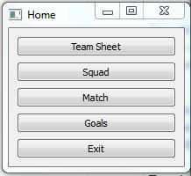

Screenshot 2:
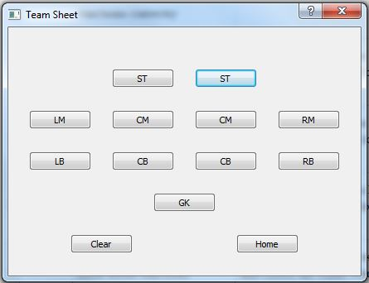

Screenshot 3:
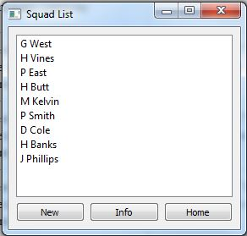

Screenshot 4:
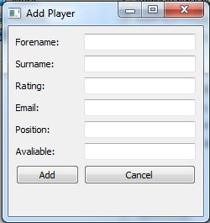

Screenshot 5:

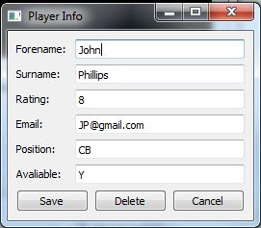

Screenshot 6:
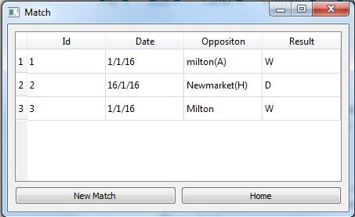

Screenshot 7:
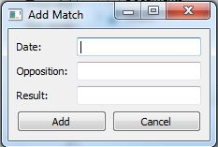

Screenshot 8:

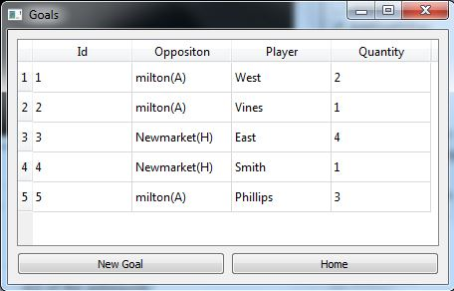

Screenshot 9:
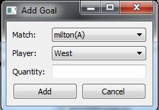

Screenshot 10:

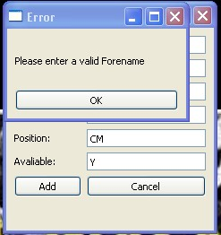

Screenshot 11:
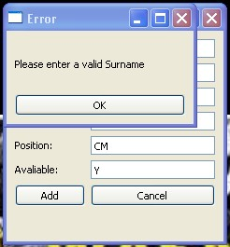

Screenshot 12:
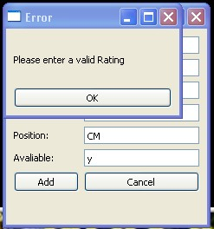

Screenshot 13:
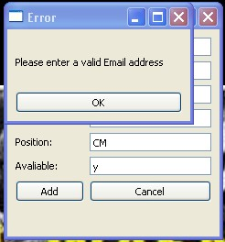

Screenshot 14:
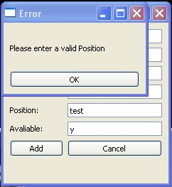

Screenshot 15:
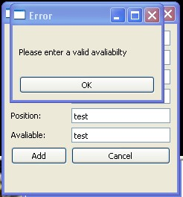

Screenshot 16:
