CS349 Exercise 2

Part A

Fix and explain the error in the following program.

public class WhatsWrong {
public static void main(String[] args) {
StringBuffer[] stringBuffers = new StringBuffer[10];

for (int i = 0; i < stringBuffers.length; i ++) {
stringBuffers[i].append("StringBuffer at index " + i);
}
}
}

Part B

Write a program that reads a series of integer numbers (stop reading when input is the empty string) and stores them in a Vector or ArrayList. Justify your choice. For this particular program, one data structure is a better choice than the other. Use generics in the declaration of your collection class (Vector or ArrayList) using the type String or Integer. Justify your choice. Sort the elements and print the results.

Explain why the following works:

Vector v = new Vector();
v.add(3);

Someone new to Java might argue it is an error because the method add(Object o) on Vector takes an object and the literal 3 is of type int. This logic suggests you should get a type mismatch error at compile time. Why does it work at compile time and runtime?

Part C

Write a program or routine that continuously (i.e. infinite loop) creates objects but also keeps references to these objects around. Since you never let go of references to these objects, your program will eventually run out of memory. This what you might refer to as a memory leak (assuming you weren’t going to need some of those objects and therefore didn’t need to keep references to them). Java avoids memory leaks as long as you don’t keep around references you don’t need.

Note, don’t just create one gigantic data structure. Instead, create the “leak” by creating many (> 1,000) medium to large objects. In other words, at the point your program runs out of memory you should have hundreds or thousands of references to objects—not just one or two references to one or two large objects.

Also as part of the assignment, make sure any new classes you define are defined within a package (not the default package). This part of the assignment is also your chance to show you know how to define classes that reside within a package.

Also, as part of the assignment, make your code as simple as possible. It should take the grader less than 20 seconds to clearly see it is continuously creating objects without releasing references to these objects. It’s not a requirements, but you should be able to do the assignment in 15 lines of code or less.

When submitting your results of this part of the assignment, be sure to include a screen snapshot of your program crashing because it ran out of memory. For example:

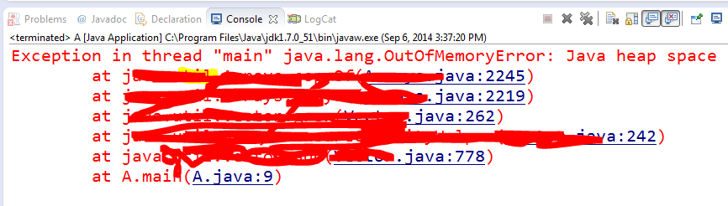

You may find it helpful to monitor CPU and memory usage as your program runs. To view this information under Windows, right click the taskbar to open the task manager, go to the processes tab and sort on Memory.

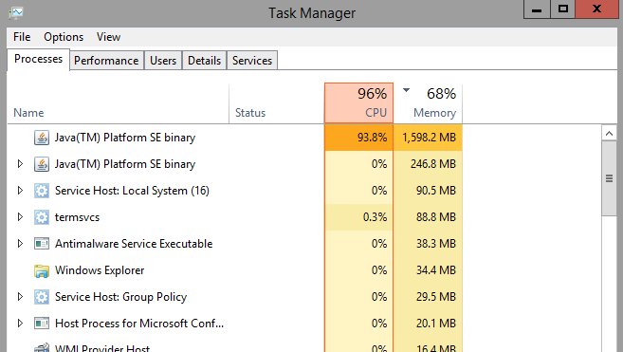

You can also view memory usable under the Performance tab:
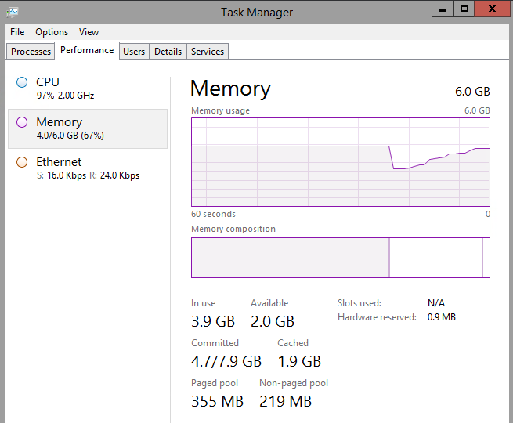

Part D

When defining a class you have to decide whether to make methods and attributes static or non-static. For each of the following pseudo code class definitions, specify whether the attributes and methods should be static or non-static. State your assumptions if you think there is any doubt as to why you made the decision you did.

class Bicycle
int frameSize;
int numberOfSpeeds;
int currentGearSetting;

void increaseGearSetting(); // e.g. currentGearSetting++
void decreaseGearSetting(); // e.g. currentGearSetting--

class CrossCountryCalculator
int time(int speed, int distance); // calc time based on speed
// and distance travelled
int speed(int time, int distance); // calc speed based on time
// and distance travelled

class PairOfDice
short valueOfFace1; // integer value 1-6
short valueOfFace2; // integer value 1-6

void randomize(); // randomize the values of face1 and face2
PairOfDice getInstance(); // create and return an instance
// of PairOfDice

class A
int b;
float c;

public void f();

