CS349 Exercise 5

Part A

Create a Java program that allows you to draw free-hand to the screen using the mouse.

Example:

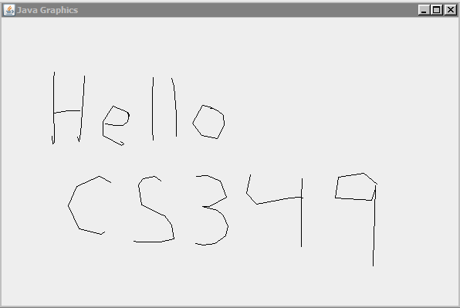

Hints:

Within mouseDragged(…) you can draw a line from old x,y to new x,y with:

int newX = e.getX();
int newY = e.getY();

Graphics g = getGraphics();
g.drawLine( oldX,oldY, newX, newY );
oldX = newX;
oldY = newY;

Extra credit

For extra credit, add a button at the bottom to clear the contents of the screen and allow the user to start a new drawing.

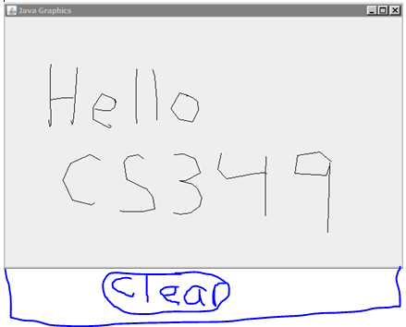

Part B

Write a program that displays one button. Override mouse enter events and disable the button the moment the user moves the mouse cursor over the button. Enable the button the moment the user moves the mouse cursor off the button. Is there any way to “press the button”?

