VISA
- Types: USB, Ethernet, GPIB, …
- Address: NI MAX, PyVisa,…
Qcodes structure (QCoDeS = Copenhagen, Delft, Sydney)
- Station (config, qcodes driver and VISA address)
- Load instrument (print_readable_snapshot() to see parameters)
- Database (.db) file (SQL)
- Experiment
- Qcodes parameter (get_cmd, set_cmd) (nex time)
- do1d, do2d
- plottr (live plotting, quick viewing)
- Qcodes Monitor (command: python -m qcodes.monitor.monitor) (nex time)
- Dataset (plotting, extracting data, snapshots… from .db file) (nex time)
Qcodes installation:
- Run the following lines in the conda prompt (Reference)
- conda create -n qcodes python=3.9 (Note: 3.10 is also fine)
- conda activate qcodes
- pip install qcodes
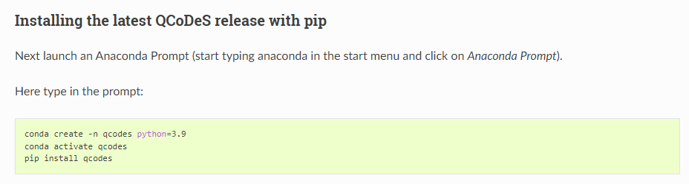
Notes:
Plottr installation (reference_1, reference_2):
- Run the following lines in the conda prompt
- conda activate qcodes
- pip install plottr==0.13.0 (or 0.14.0)
- pip install pyqt5
- Run the following command to show the plottr interface in the conda prompt
- conda activate qcodes
- plottr-inspectr

