# Testing:

Description: what is testing

Testing used:

Manual testing and Django testing

# Django testing:

## App: Registration:

### Url testing:

#### Testing code:

#### Test output:

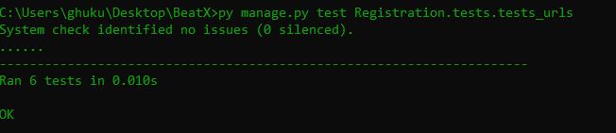

## Views testing:

#### Testing code:

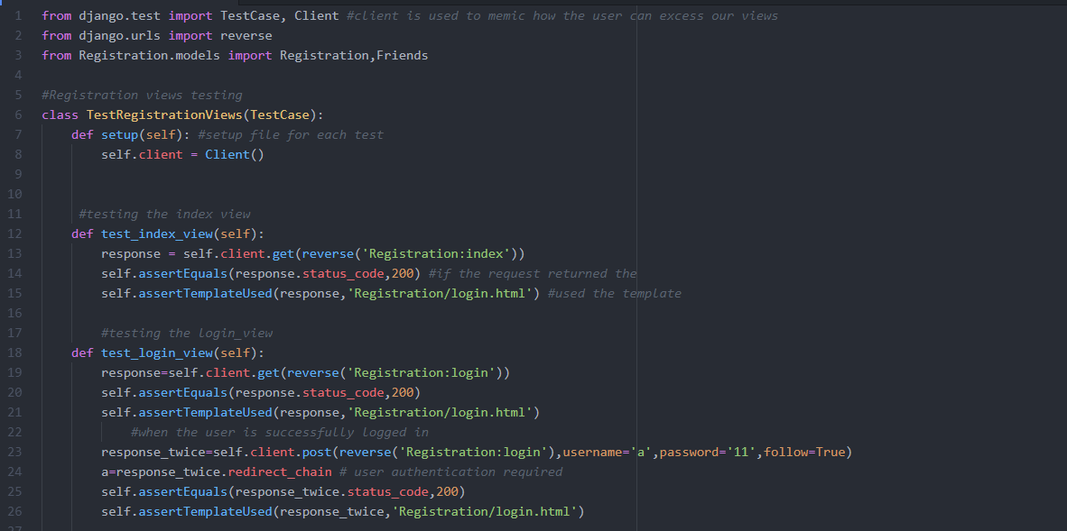

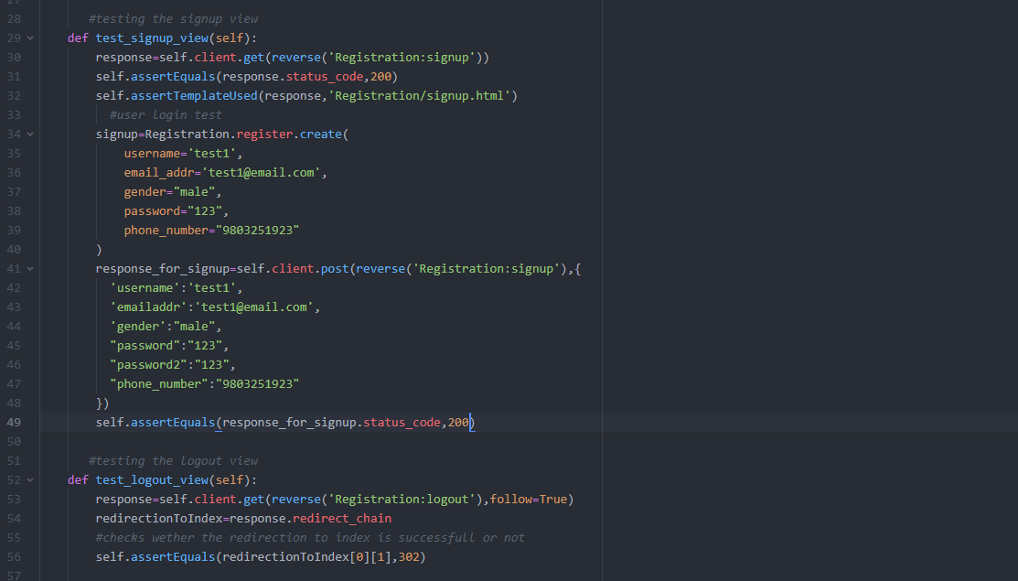

#### Test output:

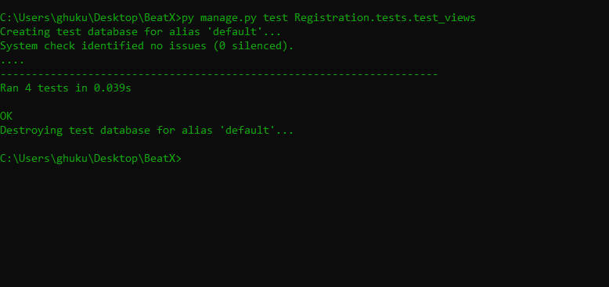

## Model testing:

#### Testing code:

#### Test output:

## App: BeatXMusic:

### Url testing:

#### Testing code:

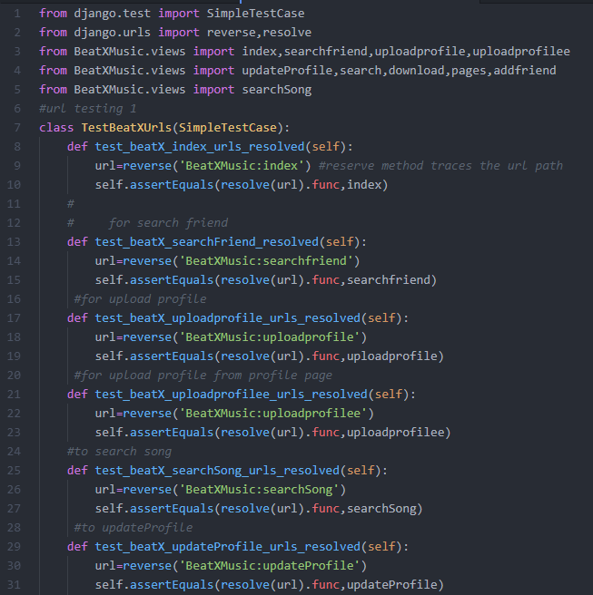

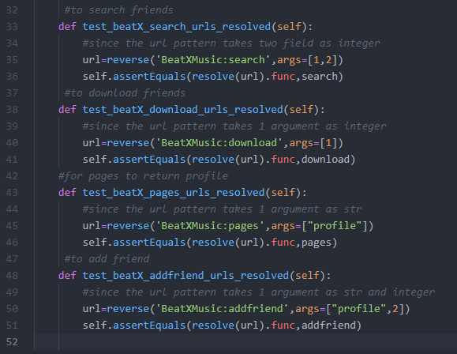

#### Test output:

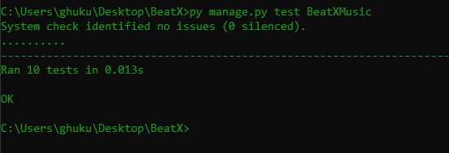

## Views testing:

#### Testing code:

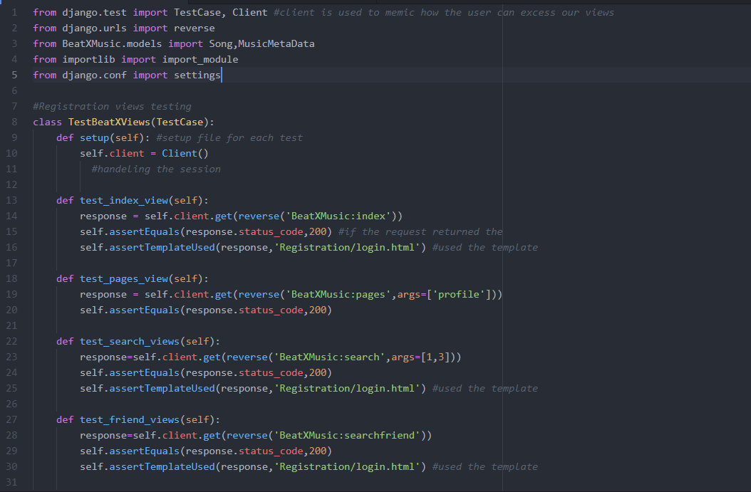

#### Test output:

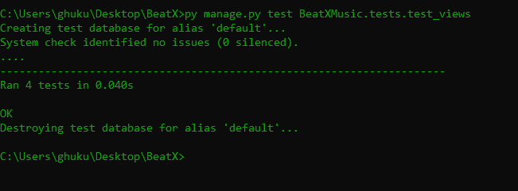

## Model testing:

#### Testing code:

#### Test output: