# Testing:

Description: what is testing

Testing used:

Manual testing and Django testing

# Django testing:

## App: Registration:

### Url testing:

#### Testing code:

#### Test output:

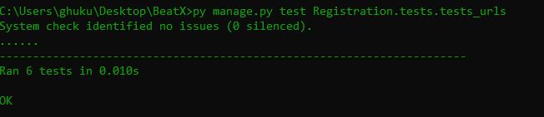

## Views testing:

#### Testing code:

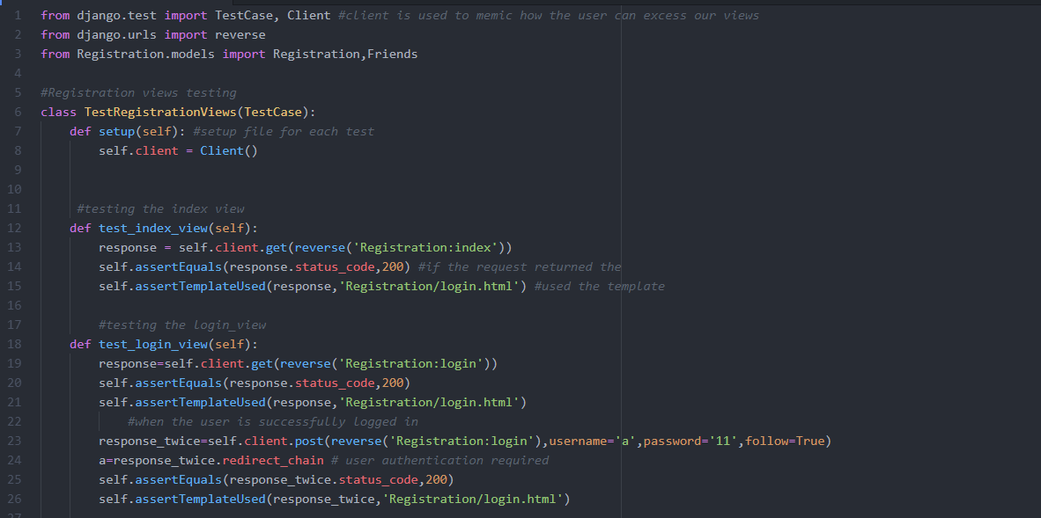

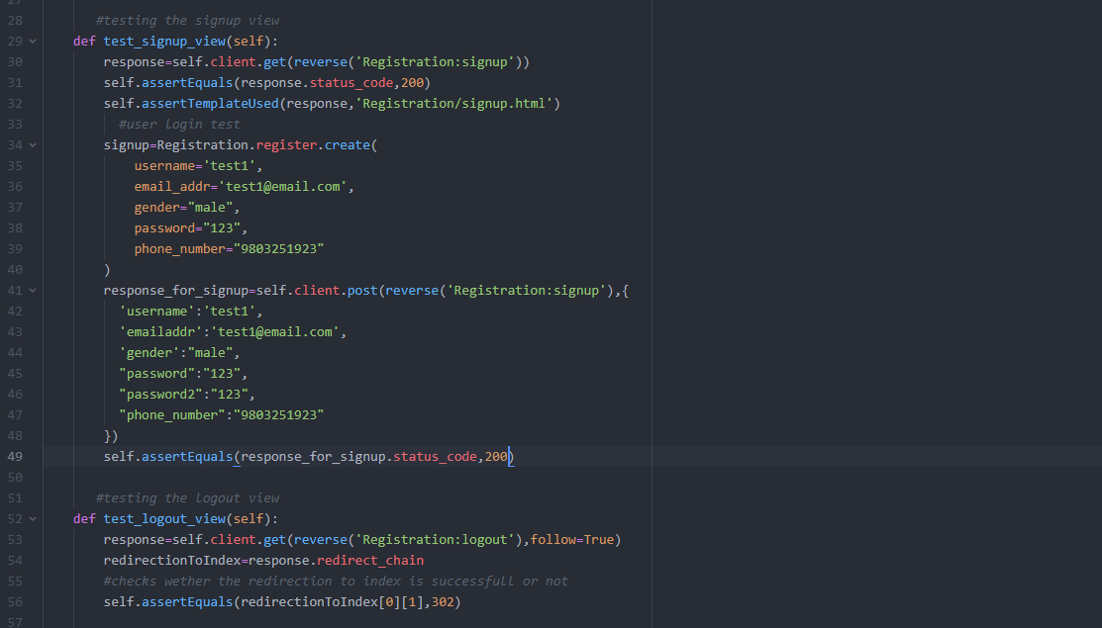

#### Test output:

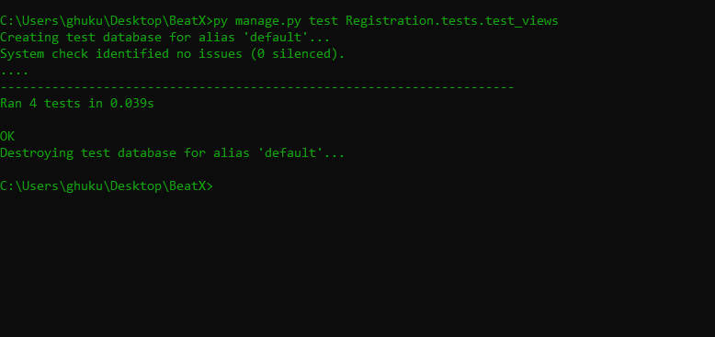

## Model testing:

#### Testing code:

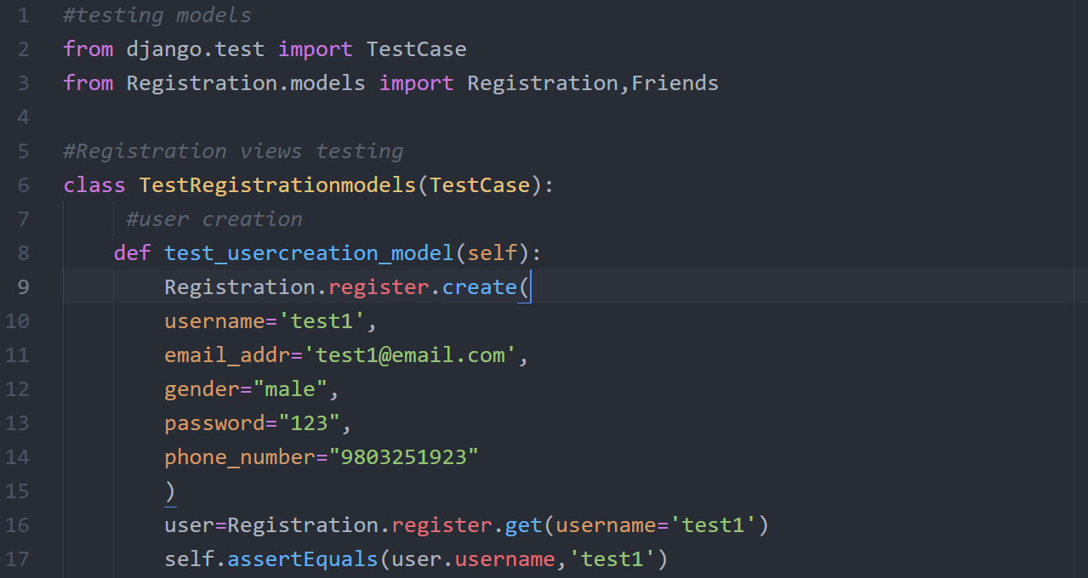

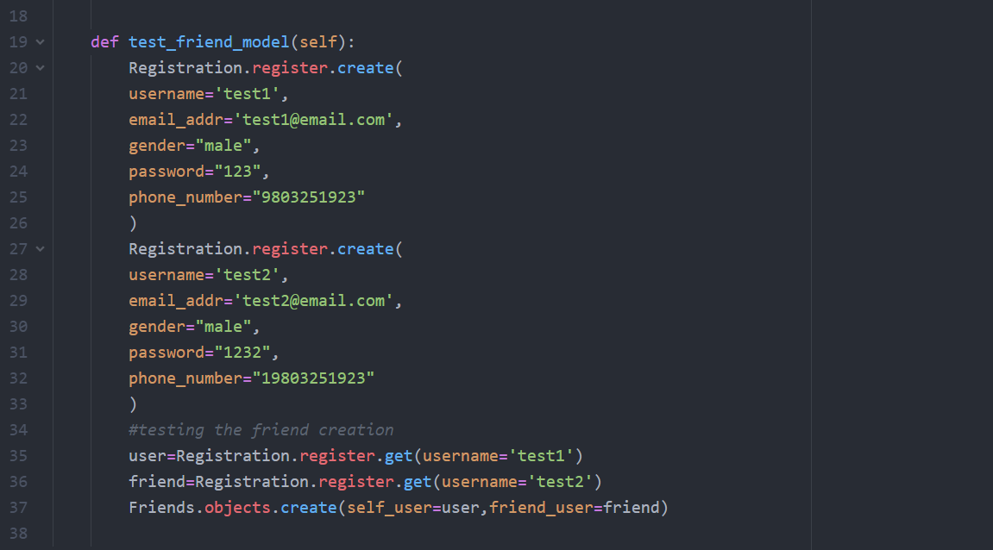

#### Test output:

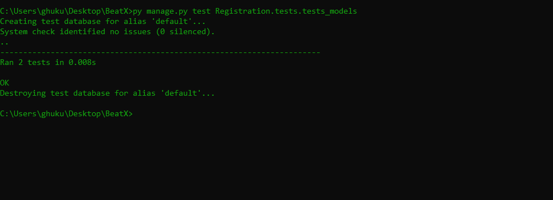

## App: BeatXMusic:

### Url testing:

#### Testing code:

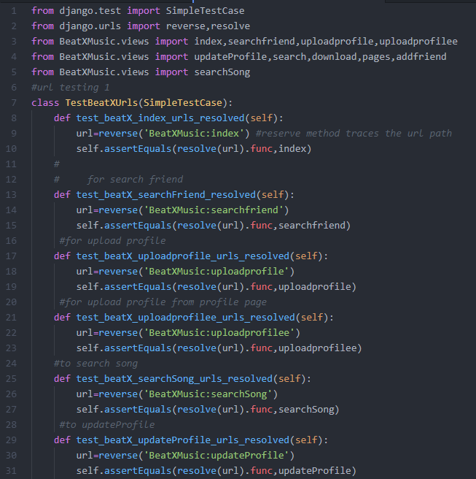

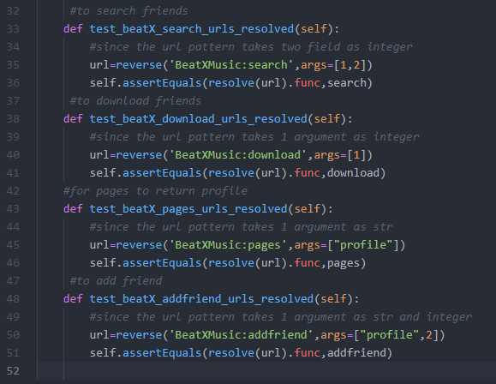

#### Test output:

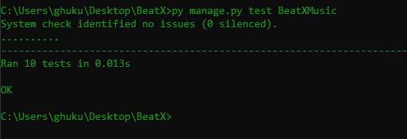

## Views testing:

#### Testing code:

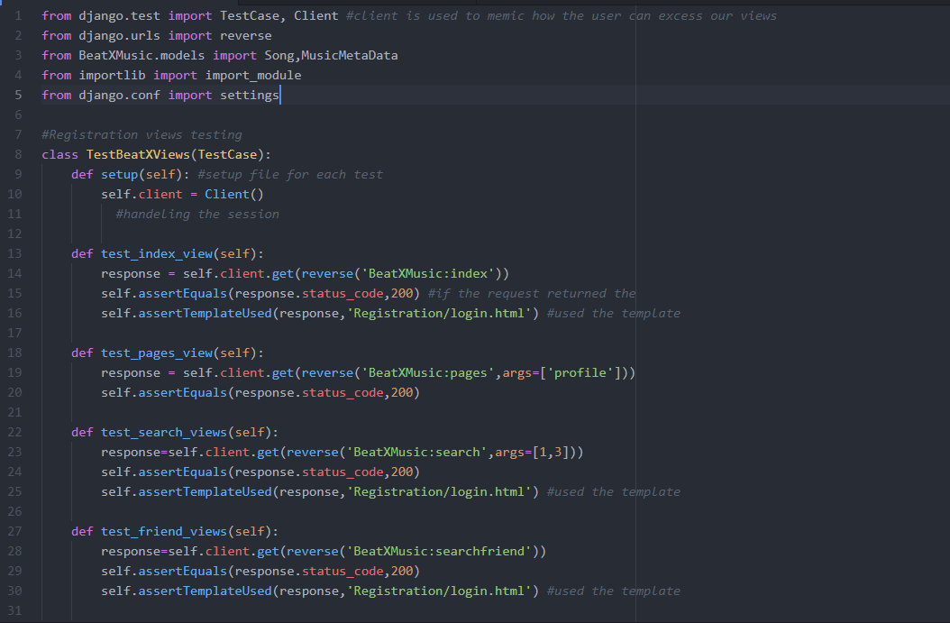

#### Test output:

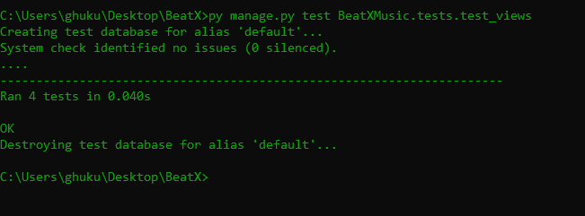

## Model testing:

#### Testing code:

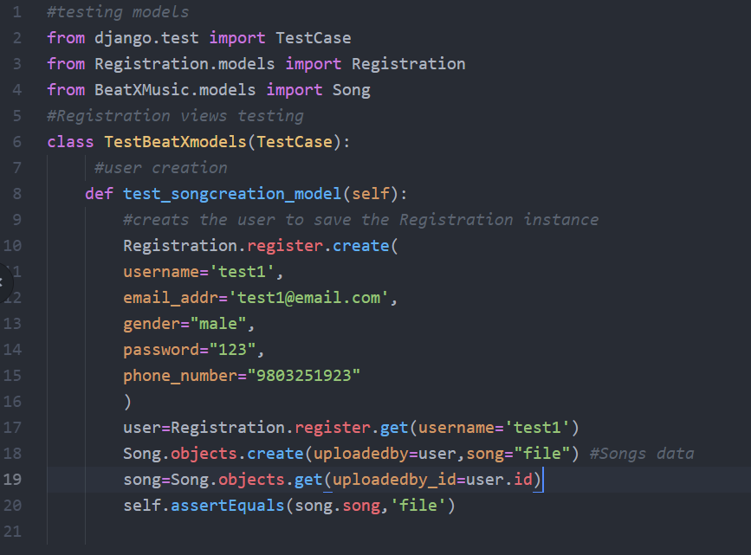

#### Test output:

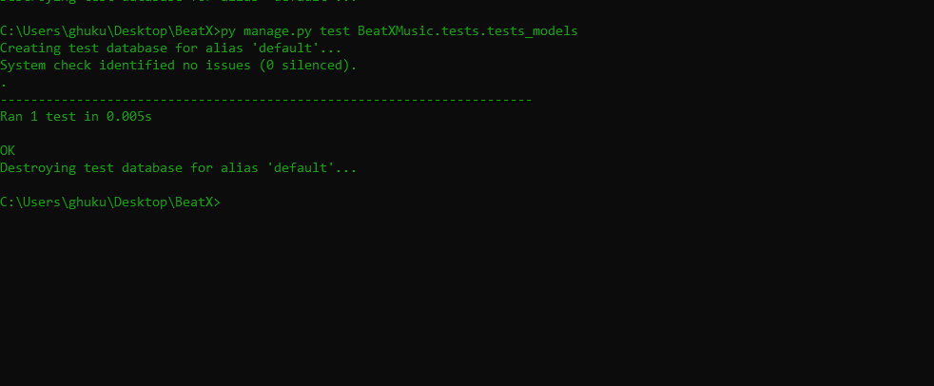

# Live Server Testing:

* Signup: where the users are created and also performs the create functionality of CRUD

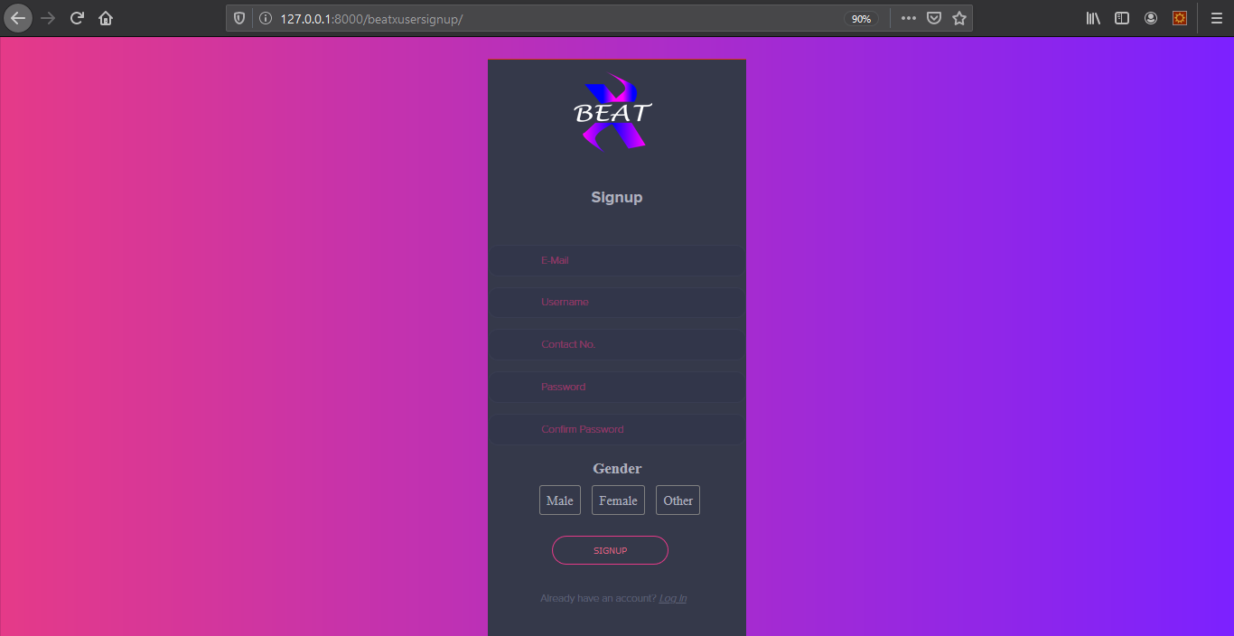

## 

* Login: where the basic logic of BeatX authorization and authentication come in to play:

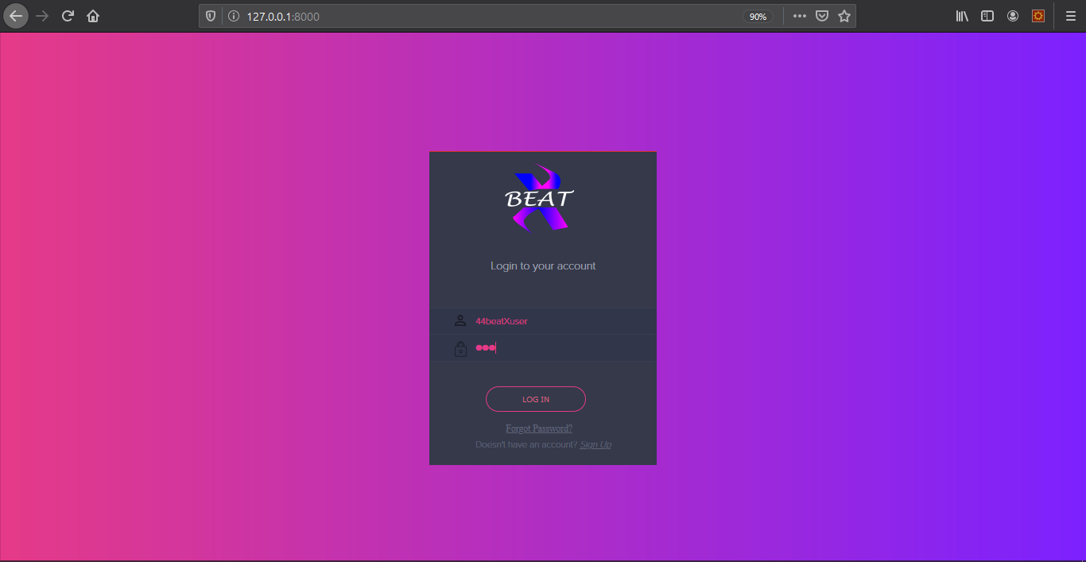

* Upload music: from where the user can upload the music for streaming all the metadata extraction logic goes inside upload music.

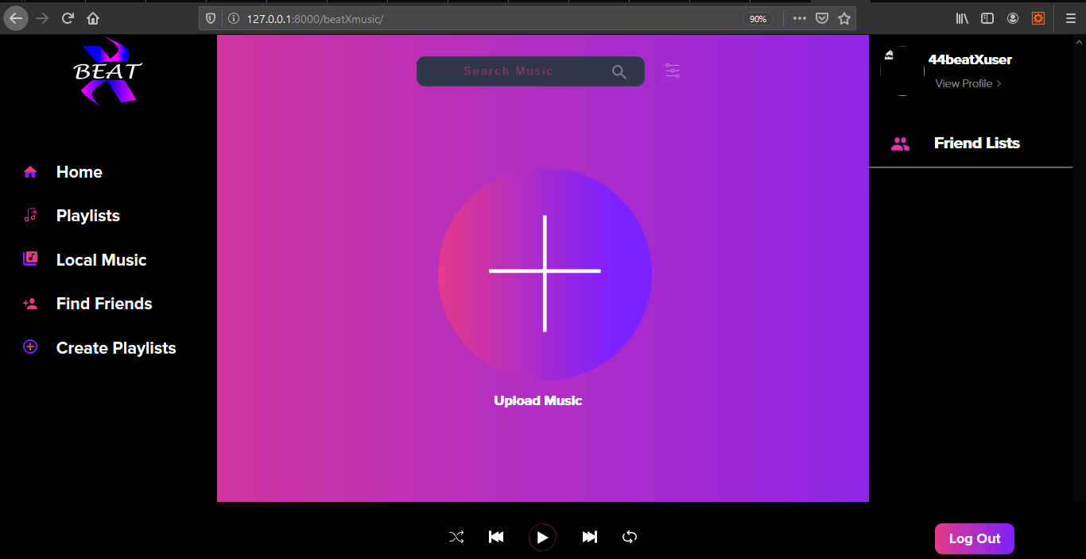

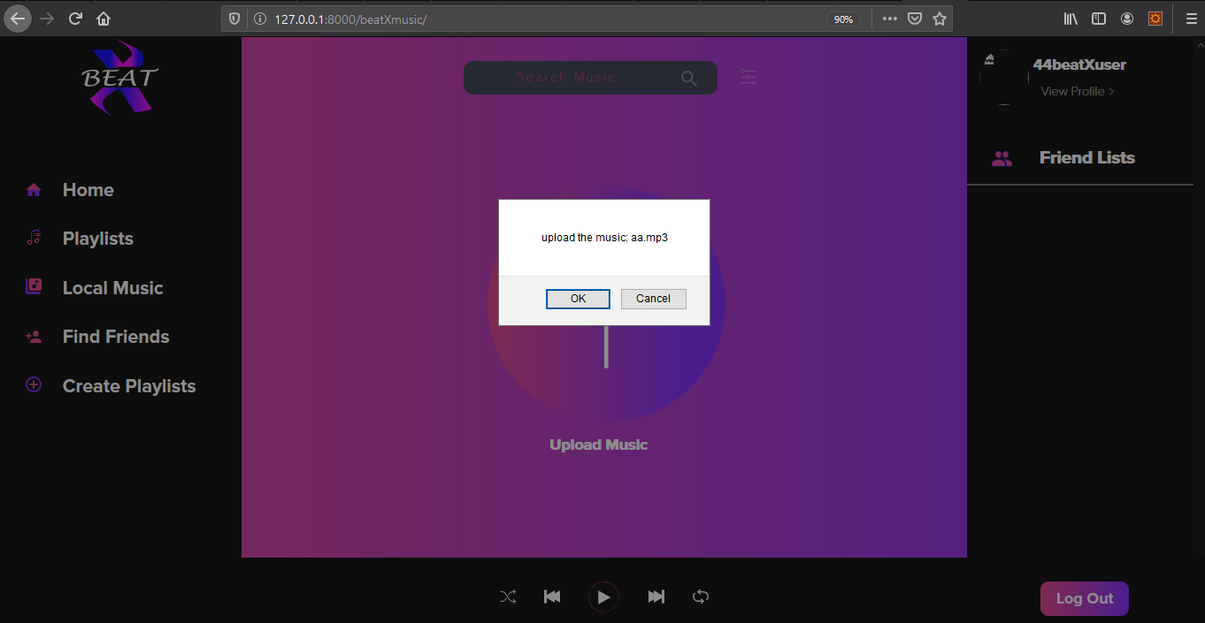

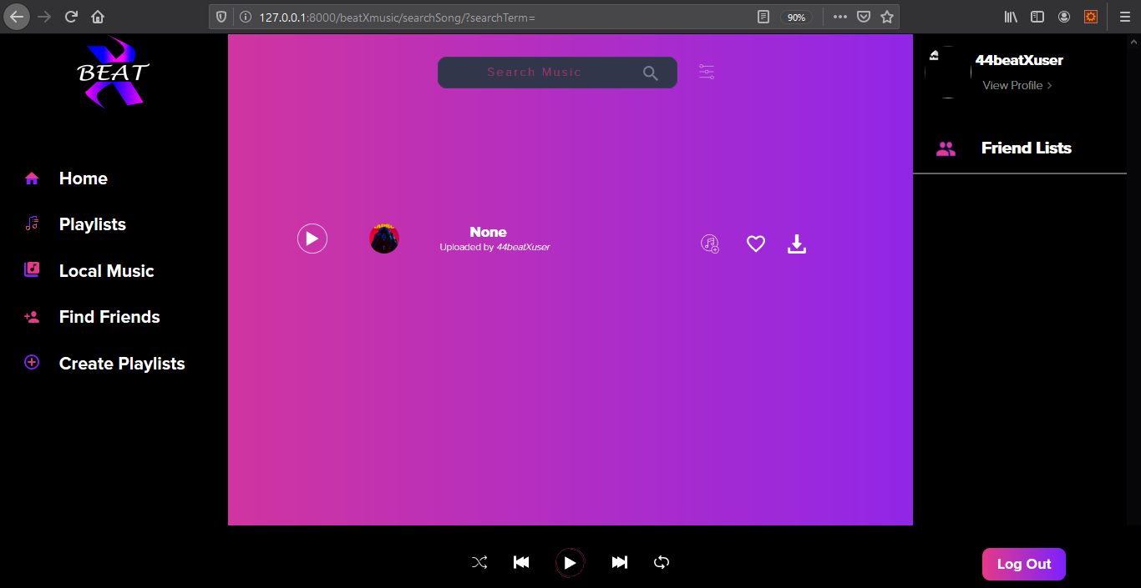

* SearchMusic: different query set logic provided by the Django are used here to search the music and from the searched result the user can download the music.
* Find friends: From here a user can find the friends and stay connected with them and also this performs the basic functionality of reading the user data which falls under 2:read option of CRUD functionality
* Logout: from here the user can logout saving all the runtime data and deleting the cookies
* Edit-profile: from here the user can update the user profile like username, password, which plays the updating part of the CRUD functionality
* Delete-user: from here user can permanently delete their data and associated properties which basically performs the 4: delete part of the CRUD functionality.