1. **Review slides for modules Lecture#6, Lecture #7, Lecture #8**

**Done**

1. **Study the example code discussed in class**

**Done**

1. **Run grayscale correspondence on the Harry Williams images as well as the Tony Dungy images and experiment with the search parameters, XSHIFT, YSHIFT to gain an appreciation for the tradeoff between resolution and performance.**

**Done**

**4. Implement color correspondence. Test color correspondence on two data sets**

**a. Tony Dungy image data (query and target images)**

I did the Dungy image by simply omitting everything that was transforming the images into grayscale and stuck with the original images**.**

**b. A query and target image of your choosing (not Harry Williams, not Tony Dungy). For this task, the query image must be from a different photograph (not cropped from the target image)**

I used to separate images of Travis Scoot. The his face was found in the box successfully.

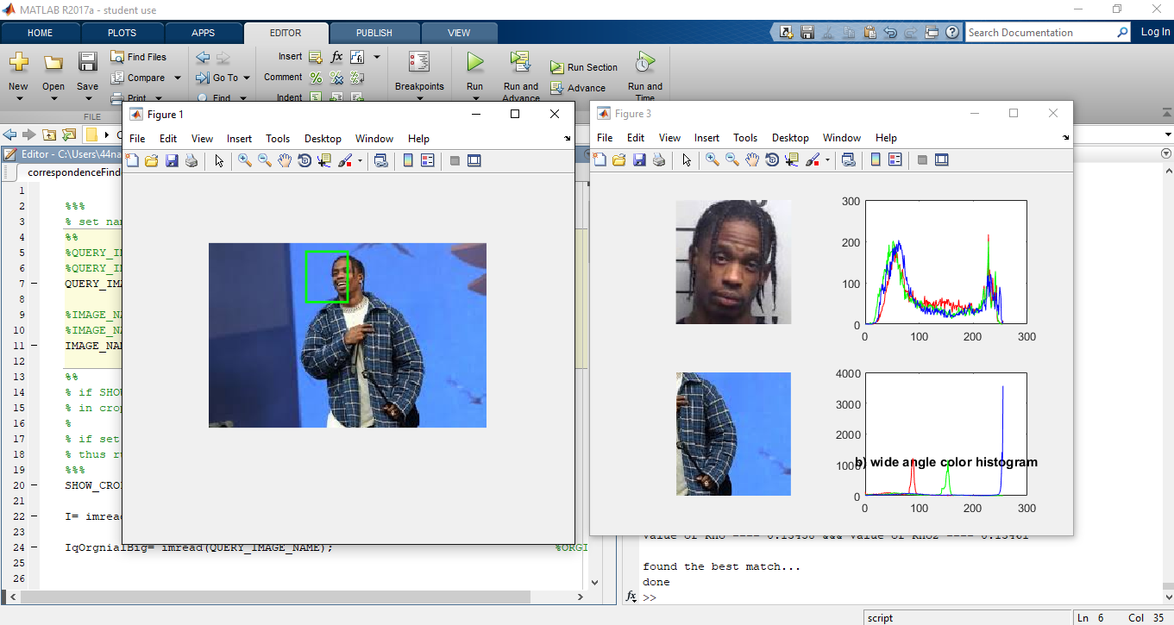

**5. Given your color correspondence approach, implement a version that works with grayscale images.**

**The correspondence worked well with both gray scale and color images**

**6. Design and implement an experiment or experiments that compare the performance of your color correspondence with the grayscale version.**

**It is faster to work with grayscale version as opposed to color correspondence because it is easier to read intensities on black and the lack of it. Where as color has a do distribution with intensity of the color as well as calculate the distribution of red greens and blues.**

I was able to get the picture of Tony Dungy to find the correlation since it was not working at first. Also I did this without grayscale.

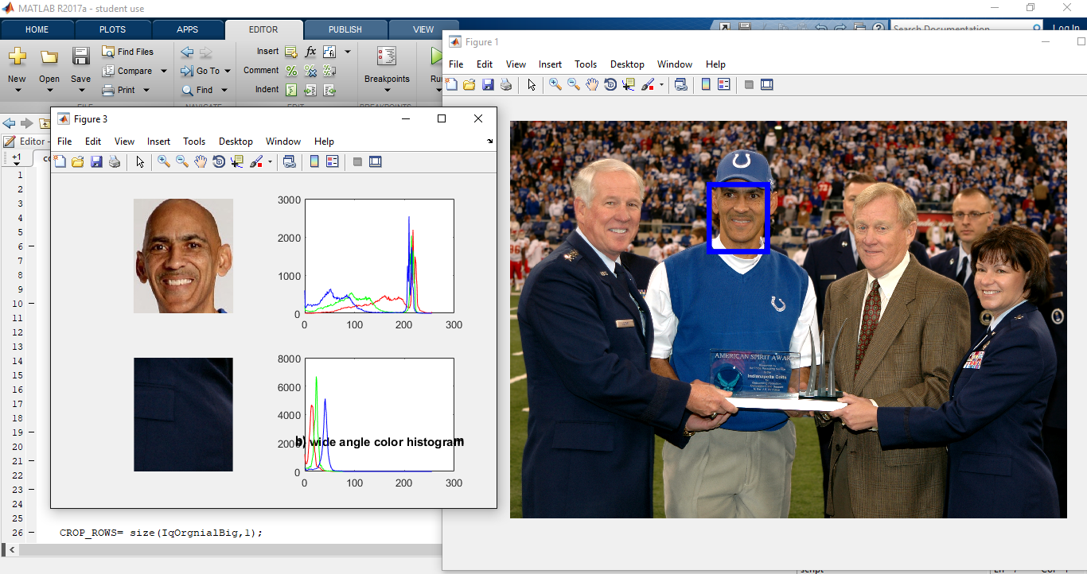

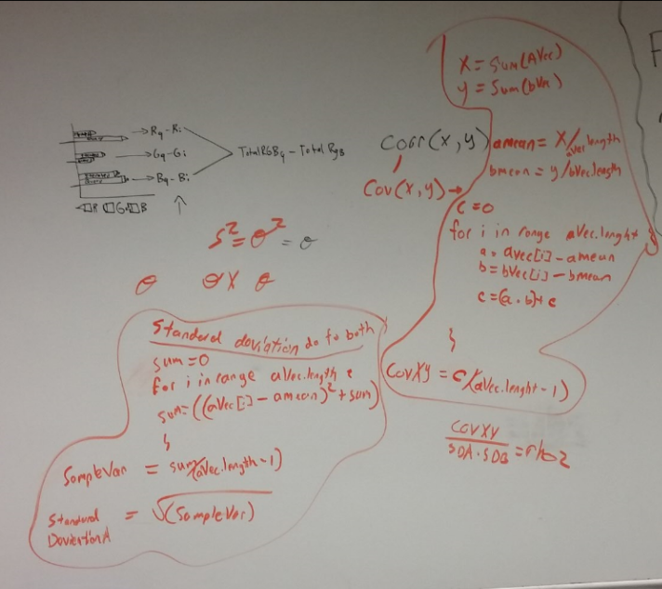

**• Describe (in writing) the correspondence match function you designed and implemented? How does it use color?**

**The drawing above is a crud design to the correspondence function. Turned Corr(aVec, bVec) to ( Cov(aVec,bVec)/ Standard deviation aVec * Standard deviation bVec).**

**To find the standard deviation we had to find the variance first. So for the lead to solving the equation Var(aVec). Var(aVec) was finding the summation of the index minus the mean of the aVec and Squaring that number(used for loop here). (aVec(i) – (aVec mean number))**2. After this you take the pervious answer and divide it by one less length of aVec thus giving you a sample variance of aVec. After you obtain the sample variance you take the square root and end with the Standard deviation for aVec. You repeat the same steps with bVec and store those pieces of information.**

**To find Cov(X,Y) you first must find the mean of the both the aVec and the bVec. Then you have to find the summation of an entry aVec minus the mean for aVec times an entry bVec minus the mean for bVec. Then keeping doing this until you run out of entries for both aVec and bVec (done with forloop). Store it to a variable named “c”. After this part to simple do c divided by the Length of aVec or bVec. This will result in the answer of the Covariance(aVec,bVec) which I called CovXY.**

**Last portion is simply dividing the CovXY/( Standard deviation for aVec)*( Standard deviation for bVec) which will produce an answer similar to that of the Corr(X,Y) function in matlab.**

**Below is that code more in def.**

**The results of Rho which is the built in function and Rho2 which is my man made function are accurate until 2 decimal place after the decimal point.**

**Code Implementation is shown below.**

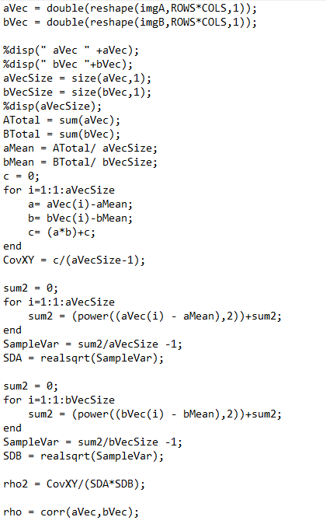

**• Does (in writing) your match function work with grayscale as well? If so describe what it does? If not, discuss how you got your match function to work with grayscale?**

**It works similarly well but slightly faster with the grayscale snice it is the simplifying of and image.**

**• Discuss (in writing) the performance of your color and grayscale correspondence finder (i.e. your match or similarity function) on the Tony Dungy image data**

**It is faster to work with grayscale version as opposed to color correspondence because it is easier to read intensities on black and the lack of it. Where as color has a do distribution with intensity of the color as well as calculate the distribution of red greens and blues.**

**• Discuss (in writing) the performance of your color and grayscale correspondence finder (i.e. your match or similarity function) on the additional image data you selected.**

**Results where the same for grayscale and color**

**• Was there a difference between image data sets (Dungy vs. your selection)? Discuss (in writing) what you think is the reason for this difference? If there was not a difference, discuss (in writing) the reason you think there was no difference.**

**The difference between my image of Travis Scoot and the image and Dungy was quite similar and well results. The original images where spot on and frontal and the program was able to pic up the details in his face which it was primarily used to correlate.**

**“Penn State Eberly College Of Science”**

**Big help in understanding the Variance and Standard Deviation**

[**https://onlinecourses.science.psu.edu/stat414/node/111**](https://onlinecourses.science.psu.edu/stat414/node/111)