First I used a online computer to get the correct values for the z score and was able to hard code that data in. The reasoning because the data seemed universal and then it seemed logical to hardcode it in because it was only 10 different choices.

Second the math was drawn up on the board to have a nice general layout of task to do.

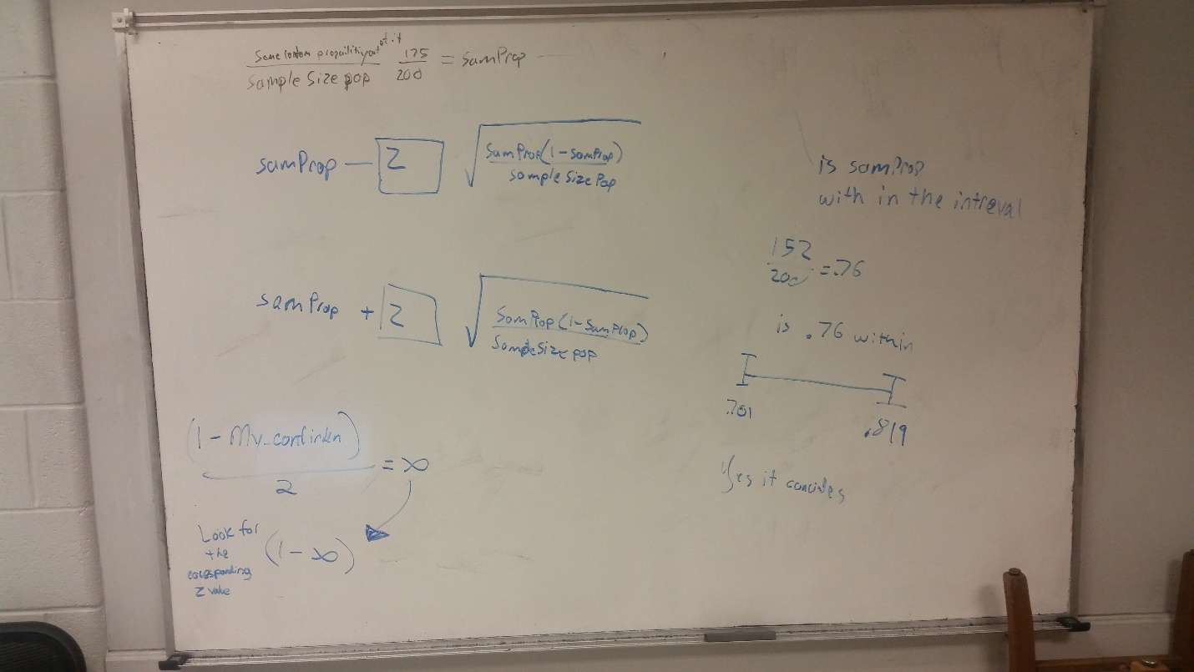

First show the math needed to get MU depending on the sample size and what portion of the sample size you are test for.

Then below that is the math for obtaining the confidence intervals.

Below that was where the math is done in order to find the Z score and then relate it to the array later.

Over in the right hand side shows the where I am trying to see MU or Var is in between the intervals.

A lot of information was a mixture of notes and YouTube Videos

I found the MU and Var when are called they are always in between the Confidence intervals. The Lower the Confidence interval the shorter the difference was between the spaces. The higher the Confidence interval the larger the difference was. But no matter what whatever MU or Var was it the Confidence interval was around them. However with my on test of the sample size the bigger the sample size the constant the Confidence interval where from 10%, 20%.... 90%.