Lab Exercise 1
Implement a simple MPI program to find pow(x, rank) for all the processes where x is the integer constant and rank is the rank of the process.
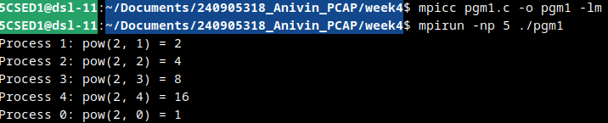

Lab Exercise 2
Implement a program in MPI to toggle the character of a given string indexed by the rank of the process.
Hint: Suppose the string is HELLO and there are 5 processes, then process 0 toggles H to h, process 1 toggles E to e, and so on.

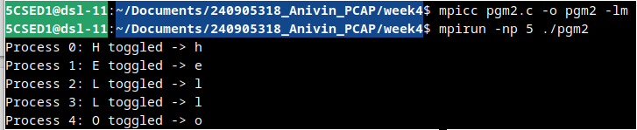

Lab Exercise 3
Implement a program in MPI where even process prints factorial of the rank and odd ranked process prints ranks Fibonacci number.

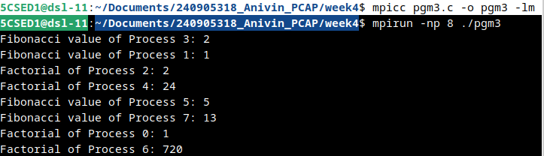

Lab Exercise 4
Implement an MPI program using synchronous send. The sender process sends a word to the receiver. The second process receives the word, toggles each letter of the word and sends it back to the first process. Both processes use synchronous send operations.

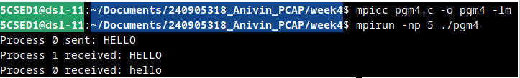

Lab Exercise 5
Implement an MPI program where the master process (process 0) sends a number to each of the slaves and the slave processes receive the number and print it. Use standard send.

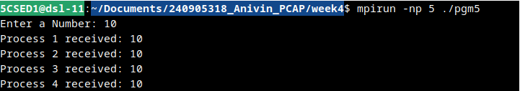

Lab Exercise 6
Implement an MPI program to read an integer value in the root process. Root process sends this value to Process1, Process1 sends this value to Process2 and so on. Last process sends the value back to root process. When sending the value each process will first increment the received value by one. Implement the program using point to point communication routines.

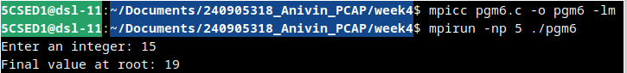

Lab Exercise 7
Implement an MPI program to read N elements of the array in the root process (process 0) where N is equal to the total number of processes. The root process sends one value to each of the slaves. Let even ranked process finds square of the received element and odd ranked process finds cube of received element. Use Buffered send.

