**ASSIGNMENT 1: Simple SQL Query with a single table with where clause**

**1.** Write a query to get a Product list (id, name, unit price) where current products cost

less than $20.

**Solution:** select Productid, productname, unitprice from products where unitprice<20 and discontinued='false'

**Output:**

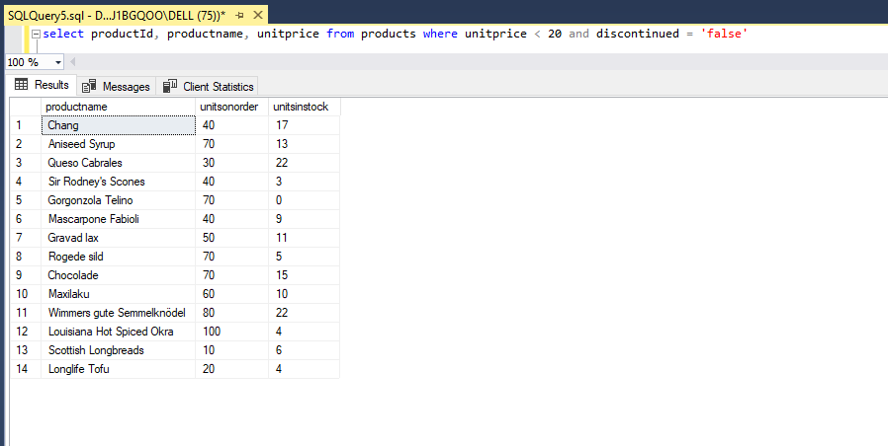

**2**. Write a query to get Product list (id, name, unit price) where products cost between

$15 and $25

**Solution:** select Productid, productname, unitprice from products where unitprice<=25 and unitprice>=15

**Output:**

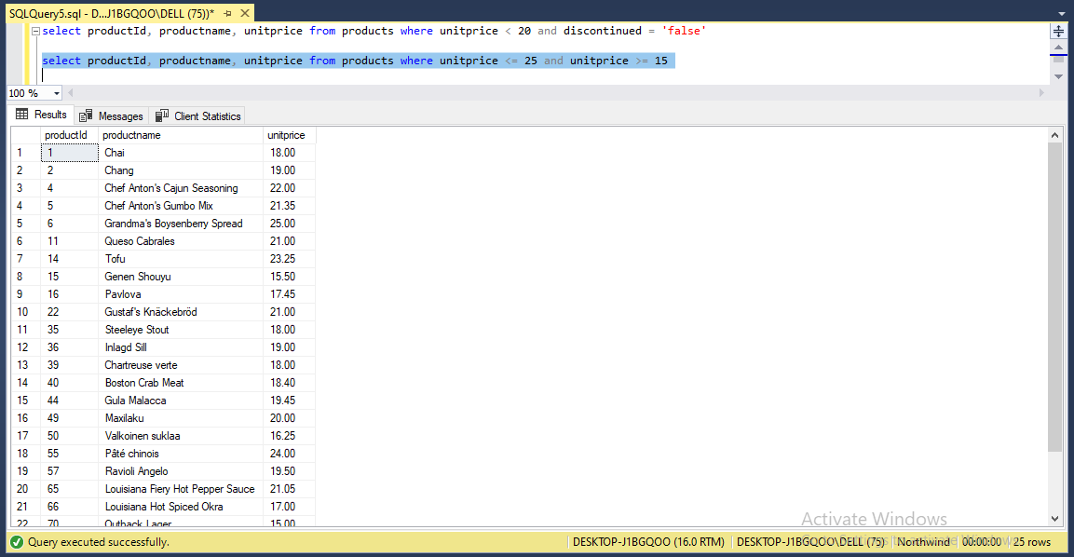

**3**. Write a query to get Product list (name, unit price) of above average price.

**Solution:** select productname, unitprice from products where unitprice> (select avg(unitprice) from products)

**Output:**

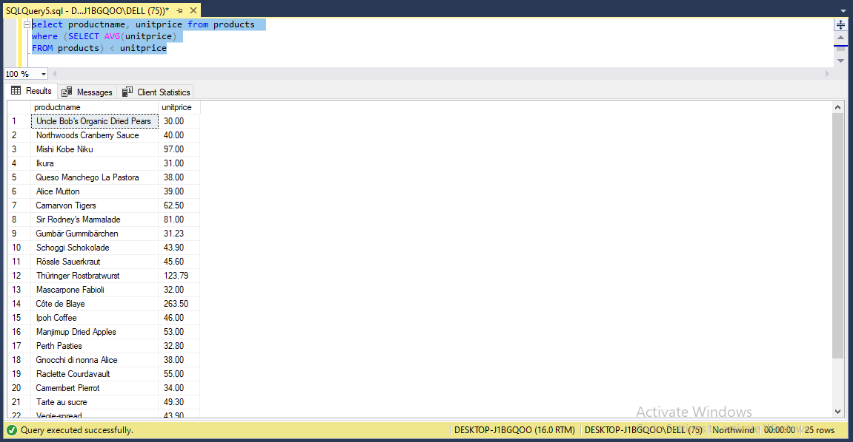

**4.** Write a query to get Product list (name, unit price) of ten most expensive products

**Solution:** select top 10 productname, unitprice from products order by unitprice desc

**Output:**

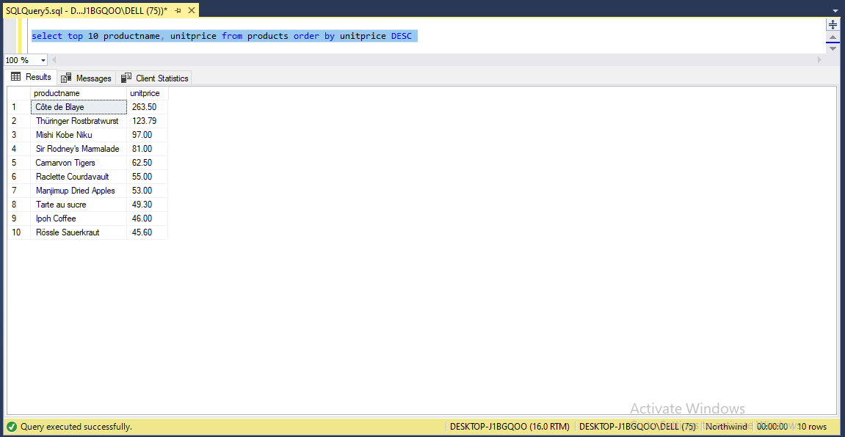

**5.** Write a query to count current and discontinued products

**Solution:** select count(discontinued) as currentproducts from products where discontinued='false'

select count(discontinued) as discontinuedproducts from products where discontinued='true'

**output:**

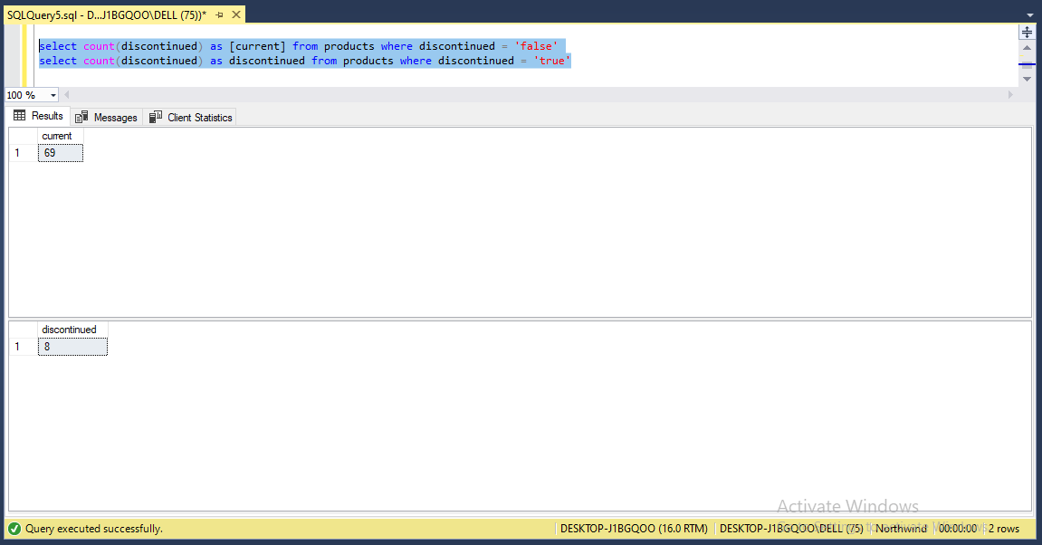

**6.** Write a query to get Product list (name, units on order , units in stock) of stock is less

than the quantity on order

**Solution:** select productname, unitsonorder, unitsinstock from products where unitsinstock< unitsonorder

**Output:**

