**ASSIGNMENT 2: Retrieve data using join with where clause**

**1.** write a SQL query to find the salesperson and customer who reside in the same city.

Return Salesman, cust_name and city

**Solution:**

select salesman.name as [salesman name], customer.cust_name as [customer name], customer.city

from salesman

inner join customer

on salesman.city = customer.city

**Output:**

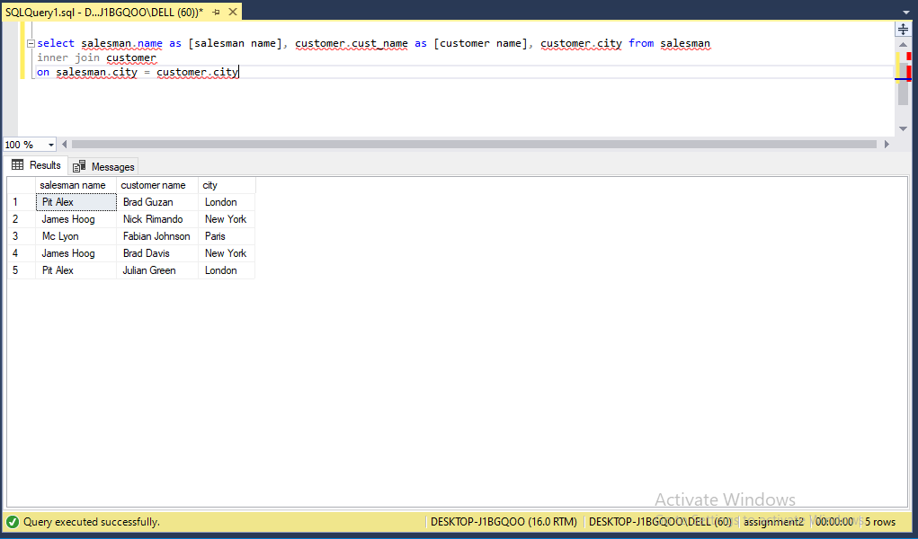

**2**. write a SQL query to find those orders where the order amount exists between 500

and 2000. Return ord_no, purch_amt, cust_name, city

**Solution:**

select orders.ord_no, orders.purch_amt, customer.cust_name, customer.city

from customer

inner join orders

on orders.customer_id = customer.customer_id

where orders.purch_amt between 500 and 2000

**Output:**

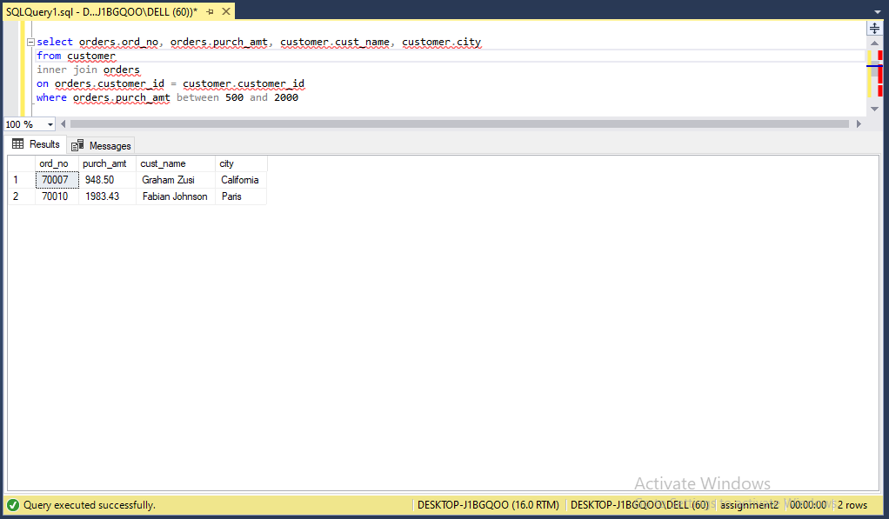

**3**. write a SQL query to find the salesperson(s) and the customer(s) he represents.

Return Customer Name, city, Salesman, commission

**Solution:**

select customer.cust_name, customer.city, salesman.name, salesman.commission

from salesman

inner join customer

on customer.salesman_id = salesman.salesman_id

**Output:**

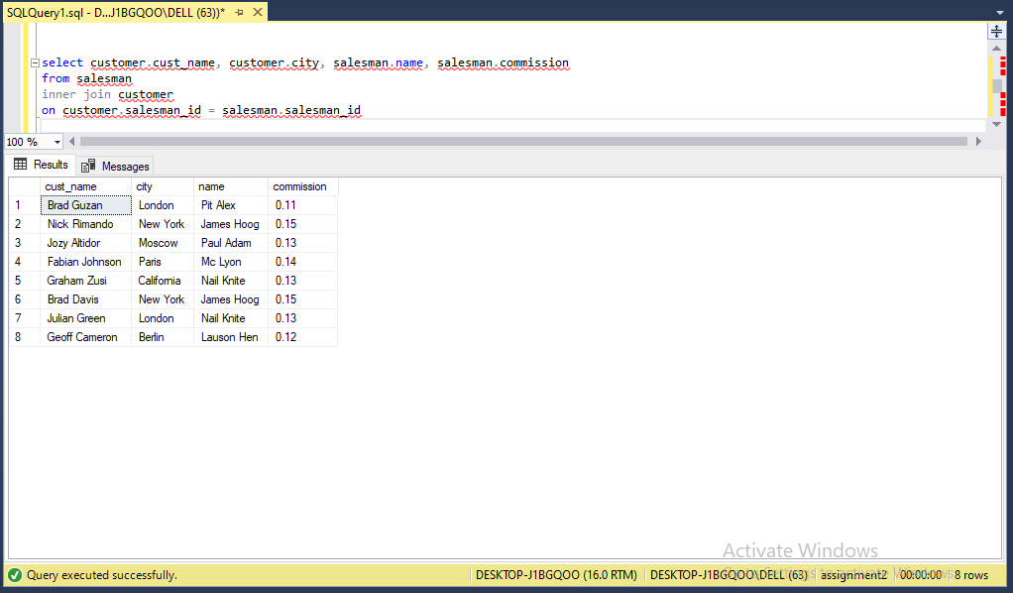

**4.**write a SQL query to find salespeople who received commissions of more than 12

percent from the company. Return Customer Name, customer city, Salesman,

commission.

**Solution:**

select customer.cust_name, customer.city, salesman.name, salesman.commission

from salesman

inner join customer

on customer.salesman_id = salesman.salesman_id

where salesman.commission > 0.12

**Output:**

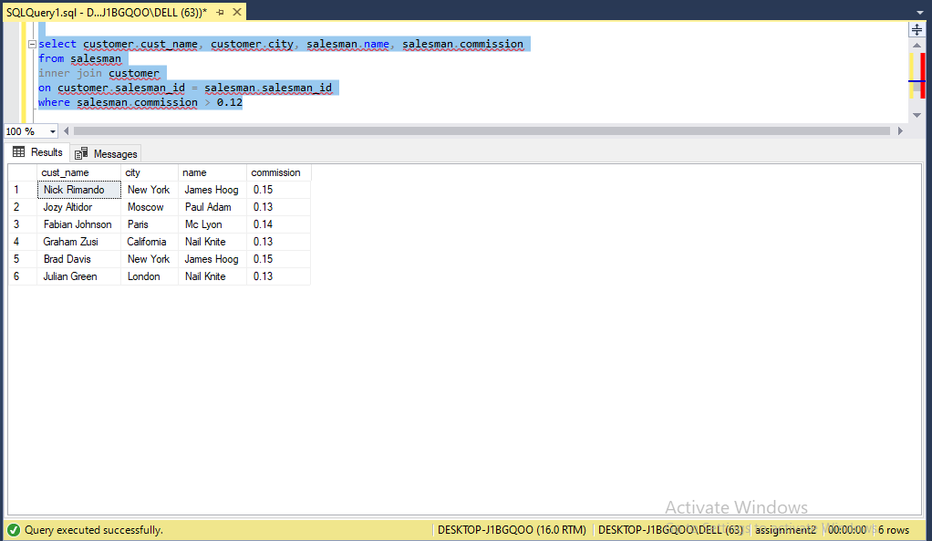

**5.** write a SQL query to locate those salespeople who do not live in the same city where

their customers live and have received a commission of more than 12% from the

company. Return Customer Name, customer city, Salesman, salesman city,

commission

**Solution:**

select customer.cust_name, customer.city, salesman.name, salesman.city

from salesman

join customer

on customer.salesman_id = salesman.salesman_id

where salesman.commission > 0.12 and salesman.city != customer.city

**output:**

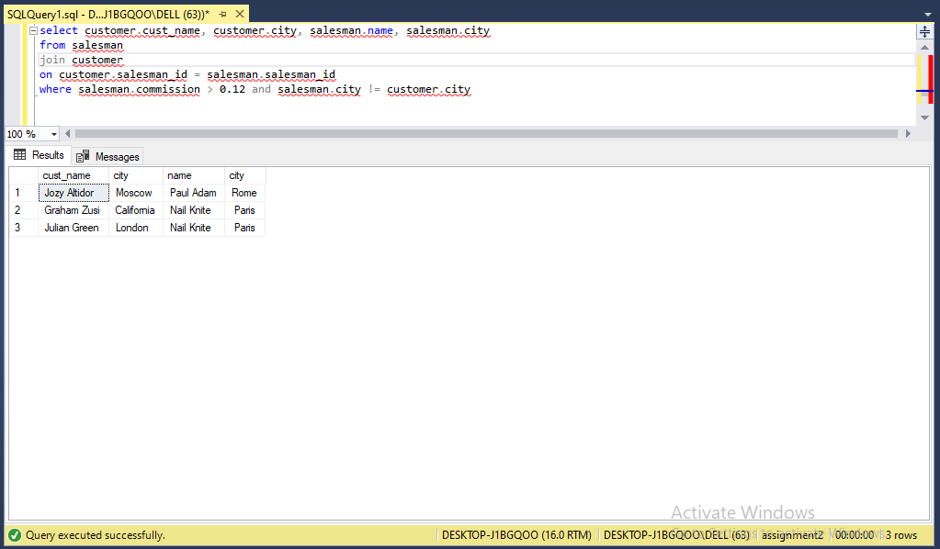

**6.** write a SQL query to find the details of an order. Return ord_no, ord_date,

purch_amt, Customer Name, grade, Salesman, commission

**Solution:**

select o.ord_no, o.ord_date, o.purch_amt, c.cust_name, c.grade, s.name, s.commission

from salesman s

join customer c

on c.salesman_id = s.salesman_id

join orders o

on o.customer_id = c.customer_id

**Output:**

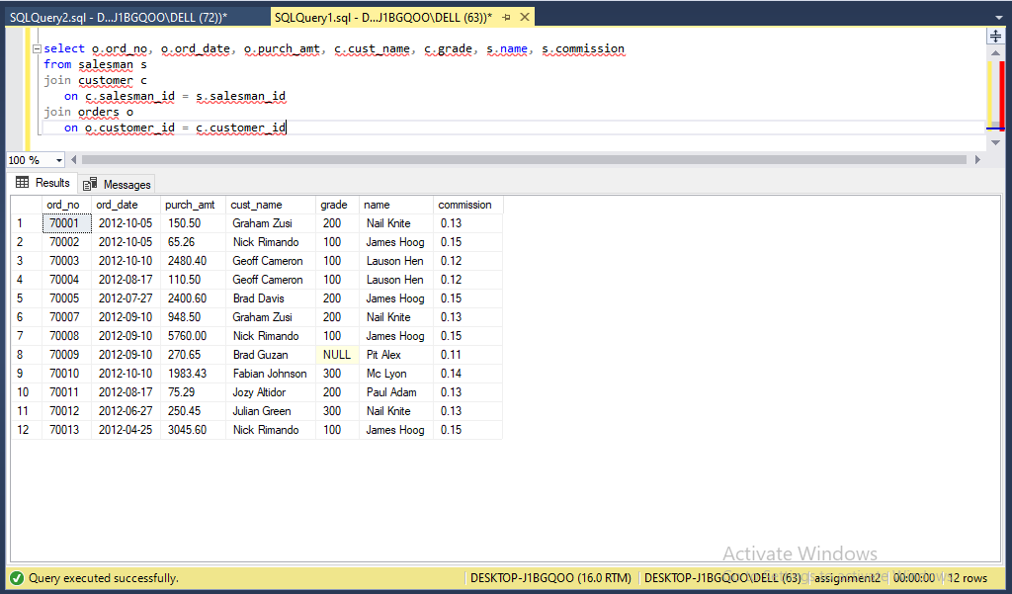

**7.** Write a SQL statement to join the tables salesman, customer and orders so that the

same column of each table appears once and only the relational rows are returned.

**Solution:**

select distinct c.*, s.name, s.commission, o.ord_no, o.purch_amt, o.ord_date

from customer c

left join salesman s

on c.salesman_id = s.salesman_id

left join orders o

on o.customer_id = c.customer_id

**Output:**

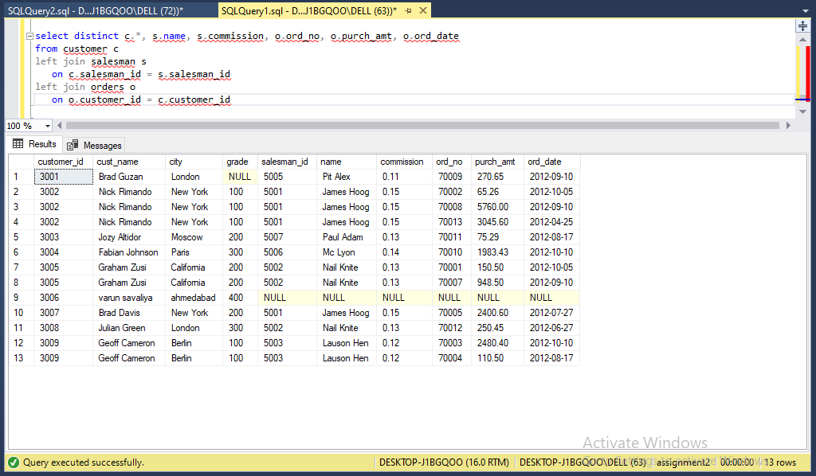

**8.** write a SQL query to display the customer name, customer city, grade, salesman,

salesman city. The results should be sorted by ascending customer_id.

**Solution:**

select c.cust_name, c.city, c.grade, s.name, s.city

from customer c

join salesman s

on c.salesman_id = s.salesman_id

order by customer_id ASC

**Output:**

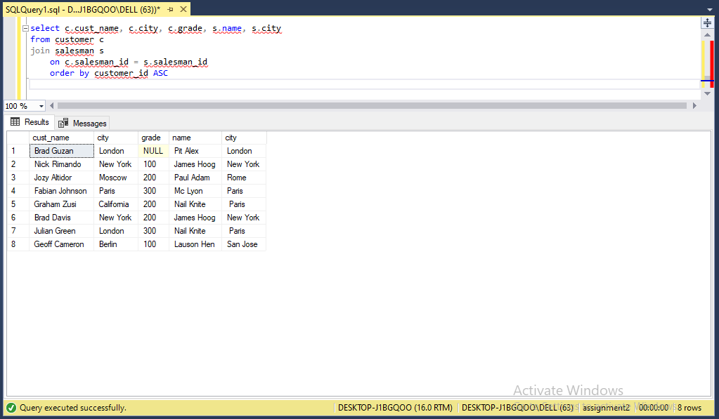

**9.** write a SQL query to find those customers with a grade less than 300. Return

cust_name, customer city, grade, Salesman, salesmancity. The result should be

ordered by ascending customer_id.

**Solution:**

select c.cust_name, c.city, c.grade, s.name, s.city

from customer c

join salesman s

on c.salesman_id = s.salesman_id

where c.grade < 300

order by customer_id ASC

**Output:**

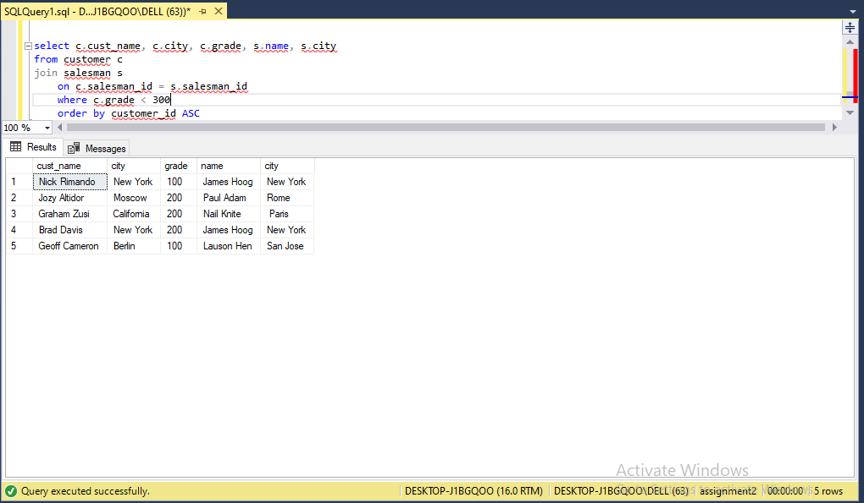

**10.** Write a SQL statement to make a report with customer name, city, order number,

order date, and order amount in ascending order according to the order date to

determine whether any of the existing customers have placed an order or not

**Solution:**

select c.cust_name, c.city, o.ord_no, o.ord_date, o.purch_amt

from customer c

left join orders o

on c.customer_id = o.customer_id

**Output:**

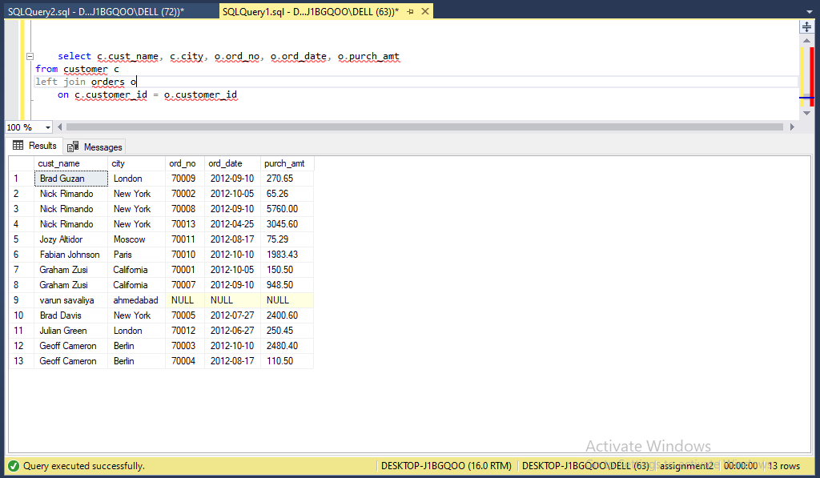

**11.** Write a SQL statement to generate a report with customer name, city, order number,

order date, order amount, salesperson name, and commission to determine if any of

the existing customers have not placed orders or if they have placed orders through

their salesman or by themselves

**Solution:**

select c.cust_name, c.city, o.ord_no, o.ord_date, o.purch_amt

from customer c

left join orders o

on c.customer_id = o.customer_id

left join salesman s

on c.salesman_id = s.salesman_id

**Output:**

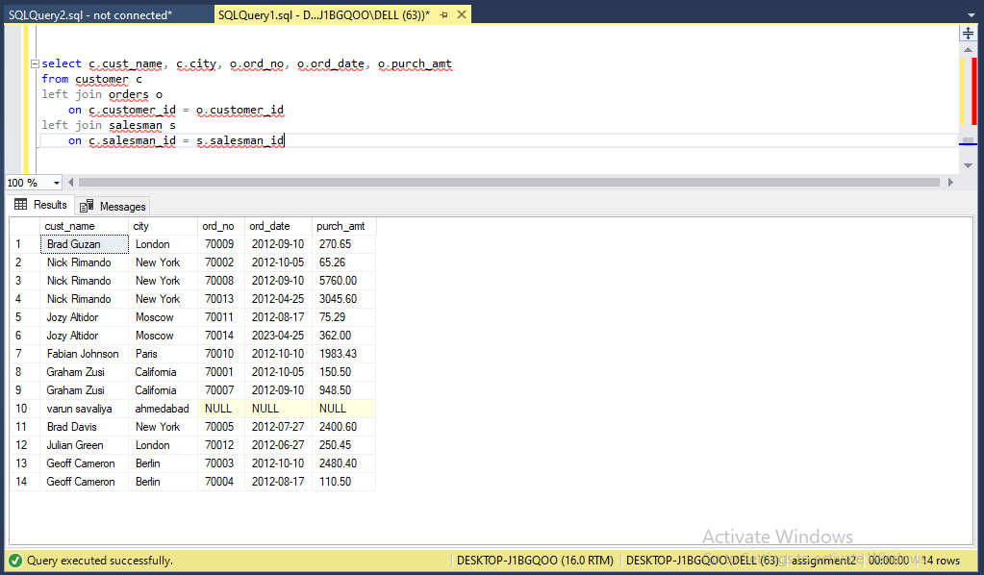

**12.** Write a SQL statement to generate a list in ascending order of salespersons who

work either for one or more customers or have not yet joined any of the customers

**Solution:**

select s.name AS "Salesman", c.cust_name

from salesman s

left join customer c

on s.salesman_id = c.salesman_id

order by s.salesman_id;

**Output:**

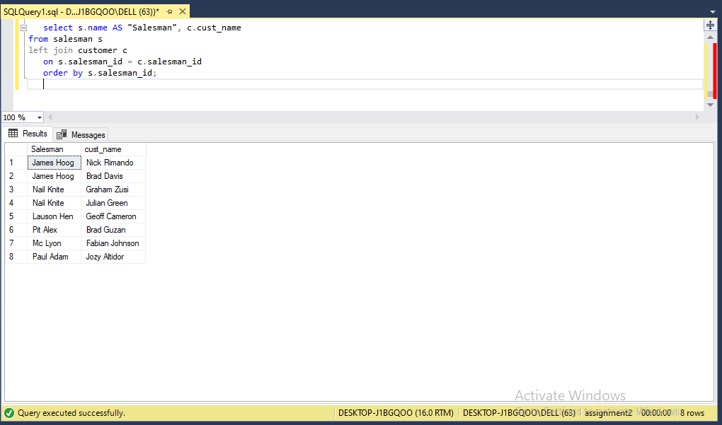

**13.** write a SQL query to list all salespersons along with customer name, city, grade,

order number, date, and amount.

**Solution:**

select s.name as salesman_name, c.cust_name, c.city, c.grade, o.ord_no, o.ord_date, o.purch_amt

from salesman s

join customer c

on s.salesman_id = c.salesman_id

join orders o

on c.customer_id = o.customer_id

**Output:**

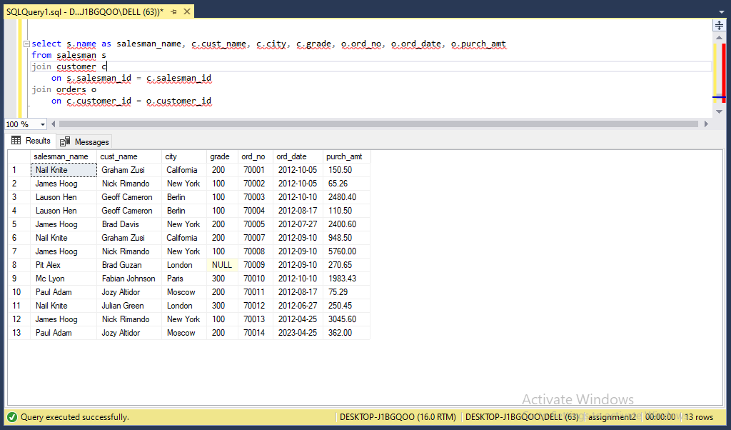

**14.** Write a SQL statement to make a list for the salesmen who either work for one or

more customers or yet to join any of the customers. The customer may have placed,

either one or more orders on or above order amount 2000 and must have a grade, or

he may not have placed any order to the associated supplier.

**Solution:**

select distinct s.name as salesman_name

from salesman s

left join customer c

on s.salesman_id = c.salesman_id

left join orders o

on c.customer_id = o.customer_id

where o.purch_amt >= 2000 and c.grade is not null

**Output:**

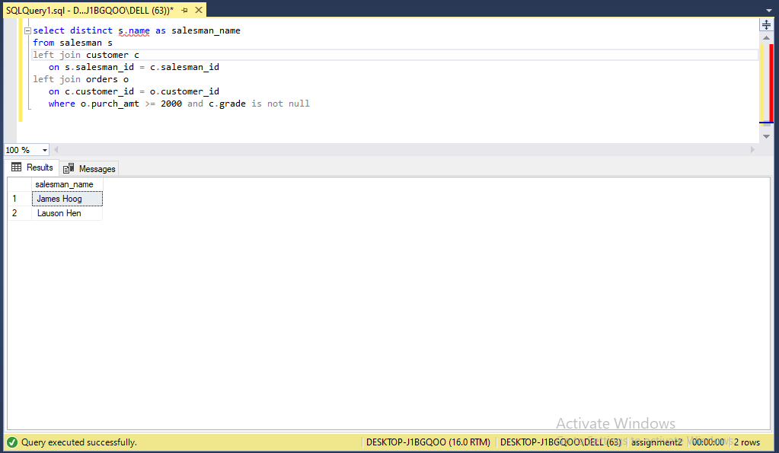

**15.** Write a SQL statement to generate a list of all the salesmen who either work for one

or more customers or have yet to join any of them. The customer may have placed

one or more orders at or above order amount 2000, and must have a grade, or he

may not have placed any orders to the associated supplier.

**Solution:**

select distinct s.name as salesman_name

from salesman s

left join customer c

on s.salesman_id = c.salesman_id

left join orders o

on c.customer_id = o.customer_id

where o.purch_amt >= 2000 and c.grade is not null

**Output:**

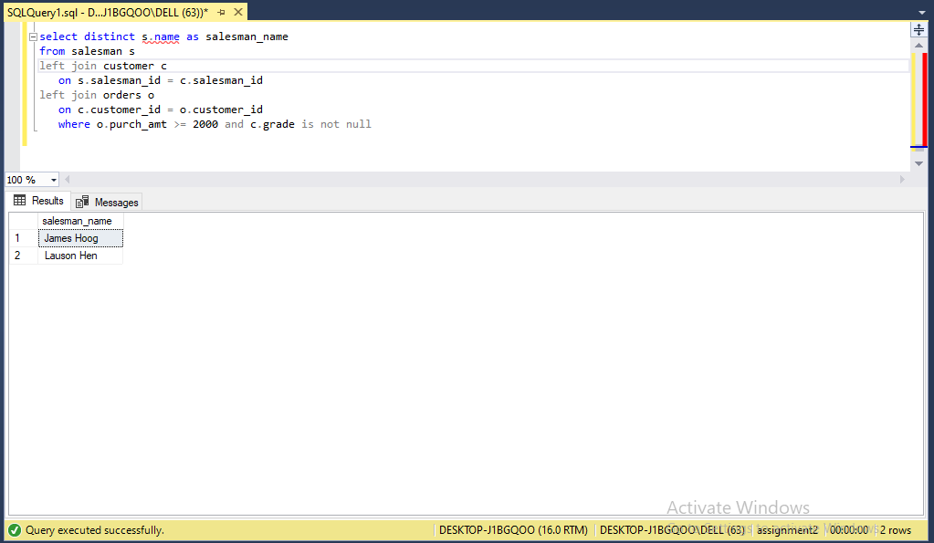

**16.** Write a SQL statement to generate a report with the customer name, city, order no.

order date, purchase amount for only those customers on the list who must have a

grade and placed one or more orders or which order(s) have been placed by the

customer who neither is on the list nor has a grade.

**Solution:**

select c.cust_name, c.city, o.ord_no, o.ord_date, o.purch_amt

from customer c

left join orders o

on c.customer_id = o.customer_id

where (c.grade is not null and o.ord_no is not null)

or (c.customer_id = null and grade = null)

**Output:**

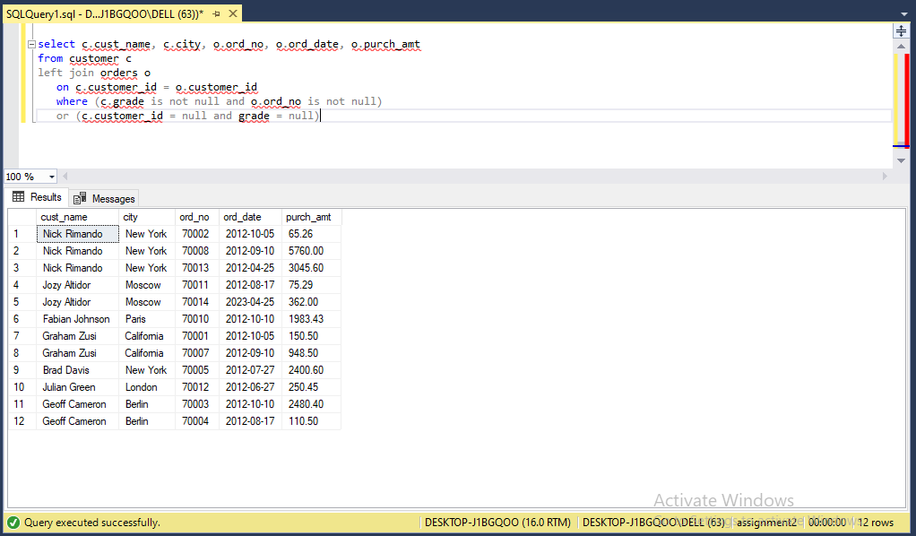

**17.** Write a SQL query to combine each row of the salesman table with each row of the

customer table

**Solution:**

select *

from salesman s

cross join customer c

**Output:**

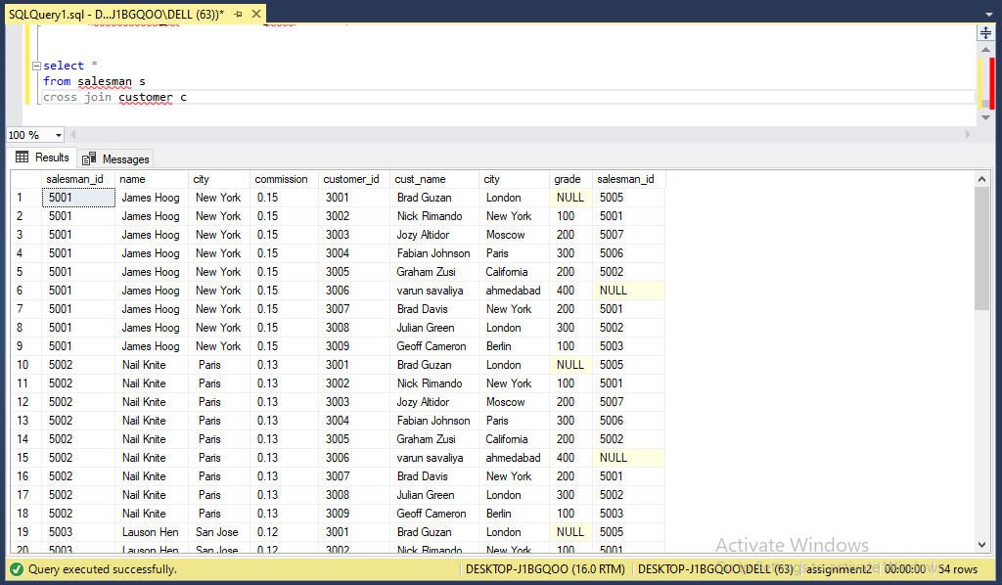

**18.** Write a SQL statement to create a Cartesian product between salesperson and

customer, i.e. each salesperson will appear for all customers and vice versa for that

salesperson who belongs to that city

**Solution:**

select *

from salesman s

cross join customer c

where s.city = c.city

**Output:**

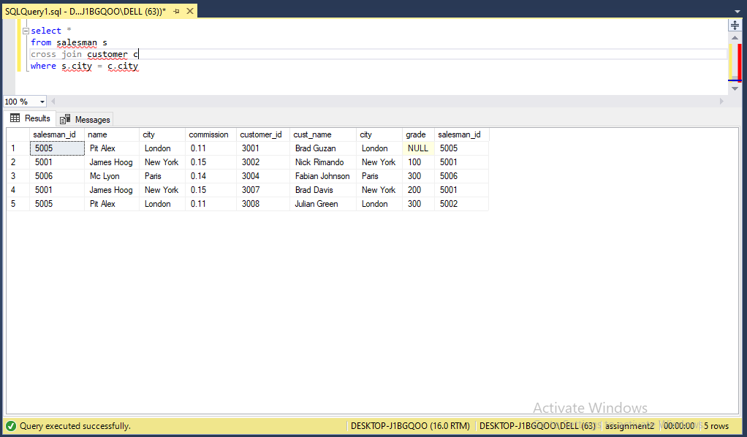

**19.** Write a SQL statement to create a Cartesian product between salesperson and

customer, i.e. each salesperson will appear for every customer and vice versa for

those salesmen who belong to a city and customers who require a grade

**Solution:**

select *

from salesman s

cross join customer c

where s.city is not null and grade is not null

**Output:**

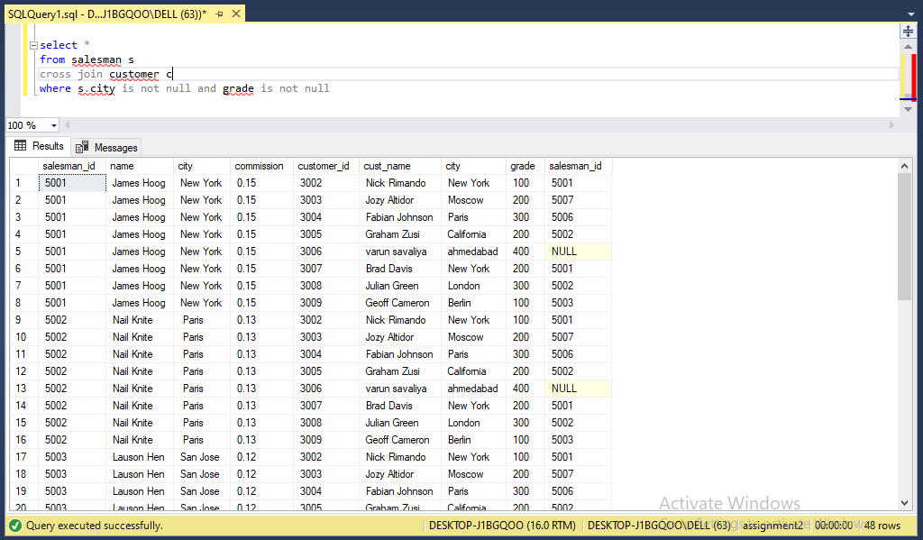

**20.** Write a SQL statement to make a Cartesian product between salesman and

customer i.e. each salesman will appear for all customers and vice versa for those

salesmen who must belong to a city which is not the same as his customer and the

customers should have their own grade

**Solution:**

select *

from salesman s

cross join customer c

where s.city != c.city and c.grade is not null

**Output:**

