**ASSIGNMENT 3: Retrieve data using Group By clause**

**1.** write a SQL query to find Employees who have the biggest salary in their Department

**Solution:**

select e.emp_name, e.dept_id salary

from employee e

join (select dept_id, max(salary) as max from Employee group by dept_id) d

on e.dept_id = d.dept_id

where d.max = e.salary

**Output:**

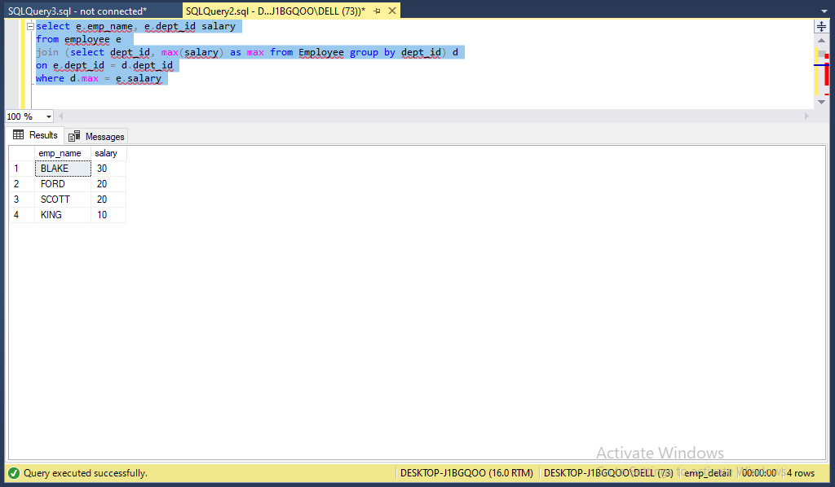

**2**. write a SQL query to find Departments that have less than 3 people in it

**Solution:**

select d.dept_name

from Employee e

right join Department d

on d.dept_id = e.dept_id

group by dept_name having count(e.emp_id)<= 3

**Output:**

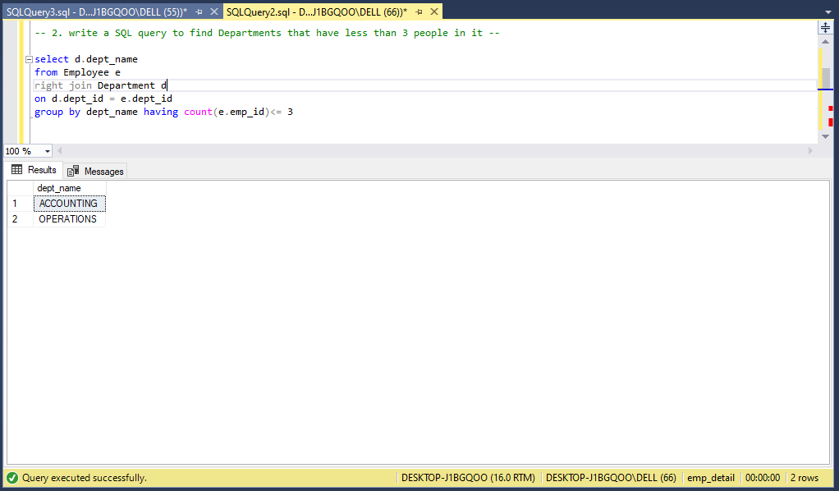

**3**. write a SQL query to find All Department along with the number of people there

**Solution:**

select d.dept_name, count(e.emp_id)

from Employee e

right join Department d

on d.dept_id = e.dept_id

group by dept_name

**Output:**

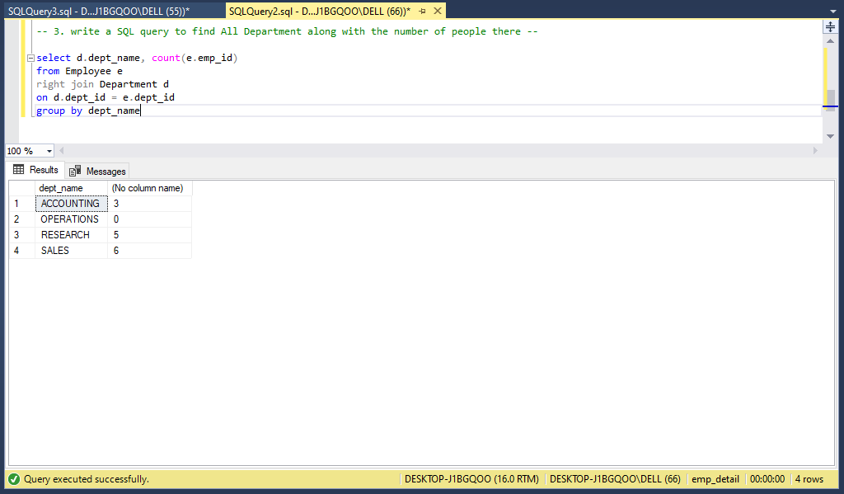

**4.**write a SQL query to find All Department along with the total salary there

**Solution:**

select d.dept_name, isnull(sum(e.salary), 0)

from Employee e

right join Department d

on d.dept_id = e.dept_id

group by d.dept_name

**Output:**

