My 7 favorite United States Punk Albums of All Time

This list is some of my favorite Punk albums of all time,which largely consists of albums I feel as though they pioneered sub-genres as well as Punk itself.

# Knife Man-AJJ

# Bad Brains- Self Titled

# Black Flag-Damaged

# 

# MK Ultra Support Group-MSG 1

# 

# Bikini Kill-Yeah Yeah Yeah

# 

# Descendants-Milo Goes to College

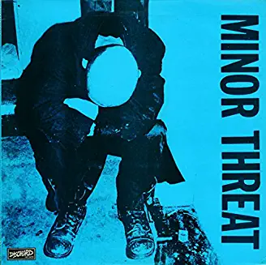

# Minor Threat- Self Titled