华南理工大学计算机学院双语班期中考试试题
课程： 计算机网络 教师：

班级： 姓名： 分数：

一、选择题
No. | 1 | 2 | 3 | 4 | 5 | 6 | 7 | 8
Answer
No.
Answer | 9 | 10 | 11 | 12 | 13 | 14 | 15

1 What is the term to describe the maximum number of bits that can be transferred in a given amount of time?
A. impedance
B. propagation
C. attenuation
D. bandwidth

2 Which factor reduces throughput?
A. increased number of users
B. decreased number of users
C. increased distance of network
D. decreased distance of network

3 Which of the following best describes networking protocols?
A. a formal description of a set of rules and conventions that govern how devices on a network exchange information
B. the use of the same network topology for all networks
C. a set of guidelines that can be customized to meet individual needs
D. all of the above

4 What is the function of the session layer?
A. concerned with data structures and the negotiation of data transfer syntax
B. provides reliable transit of data across the physical layer
C. provides connectivity and path selection between two end systems
D. manages data exchange between presentation layer entities

5 Which of the following are not the advantages of UTP cable installation?

A. less expensive than fiber optic media
B. flexible and easy to install in a building
C. receives less RFI and EMI interference than fiber optic media
D. considered the fastest copper-based media

6 What is the Organizational Unique Identifier (OUI)?
A. all hex digits of a MAC address
B. the 1st 6 hex digits of a MAC address
C. the last 6 hex digits of a MAC address
D. the prefix to all network device model numbers

7 In a connection-oriented system, what happens before any user data is transferred?
A. a connection is established with the recipient's local router
B. a connection is established between the sender and receiver
C. a connection is established with the sender's local router
D. the destination is not contacted before any actual data is sent

8 Two peer hosts are running applications that exchange data using UDP. During the current session, a datagram fails to arrive at the destination. What is true concerning the retransmission of the datagram?

A. Datagram retransmission occurs when the retransmission timer expires in the source host.
B. Datagram retransmission occurs when the retransmission timer expires in the destination host.
C. Datagram retransmission is controlled by the application layer protocol.
D. Datagram retransmission involves only the data with sequence numbers equal to or higher than the sequence number of the current datagram.

9 What describes the time necessary to move a packet from the data link layer to the physical layer?
- Packet delay
- Transmission time
- Convergence
- Queuing

10 Switches that receive the entire frame before sending it, use what type of frame forwarding?
- Cut-through
- Receive and send
- Copy and send
- Store-and-forward

11 Frame tagging functions at what OSI layer?
- 2
- 3
- 1
- 4

12 Dynamic VLANs can be based on which of the following?
- MAC addresses
- Protocol type
- Logical addressing
- All of the above

13 VLANs, along with routers, establish which of the following?
- WANs
- LANs
- Broadcast domains
- Collision domains

14 What do HDLC, PPP, Frame Relay and ISDN have in common?
- They operate at the physical layer.
- They operate at the network layer.
- They operate at the data link layer.
- They are proprietary standards.

15 What PPP protocol is used to establish, maintain and terminate the point-to-point connection?
- SNMP
- IPX/SPX
- TCP/IP
- LCP

二、问答题
1．Why Ethernet chooses CSMA/CD as its protocol instead of others. Please list its advantages and compare it with slotted ALOHA, pure ALOHA and CSMA.

- Use module 2 arithmetic to compute the CRC code for message 101101110011 with the generator 10011

- what course the data link layer LLC protocol develop from “An Unrestricted Simplex Protocol ” to “Sliding Window Protocols”. Explain all the process step by step.

4. What kind of protocol indicated by the figure blow. Explain the meaning and purpose of every word in the figure

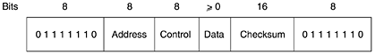 (1)
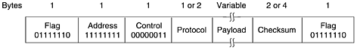(2)

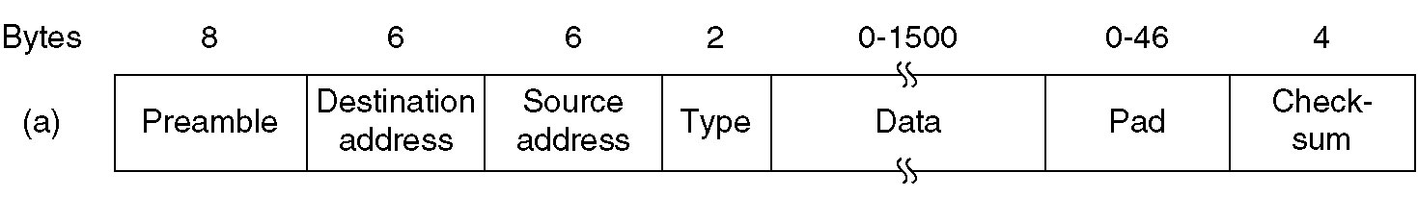 (3)

- Consider building a CSMA/CD network running at 500Mbps over a 2-km cable with no repeaters. The signal speed in the cable is 200,000 km/sec. What is the minimum frame size? Why?

5. Briefly describe the difference between store-and-forward and cut-through switches.

