诚信应考,考试作弊将带来严重后果！
_____________ ________
…

姓名 学号
学院 班级 座位号
( 密 封 线 内 不 答 题 )
……………………………………………………密………………………………………………封………………………………………线……………………………………线………………………………………

华南理工大学期末考试
《 编译原理 》试卷A
注意事项：1. 考前请将密封线内填写清楚；
2. 所有答案请直接答在试卷上；
3．考试形式：闭卷；
4. 本试卷共 大题，满分100分， 考试时间120分钟。
题 号 | 一 | 二 | 三 | 四 | 五 | 总分
得 分
评卷人
Note: Whether English or Chinese doesn’t impact your score.

- Fill in the blanks (18%)
a. Normally, A complier consists of a number of phases. They are Scanner, _________________, ______________________, ______________________, Code Generator, and ___________________.
b. The logical units the scanner generates are called Tokens. For a modern programming language, there are five types of token. They are ________________, _______________, __________________, ____________________, ________________.
c. Based on the following C source code fragment
int gets(char *s)
{
if (s == NULL)
{
printf(“illegal point parameter \n”);
return -1;
}
return 0;
}
Please answer:
a) “int” is a ___________________
b) “printf” is a _________________
c) “s” is a (an) _________________
d) “= =” is a ____________________
e) “0” is a _____________________
d. A grammar G usually includes four components, they are _______________, __________________, _______________, and _____________________.

- (Terms Translation, 12%)
Please give a brief explanation to the following terms in compiler science domain
  - Compiler ——

  - Source code ——

  - Scanner ——

  - Tokens ——

  - Terminal symbol ——

  - Ambiguous Grammar ——

- (Scanning; 20%)

(a) (10%) Construct an NFA that recognizes the same language as defined by the following regular expression:
(a*ba*b)*ba*
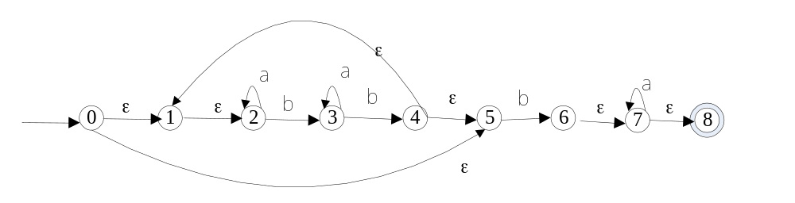

(b) (10%) Using the subset construction, convert the NFA into a DFA.

 | a | b
A={0,1,2,5} | B | C
B={2} | B | D
C={3,6, 7,8} | E | F
D={3} | D | F
E={3,7, 8} | E | F
F={1,2,4,5} | B | C

4. (LL parsing; 25%) Consider the following grammar G(S):
S->number | List
List -> (Seq)
Seq -> Seq, S | S
Where number and “,” are terminal symbols, and the others symbols are non-terminal.

(a) (7%) Please write the left-most derivation for sentence “(4, (34))”

(b) [8%]Please convert the grammar G into a LL(1) grammar G1 by remove the left recursion.

(c) [10%]Based on your LL(1) grammar G1, please calculate the FOLLOW set and FIRST set, and build it’s LL(1) table.

5. (LR parsing; 25%)
Consider the following grammar G[S]:
E→(L)|a L→EL |E
Where a ,” (”，” )” are terminal symbols and the others are non-terminal symbols.

(a) [5%.] Construct the DFA of LR(0) items of this grammar.

(b) [10%] Construct the SLR(1) parsing table.

(c) [10%] Show the parsing stack and the action of a SLR(1) parser for the input string: (a (a a))

