Answer:
2.
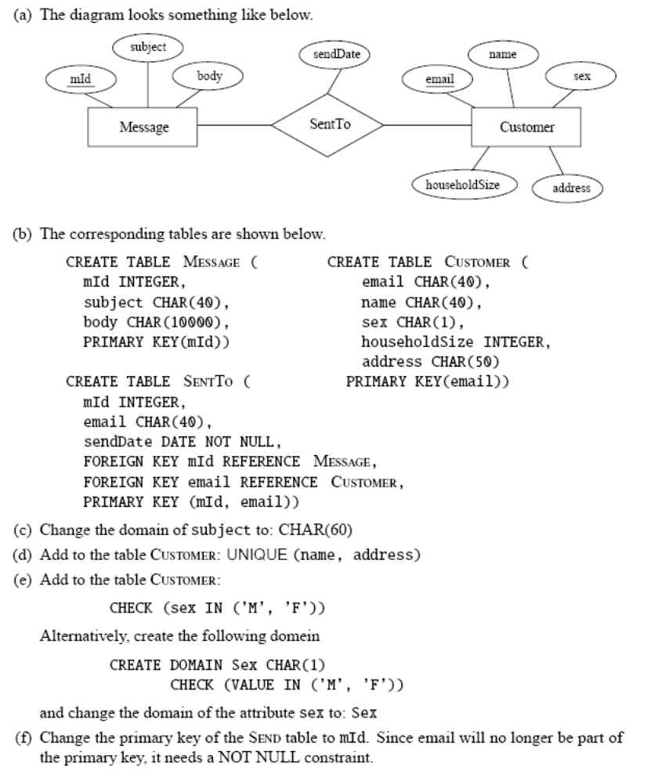
(g)
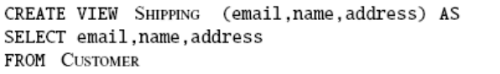
3.
a. 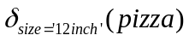
b.
c. 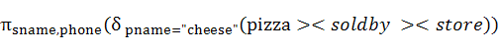
d. ∩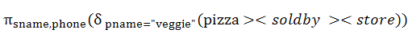
5.
a. select pname
from pizza
where size=’12 inch’
b. delete from pizza where pname=”cheese” and size=”12 inch”
c. select sname, phone
from pizza, store, soldby
where pname=”cheese” and soldby.pid=pizza.pid and soldby.sname=store.sname and soldby.sname in
(select sname
from pizza, soldby
where pname=”veggie” and soldby.pid=pizza.pid)
d. select sname
from soldby
minus
(select sname
from soldby, pizza
where pname=”veggie” and soldby.pid=pizza.pid)
e. select pizza.pid, quality, avg(price)
from soldby, store
where store.sname=soldby.sname
group by pid, quality
having avg(price)>5

6. a. Can there be a key that does not contain D? Explain.
Solution:
No - Since D is not uniquely determined by any other attributes, it must be part of
all keys.

b. Is the schema in BCNF? Explain.
Solution:
No - None of the left hand sides are superkeys.

c. Use one cycle of the BCNF algorithm to decompose R into two subrelations. Are
the subrelations in BCNF?
Solution:
We can choose any of the FD as a basis for a decomposition. For example, R1 =
(ABDEFGH, {BE →GH, G →FA, F →B}), R2 = (DC, {D →C}). In this case
R1 is not in BCNF (since the LHS of all its FDs are not superkeys), but R2 is.

d. Showt hat your decomposition is lossless.
Solution:
{ABDEFGH} ∩ {CD} is a key of R2.

e. Is your decomposition dependency preserving? Explain.
Solution:
The decomposition is dependency preserving because each of the FDs of R is a FD
of one of the component relations.

7.
a.
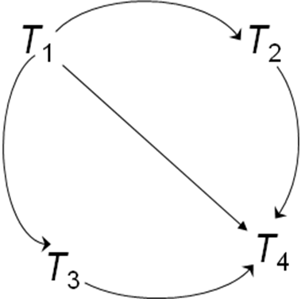 with T₅ is a single node in the precedence graph.
b: It is a conflict serializable schedule, for the precedence graph is acyclic that is with no cycles in it.

