2023年3月英语六级真题及参考答案

六级试卷采用多题多卷形式，大家核对答案时，找准具体选项内容，忽略套数！

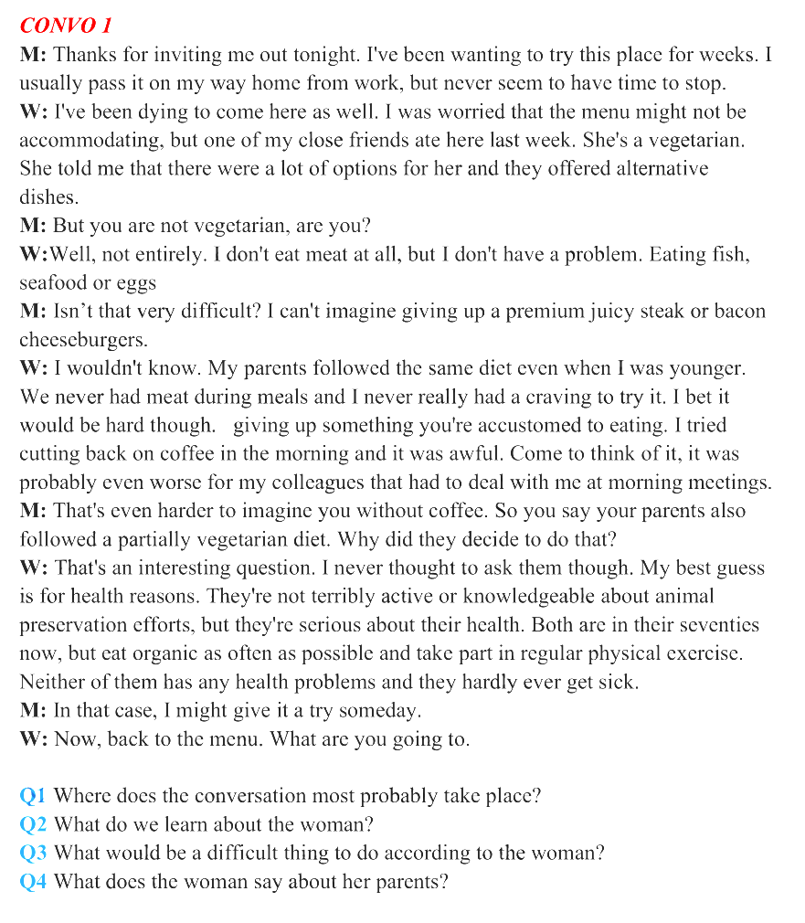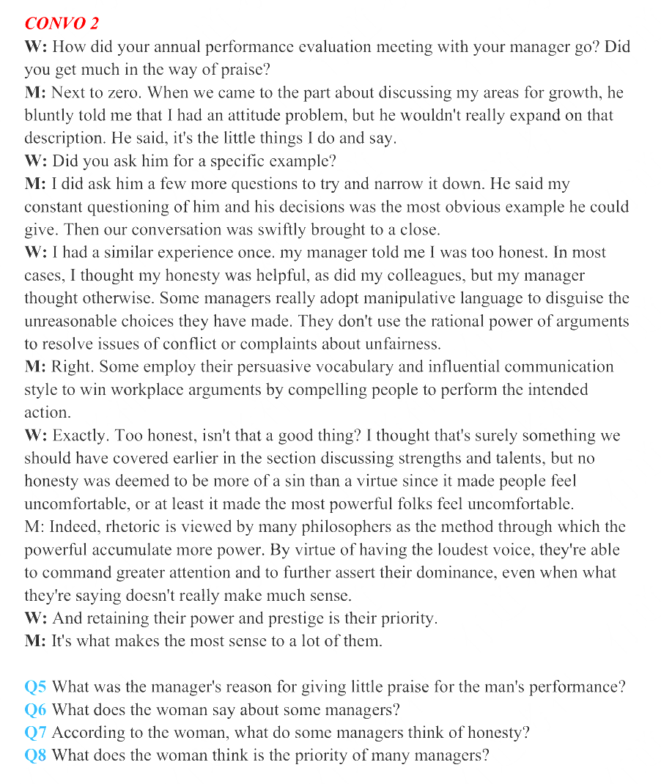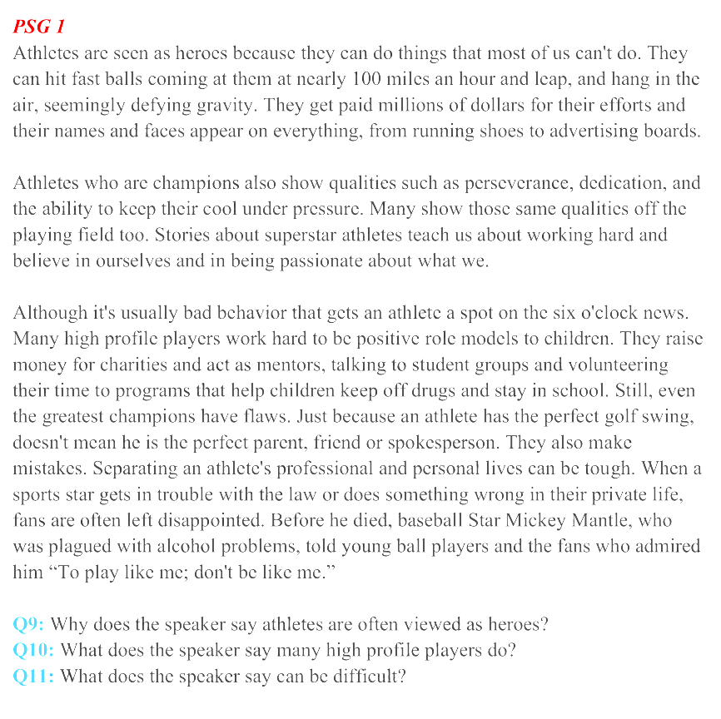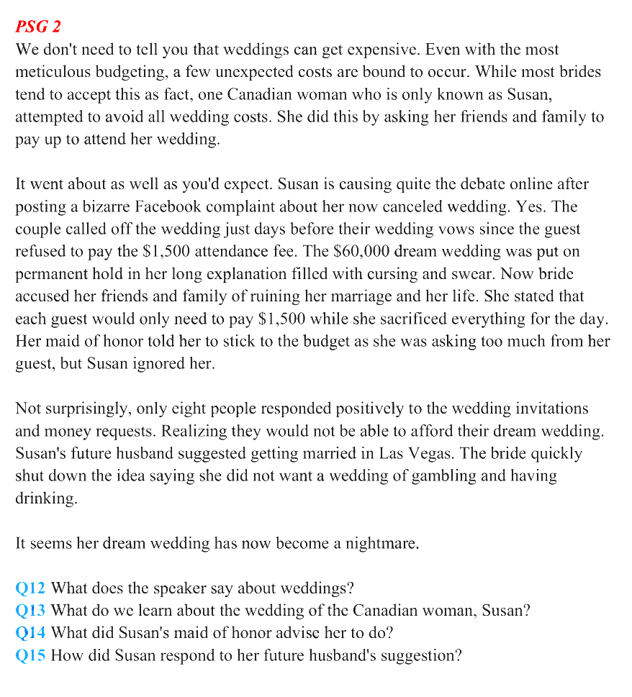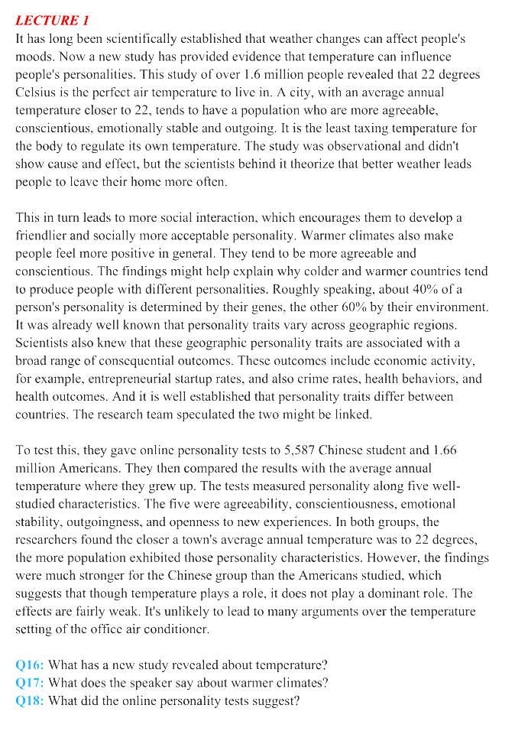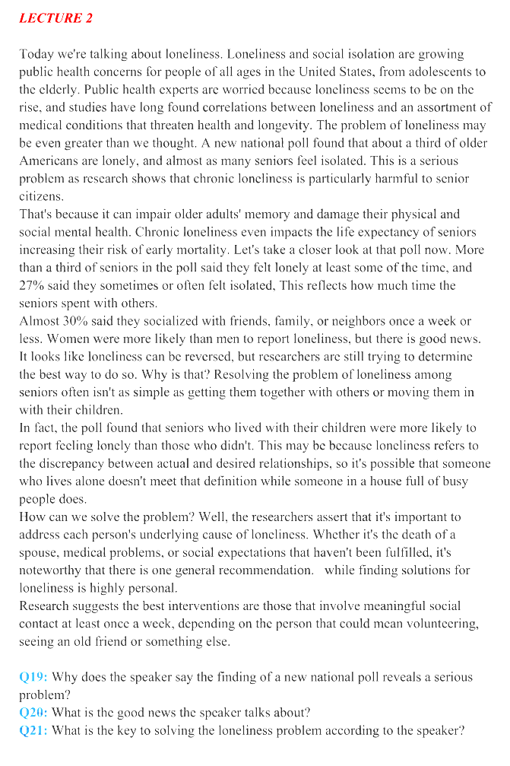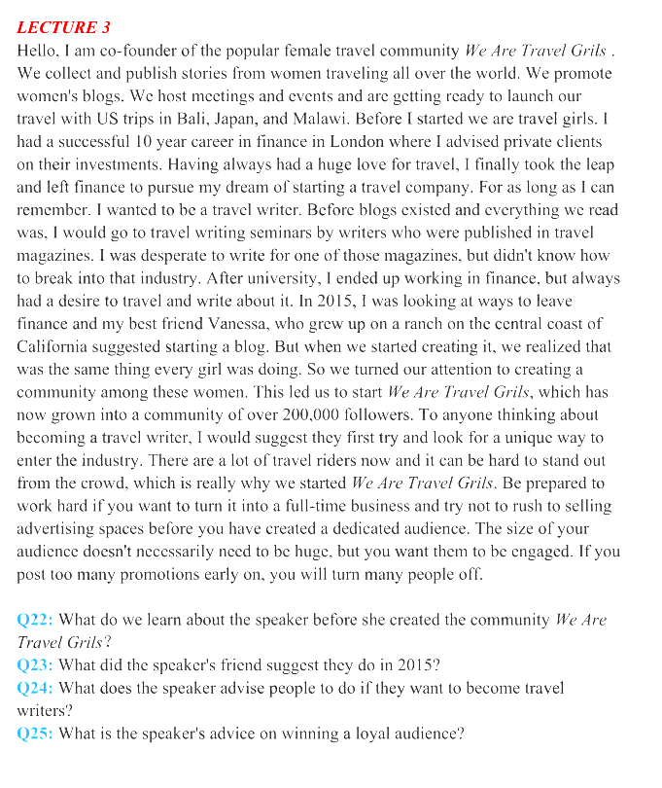
01 听力部分
1.A) In a restaurant.
2.D) She is a partial vegetarian.
3.B) Changing one's eating habit.
4.A) They enjoy perfect health.
5.D) The man had an attitude problem.
6.C) They use manipulative language to mask their irrational choices.
7.B) It is more of a sin than a virtue.
8.D) Preserving their power and prestige
9. B) They accomplish feats many of us cannot.
10. C) They try to be positive role models to children.
11. A) Separating an athlete's professional life from their personal life.
12. A) They always cost more than expected.
13. B) It was cancelled.
14. C) Keep to her budget.
15. D) She rejected it flatly.
16. D) It can influence people's personalities.
17. C) They tend to produce positive feelings
18. A) The link between temperature and personality is fairly weak.
19. B) Chronic loneliness does harm to senior citizens in particular.
20. D) Loneliness is probably reversible.
21. C) Meaningful social contact.
22. A) She had a successful career in finance.
23. B) Start a blog.
24. D) Create something unique to enter the industry.
25. C) Avoiding too much advertising early on.

02 作文部分

外貌焦虑
Directions: For this part, you are allowed 30 minutes to write an essay that begins with the sentence“People are now increasingly aware of the danger of 'appearance anxiety'or being obsessed with one's looks.” You can make comments, cite examples or use your personal experiences to develop your essay You should write at least 150 words but no more than 200 words
With the progress of society and the improvement of living standards, many people, especially young people, become too concerned about their appearance and suffer from appearance anxiety.
Appearance anxiety can cause us a lot of problems. Not only does this lead to many harmful behaviors, such as excessive exercise, eating disorders, and even cosmetic surgery, which can affect our physical health, it can also have a negative impact on our mental health, making us feel anxious, even depressed, and plunging us into deep self-doubt.
We should take positive actions to eliminate our appearance anxiety. First of all, we should keep a positive and optimistic attitude in life and study, so as to improve and overcome anxiety by increasing personal confidence. Secondly, we should have normal standards of beauty, learn to accept our imperfections, and overcome the inferiority and self-doubt brought by looks. Last but not least, we should pay more attention to our inner character instead of superficial external performance.
In conclusion, appearance anxiety can adversely affect our physical and mental health. We should take active actions to eliminate appearance anxiety through the above mentioned ways, so that we can enjoy a happier life.

面临众多选择时做决定
Directions: For this part, you are allowed 30 minutes to write an essay that begins with the sentence “People are now increasingly aware of the challenges in making adecision when faced with too many choices.”You can make comments, cite examples or use your personal experiences to develop your essay. You should write at least 150 words but no more than 200 words.
People are now increasingly aware of the challenges in making a decision when faced with too many choices. Especially for students, they often have many different choices before them, and it is indeed a major challenge to make the right choice.
For one thing, for most of us, sometimes you can make decisions in an instant, but at other times the choice feels overwhelming. Students may feel anxious when confronted with too many choices and the anxiety may cause a fear of making the wrong choice and later suffering the consequences. This may cause you to hesitate, ruminate, or fail to make any decision at all.For another, some students ,It is easy for them to blindly follow others to make choices without considering whether this choice suits them.
As far as I’m concerned,If you are struggling to decide what to do, keep your long-term goals in mind. Start journaling your ideas, and document your fears, hopes or expectations so that you have a clear idea of where you are now, and where you want to get to.Keep your goals in mind and explore your options objectively to ensure that you can make the choice that's right for you.

数字鸿沟
Directions: For this part, you are allowed 30 minutes to write an essay that begins with the sentence "People are now increasingly aware of the 'digital gap' or challenges the elderly face in a digital world. " You can make comments, give explanations or cite examples to develop your essay. You should write at least 150 words but no more than 200 words.
People are now increasingly aware of the “digital gap” or challenges the elderly face in a digital world. Digitalization has become a prominent feature of current social changes in our country. Moreover, a worrisome point is that a fair number of the elderly still face the problem of "digital siege", which should attract increasing attention nowadays.
Personally speaking, there are two reason accounting for this phenomenon. First and foremost, digital technology is rapidly updated and iterated in a short time so that it is difficult for most elderly people to keep their pace with the trend due to physical and intellectual limitations. In addition, the majority of digital technologies are based on the market needs of young people. Only the aged learn the cumbersome intelligent operation can they be able to apply the technologies, which virtually raises the technical threshold of the old people's digital life.
According to statistics, our country is officially entering a moderately aged society. Therefore, we should spare no efforts to help the aged overcome the challenges and enjoy the benefits brought by the digitalization.

03 阅读部分

词汇理解
（1）文章开头
开头：Unthinkable as it may be, humanity, every last person...
（2）答案
【答案速查】26-30 KGLHB 31-35 JAIND
26. K) scenario
27. G) extinction
28. L) severely
29. H) obscure
30. B) arise
31. J) posed
32. A) advocate
33. I) particular
34. N) species
35. D) encounter

长篇阅读
（1）文章标题
标题San Francisco Has Become One Huge Metaphor for Economic Inequality in America
（2）答案速查
36-40DGCEH 41-45KFMBJ

36. San Francisco city government offered tax benefits to attract tech companies to establish operations in a less developed area.
36. D【定位】Policies pushed by Mayor Ed Lee provided tax breaks for tech companies to set up shop along the city’s long-neglected Mid-Market area.

37. The fast rise in the prices of land and houses increases the economic inequality among people
37.G【定位】When home prices soar above the reach of most households, the gap between the rich and the poor dramatically increases.

38. San Francisco has been found to have the biggest income gap in California between the rich and the poor.
38.C【定位】 According to a recent study, San Francisco ranks first in California for economic difference.

39. The higher rate of employment, combined with limited housing supply, did not make it any easier to buy a house.
39. E 【定位】In spite of all that, the strength of the recent job growth, combined with policies that have traditionally limited housing development in the city and throughout the peninsula, did not help ease the affordability crisis.

40. When people compare their own living standard with others’, it has a greater impact on their sense of contentment.
40.H【定位】This means that how a person judges their security in comparison to their neighbors’ has more of an impact on their happiness than their objective standard of living.

41. Improved transport networks connecting the city to distant outlying areas will also help solve the housing crisis.
41. K【定位】Real estate alone will not solve the problem, of course. Transportation, too, needs to be updated and infrastructure extended to link distant regions to Silicon Valley and the city.

42. Average incomes in the Bay Area make it virtually impossible for most tenant families to buy a home.
42.F【定位】Considering that the average household income in the city currently stands at around $80,000, it is not an exaggeration to say that the dream of home ownership is now beyond the grasp of the vast majority of today's people who rent.

43. Innovative solutions to social and economic problems should be introduced before it is too late.
43.M【定位】It doesn't have to be this way. But solutions need to be implemented now, before angry crowds grow from a nuisance to serious concern. … We need to use existing technology to shorten travel times and break the land limits.

44. Residents of the San Francisco Bay Area strongly resent the tech industry because of the economic inequality it has contributed to.
44. B【定位】… to drastic market distortions in the San Francisco Bay Area have created boiling resentment in the region towards the tech industry. A vocal minority is even calling on officials to punish those who are benefitting from the economic and housing boom.

45. One way to deal with the housing crisis is for the government to simplify the approval procedures for housing projects.
45. J【定位】The housing crisis is caused by two primary factors: the growing desirability of the Bay Area as a place to live due to its excellent economy, and our limited housing stock.

Passage One
（1）文章开头
The suggestion that people should aim for dietary diversity by trying to eat a variety of foods has been a basic public health recommendation for decades in the United States everywhere.
（2）答案
【答案速查】 46-50 ACABC
46. What has been a standard piece of dietary advice for decades?
A) People should diversify what they eat.

47. What did the new research by the American Heart Association find?
C) People seeking dietary diversity tend to eat more.

48. What could help to explain the contradiction between the new findings and the common public health recommendation?
A) There is little consensus on the definition of dietary diversity.

49. What did Dr. Rao find after 20 years of research on obesity?
B) Diversified food intake may not contribute to health.

50. What does the passage say about people who eat a great variety of food?
C) They don't feel they have had enough until they overeat.

Passage Two
（1）文章开头
The ability to make inferences from same and different…
（2）答案
【答案速查】 51-55 ADBCD
51. In what way were humans thought to be unique?
A) Being capable of same-different discrimination.

52. What do we learn from the study published in Science?
D) Our conception of birds’ intelligence was wrong.

53. What did the researchers discover about most ducklings from their experiment?
B) They could tell whether the objects were the same.

54. What was novel about the experiment in the study reported in Science?
C) The animals used received no training.

55. What do we learn from Dr. Wasserman’s comment on the study of animal minds at the end of the passage？
D) Remarkable progress is being made.

04 翻译部分

张骞出使西域
张骞(ZhangQian)是中国第一个伟大的探险家。他不畏艰险，克服重重困难，两次出使西域，开通了中国同西亚和欧洲的通商关系，将中国的丝和丝织品运往西亚和欧洲开拓了历史上著名的“丝绸之路”。同时，他又将西域的风土人情、地理文化以及特有物种等介绍到中原，极大地开阔了人们的视野正如历史学家所指出的那样，如果没有张赛出使西域，就不可能有丝绸之路的开辟也就不会有汉朝同西域或欧洲的文化交流。
Zhang Qian was the first great Chinese explorer. He made two missions to the Western Regions despite all the dangers and difficulties. He opened up trade relations between China and West Asia and Europe, shipped Chinese silk and silk fabrics to West Asia and Europe, thus opening up the famous Silk Road in history. In the meanwhile, he also introduced the customs, regional culture and unique species of the Western Regions to the Central Plains, which greatly broadened people's horizon.
As historians have pointed out, without Zhang Qian's missions to the Western Regions, there would be no opening up of the Silk Road and no cultural exchanges between the Han Dynasty and the Western Regions or Europe.

郑和下西洋
郑和是中国历史上最杰出的航海家，在航海、外交、军事等诸多领域都表现出非凡的智慧和卓越的才能。他曾七次率领庞大的船队远航，访问了西太平洋和印度洋的许多国家和地区，加深了中国同东南亚、东非的相互了解。
郑和下西洋对中外的经济和文化交流起到了十分积极的推进作用，也为维护区域和平做出了巨大贡献。为了永远铭记郑和及其丰功伟绩，7月 11日，即郑和首次率船队远航启程的日子，被定为中国的航海节
Zheng He is the most outstanding navigator in Chinese history.He has shown extraordinary wisdom and outstanding talent in many fields, including navigation, diplomacy and military. He led a huge fleet of ships on seven voyages and visited many countries and regions in the Western Pacific and the Indian Ocean, deepening mutual understanding between China and Southeast Asia and East Africa.
Zheng He's voyages played a very positive role in promoting economic and cultural exchanges between China and foreign countries, and also made great contributions to maintaining regional peace. In order to forever remember Zheng He and his great achievements, July 11, the day when Zheng He first set sail with his fleet, has been designated as China's Maritime Day.

徐霞客
徐霞客是中国明代的著名地理学家，他花费了三十多年的时间游遍了大半个中国。他主要靠徒步跋涉，寻访了许多荒远偏僻的地区。他把自己的见闻和考察结果详编记录下来，为后人留下了珍贵的考察资料。他通过对许多河流的实地调查，纠正了文献中关于水源的错误。他还详细地描述了地形、气候等因素对植物的影响，生动地描绘了各地的名胜古迹和风土人情。他的考察记录由后人整理成了《徐霞客游记》，在国内外产生了广泛的影响。
Xu Xiake is a famous geographer in the Ming Dynasty. He spent more than thirty years traveling around most of China. He explored many remote areas, mainly on foot. He wrote down his observations and investigation results in detail, leaving precious investigation materials for posterity. He corrected errors about water sources in the literature by conducting field surveys of many rivers. He also described in detail the effects of terrain, climate and other factors on plants, and vividly depicted many places of interest and local customs. His investigation records were compiled into the Travel Notes of Xu Xiake by later generations, which has a wide influence at home and abroad.

