2023年6月英语六级真题及参考答案
六级试卷采用多题多卷形式，大家核对答案时，找准具体选项内容，忽略套数！
网络综合版：
听力第一套
Conversation One
M: Hi Lily, how's the new apartment?
W: It's okay.
M:What? How can it be just okaywhen last week you were thrilledabout the place and keptnosting photos of it online?
W:Well,【1】 last week whenfmoved in, the apartment seemed cozy, justthe right size forone person. But nowit just seems tiny, shabby and solitary.
M: Al that's the problem. You missyour roommates from university,don't you?
W: I'm going to sound like G idiot【2】because Iused to complain to youall the time about how crowded ourdormitory room was, and about allthe things they did to irritate me, likewatching movies late at night withoutheadphones, or talking loudly early inthe morning. But now Imiss themterribly.
M: Of course you do. That's perfectlynormal. When I got my first place,Iremember thinking I could ti wait tolive by myself and get away from myjuvenile roommates and all their annoyipghabits.【3】 But then began issing them and feelinglonely and thinking that our dormitory was like paradise. Even though there were six of us guys inone small room.
W: I thought it was just m who reltlike thiat.

M: Look, you lived at home with us.And then you had three roommates.And this is your first time living alone.So i hard But your first apartmentis a milestone in your life. And youshould celebrate it. Tell me about theapartment.
W: Actuaily, it's not bad. In fact, it'spretty adorable. Now that I have decorated it and it has et rjthing Ineed. I have a kitchen to cook in thebathroom al! to myself.And then anothes room with my bed at one endand the sofa, a small table and chairsat the C herend.
M: That does sound adorable, and【4】Ican't wait to see it. And neither canmom and dad.
Question 1: What was the woman'sfirst impression of the apartment?
Question 2: Why does the womansay she's going to sound like an idiot?
Question 3: What do we learn about the man when he left thedormitory to live on his own?
Question 4: What is the man say hecan't wait to do.
W: Welcome to our program book talk. Q5.ourgyest today is FrankJonesiditicbf our education system and the author of new book,How to reform our universitres.
M: Hello, Susan.
W: Frank, you support radicallychanging universities in America. Yes.
Q6.I believe that the purpose of highereduad grefo prepare young peopleto enter the workforce and that ourcurrent system fails to do this, We'reallocating too many resou disciplines that don't match the needsof employers.

W: I think your attitude to education isa bit cynical Frank. Surely the purpose of university is to prepareyoung people to participate fully incivic life rather than just to find wellpaid jobs.
M: Susan, many young graduates struggle to find any job let alone agood one. The job markc isgrim.Particulaniior students who studythe arts. I agree that it isn't easy foryoungr gegple to find work, but youpropose closing down alt departments that aren't directly
related to science and technology. Isthat really the solution?
M: You're overstating my paint. Q7.My argument is that we need it use moer of our budget on areas like science and engineering. To do that, we needto take money from subjects likeliterature and music
W: Q8,But the arts have value. They'rean important part of our culture.studying literature or music or sculpture might not result in a job inthatae But it helps young people tothink about the world in a.deeperway, which makes them b citizens and makes fora better society.
M:l agree that the arts are valuable tosociety, but it's naive to think that notonly tk miost talented, but allstudents should study them at university level. The odds are verycompetitive, and most graduates willend up with a great deal of debt,obtaining a degree that has littlevalue on the job market.
Question 5. What do we learn from theconversation about the man?
Question 6. What does the manbelieve is the problem with the current American System of Higher Education?
Question 7. How should the educationbudget be allocated according to theman?
Question 8. What does the woman saythe arts can do?
Passage One
Do you ever have the annoying feetingthat you don't have time to really thinkanymore? You're not alone.【Q9】A variet dtdrs have conspired to robus of time for reflectionourselves and our lives.
preoccupied minds are rarely Silent.The average person receives hundredsof texts and voice messages a day. Andholidays for many of us are action-packed weeks more likely full of familyactivities than opportunities fortranquility and contemplation.【Q10】Regular reflection,howe,underlies all great professionals. It's a prerequisite for you to recharge yourmental batteries. See things in a newlight and tap into your creativity.
Almost all of the great advisors that Ihave studied have found ways to getaway from it all and contemplate theirlife and work. Some researchers in thefield of creativity, in fact, believe thatinsight occurs during the reflection and relaxation that follows aCeriod of intense actvity.
Schedule your time for reflection aboutyourwork ora particular proiect you're engaged in. I usually biock outhalf an hour. Don't answer the phone.Push your papers to the side. Sketch,make lists, draw mind maps of ideasthat come to you. At the end, write down any emerging ideas.
When you're alone, stop worrying andthink. A lot of our downtime is spentworrying about troublesc ne thihgs inour lives or fantasizing aboat how we'dlike our lives to be.【Q11】 Revisitthings during moments of relaxationafter a periodnof intense work. This iswhenwe are the most creative.
Question 9 What do we learn about thefeeling that one doesn't heeitime tothink anymore?
Questica 10 What trait do all greatprofessionals share?
Question 11 What is some researchersbelieve is conducive to creative ideas?
Passage Two
had post offices The first opened in 1859 in asettlement founded by migrants searching for gold,Life could be unpredictable outwest. Gold failed to appear. Drought ruinedfarmers, and settlers clashed with_NativeAmericans.
On the settlement's location now stands asprawling University campus. Amid all thechanges, one feature remained constant: thepostal service. The maps tracing America'swestward expansion are telling in 1864 therewere few postat branches on land controlledby Native Americans, which still accountedfor most of the West. Over the next 25 years,post offices grew quickly. Colonization'of theWest could be regarded as a result of biggovernment rather than pioneers.【13】Asfederal subsidies and land grants temptedpeople into the deserts and plains, the postkept them connected.
In the mid-19th century, the Post OfficeDepartment was far from a centralizedbureaucracy. To keep up with migrationpatterns, postal services were added toexisting businesses.

【14】The federal government commissioned private wagons themail. Short term contracts were granted tolocal businessman to act as postmasters.These partnerships enabled the mail to quickly followmigrants helping knit togetherremote parts of the country.
Mr. Bellavance, a digital historian, wrote abook on the history of the US postal service.
【15】 He used the data science to analyzehistorical trends, Most strikingly he built anaccompanying website, complekw;Tinteractive maps.They show readers-howwithin a generation the postal service helpedcolonize a continent. These online interactivemaps illustrate the formative power of snailmail.
Q12 What does the passage say AboutColorado before it became a state?
Q13 How did the postal service contribute toAmerica's westward expansion?
Q14 What did the federal government:do tomeet the increasing demand for the postalservice in the West?
Q15 What did Mr. Bellavance do to study thehistory of the US postal service?
听力演讲1
In last week's lecture, we discussed reasons whypeople forget things. This week we will discuss asurprising reason why we might remember somethings, anxiety. Think about something as simple asbuying a coffee. That may not seem like an experience that would make a deep impression onyour memory. But anxiety could change that. Q16.In fact, a new study suggests that people withhigher anxiety levels might remembertertain information better than people with lower anxietylevels.
That's because higher levels of anxiety may makepeople moresusceptible to negative feelings,
putting them in a more negative state of mind. Thatin turn, may make them able to better remembersome events. Let's take a closer look at that newstudy now. Q17. In this study, tseardhersstarted by giving 80 undergraduate students ananxiety test. The test measure the participantsanxiety levels over the proceeding two weeks.
Then, to test memory, the participants were showna series of neutral words one at a time. Some of thewords were printed onto photos of negative scenes,meaning images that could affect their emotionsnegatively, such as a photo of a car accident, or acemetery. The rest of the words were printed ontophotos of neutral scenes, such as a photo of a lakeor trees. Neutral words included words like table ordesk that don't elicit emotion.
Later, the participants were asked to think back tothe words they were shown earlier, which causedthem to reenter either a negative or neutral mindset. The participants were then presented withanother set of neutral words, and their memory ofthese new words was tested.
The researchers found that the new words presented to people in a negative mindset werebetter remembered by people with higher levels ofanxiety than those with lower levels of anxiety.

In other words, when highly anxious individualstook in otherwise emotionally neutral informationthat was presented to them, it became colored bytheir negative mindset, making them remember theinformation better. But these same effects were notseen in people with low levels of anxiety.
Q18. Previous studies havefound that extremeevels of anxiety such as those experienced bypeople diagnosed with an anxiety disorder can bequite detrimentalto memory and cognitive performan But the highly anxious people in thisstudy represent individuals who are managing theiranxiety and for whom anxiety is not. a seriousproblem.
Question 16. What does the speaker say the newstudy suggests?
Question 17. What did researchers do first in thenew study?
Question 18. What do we learn from previousstudies aboutlanxiety?
Over the past 20 years, the u ternet hasgradually become a dominant featureof our lives. It has changed how wecommunicate with each other. And ithas definitely transformed the way wedo business with each other:Marketinghas also changed in a number of ways.
For instance, in the past, consumershad to call a phone number and patiently wait on hold in order to getthe information they wanted.
[Q19]Today, they want the informationimmediately. They'll go to the company's sociaLmediapdc nifostcomments and questions expecting toreceive an immediate response. If theydon't get their questions answeredsoon they'll move on to anothercompany that will answer themquickly.
Marketing departments today need tofollow technological development. Forexample, this year smartphone issmarter than last years. s fariving cars are now on the road. Marketershave to do research on which techncingies:are coming into bsing,otherwise, they risk being leit behindin the virtual dust.
Marketing has also changed due to theimportance of video. People don't justwant to read text. They walt to watchthings happening. Companies now have to explore how they can use videoon a consistent basis to share information about their sinesses.Fortunately, it's extremely easy to
shoot something these days. All youneed is a smartphone.
But what's the result of all this? Shorteraitention spans? We aren't the samepeople that we were 20 yedi ago. Notonly have we grown accustomed togetting the information we want instantaneously, our attention spansare much shorter. If something doesn'tcaptulc ourattention within a few
seconds. We're on to the next piece ofcontent.[Q20]Marketers need to figureout ways to speak directly to the customer's emotions and they need tofigure out how to do that as quickly aspossible. Once people are emotionallyengaged, they'll stick with you.
If marketingi has changed this much inthe past 20 years, imagine what thenext 20 years will bring li ai recentsurvey, only 9% of marketers could saywith confidence that their marketingefforts were actually working. Theirconfidence is being shaken becausethe rules of the game change everyyear. That's why [Q21]it'simportant for marketers to pay attention to the latest technological devel and consider collaborating with technological innovators. That way,they'll be moving at the same pace asthe tech industry.
Question 19 What does the speaker sayabout today's consumers?
Question 20 How do marketers captureconsumers'attention as quickly aspossible?
Question 21 What does the speakersuggest marketers do to meet futurechalletes?
演讲3
You might be surprised to learn that [Q22] thebenefits offriendships extend beyond people's
sociallifeand into their work, which is interestingwhen cd lili the extent to which people
sacrifice friendships, or at least the time they spendwith friends because of the exte edihairsthey'redevoting to work. Just last week, rwas remarking toa colleague that I'm content with only one socialengagement per week. But according to recentresearch, that's evidently not enough.
In an initial study of more than 700 respondents,scholars from an American university [Q23] analyzethe imrf thst:fiends as opposed to family haveon sel dem Jahd well-being. Friends came outsubstantially on top. That's because to be someone's mate is a voluntary act. Unlike familywho people rarely get to choose. The researchersfound that when people choose to cultivate andmaintain supportive friendships with an individual,it means that the person is valued and worthy oftheir limited time. Such sentiments of value andworthiness boost our self-esteem.
The second study comprised more than 300 participants. It proved that the better we feel aboutourselves, the more likely we will perform our jobconfidently and competently. This follow-up studyfound that [Q24] non-work friends even improvedpeople's job satisfaction. They have as much of animpact on how much they love their jobs, as do thefriends they have at work, despite not actuallybeing at our place of work. These types of friendstend to be our preferred outlet fo nni aboutwork-related mattersyThis is an avenue that maynot be available at the office.
So even though friendships can be easy to neglectwhen confronted-by pressures at work, or evenpressures at home, neglecting our friends can turnout to be harmful and counterproductive. That'swhy when determining how to create a better work-life balance, we need to consider not only how tobalance work and family demands, but also how tocultivate and sustain supportive friendships. It's for employees for flexible work arrangements. It's
irrelevant whether their need for a desired scheduleis due to say, parenting responsibilities, or a craving to hang out with their best mate. Whatmatters is the opportunity to engage in a nourishingactiyity outside of work. That will definitely have afollow-on effect at work.
Q 22 What does the speaker say is interesting?
Q 23 What did researchers from an Americanuniversity analyze in their initial study?

Q 24 What did the second study find aboutmon-work friends?
Q 25 What does the speaker suggest managers do?
参考答案：
1.A) She is drawn to its integration of design andengineering.
2.D) Through hard work.
3.C) It is long-lasting.
4.A) Computer science.
5.B) He is well known to the public.
6.D) Serve as a personatassistant.
7.D) He has little previous work experience.
8.C) He has a high proficiency in several languages.
9.A) They have fewer rules and pressures.
10.D) They deprive kids of the opportunity todevelop team spirit.
11.C) Let them participate in some less risky outdooractivities.
12.B) Tech firms intentionally design products tohave short lifespans.
13.C) List a repairability score of their product.
14.D) Take the initintive to reduce electronic waste.
15.A) It can be solved.
16.B) How to prevent employees from cyberloafing.
17.C) Cyberloafing may relieve employees of stress.
18.A) Taking mini-breaks means better jobperfontance.

19.D) There were no trees.
20.B) He founded a newspaper and used it topromote his ideas.
21.B) The state government declared it the officialArbor Day.
22.B)They moved ou of Africa about 60,000 yearsago.
23.D) The discovery of two modern human teeth inChina.
24.A) There must have been some reason for humanmigration.
25.D) What path modern humans took to migrateout of America.

听力第二套
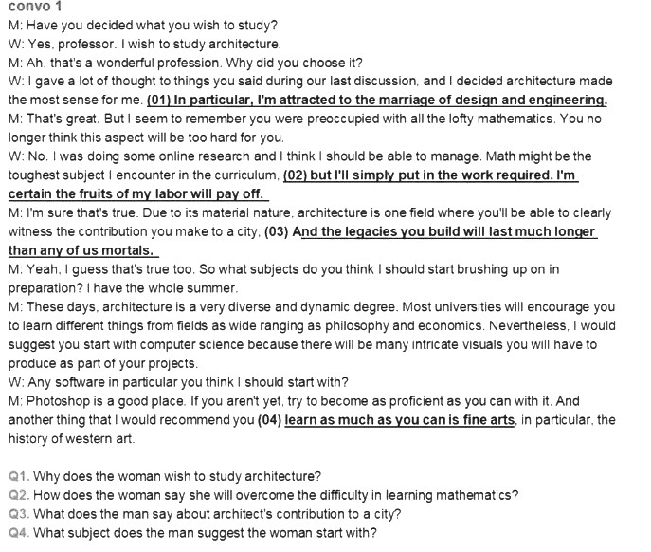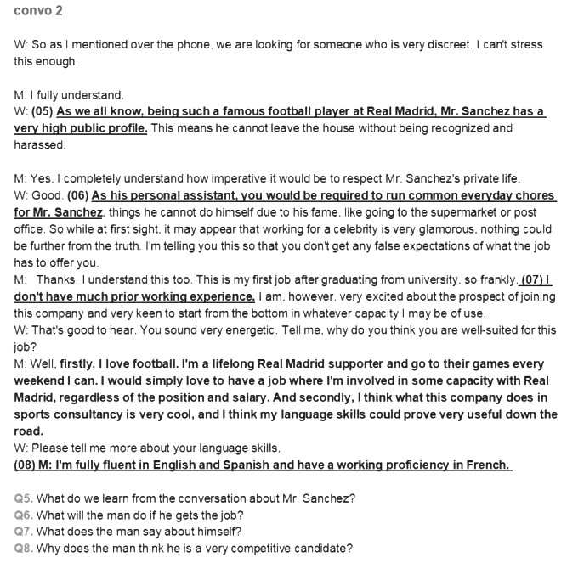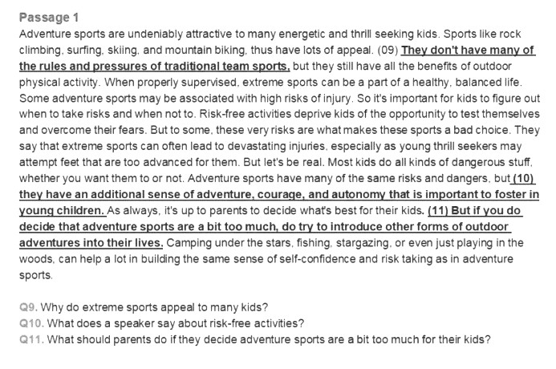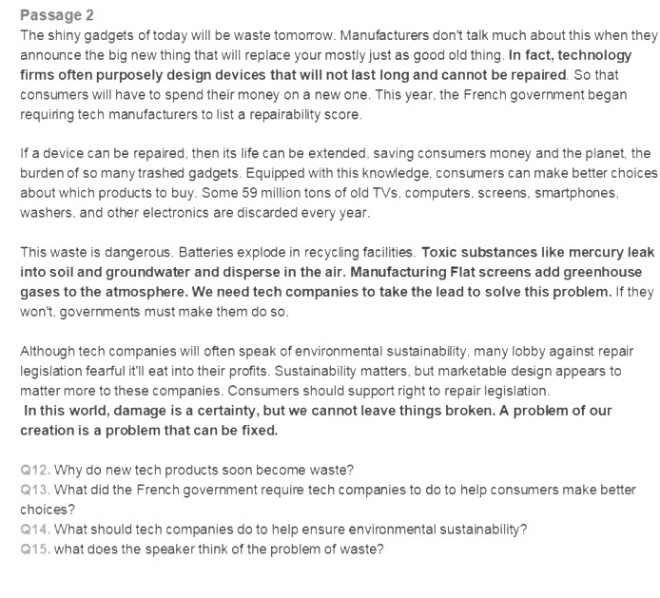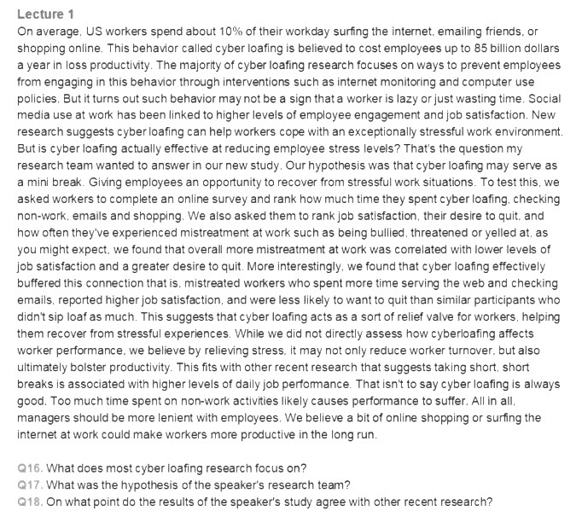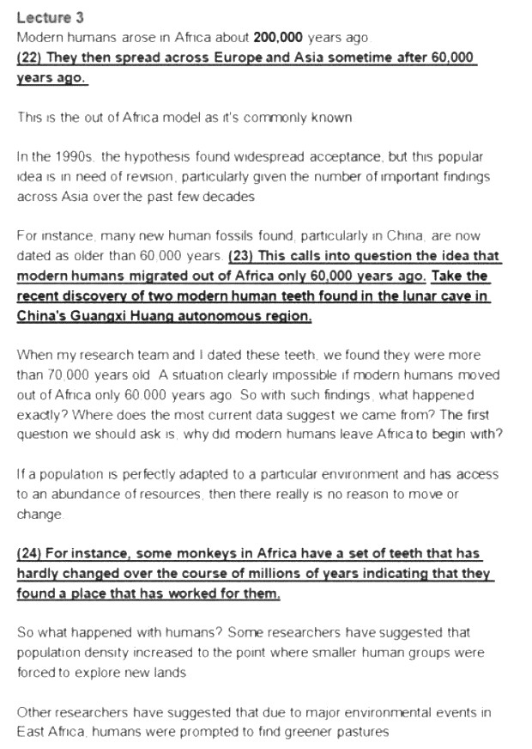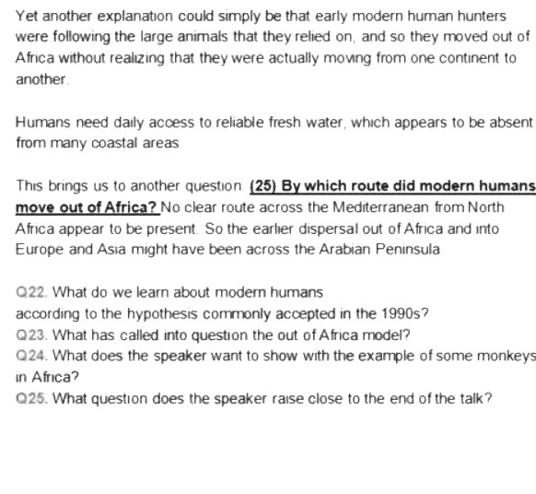
参考答案：
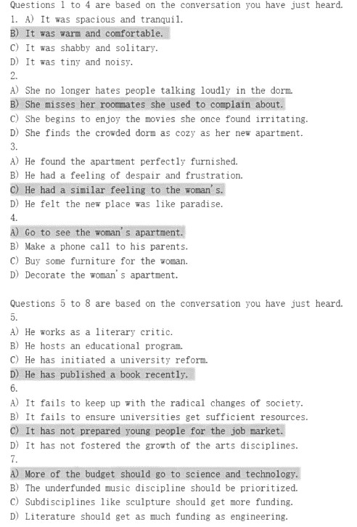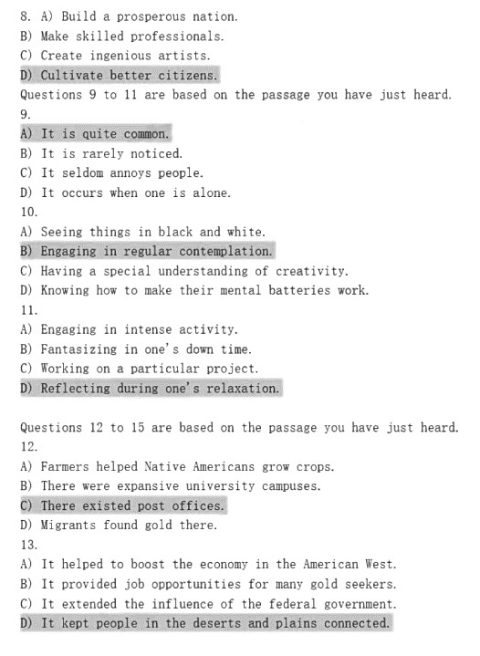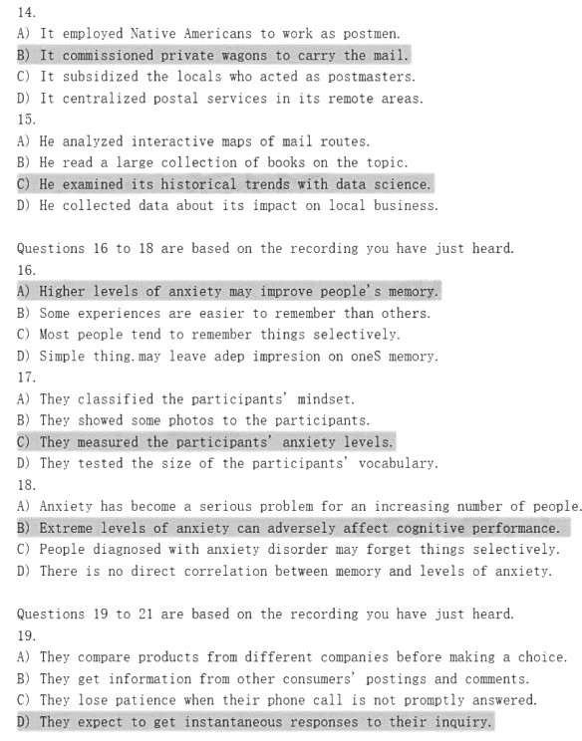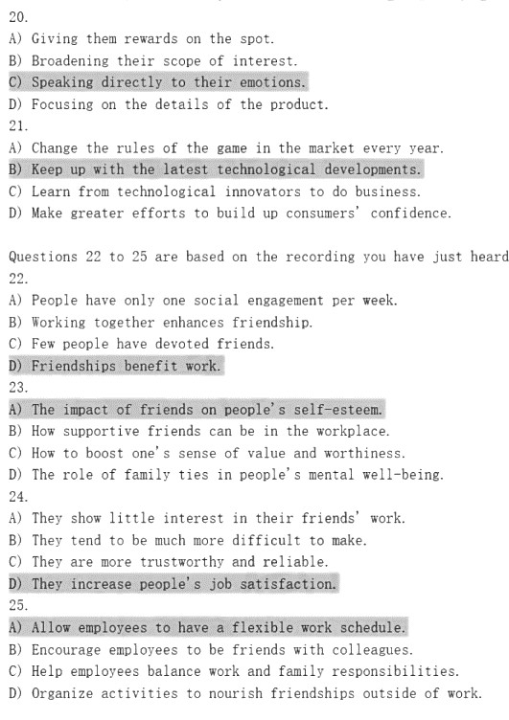
作文：
心理健康
Mental well-being is regarded as a state of health where a person is able to address normal stresses in daily life. Recently,this state has been grasped as much attention as physical health.
Obviously, there are several factors that affect people's mental well-being. Firstly, a strong contributor to mental well-being refers to the state of a person's usual environ-ment. Adverse environmental circumstances can lea negative effects on psychological wellness. Living in a positive social environment, in contrast, can provide protection against mental challenges. Secondly, people's lifestyle can also impact their mental health. Smoking, a poor diet, alcohol con-sumption, substance use, and risky sexual behavior may result in psychological harm. Smoking, a poor diet, alcohol consump-tion, substance use, and risky sexual behavior may result in psychological harm. Worse, such behaviors have been linked to depression.
In conclusion, because mental health is so important to general wellness, it's important that you take care of your mental health. Talking therapy, meditation and maintaining a positive outlook on life all contribute to people mental health. With a positive mental state, all areas of life will go towards active de-velopment.

友好的讨论
When faced with differing opinions, we should try to reach agreement through friendly discussion and reasonable argu-ment. In our daily life, it is common to see college students struggling with a polite and logical way when their views differ from others'. Apparently, this issue has sparked public con-cerns.
Friendly discussion allows individuals to share their perspec-tives and opinions in a respectful manner. This can lead to a better understanding of each other's viewpoints and poten-tially even finding common ground. In addition, reasonable ar-gument allows individuals to present evidence and logic to sup-port their position, which can help persuade others to see their point of view. However, it is important to note that not all disagreements can be resolved through discussion and argu-ment alone. In some cases, compromise may be necessary to reach a resolution that satisfies all parties involved.
To sum up, friendly discussion and reasonable argument, to a large extent, are of great use. We should be open-minded and engaged in such practices.

教育的目标
Education has played an increasingly crucial role in modern so-ciety. We aim education on different levels at cultivating the to-be successors of our global village. One important goal that education is trying to achieve is help students master the ways to acquire knowledge.
Of all the capabilities one can develop to acquire knowledge in being educated, three sorts are of the greatest significance.First of all, students who are receiving education definitely know that they are always ignorant of some branches in th eocean of knowledge, which can keep them modest and more willing to explore their unfamiliar realms, even deeper if they've already done so. Moreover, students can imitate what their teachers or professors do in or our of class and then gradually acquire the ability to undertake more scientific re-search and intellectual inquiries alone. Last but not least,youngsters who are accustomed to being educated at school or college are more likely to keep studying as a life-long habit,which will have a substantially positive effect on their own life and the future of the human world.
In my perspective, education is one of the most marvelous social inventions that ever existed in human history. Without it, the whole globe can never continue developing further in a civilized and prosperous direction.

星火英语版：
听力部分（共2套）

第一套

1.B) It was warm and comfortable.
2.B) She misses her roommates she used to complain about.
3.C) He had a similar feeling to the woman's.
4.A) Go to see the woman's apartment.
5.D) He has published a book recently.
6.C) It has not prepared young people for the job market.
7.A) More of the budget should go to science and technology.
8.D) Cultivate better citizens.
9. A) It is quite common.
10. B) Engaging in regular contemplation.
11. D) Reflecting during ones relaxation.
12. C) There existed post offices.
13. D) It kept people in the deserts and plains connected.
14. B) It commissioned private wagons to carry the mail.
15. C) He examined its historical trends with data science.
16. A) Higher levels of anxiety may improve people's memory.
17）C) They measured the participants' anxiety levels.
18.B) Extreme levels of anxiety can adversely affect cognitive performance.
19. D) They expect to get instantaneous responses to their inquiry.
20. C) Speaking directly to their emotions.
21. B) Keep up with the latest technological developments.
22. D) Friendships benefit work.
23. A) The impact of friends on people's self-esteem.
24. D) They increase people's job satisfaction.
25. A) Allow employees to have a flexible work schedule.

第二套

1. A) She is drawn to its integration of design and engineering.
2.D) Through hard work.
3.C) It is long-lasting.
4.A) Computer science.
5.B) He is well known to the public.
6.D) Serve as a personal assistant.
7.D) He has little previous work experience.
8.C) He has a high proficiency in several languages.
9.A) They have fewer rules and pressures.
10.D) They deprive kids of the opportunity to develop team spirit.
11 C) Let them participate in some less risky outdoor activities.
12. B) Tech firms intentionally design products to have short lifespans.
13. C) List a repairability score of their product.
14. D) Take the initintive to reduce electronic waste.
15. A) It can be solved.
16.B) How to prevent employees from cyberloafing.
17.C) Cyberloafing may relieve employees of stress.
18. A) Taking mini-breaks means better job perfontance.
19.D) There were no trees.
20.B) He founded a newspaper and used it to promote his ideas.
21.B) The state government declared it the official Arbor Day.
22.B）They moved ou of Africa about 60,000 years ago.
23.D) The discovery of two modern human teeth in China.
24.A) There must have been some reason for human migration.
25.D) What path modern humans took to migrate out of America.

翻译部分（共3套）

1.中国文化出口
近年来，越来越多的中国文化产品走向全球市场，日益受到海外消费者的青睐。随着中国对外文化贸易的快速发展，中国文化产品出口额已持续多年位居世界前列，形成了一批具有国际影响力的文化企业、产品和品牌。数据显示，中国的出版物、影视作品、网络文学与动漫作品等在海外的销售量连年攀升。中国政府出台了一系列政策鼓励和支持更多具有中国元素的优秀文化产品走出国门，扩大海外市场份额，进一步提升中国文化的世界影响力。

In recent years, more and more Chinese cultural products have been introduced into the global market and become increasingly favored by overseas consumers. With the rapid development of China's foreign cultural trade, the export volume of China's cultural products have ranked top in the world for many years, and a number of cultural enterprises, products and brands with international influence have been formed. Statistics show that overseas sales of Chinese publications, films, online literature and animation have been rising year after year. The Chinese government has introduced a series of policies to encourage and support more excellent cultural products with Chinese elements to go abroad, expand overseas market share, and further enhance the influence of Chinese culture in the world.

2.中国基础建设

随着中国经济的快速发展和人们牛活水平的稳步提高，城市居民对环境和牛活品质的要求越来越高。中国地方政府更加注重公共设施的建设和改进，以更好地满足人们的需求。通过兴建新的广场、公园和公共绿地或对原有公共场地重新加以规划改造，许多城市为市民提供了更多休闲和社交的场所。如今，政府出资购置的健身器械和铺设的健身步道在不少城市随处可见，既明显改善了市民户外活动的条件，又使城市更加美丽。

With the rapid development of China's economy and the steady improvement of people's living standards, urban residents are demanding more and more from their environment and quality of life. Local governments in China are paying more attention to the construction and improvement of public facilities to better meet people's needs. By building new squares, parks, and public green spaces, or redesigning existing public spaces, many cities are providing more places for citizens to relax and socialize. Today, government-funded fitness equipment and paved fitness trails can be found everywhere in many cities, significantly improving the conditions for outdoor activities and making cities more beautiful.

3.中国城市发展

近年来，中国城市加快发展，城市人居环境得到显著改善。许多城市努力探索中国特色的城市高质量发展之路，城市功能不断完善，治理水平明显提高。中国持续开展城市生态修复和功能修补，全面实施城镇老旧小区改造，大力推进城市园林绿化，消除污染，同时大力推进城市基础设施体系化建设，开展房屋建筑和市政设施普查以及安全隐患排查整治，努力为市民创造高品质的生活环境，让城市更美丽、更安全、更宜居。

In recent years, China's urban development has accelerated, and the urban living environment has been significantly improved. Many cities have made great efforts to explore the road of high-quality urban development with Chinese characteristics, and their urban functions have been continuously improved and the level of governance has been significantly improved. China continues to carry out ecological restoration and functional repair in cities, comprehensively renovating old urban communities, vigorously promoting urban landscaping and eliminating pollution, and vigorously promoting the systematic construction of urban infrastructure, carrying out surveys of housing construction and municipal facilities, as well as the investigation and rectification of potential safety hazards, in an effort to create a high-quality living environment for citizens and make cities more beautiful, safer and livable.

写作部分（共3套）

1.关于心理健康

Today there is a growing awareness that mental well-being needs to be given as much attention as physical health. More and more people are suffering from various psychological problems, which have led to many serious consequences and even caused many tragedies. Therefore, we should pay more attention to our mental health.
To begin with, we should make mental health a priority. Mental health affects our overall health and quality of life, so we cannot value it too much. Otherwise we will have serious problems with our physical and mental state. Secondly, when we have mental health problems, we can turn to teachers, relatives and friends around us for help. If necessary, you can also seek psychological counseling from a psychologist. Last but not least, regular exercise or reading an interesting book or listening to a song are recommended ways to relieve our psychological problems, for these ways can make us calm down.
In conclusion, we should realize that mental health is an important part of our happiness and should be given enough attention. As long as we deal with mental problems with the right attitude and method, then mental problems will not be a problem.

2.当面对不同意见时，我们应该友好讨论

When faced with different opinions, we should try to reach agreement through friendly discussion and reasonable argument. In today's society, where different people have different ways of thinking, differences of opinion can easily lead to conflicts and disputes.However, rather than resorting to hostility and aggression, it is important to approach these situations with an open mind and friendly debates.
For example, in a group project, each member may have his or her own ideas about how to accomplish the task. What we should do is to have a full discussion so that each member can express his or her ideas instead of dismissing each other. Through this process, the group can reach an agreement that takes into account everyone's point of view, resulting in a better outcome. The same principles apply to larger social issues, such as political or social debates. People should engage in productive discussions and avoid using derogatory language or attacking others.
In short, when we encounter differing opinions, it is vital to approach them with an open mind and engage in a friendly discussion with reasonable arguments. In this way, we can reach consensus, which can lead to greater understanding and better results.

3.学会如何学习

It is widely accepted that an important goal of education is to help students learn how to learn. It’s undoubted that learning methods are of considerable significance for one’s success in learning. With the advancement of the society, there is an increasing necessity to have a good command of learning methods.
As far as I'm concerned, there are several methods contributing to improving learning efficiency. First and foremost, making a plan according to your own conditions and arranging your time reasonably. Hence you are able to focus on the important matters everyday rather than wasting time on dealing with trifles. What’s more, fostering the habit of taking notes. In daily life, you should keep a record of what you heard, thought and studied and sort them out in time. As the saying goes, when three are walking together, I am sure to find teachers among them. It is also beneficial to learn from your classmates so that you are able to make up for your weaknesses and enhance your strengths.
In brief, taking into account all of these factors, we may reach the conclusion that learning how to learn is indispensable for us in modern society.

阅读部分（共3套）

第一套
词汇理解
（1）文章开头
开头：Scientists recently examined studies on dog intelligence and compared them with...
（2）答案
【答案速查】26-30 NKOMA 31-35 HDECI
26. N) surpass
27. K) previously
28. O) volume
29. M) prove
30. A) affirmed
31. H) outperformed
32. D) differentiate
33. E) distinct
34. C) completely
35. I) overstated
长篇阅读
（1）文章标题
标题：The lifesaving power of gratitude
（2）答案
【答案速查】36-40 CGAIF 41-45 KDMBH
（3）题干、答案和定位处
36. It does us far more good to focus on things we can be grateful for than what makes us sad and resentful.
36. C【定位】it is far more helpful to focus on the things in life for which we can express gratitude than those that incline us toward resentment and lamentation.
37. The beneficial impacts of gratitude can extend from individuals to their community and to the wider society.
37. G【定位】Broadly speaking, a community in which people feel grateful to one another is likely to be a more pleasant place to live than one characterized by mutual suspicion and resentment. The beneficial effects of gratitude may extend even further. For example, when many people feel good about what someone else has done for them, they experience a sense of being lifted up, with a corresponding enhancement of their regard for humanity.
38. The participants in a recent study repeatedly underestimated the positive effect on those who received thank-you notes.
38. A【定位】Gratitude may be more beneficial than we commonly suppose. One recent study asked participants to write a note of thanks to someone and then estimate how surprised and happy the recipient would feel —— an impact that they consistently underestimated.
39. Good deeds can sometimes make people feel uncomfortable.
39. I【定位】Of course, acts of kindness can also foster discomfort
40. People who regularly express gratitude can benefit in moral terms.
40.F【定位】 And the benefits are not only psychological and physical. They may also be moral.
41. A basketball coach advocated performing generous acts without expecting anything in return.
K 【定位】the great basketball coach John Wooden once offered two counsels to his players and students. First, he said, "it is impossible to...with an expectation of reward.
42. More and more evidence shows it makes us mentally and physically healthier to routinely count our blessings.
D【定位】there is mounting evidence that counting our blessings is one of the best habits we can develop to promote mental and physical health.
43. Of all states of mind, feeling grateful is considered one of the most healthy and beneficial
M【定位】Gratitude is one of the healthiest and most nourishing of all states of mind,
44. The principles underlying the research into gratitude are nothing new at all.
B【定位】 While this research into gratitude is relatively new, the principles involved are anything but.
45. Gratitude is likely to enhance one's sense of being connected with other people.
H【定位】Gratitude also tends to strengthen a sense of connection with others.

仔细阅读

（1）文章开头
Technology is never a neutral tool for achieving human ends.
（2）答案
【答案速查】 46-50 DAACB
（3）题干、答案选项内容及定位：
46. What do we learn about the deeper implications of AI?
D) It is reshaping humanity.
47.What is the consequence of algorithmic prescription replacing human judgment?
A) People lose the chance to cultivate the ability to make practical judgments.
48. What may result from increasing application of recommendation engines in our consumption of culture?
A) Consumers will have much limited choice.
49. What is likely to happen to larger parts of our daily life as machine learning algorithms improve?
C) They can be completely anticipated.
50. Why does the author say the creatures living in the more and more AI-mediated world will become increasingly unlike us?
B) They will no longer possess the human charactcristic of being unpredictable.
（2）文章开头：Phonics, which involves sounding out words syllable by syllable,
【答案速查】：51-55 ABBCD
51.What do we learn about phonics in many American classrooms?
A)It is ill reputed.
52. What has America been witnessing for decades?
B)An enduring debate over the approach to teaching children to read.
53. Why does Tenette Smith think a combination of teaching methods is ineffective?
B) Phonics has to be systematically applied and clearly taught to achieve the desired effect.
54. What does the author say Mississippi’s success is attributed to?
C) Adopting scientifically grounded approaches to teaching reading.
55. What have advances in statistics and brain imaging proved ineffective?
D) The immersive approach.

第二套

词汇理解

文章开头：Imagine sitting down to a big dinner: a massive steak …
答案速查：26-30：H I J A K ; 31-35:M G N E B
26. H indulging
27. I innumerable
28. J mortality
29. A attributes
30. K odds
31. M regulatory
32. G inclined
33. N still
34. E diminishing
35. B comprised

长篇阅读

（1）文章标题
标题：The problem with being perfect
（2）答案
【答案速查】36-40 E A F C H 41-45 B I E K G
（3）题干、答案和定位处

36.Socially prescribed perfectionism is described as one's self-esteem depending on other people's opinion.
答案【E】Curran describes socially prescribed perfectionism as “My self-esteem is contingent on what other people think.”
37.Jessica Pryor has learned that some graduate students work such long hours in the lab that they have little time for entertainment or socializing.
答案【A】:When psychologist Jessica Pryor lived near an internationally renowned university, she once saw a student walking into a library holding a sleeping bag and a coffee maker. She has heard of graduate students spending 12 to 18 hours at a time in the lab. Their schedules are meant to be literally punishing: If they are scientists-in-training, they won't allow themselves to watch Netflix until their experiments start generating results. Relationships become estranged
38.The author believes perfectionism may sometimes be constructive.
答案【F】 Perfectionism can,of course, be a positive force.
39.It is found that perfectionism is getting more and more prevalent among college students.
答案【C】In a study of thousands of American, Canadian, and British college students published earlier this year, Thomas Curran of the University of Bath and Andrew Hill of York St. John University found that today's college students report higher levels of perfectionism than college students did during the 1990sor early 2000s.
40.Some experts suggest parents and educators should prepare students for failures.
答案【H】While educators and parents have successfully convinced students of the need to be high performing and diligent, the experts told me, they haven't adequately prepared them for the inevitability of failure. Instead of praises like“You're so smart, parents and educators should say things like “you really stuck with it,”Pryor says...
41.Some therapists warn that young adults tend to pursue perfection in their work.
答案【B】 Along with other therapists, Pryor, who is now with the Family Institute at Northwestern University, is trying to sound the alarm about a tendency among young adults and college students to strive for perfection in their work—sometimes at any cost.
42.Psychologist Amy Bach encourages her students to aim high but be content with something less than perfect.
答案【I】She tells them, “Aim high, but get comfortable with good enough.”
43.A clinical psychologist finds perfectionism is widespread among his clients.
答案【E】Michael Brustein. a clinical psychologist in Manhattan says when he first began practicing in 2007, he was surprised by how prevalent perfectionism was among his clients,despite how little his graduate training had focused on the phenomenon.
44.In trying to overcome perfectionism, some people are still pursuing perfection.
答案【K】They try to be perfect, in other words, at no longer being perfect.
45.In pursuing perfection, some perfectionists fail to complete their tasks on time.
答案【G】 Some perfectionists are always pushing themselves forward. But others actually fall behind on work, unable to complete assignments unless they are, well, perfect.
仔细阅读
（1）文章开头
How on earth did we come to this? We protect our children obsessively from every harm:...
（2）答案
【答案速查】 46-50 ABAAD
（3）题干、答案选项内容：
46. Which group of people does the author say has almost unrestricted access to children?
A) Advertisers.
47. What kind of people should we enable children to become according to the author?
B) Those who value themselves because of their contribution to society.
48. Many child development experts and educators call attention to research that suggests _______.
A) life-long consumerism is causing more and more cases of psychological problems
49. What does the author imply about the impact of advertising?
A) It is actually infectious to many rather than a few.
50. What is the opponents' argument against a complete ban on advertising to young children?
D) It would violate the rights endowed upon advertisers.
（2）开头：Many oppose workplace surveillance，because of the inherent dehumanizing...
答案速查：51-55 ADBDC
51. Why are many people opposed to monitoring employee performance?
A) It puts workers under constant pressure.
52.What is the supporters' argument for workplace surveillance?
D)It can protect employees against aggressive behavior.
53. What does the author want to show by the example of different numbers of people interacting at lunch tables?
B) Analyzing data gathered from workers can yield something unexpected.
54. What does much of the positive effect of monitoring initiatives depend on?
D)How well bosses make known their purpose of monitoring
55.What concern do monitoring initiatives cause among many staffers?
C) They may infringe upon staffers’ entitled freedom.
第三套:
词汇理解
（1）文章开头
开头：You might not know yourself as well as you think.
（2）答案
【答案速查】26-30 LIAKD 31-35 GCEHF
26. L) relatively
27. I) probes
28. A)activated
29. K)recall
30. D) consecutive
31. G)discrepancy
32. C)assessment
33. E)cues
34. H)probably
35. F)deny
长篇阅读
（1）文章标题
标题：Why we need tiny college
（2）答案
【答案速查】36-40 GDJHB 41-45 ICLEN
（3）题干、答案和定位处
36. 【G】One tiny American college situated on a cattle farm is devoted to educating students to serve mankind throughout their lives.
37. 【D】 Much to the author's disappointment, the three institutions of higher learning where she taught largely ignore students’ growth as social beings.
38.【J】 Tiny colleges must be made affordable in order to play a role in higher education.
39. 【H】 According to a recent graduate from a tiny college, living together with faculty and fellow students is conducive to a student's growth as a person.
40. 【B】Rather than going small, most American universities are trying to go big.
41.【I】 In a certain tiny college, rigorous academic work and traditional manual labor are integrated.
42.【C】 Tiny colleges focus on educating students to become well-rounded citizens instead of seeking their own expansion.
43. 【L】The essence of education lies in the interaction between people.
44. 【E】After her retirement, the author has decided to set up a tiny college in her hometown.
45. 【N】Tiny colleges are justified as it is believed that our growth into full humanity comes through interaction with people near and dear to us.
仔细阅读
（1）开头：if you’re someone who has turned to …
答案速查：46-50 ADBCD
46 A) They are all addictive.
47 D) Memory
48 B) They attempt to use consumers' long-term memories to promote addiction.
49 C) Focusing on how quickly the work is done.
50 D)They are hooked on manufacturing convenience foods.
（2）开头：Chimpanzees, human beings’ closet animal relatives, share up to 98% of our genes…
答案速查 51~55 CDABB
51. C) They possess the most outstanding ability to think.
52. D) They meet challenges by imitating others carefully.
53. A) Children irrationally imitated every action of the experimenters.
54. B) It stems from the way people learn complex technologies.
55. B) It is characteristic of human beings to copy others.

