诚信应考,考试作弊将带来严重后果！
_____________ ________
…

姓名 学号
学院 专业 座位号
( 密 封 线 内 不 答 题 )
……………………………………………………密………………………………………………封………………………………………线……………………………………线………………………………………

华南理工大学期末考试
《软件需求分析、设计与建模》试卷A
注意事项：1. 考前请将密封线内各项信息填写清楚；
2. 所有答案请直接答于答题纸上；
3．考试形式：闭卷；
4. 本试卷共四大题，满分100分，考试时间120分钟。
题 号 | 一 | 二 | 三 | 四 | 五 | 总分
得 分
评卷人

一、单项选择题（本大题共15题，每题2分，共30分）
注：所有的选项中，只有一个答案最符合题目要求，多选、错选均不得分,请将所选的答案依照题号对应填入下表。

1. | 2. | 3. | 4. | 5. | 6. | 7. | 8.
9. | 10. | 11. | 12. | 13． | 14. | 15.

1. Which kind of diagram in UML can be applied to describe external system events that are recognized and handled by system operators in the context of a use case ?
A. Statechart Diagram.
B. Activity Diagram.
C. Sequence Diagram.
D.Collaboration Diagram.

2. Why do we model?
A. Helps to visualize a system.
B. Gives us a template for constructing a system.
C. Documents our decisions.
D. All of the above.
(Helps us to visualize a system as we want it to be.
Permits us to specify the structure or behavior of a system.
Gives us a template that guides us in constructing a system.
Documents the decisions we have made.)

3. What phrase best represents a composition relationship?
A. Is a part of. B. Is a kind of.
C. Is an only part of. D. Is an inheritance of.

4. Which of the following is good practice to use while designing for reuse?
A. Define a persistence framework that provides services for persisting objects.
B. Use design patterns, wherein complete solutions are already defined.
C. Use controller objects to control the flow of processes in the system.
D. Assign responsibilities to classes such that coupling between them remains high.
E. A and B.
F. A, B and C.
G. A, B,C and D.

5. Which of the following statement is Not TRUE?
A. A subsystem is a package that has separate specification and realization parts.
B. A subsystem is a discrete entity that has behavior and interfaces.
C. A subsystem can be identified by the stereotype <<subsystem>>.
D. A subsystem is a package that has specification part only.

6. In an OO system, it is NOT desirable to assign responsibilities:
A. relatively evenly across the classes.
B. more heavily in a few controlling classes.
C. according to interaction diagram messaging.
D. according to the use case diagram.
E．A and B
F．B, C and D

7. For showing how several objects collaborate in single use case, which one of the following OOAD artifacts is the MOST useful?
A. Interaction Diagrams B. Activity Diagrams
C. State Diagrams D. Class Diagrams

8. What methods MUST be implemented by the CreditProcessor class in the payment sequence diagram?
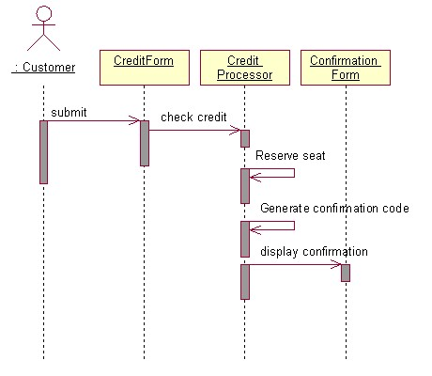
A. checkCredit, generateConfirmationCode, displayCofirmation.
B. checkCredit, generateConfirmationCode.
C. checkCredit, generateConfirmationCode, reserveSeat.
D. checkCredit, reserveSeat, displayCofirmation.

9. Which of the following is TRUE about a deployment diagram?
A. Since there is always some kind of response to a message, the dependencies are two-way between deployment components.
B. Dependencies between deployment components tend to be the same as the package dependencies.
C. Deployment diagrams are NOT to be used to show physical modules of code.
D. Deployment diagrams do NOT show physical distribution of a system across computers.

10. When using OOAD artifacts to organize and assign team responsibilities on a project, it is BEST to:
A. evenly distribute use cases among team members and have them work as independently as possible in order to minimize code dependencies.
B. designate one team for implementing interaction diagrams related to the "common code path" and another team for implementing interaction diagrams related to "code path variations" (for example , conditional or error paths).
C. divide teams according to the layers in the software architecture and have them work as independently as possible in order to mini mize dependencies between the layers.
D. divide teams according to package diagram dependencies and utilize use cases to schedule the work for the individual team members.

11. To MOST effectively manage teams working on different packages within a large project, which one of the following should be TRUE?
A. One technical leader should control the project details and communicate decisions to the different teams.
B. The team leaders should focus on which type of database ( DB2 UDB, Oracle, Sybase, or Instant DB ) is used.
C. The team leaders should focus on quality designs for the internals of their packages, mentoring their team members.
D. Communications between the teams should be minimized to reduce overhead burdens while they work on separate, independent use cases for their packages.

12. Use cases CANNOT be used for :
A. modeling the non behavioral aspects such as data requirements, performance and security.
B. capturing behavioral aspect of a system.
C. capturing functional aspect of a system.
D. capturing the business process at high level.

13. What kind of association between the 2 classes described in java below?
public class A{
private ArrayList _Bs=new ArrayList();
public A(_Bs：B){
this._Bs.add(_Bs);
}
}
public class B{
…;
}
A．Inheritance B. Dependency（
C．Composition D. Aggregation

14. Referring to the diagram below, which of the following is TRUE?
A．Class "Teacher" is a parent class of class "Professor" and class "Lecturer" .
B．Instance of "Professor" has to realized all of the behavior s of "Teacher".
C．There are instances of "Teacher" in the system.
D．"Professor" is a kind of "Teacher" and so does the "Lecturer".

组合composition：contains a 聚合aggregation ：has a
继承inheritance：is a 或者is a kind of
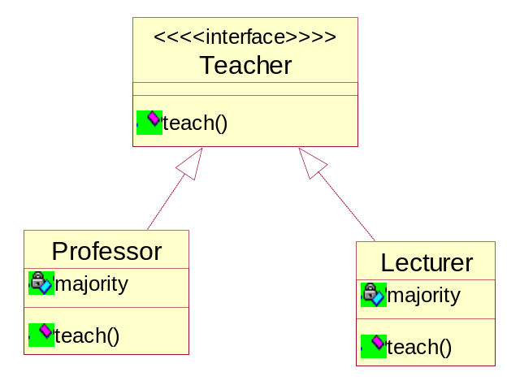

15. During the process of requirement engineering, the software engineer and the user of the system should work together to define
A. visible context of using the system for the user
B． crucial software properties
C． input and output of the system
D. A and B
E. A, B and C

二、填空题 （共10分）
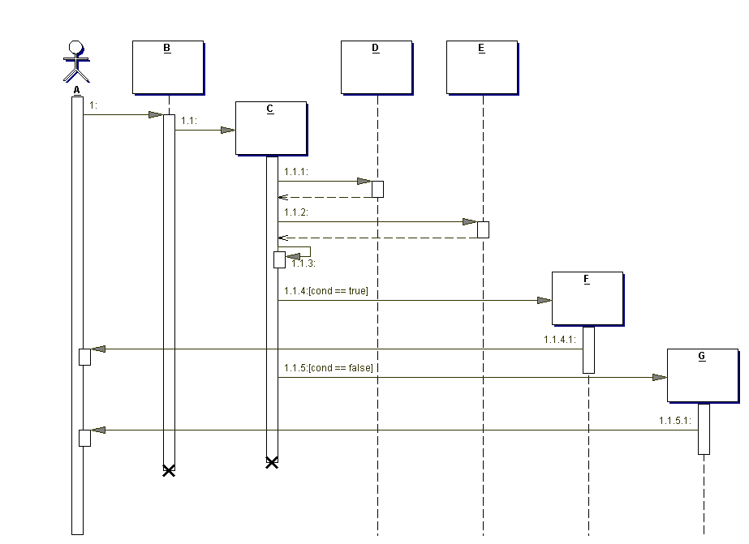
1. A is a(n) actor.
2. B is a(n) boundary classobject.
3. “1.1.3” is a(n)发给‘自身’local invocation__p117_ message
4. “1.1” is a(n) create object message.
5. The dotted line below the boxes is called the _lifeline__.
6. The rectangle below the boxes is called the 控制焦点的执行规格条p166
7. If this system represented part of a web site, what would B most likely represent?
界面类

8. Why is C lower than A, B, D, and E?
P168 “调用操作符new 并调用其构造器”

9. Why are A through G underlined?
区分对象名和类名

10. Which of the following is an invalid (无效的)sequence of messages, according to the diagram? ( B )
- 1, 1.1, 1.1.1, 1.1.2, 1.1.3, 1.1.4, 1.1.4.1
- 1, 1.1, 1.1.1, 1.1.2, 1.1.3, 1.1.4, 1.1.4.1, 1.1.5, 1.1.5.1
- 1, 1.1, 1.1.1, 1.1.2, 1.1.3, 1.1.5, 1.1.5.1

三、问答题 （本大题共4小题，共25分）
1. Please describe the risks of the software developing and the approaches to avoiding them (Score 8).
(1)Some Risk Types:
Technical/Architectural risks
Unproven technology, uncertain scope
Resource risks
People, skills, funding
Business risks
Competition, ROI, supplier interfaces
Schedule risks
Project dependencies
Only 24 hours in a day
(2) approaches to avoiding them
Develop Iteratively
Manage Requirements
Use Component Architectures
Model Visually (UML)
Continuously Verify Quality
Manage Change

2.Please outline the phases and workflows of RUP (Score 5) .
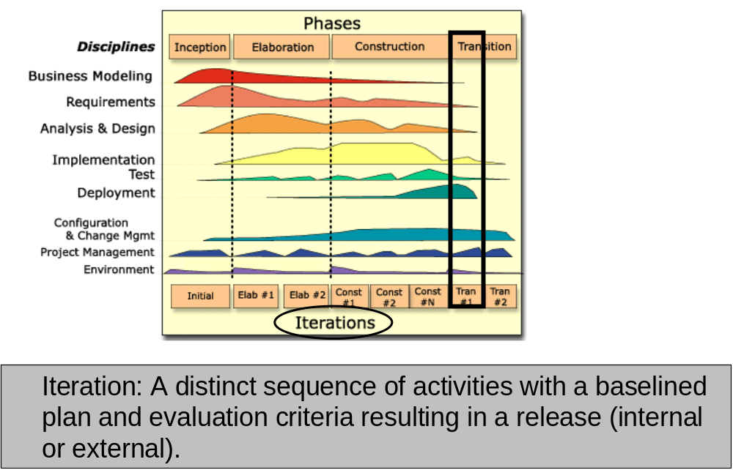

4 phases and 9workflows.

3. Please name and briefly describe the “4+1 view” of software architecture adopted in RUP (Score 5).
Use-case view+Logical view+Implementation view+Process view+Deployment view】
用例视图，逻辑视图，实现视图，过程视图+部署视图

4. Please describe the use case analysis steps in OOA/D (Score 7).
Ans:
- Supplement the Use-Case Description
- For each Use-Case Realization
  - Find Classes from Use-Case Behavior
  - Distribute Use-Case Behavior to Classes
- For each resulting analysis class
  - Describe Responsibilities
  - Describe Attributes and Associations
  - Qualify Analysis Mechanisms
- Unify Analysis Classes
- Checkpoints

这是设计的
. Describe interaction between design objects
Simplify sequence diagrams using subsystems
Describe persistence related behavior
Refine the flow of events description
Unify classes and subsystems

四、判断改错题（本大题共5分）
Suppose the employee of a software company can be classified by some role such as coder、project manager and software engineer. The UML diagram below is suggested as a solution to meet the change of the role of a company employee. Please judge whether the solution is true or not and explain why you make such a judgment. Please give your correction of the diagram when it is wrong (Score 5).

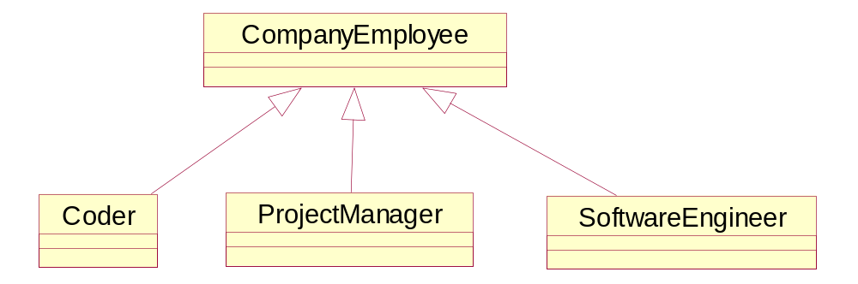

五、建模分析题（本大题共30分）
Suppose you are asked for developing a point of sale (POS) system using OOA/D technologies. A POS system is a computerized application used to record sales and handle payments and it is typically used in a retail store. Processing sale would be one of the key functions that the system has to perform. Please model the key function via the methodology of object-oriented analyze and design.
Suppose the simplified context of processing sale is under-consideration: a customer arrives at a checkout of a retail store with items to purchase. The cashier uses register of the POS system to record each purchased item. Each of the items is described a product specification, which belongs to a product catalogue. The system presents a running total and line-item details. The customer enters payment information, which the system validates and records. The system updates inventory (inventory: The quantity of goods in stock. ). The customer receives a receipt from the system and then leaves with the items and the sale is logged on a ledger with which the manager can checked the information for a period of time.

- Draw a UML use case diagram for the system including their relationships (Score 5).

- Give the class diagram with the analysis classes representing business entities involved in the system (names and brief descriptions only – no attributes or operations), along with their relationships and multiplicities (Score 10).

- Give the boundary classes、control classes and entity classes involved in the system to bear responsibility of “process sale” in the case of J2EE (names and brief descriptions with UML class stereotypes only – no attributes or operations) (Score 5).

- Draw a UML sequence diagram to model the use case of “process sale” in the case of J2EE (Score 10).

