1. What are the four principles of OO?
A.Abstraction, encapsulation, polymorphism, modularity
B.Abstraction, polymorphism, modularity, hierarchy
C.Encapsulation, polymorphism, hierarchy, modularity
D.Abstraction, encapsulation, modularity, hierarchy

2.Which of the following are effective ways to manage an OO project?(Multiple Choices)
A.Organize the scheduled tasks along the lines of the use cases.
B.Organize the test cases along the lines of the use cases.
C.Organize the user's guide along the lines of the use cases.
D.Organize development teams along the lines of the packages.

3.When designing the user interface for an application, if it is unclear what skill level the end user of an application will possess, which of the following is the BEST approach to take?
A.Define the level of skill that will be required by the end user and make the necessary
B. arrangements for educating the users.
C.Define the level of skill that will be required by the end user and provide detailed on-line help that can be accessed by the users when needed.
D.Prototype portions of the user interface and perform some usability tests to identify any problem areas. Document any issues in the product readme and have the users read it before using the product.

4.Prototype portions of the user interface and perform some usability tests to determine the users level of satisfaction. Make any necessary changes and repeat the process.
Stereotypes represent
A.generalization relationships
B.design patterns
C.the metaclassification of UML elements
D.none of the above
Stereotypes can be applied to which UML elements?
A.classes
B.packages
C.associations
D.all of the above

5.Jacobson originally introduced Actors using the following symbol: 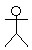
Which of the following are legal UML representations?b
- 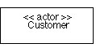
- 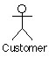
- 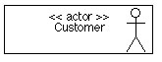
- all of the above

6.Which pairs of symbols both mean class b is a part-of class a (has by value)?
A. 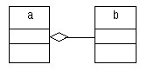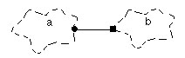
B. 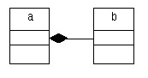
C. 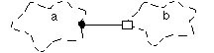
D.

7. Jacobson originally called these diagrams Object Interaction Diagrams. The notation has changed slightly in UML (see the answer key for details). What is the current UML term for these diagrams?
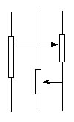
- trace diagram
- event trace diagram
- sequence diagram
- none of the above

8. In the Booch 93 notation, abstract classes were shown using this symbol:
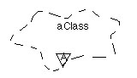
What is the new UML notation for an abstract class?
- 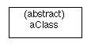
- 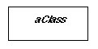
- 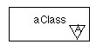
- 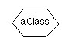

10. How many of the following are UML diagram names ?
A. collaboration diagram
B. component diagram
C. deployment diagram
D. all of the above

11. Scheduling project activities such as functional increments and test case development, which one of the following OOAD artifacts is the MOST useful?
A. Use cases
B. Interaction diagrams
C. Activity diagrams
D. Package diagrams
E. Class Diagrams

12. UML interfaces are used to: C
A. define an API for all classes.
B. program in Java, but not in C++ or Smalltalk.
C. define executable logic to reuse across classes.
D. specify required services for types of objects.

13. What is TRUE about Use Cases? (Pick 3)(Multiple Choices)ABD
A. Use cases provide the basis of communication between sponsors and developers in planning phase
B. Use cases description provides a good source to identify domain concepts
C. A fully-dressed use case should include both “whats” and “hows” so that they are ready for “realization”
D. A use case is an interaction between a user and a system.

14. UML is concerned with object-oriented analysis and design. (Pick 1) A
A. True
B. False

15. Refer to the attached diagram, the arrow indicates: (Pick 1) D
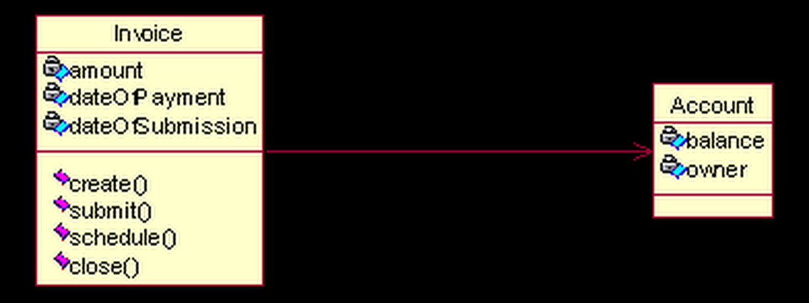
A. Refers to
B. Association
C. Dependency
D. Navigability

16. What are the strengths and weakness of Interaction Diagrams? (Pick 2) AC
A. when you want to look at the behavior of several objects within a single use case
B. they are good at precise definition of the behavior
C. they are good at showing collaborations among objects
D. they are good at exploring concurrency and multi-thread issues

17. Package diagrams are designed for: (Pick 3) ABD
A. organizing a large project into components
B. depicting the overall structure of a system
C.assisting testing
D.assisting deployment
E. reducing dependency

18. For showing scenarios, which one of the following OOAD artifacts is the MOST useful ? B
A. Sequence Diagrams
B. Activity Diagrams
C. Package Diagrams
D. State Diagrams
E. Class Diagrams
F. Collaboration Diagrams

19. For showing detailed design of procedures, which one of the following OOAD artifacts is the MOST useful ? E
A. Sequence Diagrams
B. Activity Diagrams
C. Package Diagrams
D. State Diagrams
E. Class Diagrams
F. Collaboration Diagrams

20. Which one of the following highlights the roles each object plays in an interaction model ? B
A. Sequence Diagrams
B. Collaboration Diagrams
C. All of the above
D. None of the above

21. For showing how several objects collaborate in single use case, which one of the following OOAD artifacts is the MOST userful ? A
A. Interaction Diagrams
B. Activity Diagrams
C. Package Diagrams
D. State Diagrams
E. Class Diagrams

22. Objects and classes can be found by using which of the following technique ? E
A. From nouns in a text description
B. Look for units of interaction
C. Look for places where things or objects come to rest
D. Interview Domain Experts.
E. All of the above
F. "a" and "c" only
G. "a" , "b" and "c" only

23. Which of the following statements are false ? (Pick two) C Dgq
A. If the Data Type of the feature is primitive (i.e.,provided by the language, like int or strinG., model as an Attribute.
B. If the Data Type of the feature is near primitive (i.e.,something like date or Money), model as an Attribute.
C. If the Data Type of the feature is near primitive (i.e.,something like date or Money), model as an Association.
D. If the Data Type of the feature is user defined (i.e., a Class, or a pointer or a reference to a Class), model as an Attribute.
E. If the Data Type of the feature is user defined (i.e., a Class, or a pointer or a reference to a Class), model as an Association with an external entity.

24. Refer to the diagram to answer the question.
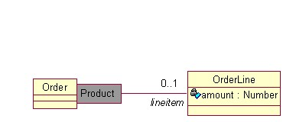
From the specification perspective, this qualified association would imply an interface alone the lines of : C
A. class Order {
public OrderLine getLineItems() ;
public void addLineItem(Number amount);
B. class Order {
public OrderLine getLineItems() ;
public void addLineItem(OrderLine lineItem);
C. class Order {
public OrderLine getLineItems(Product aProduct) ;
public void addLineItem(Number amount, Product aProduct);
D. class Order {
public Object getLineItems() ;
public void addLineItem(OrderLine lineItem);

25. Refer to the diagram to answer the question.
[MakePayment]
What methods MUST be implemented by the CreditProcessor class in the payment sequence diagram ? C
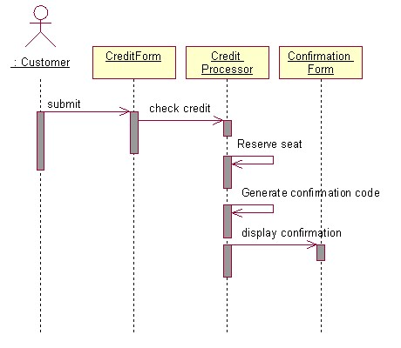
A. checkCredit, generateConfirmationCode, displayCofirmation
B. checkCredit, generateConfirmationCode
C. checkCredit, generateConfirmationCode, reserveSeat
D. checkCredit, reserveSeat, displayCofirmation
E. checkCredit, reserveSeat

26. Which of the following statements are true ? (Pick two) D B
A. Abstraction is when a client of a module does NOT need to know more than is in the interface.
B. Abstraction is when a client of a module does need to know more than is in the interface.
C. Encapsulation is when a client of a module is able to know more than is in the interface.
D. Encapsulation is when a client of a module is NOT able to know more than is in the interface.

27. Which of the following statement is true ? (Pick one).
The contents of a Package can be : D
A. a list of classes
B. another Package diagram
C. class diagram
D. All of the above
E. "b" and "c" only
F. "a" and "b" only

28. Use case : Purchase Ticket
Actors : Customer
Preconditions: The customer is logged onto the system. The customer profile already exists.
Postconditions: The ticket is sold and the seats are assigned to the customer and the system is updated.

Primary Flow :
1. The use case begins when the customer selects the option to view flight information.
2. The system prompts for the departure and destination cities and the departure and return dates.
3. The user enters the departure and destination city, departure date, and return date.
4. The system displays a list of available flights, including the fare.
5. The user selects the flight they would like to reserve.
6. The system displays all available fare options for that flight.
7. The user selects the fare option they would like to reserve.
8. The system displays the fare that the user will pay.
9. The user confirms the rate.
10. The system pormpts for a credit card type, number, name and expiration date.
11. The user enters the card type, number,name, and expiration date.
12. The system submits the credit purchase.
13. The system reserves a seat on the plane for the user.
14. The system generates and displays a confirmation code to the user.
15. The user confirms receipt of the code.
16. The use case ends.

Which of the following is the BEST list of candidate interaction diagrams to support the use case ?

A. select departure and destination cities and departure and return dates, select flight, enter credit information, seat is reserved, confirmation number is generated and the confirmation is displayed
B. select departure and destination cities and departure and return date. select flight, confirm the rate, enter credit information, seat is reserved
C. select flight, confirm the rate, enter credit information, seat is reserved, confirmation number is generated and the confirmation is displayed
D. select departure and destination cities and departure and return dates, select flight, confirm the rate, enter credit information, seat is reserved, confirmation number is generated and the confirmation is displayed

29. Refer the diagrams Account Figure A and Account Figure B to answer the question.
In order to accomplish what is shown in Account Figure B, Which design is the BEST solution ? A
A. Design : Account A1 Figure
B. Design : Account A2 Figure
C. There is nothing wrong with the design. No change is necessary.
D. This problem cannot be solved.
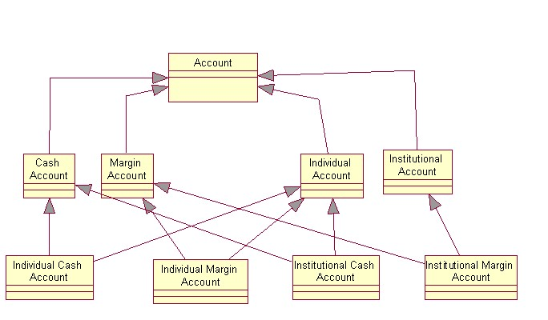

Account Figure B
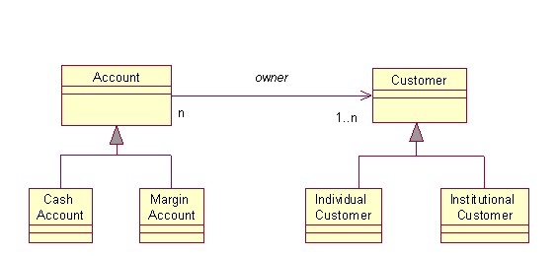
Account A1 Figure
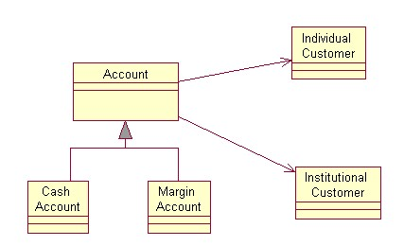
Account A2 Figure

30. Which model represents the following code generated by a Modeling tool ? (Single select) A
class Order {
private Customer recipient;
// ...
}
A. Design A
B. Design B
C. Design C
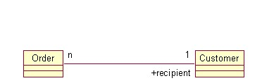Order Design A
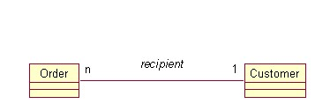Order Design B
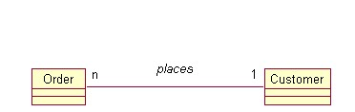Order Design C

31. Which of the following statement is true about the following sequence of activities ? (Single select)
1. Identify the use cases of system behavior.
2. Specify and refine each use case.
3. Define a scenario for each "interesting path" through the use case.
4. Draw an interaction diagram for each scenario.
5. Identify object models from object interactions in the interaction diagrams.
6. Define each state-based object's behavior with a state transition diagram using interaction diagrams for guidance. Typically, any events consumed or produced by the state transition diagram are mesages to and from that object in the interaction diagrams.
A. This describes the System Dynamics of Bottom-Up Design approach.
B. This describes the System Dynamics of Top-Down Design approach.

32. Which of the following statement is false ? (Pick one).
A. A subsystem is a package that has separate specification and realization parts.
B. A subsystem is a discrete entity that has behavior and interfaces.
C. A subsystem can be identified by the stereotype <<subsystem>>
D. A subsystem is a package that has specification part only.

33. Consider a system that manages the assignment of students and instructors to courses in a university. The CourseSchedule class has add(c:CoursE. and remove(c:CoursE. methods defined in it. What is the relationship between CourseSchedule and Course classes ?
A. Generalization relationship
B. Composition relationship
C. Inheritance relationship
D. Dependency relationship
E. Association relationship

34. A well designed Object Oriented System is : B(Single select)
A. Is loosely cohesive and loosely coupled.
B. Is tightly cohesive and loosely coupled.
C. Is tightly cohesive and tightly coupled.
D. Is loosely cohesive and tightly coupled.

35. Component diagrams can contain which of the following ? (Single select)
A. Interfaces
B. Dependency, generalization, association, and realization relationships
C. Components
D. Packages or Subsystems
E. Notes and constraints
F. All of the above
G. "a", "b" and "c" only.

36. Deployment diagrams are used : (Single select)
A. For modeling an embedded system
B. For modeling a client/server system
C. For modeling a fully distributed system
D. To do modest amount of forward and reverse engineering
E. All of the above
F. "a" , "b" and "c" only

37. Deployment diagrams can contain which of the following ? (Single select)
A. Nodes
B. Dependency, and association relationships
C. Components
D. Packages or Subsystems
E. Notes and constraints
F. All of the above
G. "a", "b" and "c" only.

38. Use cases CANNOT be used for : A(Single select)
A. modeling the nonbehavioral aspects such as data requirements, performance and security.
B. capturing behavioral aspect of a system.
C. capturing functional aspect of a system.

39. A well modularized design consists of objects that are: C
A strongly coupled
B uncohesive
C highly cohesive and loosely coupled
D polymorphic

40. The letters CRC stand for: C
A Common Recursive Classes
B Carefully Restricted Configuration
C Class Responsibility Collaboration
D Concurrent Re-entrant Communication

41. In Object-oriented Technology the word "UML" means A
A: Unified Module Language
B: Unified Modeling Language
C: Universal Module Leveling
D: Universal Module Language

42. Which of the following statements is true? C
A: Structured analysis was developed from Object-oriented Technology.
B: UML is a collaboration of the main stream Object-Oriented Methodologies.
C: Object-Oriented Technology is the culmination of High level Programming languages such as Java and C++.
D: Only object-oriented programming languages can be used to implement object-oriented designs.

43. What is true about Object-oriented Analysis?
A: It is a method of modeling requirements of the system
B: It is a technique for analyzing the design of the system
C: Code can be written directly from the Analysis
D: It comes after object-oriented design in the product life cycle.

44. Which of the following is true? E
A: An object is an instance of a class
B: A class is an abstract definition for a set of objects
C: An object can be in more than one class
D: An object has a life span.
E: All of the above

45. A class's structure is E
A: Represented in code
B: Represented by attributes and relationships
C: Represented by operations.
D: Represented by object interactions.
E: Answers A and B
F: Answers B and C

46. A class's behavior is
A: Determined by a set of operations
B: Determined by its attributes
C: Is unique for each object of the class
D: Determined by its parent class.
E: Answers A and B
F: Answers B and C

47. Which of the following statements are true about method visibility?
A: A class's methods are visible to all other objects of the same class independent of its visibility.
B: Other objects can access operations of a class if the visibility of the operation is public.
C: An object can access all of its methods regardless of the visibility of the operation's visibility.
D: A child class can access all of its parents operations regardless of visibility.
E: Answer A and B
F: Answer B and C
G: None of the above

48. Which of the following is false about cardinality mapping? D
A: "1" - exactly one and only one
B: "0..n" - any real number including zero
C: "0..1" - zero or one
D: "3..7" - 3 or 7
E: "3,7" - 3 or 7

49. Polymorphism is C
A: When an operation in a child class has the same name and operation signature as the parent class.
B: When an object changes the class that it belongs.
C: When an operation in the same class has the same name and a different signature.
D: When an attribute in a child class has the same, name and type, of the parent class.

50. Attributes of children classes in an inheritance relationship can have the same name as attributes in the parent class.
A: This is called attribute overriding.
B: This is called attribute polymorphism.
C: This statement is not a valid in Object-oriented technology.
D: This is called attribute redefinition.

51. What visibilities can attributes can have?
A: Public
B: Protected
C: Private
D: Implementation
E: All of the above
F: Answers 1 and 4
G: None of the above

52. A utility class refers to
A: A class that creates and destroys other classes
B: A class that has 1 as the cardinality
C: A group of common operations grouped together in a class
D: A class that controls the behavior of other classes.

53. What statement best describes an inheritance relationship?
A: "HAS A" relationship.
B: "IS A" relationship
C: "IMPLEMENTS" relationship
D: "USES" relationship
E: "IS A MEMBER" relationship

54. What statement best describes a dependency relationship?
A: "HAS A" relationship.
B: "IS A" relationship
C: "IMPLEMENTS" relationship
D: "USES" relationship
E: "IS PART OF" relationship

55. A car has four wheels. The class car and the class wheel have what type of relationship?
A: Association
B Aggregation
C: Inheritance
D: Realization
E: Dependency

56. When to use Interaction Diagrams?
When you want to look at the behavior of several objects within a single use case or several use cases
A. They are good at showing collaborations among objects; they are not so good at conditions and looping
B. They are good to look at behavior of a single object across many use cases.
C. All of the above
D. None of the ABOVE

57. What of the following is true about use case analysis?
A: The actors of the system determine the boundary of the system.
B: The set of all actors delimits the system.
C: Use Cases describe the responses of the system to stimuli from its actors.
D: Use Cases can send stimuli to actors of the system.
E: All of the above

58. Which statements are true for use case relationships
1) An Include relationship means that a UseCase includes the behavior described in another UseCase
2) an Extend relationship implies that a UseCase may extend the behavior described in another UseCase
3) Generalization between UseCases means that the child is a more specific form of the parent. The child inherits all Features and Associations of the parent, and may add new Features and Associations
A. All of the above
B. Only 1. and 2
C. Only 2. and 3.

59. Which statements are true for an Actor? (TWO CHOICES)
A. an actor is a role a user plays with respect to the system
B. generalization is not applicable to actors
C. an actor does not need to be human. A subsystem or external system can be modelled as an actor

60. Inheritance relationships can best be modeled using which construct?
A. association
B. aggregation
C. recursion
D. generalization

61. The term "interaction diagram" now means:
A. what used to be a Booch Object diagram
B. a Wirfs-Brock Class Collaboration Graph
C. collectively, sequence diagram and collaboration diagrams
D. none of the above

62. Which of the following is the BEST list of candidate classes for the Library System described below ? (Single select)
Libraries R Us Inc is developing code to handle checkout duties at a library. Library members may check out books and videos from the library. The system
must keep track of which books and videos each member currently has checked out.
Each book and video has a nunique item number that is used by the system to index that book or video. A clerk may check the status of a book or video (in the
library, checked out, checked out and overduE. by supplying the item number. A clerk may also check either on a book by supplying the thitile and author, or on
a video by supplying only the thitle.
Each library member has a library card that includes their membership number. When a member checks out a book or video, a clerk enters the membership
number and the item number of the book or video. If the borrower hsa fewer than ten borrowed books or videos (in total), and if the borrower has no overdue
books or videos, the book or video is loaned to the borrower. The conditions of the loan include a due date (two weeks for books and three days for
videotapes)

A. Library, Library Member, Book, Video, Clerk, Checkout Transaction
B. Library Card, Book, Video, Clerk
C. Borrower, Member, Book, Video, Title
D. Library, Library Member, Book, Video, System
E. Library, Library Member, Book, Video, Author

63. Which of the following is false about Use Case Analysis?
A: An Actor must be directly associated with at least one use case in the system.
B: A use case must be directly related to at least one actor of the system
C: A use case can be related to actors and other use cases.
D: Actors can be people, machines, or other systems.
E: All of the above are true

64. A software designer wants to show a scenario that has a time critical flow of control between multiple objects. What diagramming technique should they use?
A: Sequence Diagram
B: Collaboration Diagram
C: State Diagram
D: Class Diagram

65. A Sequence diagram contains
A: Objects
B: Messages
C: Object Visibility
D: Timing constraints
E: Focus of control
F: All of the above
G: All of the above except 3
H: All of the above except 5
I: All of the above except 1

66. Collaboration diagrams contain
A: Objects
B: Messages
C: Object Visibility
D: Timing constraints
E: Focus of control
F: All of the above
G: All of the above except 3
H: All of the above except 5
I: All of the above except 1

67. What is false about design patterns?
A: A design pattern can decrease time to market and increase quality.
B: A design pattern is a map from object-oriented design to specific language implementation.
C: A design pattern contains well-defined constructs for specific types of problems.
D: Design patterns can be applied to software problems, and organizational problems.

68. Which of the following statements is false?
A: An object can be in more than one state at a time
B: A state machine can have multiple termination states
C: A state can remember which sub state was the last state
D: A transition can fire conditionally.

69. What kinds of items are related in realization relationships?
A: An interface and its implementation class
B: A Parameterized class and an instantiated class
C: An operation and a class
D: An attribute and a class
E: A package and a class
F: All of the above
G: Answers 1 and 2
H: Answers 1 and 3
I: Answers 2 and 3

