诚信应考,考试作弊将带来严重后果！
_____________ ________
…

姓名 学号
学院 专业 座位号
( 密 封 线 内 不 答 题 )
……………………………………………………密………………………………………………封………………………………………线……………………………………线………………………………………

华南理工大学期末考试
《计算机组成与体系结构》试卷B
注意事项：1. 考前请将密封线内填写清楚；
2. 所有答案请直接答在试卷上；
3．考试形式：闭卷；
4. 本试卷共 三 大题，满分100分， 考试时间120分钟。
题 号 | 一 | 二 | 三 | 四 | 五 | 总分
得 分
评卷人

- 单选题（2 points each）
For each question in this section, choose 1 answer. Choose the best answer. Fill your choice in the following table.

- The part of machine instruction, which tells the central processor what was to be done is .
A. operation code B. address C. operand D. none of the above
- Which of the following is not the basic I/O method in a computer system? .
A. DMA approach B. interrupt-driven
C. event-driven D. program-controlled I/O
- In the following statements, which is true? .
- There is only one kind of hazard in a pipelined system. It is called control hazard which is due to branch instructions.
- When a miss occurs in a direct mapped cache, either a random or a LRU strategy is employed to select the block to be replaced.
- Operand forwarding can always eliminate stalls due to potential data hazards between any two data dependent instructions.
- In cache design, if write-back policy is used for writes, then we need a “dirty bit” associated with each cache entry.
- A CPU has an arithmetic unit that adds bytes and then sets its V, C, and Z flag bits as follows. The V-bit is set if arithmetic overflow occurs (in two’s complement arithmetic). The C-bit is set if a carry-out is generated from the most significant bit during an operation. The Z-bit is set if the result is zero. What are the values of the V, C, and Z flag bits after the 8-bit bytes 1100 1100 and 1000 1111 are added? .
A. V:0, C:0, Z:0 B. V:1, C:1, Z:0 C. V:1, C:1, Z:1 D. V:0, C:0, Z:1
- In carry-lookahead adder, the expression is called the propagate function P_{i} for stage i.
A. x_{i}+y_{i} B. x_{i}⊕y_{i} C. x_{i}y_{i} D. x_{i}⊕y_{i}⊕c_{i}
- In hardwired control unit, the required control signals are determined by the following information except .
A. contents of the control step counter B. contents of the instruction register
C. contents of the condition code flags D. contents of the program counter
- When I/O devices and the memory share the same address space, the arrangement is called .
A. memory-mapped I/O B. mixed I/O C. separated I/O D. relative I/O
- Suppose that a 2M x 16 main memory is built using 256K x 8 RAM chips and memory is word-addressable. How many RAM chips are necessary? .
A. 4 B. 8 C. 16 D. 32
- The parameters of a hierarchical memory system are specified as follows: Main memory size = 8K blocks, Cache memory size = 512 blocks, Block size = 16 words. Determine the size of the tag field under the following conditions: Set associative mapping with 16 blocks/set. .
A. 13 B. 8 C. 4 D. 7
- In the following, which is not the characteristic of CISC style? .
- More complex addressing modes
- Load/store architecture
- Many instructions that implement complex tasks
- Arithmetic and logic operations that can be performed on memory operands as well as operands in processor registers
- In microprogram-controlled machines, the relationship between the machine instruction and the microinstruction is .
- a machine instruction is executed by a microinstruction
- a microinstruciton is composed of several machine instructions
- a machine instruction is interpreted by a microroutine composed of microinstructions
- a microroutine is executed by a machine instruction
- The program counter is .
- a binary counter that keeps track of the number of instructions executed
- a register that stores the next instruction to be executed
- a register that stores the address of the next memory location to be written to
- a register that stores the memory address of the next instruction
- A page fault is .
- an attempt by the computer to run instructions stored on the hard disk
- the process the computer uses to start itself
- an error the computer makes when a device driver is missing
- an out of memory error
- In a CISC computer, the conditional branch instruction uses Relative addressing. If the machine is currently executing a conditional branch located at memory location 0x0100 and the offset specified by the branch is 0x0010, what address contains the next instruction to execute if the branch is taken? .
A. 0x0100 B. 0x0010 C. 0x0110 D. 0x0111
- _____ is any condition in which either the source or the destination operands of an instruction are not available at the time expected in the pipeline.
A. Control hazard B. Data hazard
C. Structural hazard D. Instruction hazard

II. 简答题 (5 points each)
For each question in this section, give your answer briefly.
- What are the advantages and disadvantages of hardwired and microprogrammed control?

Solution:

- The cache block size in many computers is in the range of 32 to 128 bytes. What would be the main advantages and disadvantages of making the size of cache blocks larger or smaller?

Solution:

- Using 32-bit IEEE 754 single precision floating point format, show the representation of -0.6875.

Solution:

- What is the difference between a subroutine and an interrupt-service routine?

Solution:

III. 综合题（10 points each）
- Assume that there are two types of static memory chips: 128K×16 bit (total 8 chips) and 1M×8 bit (total 2 chips). Please use these memory chips to implement a 1M×32 bit memory. Draw the figure of the memory organization.
Solution:

- Using sequential multiplication algorithm, perform the operation A×B on the 5-bit unsigned numbers A= 10011 and B= 01101. Write the computation processes in a computer machine.
Solution:

- Assume that a computer’s instruction length is 16-bit, and its operand address is 4-bit. Suppose the designers need 16 zero-address instructions, 31 one-address instructions, 14 two-address instructions and 15 three-address instructions. How should we design the instruction format?

Solution:

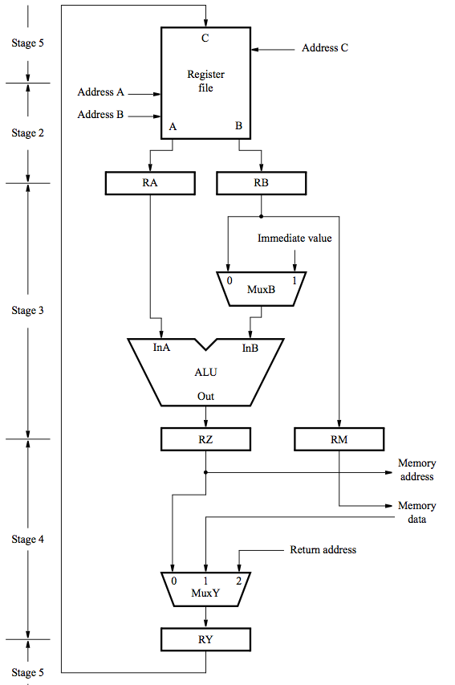
- Give the sequence of steps needed to fetch and execute the instruction
Store R6, X(R8)
on a 5-stage RISC processor. Assume 32-bit operands.

Solution:

- Consider the two-dimensional array A:
int A[][] = new int[100][100];
Where A[0][0] is at location 200, in a paged memory system with pages of size 200. A small process is in page 0 (locations 0 to 199) for manipulating the matrix; thus, every instruction fetch will be from page 0.
Suppose that the elements of the array are stored in row order in the virtual memory. For three page frames, how many page faults are generated by the following array-initialization loops, using LRU replacement, and assuming page frame 1 has the process in it, and the other two are initially empty?
  - for (int j = 0; j < 100; j++) (2) for (int i = 0; i < 100; i++)
for (int i = 0; i < 100; i++) for (int j = 0; j < 100; j++)
A[i][j] = 0; A[i][j] = 0;

Solution:

