2016年试卷结构：
I、填空（15空，30分）
II、判断（15题30分）
III、分析题（40分）
诚信应考,考试作弊将带来严重后果！
_____________ ________
…

姓名 学号
学院 专业 座位号
( 密 封 线 内 不 答 题 )
……………………………………………………密………………………………………………封………………………………………线……………………………………线………………………………………

华南理工大学期末考试
《电路与电子技术》（双语）试卷B
考试时间：120 minutes
注意事项：1. 考前请将密封线内填写清楚；
2. 所有答案请直接答在答题纸上；
3．考试形式：闭卷；
4. 本试卷共 11 大题，满分100分， 考试时间120分钟。
题 号 | I | II | III | IV | V | VI | VII | VIII | IX | X | XI | 总分
得 分
评卷人
I．Complete each of the following questions (30%)
1. who is this course speaker? Write the name in Chinese 、
2. Write the name of the textbook in Chinese，they are 、
3. Write KVL in Chinese
4. Write PMOSFET in Chinese
5. Write BJT in Chinese
6. Voltage gain of the source follower
7. The ideal op amp open-loop gain is
8. PN turn-of, should be high potential.
9. The work of BJT requires the addition of voltage to the
emitter junction, and the voltage is applied to the collector junction.
10. The gate current of the PMOS transistor is
11. The relationship between the transistor collector current and the base
current is
12.The power amplifier is generally working in state.
II. Determine v₁ through v₄ in the circuit in Fig. 2. (4%)
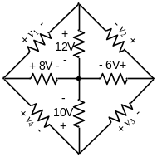
Fig. 2
III．As shown in Fig.3, the two ideal diodes are of the same type. Determine the states of the diodes. (8%)
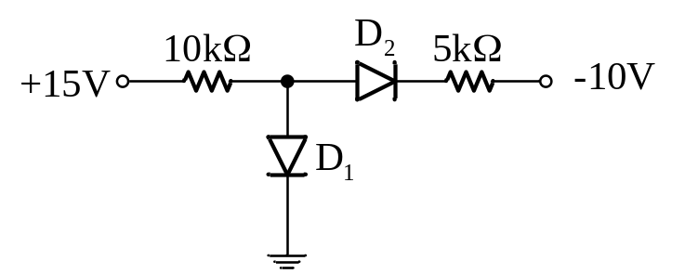
Fig. 3
IV．In Fig.4, assuming that the op-amp is ideal, find the value of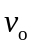. (5%)
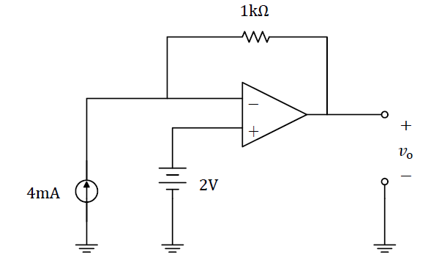
Fig. 4

V. In Fig.5. (1) Draw the small signal equivalent circuit; (2) compute the voltage gain, input resistance, and output resistance. (8%)
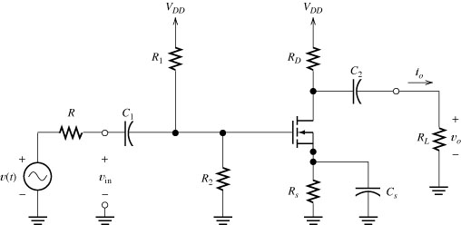

Fig. 5

VI. Compute the voltage gain, input impedance, current gain, power gain, and output impedance of the emitter-follower amplifier displayed in Figure 6. (11%)
(a) Draw the dc circuit and find the values of I_{C} and V_{CE} in the circuit of Figure 6 for β=100. V_{BE} =0.7V.
(b) draw the small signal equivalent circuit; find A_{v}, Z_{in}, and Z_{O} .
(c) Then, if v_{S} (t) =0.001sin (ωt)V, find an expression for v_{O} (t).
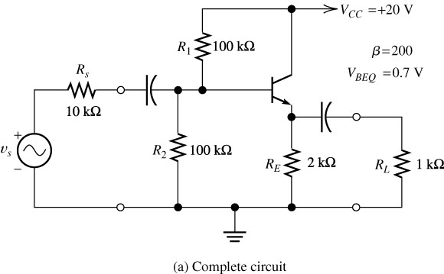
Figure 6 Common-emitter amplifier

VII. Find the voltage gain 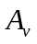=/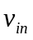 and input impedance of the circuit shown in Figure 7 with the switch closed.. (4%)
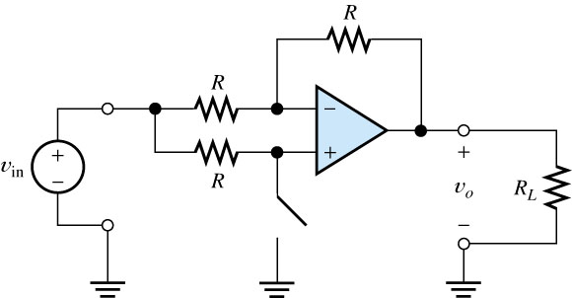
Figure 7.

VIII. A real op amp cannot produce infinite output voltage; instead, the output voltage magnitude cannot exceed a particular value. Let us assume that the op amp shown in Figure 8 has extreme output voltages of ±5V. Thus, the circuit does not function as an amplifier—the output voltage becomes stuck either at +5V or at －5V, depending on the initial polarity of =10sin (ωt)V. draw the plot of the output voltages (5%)
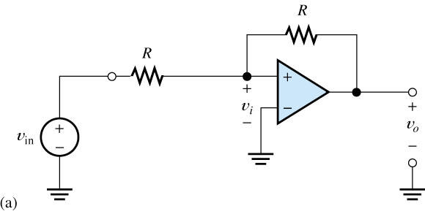
Fig 8.

IX. A power-supply circuit is needed to deliver 0.1A and an average of 15V to a load. The ac source available is 110V rms with a frequency of 60 Hz. Assume that the full-wave circuit of Figure 9 is to be used with a smoothing capacitor in for forward diode drop. Find the turns ratio n that is needed and the approximate value of the smoothing capacitor (Hint: To achieve an average load voltage of 15V with a ripple of 0.4V, design for a peak load voltage of 15.2V.)（8%）
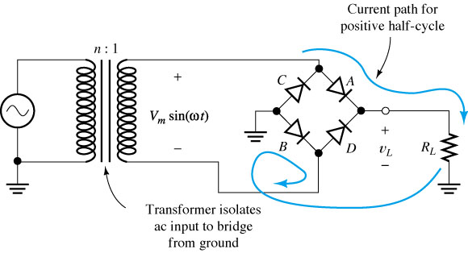
Fig 9 ( C 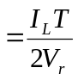 )

X. in the circuit of Figure 10 . (a) Draw the dc circuit and find the values of I_{C} and V_{CE}; (b) draw the small signal equivalent circuit; find A_{v}, Z_{in}, and Z_{O}（8%）。
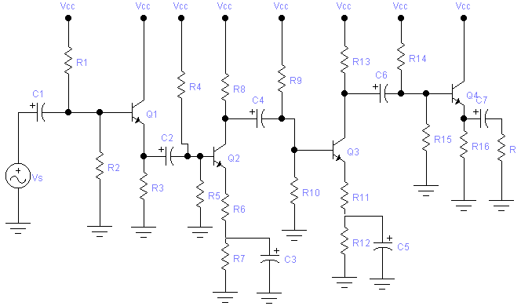
Fig 10

XI. Analyze the circuit of Figure 11. （9%）
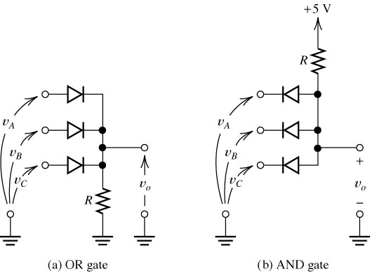
Fig 11

