《Discrete Mathematics》2012A卷参考答案

答案是给老师看的, 不能保证正确. 答题格式非常不标准, 你们答题不可如此, 应该模仿教材.

一．CDDCACBACA

二．
1. True_.
2. ∃x∃y(C(x) ∧D(y) ∧┒P(x,y))
3. ¬(l∧j)→e
4. {<l，x>，<m，y> ，<m，z>}
5. { ∅, {∅},{{∅}}, {∅,{∅}}}
6.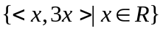
7. <
8. ①③
9. no
10. 11

三．
(1). Proof.
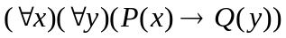
2’
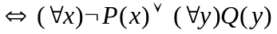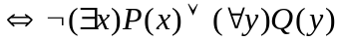 2’
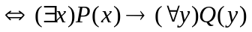 2’

(2). Proof.

(1) A Premise
(2) ¬A∨B Premise
(3) B (1)(2) 2’
(4) ¬C→¬B Premise
(5) B→C (4)
(6) C (3)(5) 2’
(7) C→D Premise
(8) D (6)(7) 2’
(9) A→D (1)(8)

(3). Solution:

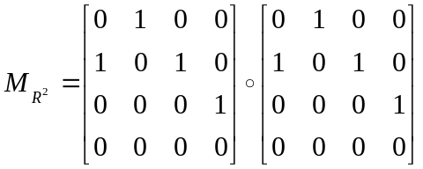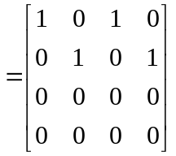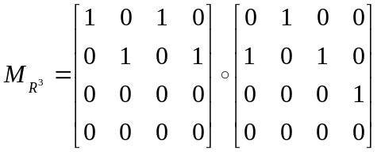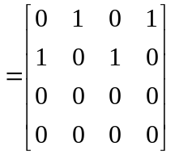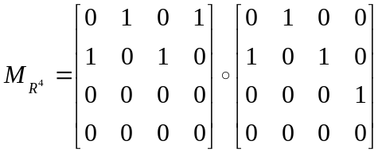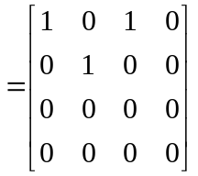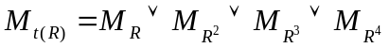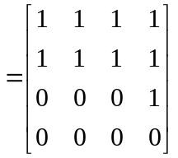 1’

1’

1’

3’

(4). Solution:
Theorem: A connected graph has an Euler path but not an Euler circuit if and if only if it has exactly two vertices of odd degree.(2’)
The degrees of vertex a and b of graph G are odd, and the degrees of other vertices are even, which is following the sufficient condition of Euler path. Thus, G be drawn in one stroke.(4’)
(5) Solution:
They are isomorphic. The isomorphism is:
f(u1)=v6, 1’
f(u2)=v3, 1’
f(u3)=v4, 1’
f(u4)=v5, 1’
f(u5)=v1, 1’
f(u6)=v2 1’

(6). Proof.
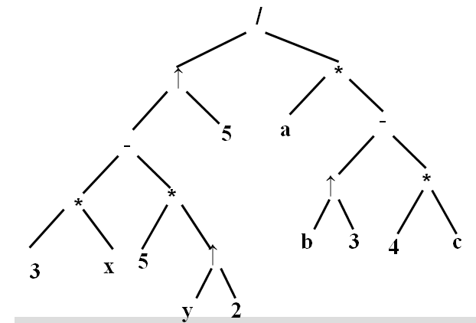

四．
1．
Solution:
Symbolize the propositions. W(x): x likes walking; D(x): x likes driving;
R(x): x likes riding.
Premises: ∀ x (W(x) →¬ D(x)), ∀ x (D(x) ∨R(x)), ∃ x(¬R(x))
Conclusion: ∃ x(¬W(x))
(1) ∃ x(¬R(x)) (Premise)
(2) ¬R(c) 2’
(3) ∀ x (D(x) ∨R(x)) (Premise)
(4) D(c) ∨R(c)
(5) D(c) (2)(4) 2’
(6) ∀ x (W(x) →¬ D(x)) (Premise)
(7) ∀ x (D(x) →¬ W(x)) (6)
(8) ¬ W(c) (5)(7)
(9) ∃ x(¬W(x)) (8) 2’

2．Solution:
- Since R is reflexive, <a,a>∈R and <a,a>∈R⇔<a，a>∈T. T is reflexive. 2’
- Since <a，b>∈R and <b，a>∈R ⇔ <a，b>∈T and <b，a>∈T. T is symmetric. 2’
- If <a，b>∈T and <b，c>∈T, then <a，b>∈R and <b，c>∈R. Since R is transitive,
<a,c>∈R. Also, <b，a>∈R and <c，b>∈R, imply <c,a>∈R. Therefore, <a,c>∈T, transitive. 2’

3． Solution:
Yes. All the tasks could be accomplished.
Denote the people by vertices and their cooperative relationships by undirected edges. Hence, we obtain a undirected graph G=<V,E>. 2’
For each vi∈V, d(vi)≥n/2, therefore, G is a Hamilton graph which contains a Hamilton circuit. 2’
In the Hamilton circuit, the adjacent vertices can be put into a group to accomplish the task. 2’

- Solution:

The roads should be paved are shown as follows. The minimum length is 160. (Each edge is worth 1’.If the MST is construct correctly, 6’)

