诚信应考,考试作弊将带来严重后果！
_____________ ________
…

Name Student ID
( 密 封 线 内 不 答 题 )
……………………………………………………密………………………………………………封………………………………………线……………………………………线………………………………………

华南理工大学期末考试
《Discrete Mathematics》
note： 1. 考前请将密封线内填写清楚；
2. 所有答案请直接答在答题纸上；
3．考试形式：闭卷；
4. 本试卷共 4 大题，满分100分， 考试时间120分钟。
题 号 | 1 | 2 | 3 | 4 | 总分
得 分
评卷人

- Choose an answer to the following question. (10 x 2’ = 20’)
(1) Which is a proposition? ( )
A) I am lying. B) How smart George Boole is!
C)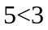. D)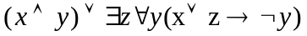.

(2) Which is logically equivalent to ? ( )
A）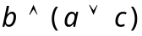. B）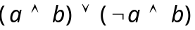.
C）. D）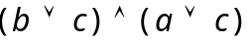.

(3) 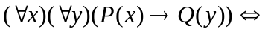 ( )
A）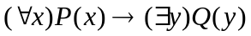
B）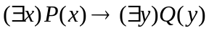
C）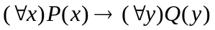
D）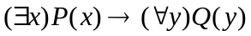

(4) Function  is defined as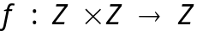. Which function is not onto? ( )
A）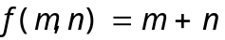 B） 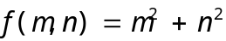
C）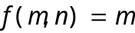 D） 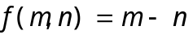
(5) Suppose a relation R on the set A = { 1, 2, 3 }, R is ( )
1
A) reflexive
B) antisymmetric
2
C) transitive
D) irreflexive
3

(6) 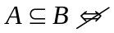 ( )
A) 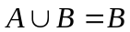 B) 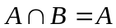
C) 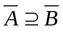 D) 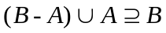

(7) Suppose that A, B and C are all set, if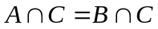, which answer is right?  is the universal set. ( )
A) 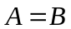 B) 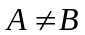
C) if 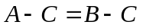, then D) if 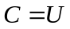, then

(8) Which statement is false? （ ）
A) Given an incidence matrix, we can determine the corresponding graph.
B) The graph isomorphism is an equivalence relation.

C) G = (V,E) is a bipartite graph with bipartition 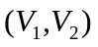. If 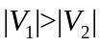, then 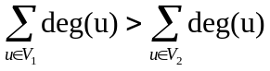
.
D) 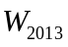 has 4026 edges and exactly 2014 vertices
.

(9) A tree T has three 3-degree vertices, two 2-degree vertices, and all the other vertices are leaves. How many leaves are there in T? ( )
A) 1 B) 4 C) 5 D) 6

(10) Which graph has both Euler and Hamilton circuits? ( )
A) K_{9.} B) K₁₀. C) K_{2,3}. D) K_{3,3}.

2． Fill in the blanks. (10 x 2’ = 20’)
(1) What is the propositional logic notation corresponding to the condition operation “&&” in the programming language of C/C++/Java ?
(2) Let P(x) be the statement “x can speak Russian” and let Q(x) be the statement “x knows the computer language C++.” For the universe of discourse for quantifiers use the set of all students at your school. Express the following sentences in terms of P(x), Q(x), quantifiers and logical connectives.
There is a student at your school who can speak Russian but who doesn’t know C++.
___________________________
(3) Suppose that f(x)=x²+1 and g(x)=x+2 are functions from R to R.
f+g=__________________________ _______
(4) Let R be the relation R={(a, b)| a divides b} on the set of positive integers.
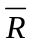 =_____________
(5) Whether the relation with the directed graph shown is a partial order. (Yes or No)______________.
d
c
b
a

(6) Give an example of a relation on a set that is symmetric and antisymmetric.
____________________________
(7) There are _____ edges a graph have if it has vertices of degree 4,3,3,2,2. (How many)
(8) Let p and q be the propositions.
p: I bought a lottery this week.
q: I won the million dollar jackpot on Friday.
Express the proposition “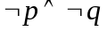” as an English sentence.
__________________________________________
(9) If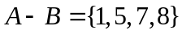, 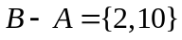 and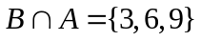, then A=________
(10) The relation R’s transitive closure t(R)=____________.

- Computation and Analysis. (6 x 5’ = 30’)
- Let A, B and C be any sets. Prove or disprove: 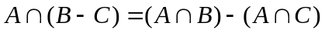

- Let R be the relation represented by the matrix 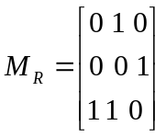. Find the matrix that represents R².

- Show that 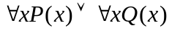 and 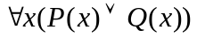are not logically equivalent.

- Determine whether the relation R, where (x,y) ∈R if and only if x=y+1 or x=y-1, on the set of all integers is reflexive, symmetric, antisymmetric, and/or transitive.

(5) Draw all the spanning trees of the given simple graph.
f
e
d
c
b
a

(6) Let f be a 1-1 function from A to B. Let S and T be subsets of B. Show that 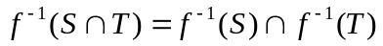.

- Application of Discrete Mathematics. (3x 10’ = 30’)
- Prove that the undirected graph is a connected graph or its complementary graph is a connected graph.

- Let A be a set of positive integers, definite the relation R: <x,y> R <u,v> on 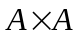 if and only if xy=uv. Prove that R is the equivalence relation of .

- An undirected tree has five leaves, one 2-degree vertex, one 3-degree vertex and the degree of the rest vertexes is all 4. How many vertexes dose the tree has in total? Please draw all of the undirected trees which are non-isomorphism to each other.

