华南理工大学期末考试答案
《 编译原理 》试卷 A

- Fill in the blanks (18%)

a. __Grammar_Parser_, ____Sematic Analyzer___, __Source Code Optimizer_, _Target Code Optimizer _.
b.__Reserved Words____, ___Identifier______, ___Number____, ____Operator___, __Special Symbol__
c.
a) “int” is a ___ Reserved Word b) “printf” is a ___Reserved Word c) “s” is a (an) _ Identifier __
d) “= =” is a _____ Operator_____ e) “0” is a______ Number_ ____
d. Terminal symbol Non-Terminal symbol, start symbol ,and ___Product Rules

2. (Terms Translation, 12%)
  - Compiler —— 一种应用程序，将源代码转换为指定的目标代码。
  - Source code —— 文本文件，其中内容是按照指定的文法规则描述特定的算法，
  - Scanner —— 将文本字符串按照词法规则，转换为特定的内部标识，供编译器后续分析。
  - Tokens ——源文件中最基本的信息单元
  - Terminal symbol ——文法规则中不需要产生式定义的符号
  - Ambiguous Grammar —使用不同推导方法，推导出不同语法树，就称该文法为二义文法。
3. (Scanning; 20%)(a)
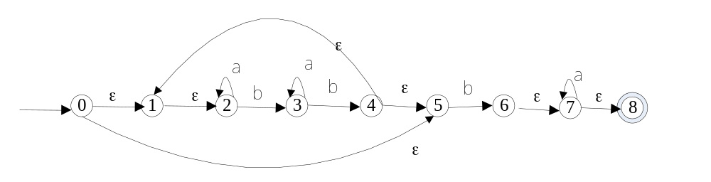
(b) (10%)
 | a | b
A={0,1,2,5} | B | C
B={2} | B | D
C={3,6, 7,8} | E | F
D={3} | D | F
E={3,7, 8} | E | F
F={1,2,4,5} | B | C
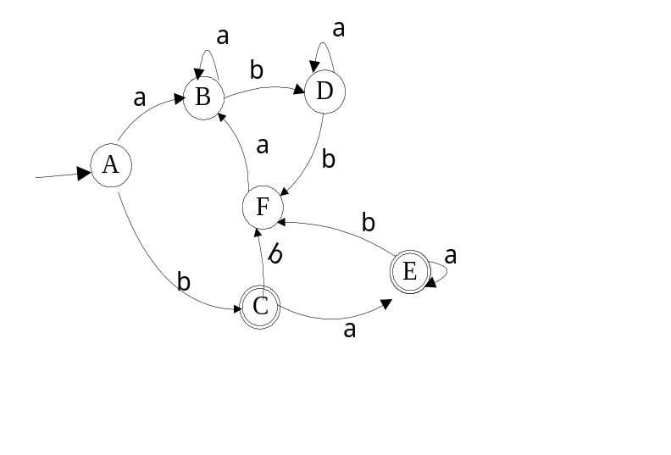

4. (LL parsing; 25%)
(a) (7%)
S ->List->(Seq)->(Seq,S)->(S,S)->(number, S)
->(4,S)->(4,List)->(4,(Seq))->(4,(S))->(4,(number))->(4, (34))

(b) (8%)
S->number | List
List -> (Seq)
Seq -> S Seq1
Seq1->,S Seq1|ε
(c)(10%)

 | FIRSTSET | FOLLOWSET | ( | ) | , | number | $
Seq | {number,(} | {)} | S Seq1 |  |  | S Seq1
Seq1 | {ε, , } | {)} |  | ε | ,S Seq1
List | {(} | {$,), ,} | (Seq)
S | {number,(} | {$,), ,} | L |  |  | number

5. (LR parsing; 25%)

（a）(5%)
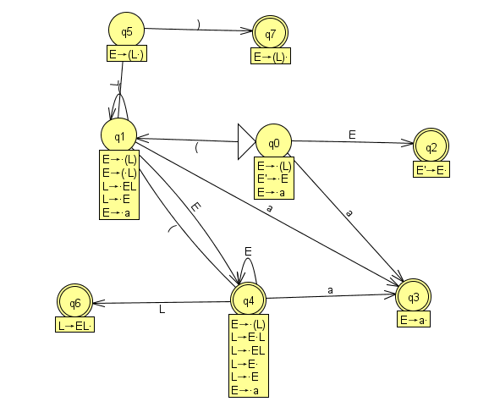

(b)(10%)
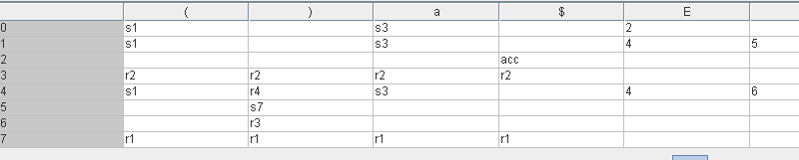

(c) (10%)

1  2  3  4  5  6  7  8  9  10  11  12  13  14  15  16  17 | Parsing stack Input Action
1  2  3  4  5  6  7  8  9  10  11  12  13  14  15  16  17 | $ 0 (a (a a)) $ shift1  $ 0 ( 1 a (a a))$ shift3  $ 0 ( 1a3 (a a)) $ r E->a  $ 0(1E4 (a a)) $ shift1  $ 0(1E4(1 a a)) $ shift3  $ 0(1E4(1 a 3 a)) $ r E->a  $ 0(1E4(1E4 a)) $ shift3  $ 0(1E4(1E4a3 )) $ r E->a  $ 0(1E4(1E4E4 ))$ r L ->E  $ 0(1E4(1E4L6 )) $ r L->EL  $ 0(1E4(1L5 )) $ shift7  $ 0(1E4(1L)7 ) $ r E->(L)  $ 0(1E4E4 ) $ r L->E  $ 0(1E4L6 ) $ r L->EL  $ 0(1L 5 ) $ shift7  $ 0(1L 5)7 $ r E->(L)  $0E2 $ acc

