诚信应考,考试作弊将带来严重后果！
_____________ ________
…

姓名 学号 学院 专业 座位号
( 密 封 线 内 不 答 题 )
……………………………………………………密………………………………………………封………………………………………线……………………………………线………………………………………

华南理工大学期末考试
《 Computer Networks 》B试卷 2010
注意事项：1. 考前请将密封线内填写清楚；
2. 所有答案请直接答在试卷上(注：选择题答案请填入题目前面的表格中)；

3．考试形式：闭卷；
4. 本试卷共五大题，满分100分, 考试时间120分钟。
题 号 | 1 | 2 | 3 | 4 | 5 | 总分
得 分
评卷人
- Select the correct choice. (30 scores, every one is 2 scores)
NO. | 1 | 2 | 3 | 4 | 5 | 6 | 7 | 8 | 9 | 10 | 11 | 12 | 13 | 14 | 15
solution
- Which of the following is different from others? ( B )
A. CSMA/CD B. TDMA C. ALOHA D. CSMA
- Based on TCP/IP architecture, which of the following protocol belongs to data-link layer ? ( D )
A. HTTP B. IP C. UDP D. PPP
- About the encapsulation relationships of segment、datagram and frame, which of the following is correct? ( C )
A. Segment is encapsulated within the frame, and the frame is encapsulated within the datagram.
B. Datagram is encapsulated within the Segment, and the Segment is encapsulated within the frame.
C. Segment is encapsulated within the datagram, and the datagram is encapsulated within the frame.
D. Frame is encapsulated within the datagram, and the datagram is encapsulated within the segment.
- Which of the following is right？( C )
A. The function of route selecting is provided by application layer.
B. The communication between processes is provided by network layer.
C. The services which are connection-oriented and connectionless are provided by transport layer.
D. The end to end communication is provided by transport layer
- Which of the following functions belong to a link-layer protocol? ( D )
A. Framing B. Link access C. Error detection D. All above
- Which of the following is the main function of DNS? ( C )
A. Query the computer name of a host.
B. Query the MAC address of a host.
C. Get the information between host and network through querying.
D. Assign rationally the usage of IP addresses.
- Suppose Host A wants to send a file to Host B, the path from Host A to Host B has three links, their rates R1=500 kbps, R2=250 kbps, and R3= 1 Mbps. Assuming no other traffic in the network, what is the throughput for the file transfer? ( C )
A. 500 kbps B. 1 Mbps C. 250 kbps D. 1.75 Mbps
- In network communication，what are the uses for the well-known ports usually？ ( B )
A. Start of the three handshakes of TCP
B. Identify the network applications which are being accessed
C. Identify the server
D. Identify the client
- Consider sending a packet from a source host to a destination host over a fixed route, which of the end-to-end delays are variable? ( A )
A. Queuing delays. B. Processing delays
C. Propagation delays D. Transmission delays
- What is the relationship between Internet and World Wide Web (WWW)? ( B ).
A. Both are Internet, just has different name
B. WWW is only an application of Internet
C. No relationship between them.
D. Internet is the World Wide Web
- The function of URL is ( B ).
A. locating the host address.
B. locating the network resource address.
C. converting from the host domain name to IP address.
D. indicating the email address.
- A socket consists of ( C ).
A. a machine address and a port number.
B. a machine address and an IP address.

C. the IP addresses and the port numbers
D. a host name and a port number.
- Forwarding packets for Ethernet are based on ( B ).
A. IP address B. MAC address C. LLC address D. port number
- Which of the following is the physical address for Ethernet? ( B )
A. 10.254.1.220 B. 00-60-08-00-A6-38
C. 10-65-08 D. 10.0.0.1
- In Internet communication, IP datagram will go through the source host and routers to reach the destination host, usually ( D ).
A. both source host and routers all know the complete path to the destination host that will be reached by IP datagram.
B. source host knows the complete path to destination host that will be reached by IP datagram, but none the intermediate routers.
C. the intermediate routers know the complete path to destination host that will be reached by IP datagram, but none the source host.
D. neither source host nor the intermediate routers know the complete path to destination host that will be reached by IP datagram.
- Fill the blank. ( 20 scores, every blank is 1 score )
  - Data link layer in IEEE802.3 is divided to two function sub-layers. They are ( LLC ) and ( MAC ).
  - DNS provides the convert from ( domain name ) to ( IP address ), APR provides the convert from( IP address ) to ( MAC address ).
  - The routing protocol ( OSPF ) is recommended for a intra AS, which is based on( link state ) routing algorithm, and the routing protocol ( BGP ) is recommended for inter AS, which is based on ( distance vector ) routing algorithm.
  - In E-mail system, SMTP is a protocol used to ( sending ) E-mail, and POP3 is a protocol used to ( receiving ) E-mail.
  - ( Virtual circuit ) subnet and ( datagram ) subnet provide connection-oriented services and connectionless services respectively.
  - RIP advertisements typically announce ( the number of hops ) to various destination; BGP updates, on the other hand, announce the (sequence of ASs on the routes) to the various destinations.
  - The task of the data link layer is providing data transmission services between ( adjacent nodes ); the task of the network layer is providing data transmission services between ( end-to-end hosts ); and the task of transport layer is providing data transmission services between ( application processes ).
  - In the TCP, connection establishment of transport layer uses method of ( three-way handshake ).
- Judge the following questions as true or false. (10 scores, every one is 1 scores)
  - ARP is a network layer protocol. F
  - C/S model is one of network architectures. F
  - Virtual circuit switching is not the same as circuit switching, but a packet switching. T
  - When a TCP connection is established，there is no any change for the size of RcvWindow. F
  - TCP is an end to end transport protocol, but UDP is not. F
  - Every end-system must use the same operating system in Internet. F
  - In a P2P file-sharing application, there is no notion of client and server sides of a communication session. F
  - It is possible to have same alias for an organization Web server and Email server. T
  - There are same address table entries for forwarding tables in routers and in two-layer switches. F
  - With a window size of 1, SR, GBN, and the alternating bit protocol are functionally equivalent. T
- Answer the following questions briefly. (20 scores, every one is 5 scores)
  - To take TCP/IP architecture for an example, summarize the process of data encapsulation.
Answers
①应用层将要发送的报文送到传输层，假如报文长度过大则将其分成若干块，每块封装成一个报文段中，报文段包含应用层载荷和具有地址信息(端口号)和序列号的头部。②传输层报文段送到网络层，并封装成网络层分组，每个分组除传输层载荷外，包含一个有地址信息(IP地址)和其它控制信息的头部。③网络层分组传递到数据链路层，分组被封装到链路层数据帧中，除网络层载荷，每帧还包含有地址信息(MAC)和其它控制信息等的头部。

  - Try to describe the main principles of reliable data transfer for SR as figure 1.

Figure1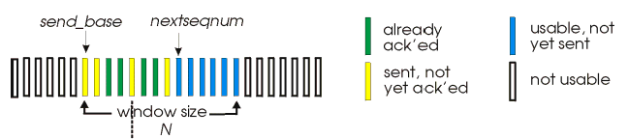 SR window mechanism
Answers:
- “window” of up to N, consecutive unack’ed pkts allowed, buffers pkts, as needed
- ACK(n): individually acknowledges all correctly received pkts, sender timer for each unACKed pkt
- Timeout (n)- retransmite pkts for which ACK not received

  - As figure 1, suppose Host A sends a datagram to Host B via router R. Please draw up the source and destination MAC addresses, and source and destination IP addresses in the frame as required below:
      - From A to the R
      - From R to B.
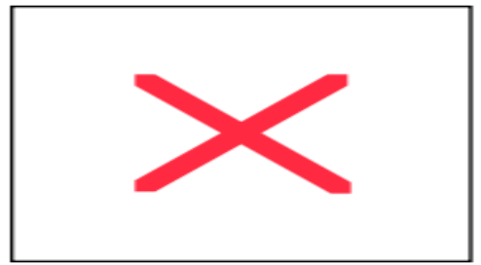
R
1A-23-F9-CD-06-9B
222.222.222.220
111.111.111.110
E6-E9-00-17-BB-4B
CC-49-DE-D0-AB-7D
111.111.111.112
111.111.111.111
A
74-29-9C-E8-FF-55
222.222.222.221
B
222.222.222.222
49-BD-D2-C7-56-2A
88-B2-2F-54-1A-0F

Figure 1
Answers:
- From A to R: Source MAC address: 74-29-9C-E8-FF-55
Destination MAC address: E6-E9-00-17-BB-4B
Source IP: 111.111.111.111
Destination IP: 222.222.222.222
- From R to B: Source MAC address: 1A-23-F9-CD-06-9B
Destination MAC address: 49-BD-D2-C7-56-2A
Source IP: 111.111.111.111
Destination IP: 222.222.222.222
Try to fill the table 3 based on table 1, table 2 and figure 2.
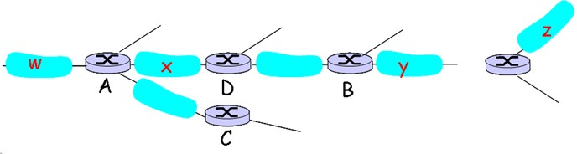

Figure 2
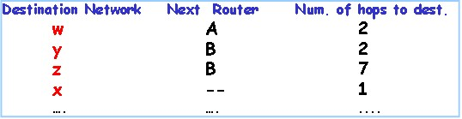

Table 1: primeval routing table in D (figure 2)

1
1

Table 2: Advertisement from A to D (figure 2)
Answers：
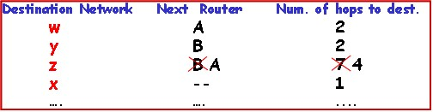

Table 3: routing table in D (figure 2)

- Comprehensive Questions (20 scores, every one is 10 scores)
  - Reading the following instructions, answer questions [1] to [5].
A network that address 192.168.75.0 has five hosts A, B, C, D and E, their IP addresses and subnets mask as following.

Table 4 Host IP address and Subnet Mask
host | IP address | Subnet Mask | host | IP address | Subnet Mask
A | 192.168.75.18 | 255.255.255.240 | D | 192.168.75.161 | 255.255.255.240
B | 192.168.75.146 | 255.255.255.240 | E | 192.168.75.173 | 255.255.255.240
C | 192.168.75.158 | 255.255.255.240
- How many subnets do the five hosts A, B, C, D and E belong to? List the hosts that belong to the same subnet. (2)
- What is the network address of the host D? (2)
- To add the sixth host F, make it together with A belong to the same subnet, what is the IP address range? (2)
- If adding a host in the network, its IP address is 168.192.80.164, what is its broadcast address? Which hosts can receive its broadcast information? (2)
- If using VLAN technology to divide the subnet, what device can implement the data forwarding between VLAN? (2)

Table 5 the Conversion of Binary and Decimal
binary | decimal | binary | decimal
11110 | 30 | 10101000 | 168
10010001 | 145 | 10101110 | 174
10010111 | 151 | 11110000 | 240
Answers：
  - 分属3个网段，位于同一网段的有A、BC、DE。
  - 网络地址为168.192.80.160
  - 答案应为： 168.192.80.17到168.192.80.29
  - 168.192.80.175，DE
  - 路由器/三层交换机
(2) Assuming TCP is the protocol experiencing the behavior shown figure 3. Please answer the following questions.
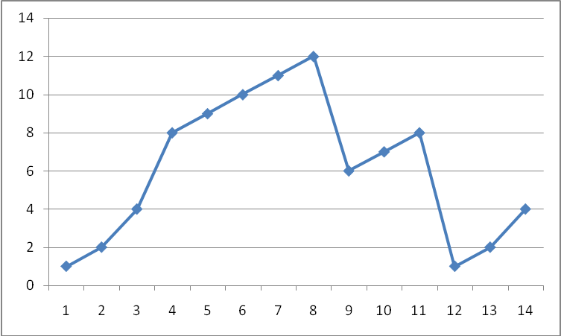

Figure 3
- Indentify the intervals of time when TCP slow start is opening. (2)
- Indentify the intervals of time when TCP congestion avoidance is operating. (2)
- What is the initial value of threshold at the first transmission round? (2)
- After the 8th transmission round, What has happened? And which version of TCP protocol(Reno or Tahoe) is used base on this information? (2)
- Assuming no packet loss is found until the 16th transmission round, what the window size will be at that time?
Answers:
- TCP slow start is operating in the intervals [1,4] and [12, 14]
- TCP congestion avoidance is operating in the intervals [4,8] and [9, 11] .
- The first threshold is initially 8, since it is at this window size that slow start stops and congestion avoidance begins.
- After the 8th transmission round, packet loss is recognized by a triple duplicate ACK, the cwnd size drop to the half of the cwnd size last interval. TCP version is Reno.
- The window size will be 6.

add

1.Select the correct choice.
(1)In Cyclic Redundancy Check situation, data bit D = 101110, generator pattern G = 1001, then CRC bit R will be ( A ).
A. 011 B. 101 C.110 D.111

(2)suppose there are 3 routers between a source host and a destination host. ignoring fragmentation, an IP datagram sent from source to the destination host will travel over ( D ) interfaces?
A. 3 B. 5 C.7 D.8

(3)Which of the following is the physical address for Ethernet? ( B )
A. 10.254.1.220 B. 01-6E-09-00-A6-38
C. 2001:da8:2000:2193:23:33 D. 10.0.0.1

(4)We sometimes use UDP because it is ( ) comparing to the TCP.
A. fast B. simple
C. data loss-tolerance D. All of above

4. Answer the following questions briefly.
(1) Consider the following network. With the indicated link cost, use Dijkstra's shortest-path algorithm to compute the shortest path from node u to all network nodes. Show how the algorithm works by drawing a table.
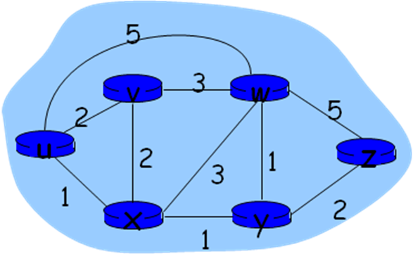

(2)To take TCP/IP architecture for an example, summarize the process of data encapsulation.

5. Comprehensive Questions
(2)Consider the topology shown here. Denote the three subnets with hosts as Network A,B,C. Denote the subnets without hosts as Networks D,E,F.
Assign network address to each of these six subnets, with the following constrains:
All address must be allocated from 214.97.254/23;
subnet A should have enough addresses to support 250 interface; subnet A should have enough addresses to support 120 interface; subnet A should have enough addresses to support 120 interface; of cause D,E,F should each be able to support 2 interface.
For each subnet, you should use the pattern like a.b.c.d/x or a.b.c.d/x - e.f.g.h/y
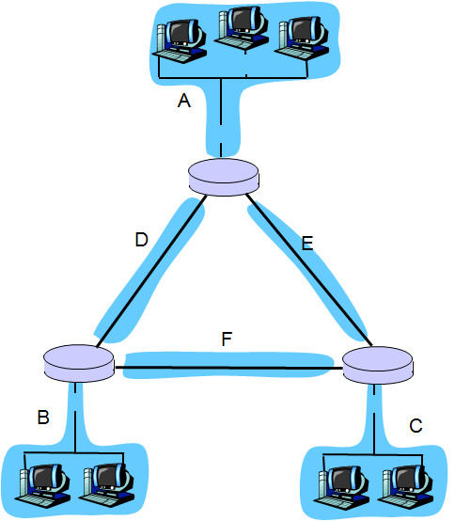
Answer:
Subnet A: 214.97.255/24 (256 addresses)
Subnet B: 214.97.254.0/25 - 214.97.254.0/29 (128-8 = 120 addresses)
Subnet C: 214.97.254.128/25 (128 addresses)
Subnet D: 214.97.254.0/31 (2 addresses)
Subnet E: 214.97.254.2/31 (2 addresses)
Subnet F: 214.97.254.4/30 (4 addresses)

