诚信应考,考试作弊将带来严重后果！
_____________ ________
…

姓名 学号
学院 专业 座位号
( 密 封 线 内 不 答 题 )
……………………………………………………密………………………………………………封………………………………………线……………………………………线………………………………………

华南理工大学期末考试
《面向对象分析与设计》补考试卷 2007B
注意事项：1. 考前请将密封线内填写清楚；
2. 所有答案请直接答在试卷上(或答题纸上)；
3．考试形式：闭卷；
4. 本试卷共 5 大题，满分100分， 考试时间120分钟。
题 号 | 一 | 二 | 三 | 四 | 五 | 总分
得 分
评卷人

- Multiple Choice (15 points)
1). What is TRUE about Use Cases? (4 answers)（ ）
A. Use case diagrams are the primary tool to document requirements
B. Use cases provide the basis of communication between sponsors and developers in planning phase
C. Use cases description provides a good source to identify domain concepts
D. A fully-dressed use case should include both “whats” and “hows” so that they are ready for “realization”
E. A use case is an interaction between a user and a system.
F. Use cases are not object-oriented
2) Scenario: Prepare for an Event（ ）
In preparation for a party, the chef will look at the menu. The chef requires a shopping list from each recipe on the selected menu. The system generates the shopping list of ingredients that he needs to buy. Then he just crosses off anything that he already has.
Because the chef is picky about his cooking utensils, he brings his own and doesn't like to depend on the clients to supply anything. In order to make sure that he doesn't forget anything, he uses the system to generate the list of utensils that he'll have to bring with him to the party.
He then proceeds to generate a to do list for the day of the party based on the time that the dinner is to be ready. He finds this to be useful so that everything's ready at the specified time, and nothing is forgotten.
When creating the use cases related to the "Prepare for an Event" scenario, which of the following BEST represents the type of terminology that the use cases should contain?

A. Chef, menu, recipes, ingredients
B. End user, bill of fare, cooking specifications, food contents

C. Chef object, menu object, recipe object, ingredient object
D. Person record, menu print stream, recipe container, ingredient array
3). Which statements are true for use case relationships? (1 answers) （ ）
A. An Include relationship means that a UseCase includes the behavior described in another UseCase
B. an Extend relationship implies that a UseCase may extend the behavior described in another UseCase
C. Generalization between UseCases means that the child is a more specific form of the parent. The child inherits all Features and Associations of the parent, and may add new Features and Associations
D. All of the above
E. Only a) and b)
F. Only b) and c)
4) Which of the following are TRUE about a deployment diagram?（3 Answers）（ ）
A. Since there is always some kind of response to a message, the dependencies are two-way between deployment components.
B. Dependencies between deployment components tend to be the same as the package dependencies.
C. Deployment diagrams can used to show physical modules of code.
D. Deployment diagrams can be used to show the physical distribution of a system across computers.

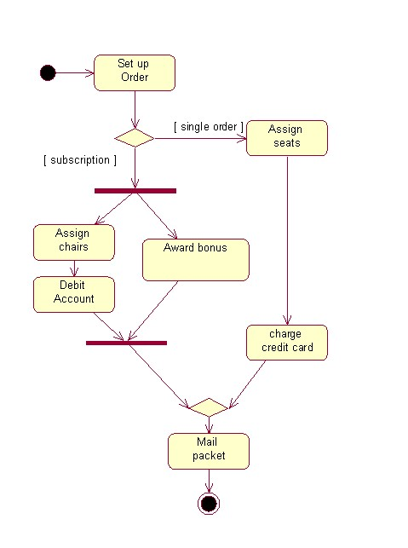
5) Refer to the diagram to answer the question. What is the maximum concurrent threads that is possible in the activity diagram?

A. 3
B. 2
C. 4
D. 1
E. 5

2． Fill the blanks (15 points)
1) Which UML diagram is specifically intended to describe the behavior of a single class? ________________________
2) Explain the difference between composition and aggregation. How are each represented in UML.
_______________________________________________________________________
_______________________________________________________________________
- The UML architecture is a four-layer metamodeling architecture. This architecture is a proven infrastructure for defining the precise semantics required by complex models ,Which include (4 points )
___ __, _____ _, __ __ and_ _____ .
4) UML provide three extension Extension Mechanisms : __________ , ___________, and TaggedValue. These mechanisms can be used separately or together to define new modeling elements that can have distinct semantics, characteristics, and notation relative to the built in UML modeling elements specified by the UML metamodel.
3. Point out the wrong place in the following diagram . (20 points )
1) Use Case Diagram: 业务用例模型 / 审核(0-100)
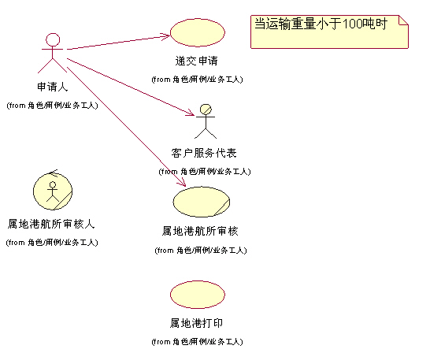
2) 水陆运输Use Case Model / 水路运输Sequence Diagram
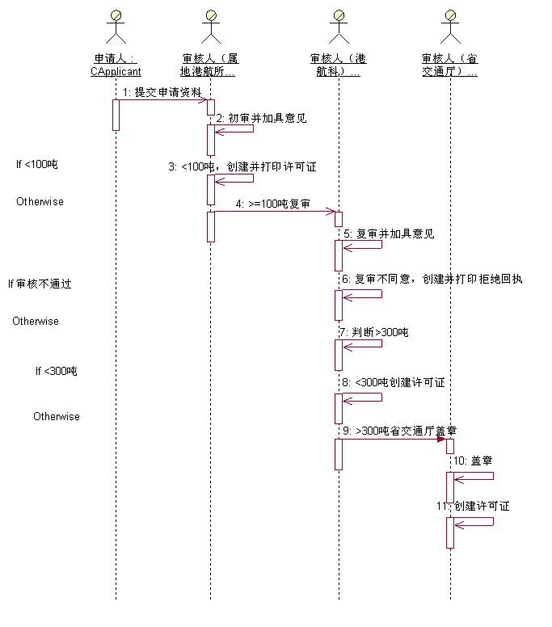
- Answer the following questions (Total 10 point)
(1) Compare the difference between the OOA and traditional structured analysis.
(2) How to discover the objects and actors in system.
5. Design (Total 40 point)
Consider the following problem:
On the scut campus, students can apply for a consumed-card(消费卡) .The card administrator would create a new consumed-card when receiving an application. The consumed-card can be used in the campus super-market(校园超市). When the students consume with the card , the salesperson would deduct the money from the card. Also , The card administrator can deposit money into the card for the students. Imagine that you have been hired to develop the supporting software.
- Draw a UML use case diagram for the system. Include one example of either an “extends” or a “uses” relationship. (20 points)
- Draw a class diagram for the system. (20 points)

