Chapter1 Introduction
1.What is OS?
It is an extended machine
It is a resource manager

2.OS Concepts
processes
address Spaces & Files
protection & Shell

3.System Calls
System calls provide the interface between a running program and the operating system.
(1)Process
- UNIX examples
  - fork system call creates new process.
  - execve system call used after a fork to replace the process’ memory space with a new program.
  - waitpid system call used to move the parent process off the ready queue until the termination of the child.
exit system call is used when a process is finished executing.
例1：
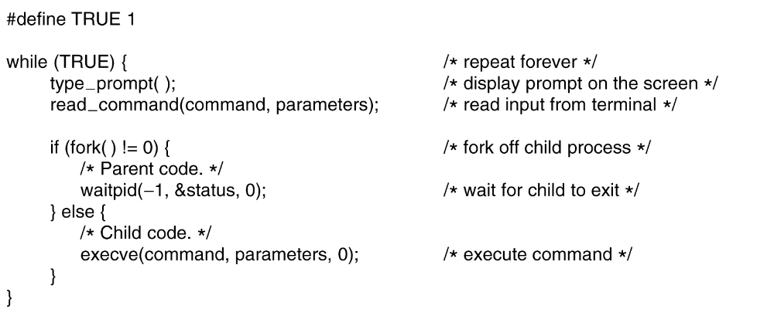
例2：
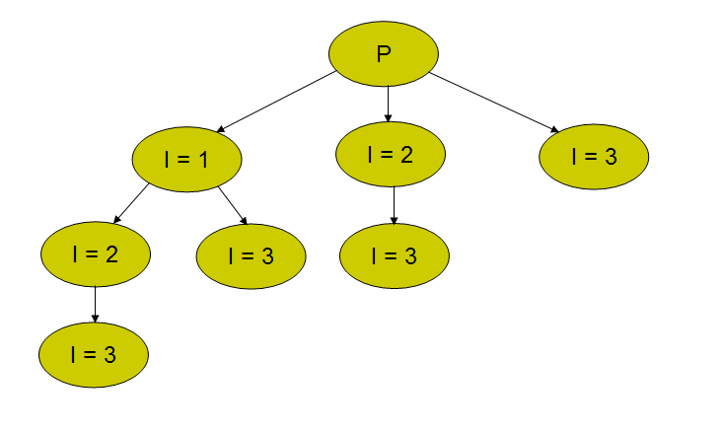
/* fork processes */
main()
{
int i, pid;

for (i=1; i<=3; i++) {
if ((pid = fork()) == 0) {
printf("In child %d. \n", i);
}
}
}

(2)File
(3)Directory
(4)Linking
(5)Mounting

Chapter2 Process and Thread
1.Process Model
Multiprogramming, concurrency

2.Process
- Definition进程，即是一个具有一定独立功能的程序关于某个数据集合的一次活动。
- Process vs. Program
(1)Program: the collection of instruction, static concept;
Process: describe concurrency, dynamic concept
(2)Process include program, data, and PCB(Process Control Block 进程控制块)
(3)Process: temporary; Program: permanent
(4)A program can be the execution program of multiple process;
also, a process can call multiple programs.
(5)Process can create other process in it.

3. Process Creation
  - System initialization (reboot)
  - Execution of a process creation system call (fork())
  - User request to create a new process
Command line or click an icon
4. Initiation of a batch job 批处理作业的初始化

4. Process Termination
  - Normal exit (voluntary)
  - Error exit (voluntary)
  - Fatal error (involuntary) 严重错误
  - Killed by another process (involuntary)

5.Process States
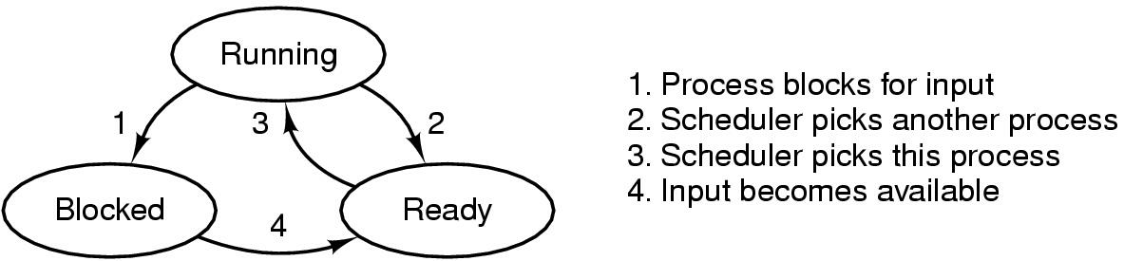
6.Process Control Block (PCB)
(process attribute)
In kernel

7.Process context switch
  - Switch CPU from one process to another
  - Performed by scheduler (chapter 2.5)
  - It includes:
    - save PCB state of the old process;
    - load PCB state of the new process;
    - Flush memory cache;
    - Change memory mapping;
  - Context switch is expensive(1-1000 microseconds)
    - No useful work is done (pure overhead)
    - Can become a bottleneck

8.Thread
(1)What is thread? lightweight process (LWP)
(2)Why need threads? Process spend much time and space, restrict the concurrency
  - Responsiveness: Multiple activities can be done at same time. They can speed up the application.
  - Resource Sharing: Threads share the memory and the resources of the process to which they belong.
  - Economy: They are easy to create and destroy.
  - Utilization of MP (multiprocessor) Architectures: They are useful on multiple CPU systems.
(3)Thread vs. process
  - Thread: a basic unit of CPU utilization.
  - Process: a basic unit of resource allocation.
  - 进程是资源分配的基本单位，所有与该进程有关的资源分配情况，如打印机、I/O缓冲队列等，均记录在进程控制块PCB中，进程也是分配主存的基本单位，它拥有一个完整的虚拟地址空间。而线程与资源分配无关，它属于某一个进程，并与该进程内的其它线程一起共享进程的资源。
  - 不同的进程拥有不同的虚拟地址空间，而同一进程中的多个线程共享同一地址空间。
  - 进程调度的切换将涉及到有关资源指针的保存及进程地址空间的转换等问题。而线程的切换将不涉及资源指针的保存和地址空间的变化。所以，线程切换的开销要比进程切换的开销小得多。
  - 进程的调度与切换都是由操作系统内核完成，而线程则既可由操作系统内核完成，也可由用户程序进行。
  - 进程可以动态创建进程。被进程创建的线程也可以创建其它线程。
  - 进程有创建、执行、消亡的生命周期。线程也有类似的生命周期。
(4)TCB 线程控制块TCB用来说明线程存在的标识、记录线程属性和调度信息
(5)Implementation
Three mechanism 机制
  - Implementing threads in user space
  - Implementing threads in kernel space
  - Hybrid Implementations
  - Pop-up threads

9.Inter-Process Communication (IPC)
  - Process Synchronization进程同步and Mutual Exclusion 互斥
  - Critical Resource临界资源, Critical Region/Section
一次仅允许一个进程访问的资源称为临界资源
The part of the program where the critical resource is accessed is called critical region or critical section
- Possible Solutions
Disabling Interrupts
Lock Variables
Strict Alternation
Peterson’s solution
TSL
Sleep and Wakeup

  - Semaphore 信号量and PV operations
use semaphores in two different ways:
mutual exclusion (mutex);
process synchronization (full, empty).
mutex设初始值为1，down(mutex)进入临界区，up(mutex)离开临界区
empty空槽数目，full满槽数目
1) 信号量的物理含义
S.count>0表示有S.count个资源可用
S.count=0表示无资源可用
S.count<0则|S.count|表示S等待队列中的进程个数

P(S)：表示申请一个资源
V(S)：表示释放一个资源。信号量的初值应该大于等于0
2) P,V操作必须成对出现，有一个P操作就一定有一个V操作
  - 当为互斥操作时，它们同处于同一进程；
当为同步操作时，则不在同一进程中出现。

  - 如果P(S1)和P(S2)两个操作在一起，那么P操作的顺序至关重要，一个同步P操作与一个互斥P操作在一起时同步P操作在互斥P操作前；

  - 而两个V操作的顺序无关紧要。

  - Monitors管程, why use monitor?
wait操作必须在signal之前，否则该信号会永远丢失
  - Message passing
  - Using semaphore to solve Classical IPC problems
    - Dining-Philosophers Problem
    - Readers and Writers Problem

10.Process Scheduling
  - Scheduling opportunity (when to schedule)
- A new process is created
- The running process exits
- The running process is blocked
- I/O interrupt (some processes will be ready)
- Clock interrupt (every 10 milliseconds)

  - Scheduling algorithm
    - Batch systems 批处理
      - First-Come First-Served (FCFS)
      - Short Job First (SJF) 短作业优先
只有在所有的作业都可以同时运行的情形下，SJF才是最优化的
    - Interactive system
      - Round Robin (RR) 轮转调度
      - Priority Scheduling
      - Multi Queue & Multi-level Feedback多级队列

Chapter6 Deadlock
1.Resource Type
  - Preemptable Resources
  - Non-preemptable Resources

2.Deadlock Definition
A set of processes is deadlocked if each process in the set is waiting for an event that only another process in the set can cause.

3.Four Conditions for Deadlock（资源死锁的4个条件）
  - Mutual exclusion condition
  - Hold and wait condition 占有和等待
  - No preemption condition 不可占有
  - Circular wait condition 环路等待

4.Deadlock Modeling
  - Resource Allocation Graph
○是进程□是资源
□→○资源到进程已占用
○→□进程到资源已阻塞
- If graph contains no cycles ⇒ no deadlock.
- If graph contains a cycle ⇒
  - if only one instance per resource type, then deadlock.
  - if several instances per resource type, possibility of deadlock.

5.Methods for Handling Deadlocks
  - The Ostrich Algorithm
Pretend假装there is no problem

  - Detection
    - One resource of each type: resource allocation graph algorithm
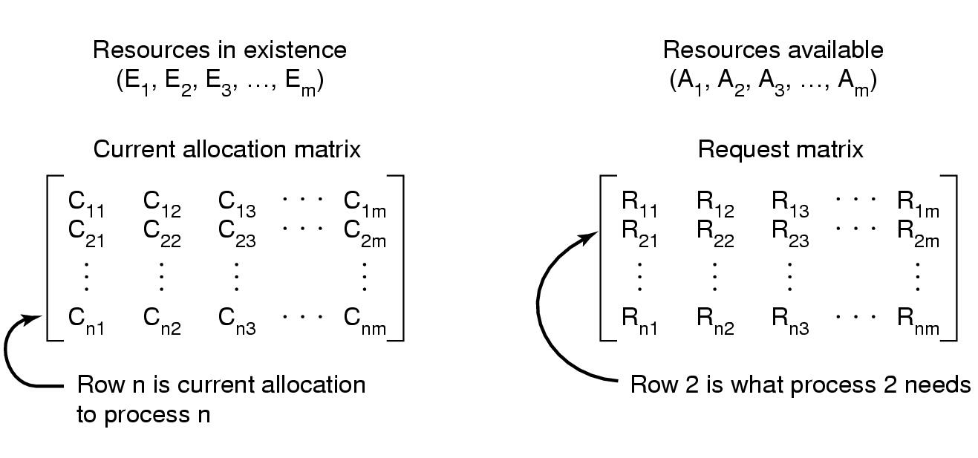
    - Multiple resources of each type: matrix-based algorithm
算法：R_{i}<A则将C_{i}加到A上并计算下一条，若都没有则死锁。
  - Recovery
    - Through preemption 抢占
    - Through rollback 回滚（可提高软件可靠性）
    - Through killing process
  - Avoidance
    - Safe state（系统能够保证所有进程都能完成）
- If a system is in safe state ⇒ no deadlocks.
- If a system is in unsafe state ⇒ possibility of deadlock.

    - Banker’s algorithm
  - Prevention
    - Attacking one of the conditions for deadlock
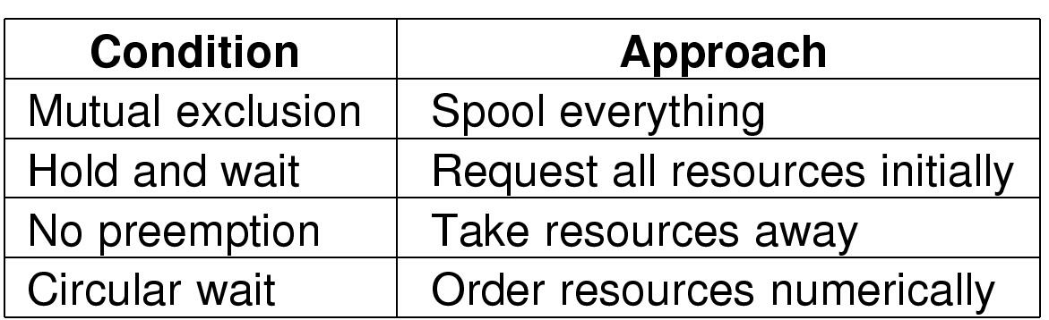

Chapter3 Memory Management
- Storage Hierarchy
  - A few MBs of fast, expensive, volatile cache memory
  - A few GBs of medium-speed, medium price, volatile main memory (RAM)
  - A few TBs of slow, cheap, nonvolatile disk storage

2.Memory Management Schema
(1)No Memory Abstraction
    - Every program simply saw the physical memory
    - It is not possible to run two programs in memory at the same time.
(2)Address Space
    - Protection & Relocation: base and limit register
(3)Swapping
(4)Memory Management: Bitmap, Linked List
Linked List ： 空闲区（H） 进程（P）两个数字：第一个是开始的地方，第二个是长度
(5)Partition Allocation（Storage Placement Strategies ）: First fit, Next fit, Best fit, Worst fit, Quick fit

3.Virtual Memory
  - Principal
  - Implementation: Paging 分页, Segmentation分段
4.Paging
  - Page tables
The purpose of the page table is to map virtual pages onto page frames
虚拟地址——页面
物理内存——页框（page frame）
输入的16位的虚拟地址被分为4位的页号和12位的偏移量，4位（高位部分）的页号可以表示16个页面，12位（低位部分）的偏移可以为一页内的全部4096个字节编址。

Page table entry页表项
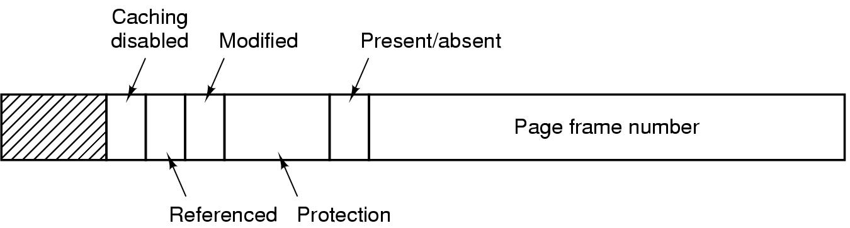

    - TLB (Translation Look-aside Buffer ) 转换检测缓冲区
反复读取的页表项
    - Multi-level page tables
（1）Multi-level page tables Advantage:
reduce the table size.
don't keep page tables in memory that are not needed.
（2）Example:
32 bit machine 虚拟地址 with 4k page size页面长度
4K—>2¹² 所以偏移量为12位（Offset）
所以页号为（32-12）=20位—>被分为10bits PT1域、10bits PT2域
    - Inverted page tables
每个页框（物理内存）有一个页表项，而不是每一个虚拟页面
  - Address Translation Scheme
  - Page Fault 缺页中断
程序访问了一个未映射的页面
    - Page Replacement Algorithm （Second Chance是对FIFO的改进，Clock是对Second Chance的另一种实现，Aging近似于LRU并且更有效的实现，最好的两种算法是Aging、WSClock）
    - Optimal（实际不能用）
    - FIFO
    - Second Chance
    - Clock
    - NRU 最近未使用（R访问定期清零、M修改，一共分四种情况）
    - LRU 最近最少使用（访问页框k时，把行置为1，列置为0，行的和最小的就是最近最少使用的）
    - NFU 最不常使用
    - Aging （位数有限）
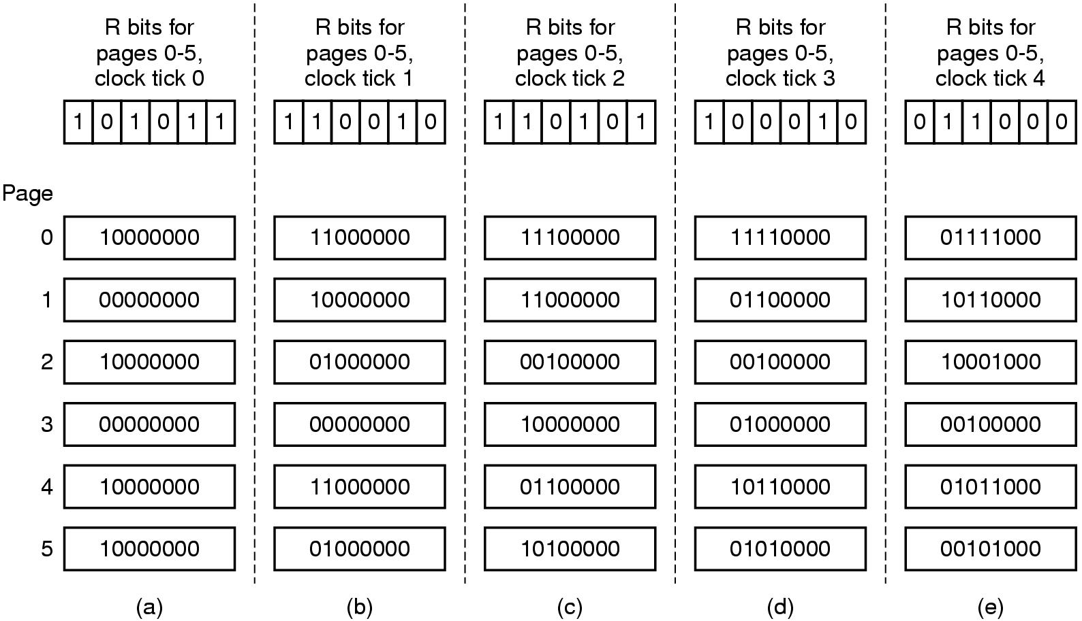
    - Working Set （开销大）
t秒实际运行时间中所访问的页面集合（其中，生存时间=当前实际时间-上次时间）
若（R==1）设置上次使用时间为当前实际时间
若（R==0且生存时间>t）移出这个页面
若（R==0且生存时间<=t）记住最小时间
    - WSClock工作集时钟算法

5.Design Issues for Paging Systems
  - Replacement Scope （全局置换通常比局部置换好）
    - Local Replacement 局部置换
    - Global Replacement 全局置换
  - Page Size
太大：最后一页平均一般是空的页面大internal fragmentation内部碎片 大，使更多没有用的程序保留在内存中
太小：需要更多页面页表，装入页面寄存器花费的时间越长
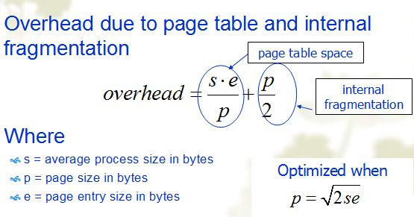
s/p是每个进程大约需要的页数

  - Separate Instruction and Data Spaces
  - Shared Pages
6.Segmentation分段: Address Translation
Allows each table to grow or shrink, independently
7.Segmentation with paging: Address Translation

Chapter4 File System
1.File and File System
  - File: A named collection of related information that is recorded on secondary storage.
  - File System: A method for storing and organizing files and the data they contain to make it easy to find and access them.

2.Basic Functions of File System
  - Present logical (abstract) view of files and directories
Hide complexity of hardware devices
  - Facilitate efficient use of storage devices
Optimize access, e.g., to disk
  - Support sharing
Provide protection

3.Files Types
  - Regular file 普通文件(ASCII, Binary) and Directory 目录文件
  - Character and Block special file (UNIX) 字符特殊文件和块特殊文件
4.File Structure
- Three kinds of files
  - byte sequence 字节序列（最大灵活性）
  - record sequence 记录序列（固定长度）
  - tree （Records not necessarily the same length ，Records contain keys ，Tree sorted on key）

5.File Access: Sequential and Random access
6.Directory Structure
  - One-level directory system
has one directory (root) containing all the files
  - Two-level directory system
has a root directory and user directories.
  - Hierarchical directory system 层次目录系统
has a root directory and arbitrary number of subdirectories.

7.Path Name: Absolute and Relative path name （路径名第一个字符是分隔符，则这个路径就是绝对路径）
8.File Implementation
  - Contiguous Allocation 连续分配
- Advantages
  - Simple to implement (Need only starting sector & length of file)
  - Read performance is excellent 读操作性能好(suits for sequential access and direct access)
- Disadvantages
  - Disk fragmentation 磁盘碎片
  - The maximum file size must be known when file is created, or files cannot grow 要提前知道文件所占的最大空间
- Good for CD-ROMs, DVDs and other write-once optical media
  - All file sizes are known in advance
  - Files are never deleted

  - Linked List Allocation 链表分配
- Advantages:
  - No external fragmentation
  - Directory entries are simple (Need only starting address)
  - A file can continue to grow as long as free blocks are available
  - Good for sequential access
- Disadvantages:
  - Random access slow 随机存取慢
  - The amount of data in a block is not a power of 2
File Allocation Table (FAT) 文件分配表
指针记录在FAT表，整个表都在内存中，不需要磁盘引用，所以对于大磁盘不适合
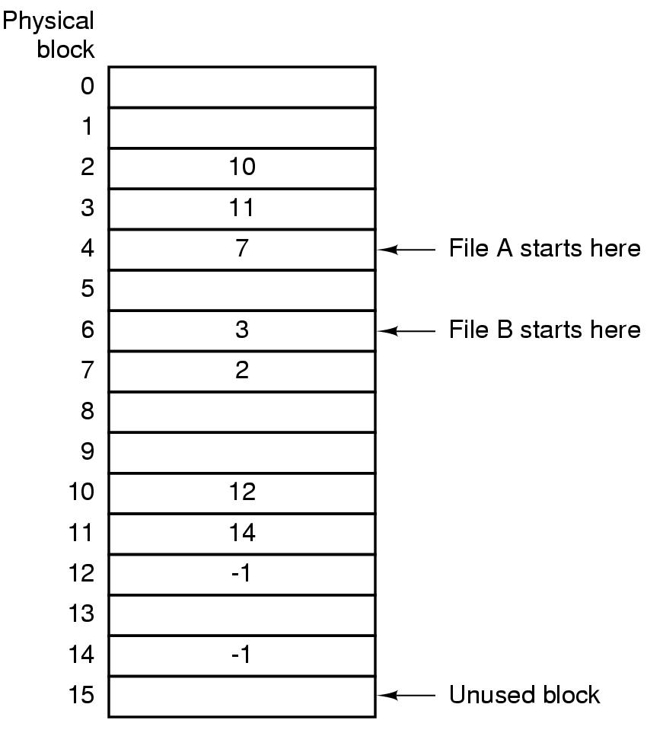
  - Indexed Allocation(i-Node)
Each file has its own index-node (i-node), which lists the attributes and disk block addresses of the file.
Without suffering from external fragmentation
只有在对应文件打开时，其i节点才在内存中

9.Directory Implementation
  - Directory entry
  - i-node
- The directory entry provides information needed to find the disk blocks.
  - disk address of the entire file (contiguous blocks)
  - the number of first block (linked list)
  - the number of i-node (i-node)

- Handling long file names in a directory:
  - Fixed-length names (Waste space)
  - In-line (When a file is removed, a variable-sized gap is introduced.)
  - Heap (The heap management needs extra effort.)

- How to search files in each directory?
  - Linearly
  - Hash table
  - Cache the results of searches

10.Shared Files: Hard link （传统型）, Symbolic link （文件为Link型）
  - Do not list disk block addresses in directories but in a little data structure, i-node ⎝ Hard Link
    - Both directories point to the same i-node (next page)
  - Create a new file of type LINK which contains the path name of the file to which it is linked ⎝ Symbolic Link (Soft Link)
    - One directory points to the file’s i-node
    - Other directory contains the “path”
- Hard Links
  - Put a “reference count” field in each i-node
  - Counts number of directories that point to the file
  - When removing file from directory, decrement count
  - When count goes to zero, reclaim all blocks in the file
- Symbolic Link (only the owner directory has a pointer to i-node) 只有一个指针指向i节点
  - Remove the real file... (normal file deletion)
  - Symbolic link becomes “broken”
删除符号链接不影响该文件
删除文件才能使文件被销毁，以后试图通过符号链接访问该文件将导致失败

11.Example File Systems (UNIX)
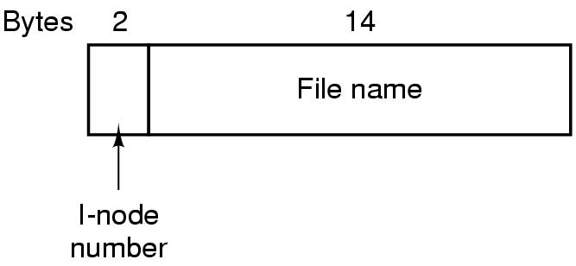

Chapter5 Input/Output
1.Devices Classification
- Block Devices 块设备
  - Stores information in fixed-size blocks, each one with its own address
  - 512B~32KB per block
  - It’s possible to read or write each block independently of all the other ones每个块独立读和写
  - E.g. Disks
- Character Devices 字符设备
  - Delivers or accepts a stream of characters
  - Not addressable and no seek operation
  - E.g. Printers, network interfaces, mouse, etc

2.Device Controller
- I/O devices have components:
  - mechanical component (the device itself) 机械部件
  - electronic component 电子部件
- The electronic component is the device controller 设备控制器or adapter 适配器
- Controller's tasks (e.g. disk)
convert serial bit stream to block of bytes 把串行的位流转换为字节块
perform error correction as necessary 进行必要的错误矫正
make available to main memory 复制到主存中

- I/O Addressing
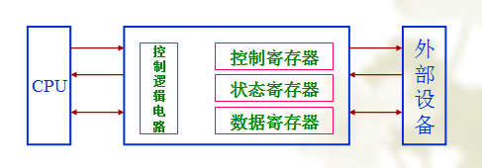
  - Separate I/O and memory space 单独的I/O和内存空间
- Each control register is assigned a special address called I/O port number I/O端口号, an 8- or 16-bit integer.

  - Memory-mapped I/O 内存映射I/O
- All the control registers are mapped into the memory space, but separating I/O ports from memory
（1）Advantages of Memory-mapped I/O
- No special instructions are needed to read and write from/to control registers 不需要特殊指令
- No special protection mechanism is necessary to protect control registers from direct access of users 不需要特殊保护机制
- Every instruction that references memory can also reference control registers. 每一条指令可以引用内存也可以引用控制寄存器
（2）Disadvantages of Memory-mapped I/O
- Caching
  - If device controller register values are caches, this can be problematic.
    - We don’t want to read cached soft copy, but we want to read the control register content.
    - Solution: Disable caching 禁用高速缓存for some virtual pages that correspond to control registers.
- Because of only one address space, all main memory modules 内存模块and all I/O device controllers must examine all memory references 内存引用to see which one to respond to.由谁做出响应
- This can be easy or difficult depending on the architecture of the system
——No problem in this single-bus architecture
——In this dual-bus memory architecture, how can I/O controllers see the addresses that are used for control registers, as all memory addresses go by on the memory bus.

  - Hybrid Scheme 混合方案
- Data buffers use memory-mapped addresses
- Control registers use addresses from a separate address space

4.Principles of I/O Software
  - Goals of I/O Software: Device independence…设备独立性
  - I/O Operations
    - Programmed I/O
- 缺点：Busy-wait 忙等待 cycle to wait for I/O from device, waste of CPU
- 优点：简单

    - Interrupt-driven I/O
    - I/O using DMA
5.I/O Software Layers
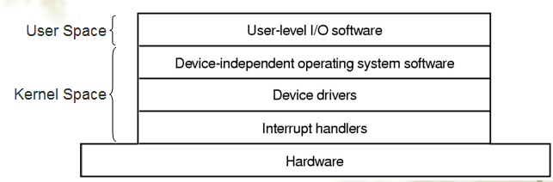
  - Interrupt handlers
  - Device drivers
设备驱动程序：控制设备的特定代码
A driver can be written for more than one OS
Generally written by device manufacturers
OSs usually classify drivers into two classes
Drivers for block devices
Drivers for character devices

  - Device independent OS Software
- Functions of the device-independent I/O software
  - Uniform interfacing for device drivers
The benefits are:
- The driver implementers know what is expected from them
- The OS implementers can developed device-independent I/O function on top of a well-defined lower-layer driver interface.
- They know which functions each driver implements and the pro-types of these function.

  - Buffering
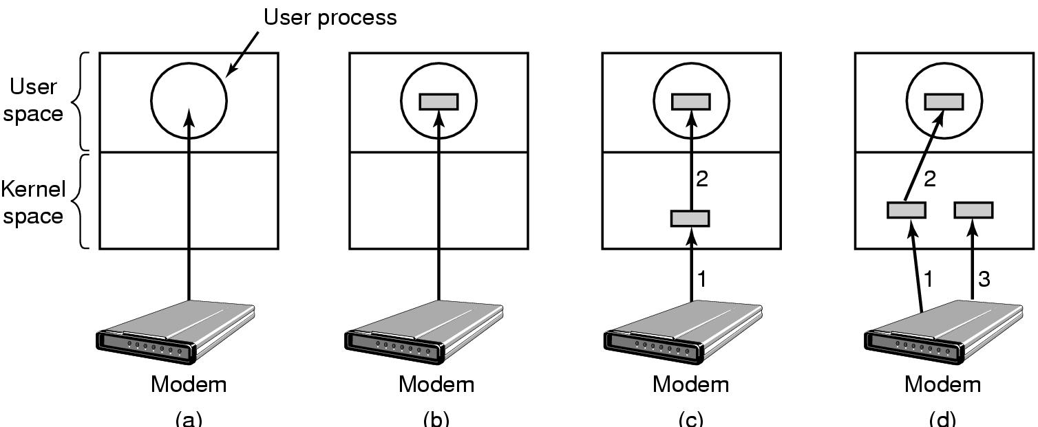
(a) Unbuffered input
(b) Buffering in user space
(c) Buffering in the kernel followed by copying to user space
(d) Double buffering in the kernel

  - Error reporting
  - Allocating and releasing dedicate devices
  - Providing a device-independent block size

  - User-level I/O Software
The I/O libraries 库 that provides the implementation of I/O functions which in turn call the respective I/O system calls.
Some programs that does not directly write to the I/O device, but writes to a spooler.假脱机

6.Disk
  - Disk Organization
Organized into cylinders Each cylinders contains tracks Each track is divided into a number of sectors

  - Disk Formatting
- After manufacturing, there is no information on the disk
  - Just empty bits
- Each platter need to have A low-level format A high-level format before disk can be used
- Each track should have formatted in the following way:
  - Sectors and inter-sector-gap between them
  - A sector will be have format like the following:
    - Preamble – data (512 bytes) – Checksum
前导码

  - Cylinder Skew 柱面斜进
每个磁道上第0扇区的位置与前一个磁道存在偏差
Example
- 10,000rpm disk drive (6ms/round)
- 300 sectors per track (20 μs/sector)
- Seek time: 800 μs
- Cylinder skew: 40secotrs

  - Disk Arm Scheduling Algorithms
    - FCFS 先来先服务
    - Shortest Seek First (SSF) 最短寻道优先
    - Elevator Algorithm 电梯
DOWN UP

