Answers are in blue.

# For Exercises 1–5, match the type of ambiguity with an example.



**Computer Science Illuminated, Seventh Edition**

Nell Dale, PhD; John Lewis, PhD

**CHAPTER 13**

EXERCISES AND ANSWERS

1. **Lexical**
2. **Referential**
3. **Syntactic**
   1. “Stand up for your flag.”
      1. Does “stand up” mean support or rise to your feet?
   2. “Go down the street on the left.”

C. Does this mean to go left down the street or go down the street that is on the left?

* 1. “He drove the car over the lawn mower, but it wasn’t hurt.”

B. What wasn’t hurt, the car or the lawn mower?

* 1. “I saw the movie flying to Houston.” C
  2. “Mary and Kay were playing until she came inside.” B

# For Exercises 6–21, mark the answers true and false as follows:

* + 1. **True**
    2. **False**
  1. A computer does some tasks much better than a human being.

A

* 1. A human being does some tasks much better than a computer.

A

* 1. A computer system that can pass the Turing test is consid- ered to be intelligent.

A

* 1. Some AI researchers don’t think we can achieve true artificial intelligence until a computer processes information in the same way the human mind does.

A

* 1. A semantic network is used to model relationships. A
  2. If information is stored in a semantic network, it is easy to answer questions about it.

B (it depends on how the network is structured)

* 1. A computer has never beaten a human at chess in master- level play.

B

* 1. An inference engine is part of a rule-based expert system. A
  2. A biological neuron accepts a single input signal and pro- duces multiple output signals.

B

* 1. Each element in an artificial neural net is affected by a numeric weight.

A

* 1. Voice synthesis is the most difficult part of natural language processing.

B

* 1. Each human has a unique voiceprint that can be used to train voice recognition systems.

A

* 1. The word “light” can be interpreted in many ways by a computer.

A

* 1. Syntactic ambiguity is no longer a problem for natural lan- guage comprehension.

B

* 1. A robot may follow the sense–plan–act approach to control its movements.

A

* 1. Isaac Asimov created three fundamental laws of robotics. A

# For Exercises 22–30, match the task with which (human or computer) can solve it more easily.

* + 1. **Computer**
    2. **Human**
  1. Identify a dog in a picture. B
  2. Add a column of 100 four-digit numbers. A
  3. Interpret a poem. B
  4. Match a finger print. A
  5. Paint a landscape. B
  6. Carry on an intelligent conversation. B
  7. Learn to speak. B
  8. Judge guilt or innocence. B
  9. Give affection. B

# Exercises 31–76 are problems or short-answer questions.

* 1. What is the Turing test?

The Turing test is a test devised by Alan Turing to answer the question “How can we know we’ve succeeded in creating a machine that can think?” The test is based on whether a computer could fool a human into believing that the com- puter is another human being.

* 1. How is the Turing test organized and administered?

A human interrogator sits in a room and uses a computer terminal to communicate with two respondents. The interro- gator knows that one respondent is human and the other is a computer. After conversing with both the human and the computer, the interrogator must decide which respondent is the computer. If the computer could fool enough interroga- tors, then it must be considered intelligent.

* 1. What is weak equivalence and how does it apply to the Turing test?

Weak equivalence is the equality of two systems based on their results. The Turing test shows weak equivalence.

* 1. What is strong equivalence?

Strong equivalence is the quality of two systems based on their results and the process by which they arrive at those results.

* 1. What is the Loebner prize?

The Loebner prize is the first formal instantiation of the Tur- ing test. It has been held annually since 1991.

* 1. Name and describe briefly five issues in the world of AI cov- ered in this chapter.

Knowledge representation: The techniques used to rep- resent knowledge so that a computer system can use it in problem solving.

Expert systems: Computer systems that embody the knowl- edge of human experts.

Neural networks: Computer systems that mimic the process- ing of the human brain.

Natural-language processing: Computer systems that pro- cess the language that humans use to communicate.

Robotics: The study of mobile robots that use AI techniques to interact with their environments.

* 1. Name and define two knowledge representation techniques. Semantic networks: A technique that represents the relation- ships among objects.

Search trees: A structure that represents alternatives in adversarial situations such as games.

* 1. What data structure defined in Chapter 8 is used to represent a semantic network?

A graph is used to represent a semantic network. The nodes in the graph represent objects and the arrows (arcs) repre- sent relationships.

* 1. Create a semantic network for the relationships among your family members. List five questions that your semantic net could easily be used to answer and five questions that would be more of a challenge to answer.

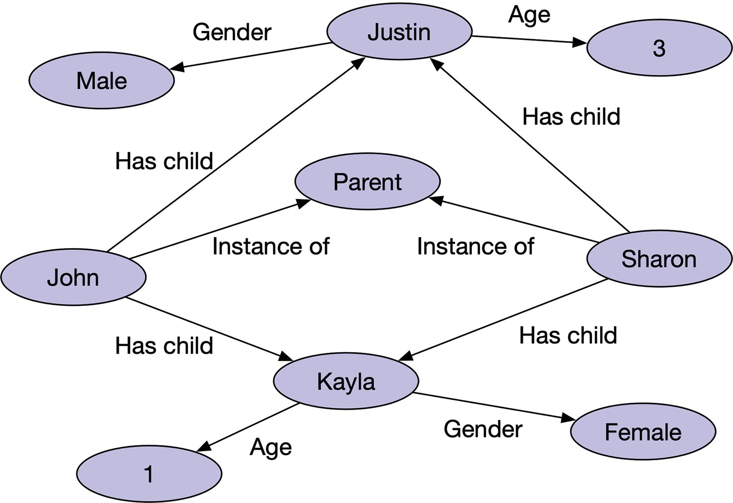

Easy questions to answer given this organization: Who are John’s children?

What is the gender of Kayla? How old are Sharon’s children?

How many female children does John have?

Does Sharon have any children older than 5 years of age?

More challenging questions to answer given this organization: Who are Kayla’s parents?

Who are Justin’s siblings?

How many female children are there? Who is the mother of John’s children? Does John have any step-children?

* 1. Create a semantic network that captures the information in a small section of a newspaper article.

This is an activity for which no answer is appropriate.

* 1. What object-oriented properties do semantic networks borrow?

Semantic networks borrow inheritance and instantiation. The inheritance is expressed in the “is-a” relationship, and instanti- ation is expressed when an object is related to something that describes it.

* 1. What is a search tree?

A search tree is a structure that represents all possible moves for both players in a two-person game.

* 1. What are trees for complex games like chess to large?

A search tree contains all possible moves from the first posi- tion, all possible moves from each of the moves from the first position, , all possible moves from all possible moves at

the level above. Thus the trees are very large for complex games like chess.

* 1. Distinguish between depth-first searching and breadth-first searching.

Depth-first searching begins at the top level (root) and con- tinues going deeper and deeper into the tree until the search has reached a leaf node, at which time the search moves back up one level and starts down again. A breadth-first search begins at the top level, then searches every node on the next lower level, then searches every node at the next lower level, until it has searched every node on every level.

* 1. What does it mean to prune a tree?

Pruning a tree means to eliminate some branches from searching.

* 1. Distinguish between knowledge-based systems and expert systems.

A knowledge-based system is a software system that uses a specific set of information from which it extracts and pro- cesses particular pieces. An expert system is sometime used as a synonym, but it also carries with it the idea of modeling the expertise of a professional in that particular field.

* 1. Distinguish be rule-based systems and inference engines.

A rule-based system is a software system that uses a set of rules to guide its processing. An inference engine is the soft- ware system that processes the rules.

* 1. What is an example of a human expert system?

A doctor is an example of a human expert system. The doc- tor asks questions and runs tests based on his knowledge and experience.

* 1. What do we call a knowledge-based system that models the expertise of professionals in the field?

An expert system.

* 1. Why is an expert system called a rule-based system?

An expert system is called a rule-based system because it uses a set of rules to guide its processing.

* 1. What is the part of the software in an expert system that determines how the rules are followed and what conclusions can be drawn?

An inference engine.

* 1. How are the rules expressed in an expert system?

The rules are expressed as selection statements (*if* statements).

* 1. What are the advantages of an expert system?

An expert system is goal oriented; it doesn’t focus on abstract or theoretical information. It is efficient; it records previous responses and doesn’t ask irrelevant questions. An expert system can provide useful guidance even if it can’t provide the answer to a specific question.

* 1. What is a single cell that conducts a chemically based elec- tronic signal?

A neuron.

* 1. What do a series of connected neurons form? A pathway in the brain.
  2. Upon what does the signal along a particular pathway depend? The signals depend on the state of the neurons through which the signal passes.
  3. What are the multiple input tentacles in a biological neuron? Dendrites
  4. What is the primary output tentacle in a biological neuron? An axon.
  5. From where do dendrites of one neuron pick up the signals from other neurons to form a network?

The dendrites of one neuron pick up the signals from the axons of other neurons to forma neural network.

* 1. What is the gap between an axon and a dendrite? A synapse.
  2. What tempers the strength of a synapse?

The chemical composition of a synapse tempers the strength of its input signal.

* 1. What is the role of a synapse?

The role of a synapse is to weight the input signal.

* 1. How is a synapse modeled in an artificial neural network?

A synapse is represented by a weight assigned to each input signal.

* 1. What is an effective weight in an artificial neuron?

An effective weight is the sum of the weights multiplied by the corresponding input values.

* 1. How is the output value from an artificial neuron calculated? Each neuron has a numeric threshold value. If the effective weight is greater than the threshold, a 1 is output; otherwise, a 0 is output.
  2. If the processing element in an artificial neural net accepted five input signals with values of 0, 0, 1, 1, and 0 and corre- sponding weights of 5, 2, 3, 3, and 6, what is the output if the threshold is 5?

1

* 1. If the processing element in an artificial neural net accepted five input signals with values of 0, 0, 1, 1, and 0 and corre- sponding weights of 5, 2, 3, 3, and 6, what is the output if the threshold is 7?

0

* 1. What is a phoneme?

A phoneme is a fundamental sound in a language.

* 1. Describe the two distinct ways that voice synthesis can be accomplished.

In dynamic voice generation, the set of phonemes for a lan- guage are generated. A computer examines the letters that make up a word and produce the sequence of sounds using the language’s phonemes.

In recorded speech, human speech is recorded. A computer chooses the correct word from its file of recorded words.

Dynamic voice generation can make an attempt to pro- nounce any word, but recorded speech can only pronounce words that have been prerecorded.

* 1. Which issues affect the ability to recognize the words spoken by a human voice?

Accents, regional dialects, voice pitch, homonyms, and the clarity of a person’s speech.

* 1. How can a voice recognition system be trained?

A voiceprint is a plot of frequency changes over time rep- resenting the sound of a human’s speech. To train a voice recognition system, a person says the same word several times and the computer records an average voiceprint for the word.

* 1. Why are personalized voice recognition systems so much better than those that are not specific to a specific person? Generalized systems have to use generic voiceprints, but personalized systems can use voiceprints specific to the user.
  2. Name and describe two categories of robots.

Fixed robots: Robots that remain in one place to accomplish their task.

Mobile robots: Robots that move around, thus having to interact with their environment.

* 1. What are planning systems?

Planning systems are large software systems that given a goal, a starting position, and an ending situation generate an algorithm for a solution.

* 1. What defines subsumption architecture?

Behaviors run in parallel unless they come into conflict, at which time the ordering of goals determine which behavior takes precedence.

* 1. Of what is a robot composed?

A robot is composed of sensors, actuators, and computa- tional elements. The sensors take in data about the outside world, the actuators move the robot, and the computational element send instructions to the actuators.