**算法设计与分析书面作业一**

1. **作业发布与提交截止时间**

作业发布时间：2024年4月28日（周日补周四的课）

作业提交截止时间：2024年5月7日（周二）

1. **作业对应章节**
2. Introduction

第二章 Fundamentals of the Analysis of Algorithm Efficiency

1. **作业提交要求**

书面作业书写在A4纸上，正上方写明“学生编号”、“学生姓名”、“学号”（学生编号见QQ群文件“学生编号表.xls”），缺少上述信息的视作未提交作业。

书面作业不需要抄题，只需写答案。

1. **作业提交方式**

书面作业由各班学委收齐，在2024年5月7日（周二）的算法课前交给助教赵煜新（QQ: 2606043591，B8-307），重修的同学直接交给助教。

1. **书面作业题**
2. The requirements of algorithm are Input, Output, Effectiveness and ___________.
3. Feasibility and Safety
4. Finiteness and Definiteness
5. Finiteness and Certainty
6. Simplicity and Certainty
7. Please write down the correct sequence of algorithm design and

analysis process:

1. Understand the problem
2. ____________________
3. ____________________
4. ____________________
5. ____________________
6. Code the algorithm
7. ______Algorithm______ + Data Structure = Programs

(4) Time efficiency is analyzed by determining the number of repetitions of the basic operation as a function of __________.

A. output size B. input size C. execution process D. running

(5) The ascending order of the following time complexity is ___4 5 3 1 2____.

①Θ(2n) ② Θ(n!) ③ Θ(n3) ④ Θ(logn) ⑤

(6) If $O\left(g1\right)=f1$, $O\left(g2\right)=f2$, then:

$O\left(g1+g2\right)=$_____max {f1, f2}_______; $O(g1*g2)$ =_____f1 * f2_________.

(7) What is the computational complexity of following pseudocode?

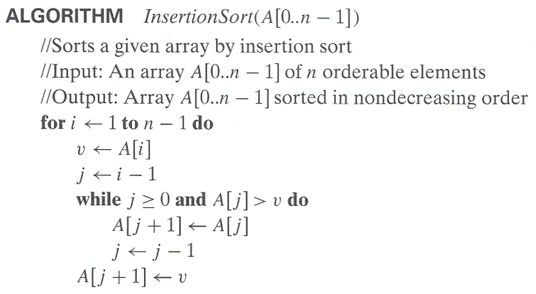

The worst case: _____O(n^2)________; The best case: _____O(n)__________