编译原理复习 #5-6 TAC

***Definition of Attribute***

*An attribute is any property of a programming language construct •Typical examples of attributes are: •****The data type of a variable****•****The value of an expression****•****The location of a variable in memory****•****The object code of a procedure***

**属性分类\***

* **综合属性（synthesized attribute）：**属性由子节点的属性确定
* **继承属性：**属性由本身、父节点和兄弟节点的属性决定

**练习题\***

**Consider the attribute grammar where the attribute val is the value of the binary real number and the attribute len is the length of N**

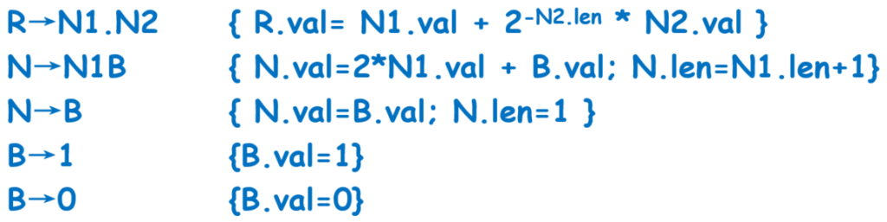

* **Draw the dependency graph for string “10.11”**

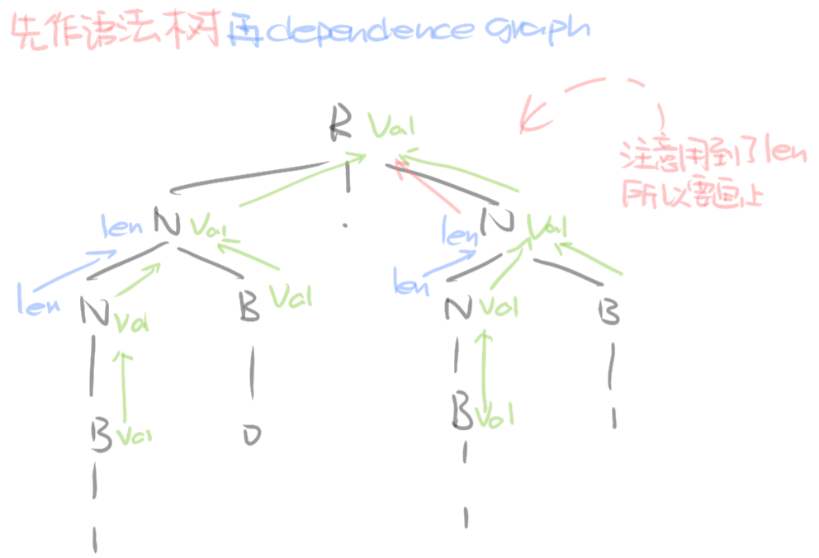

* **What’s the final value of R.val for this string?**

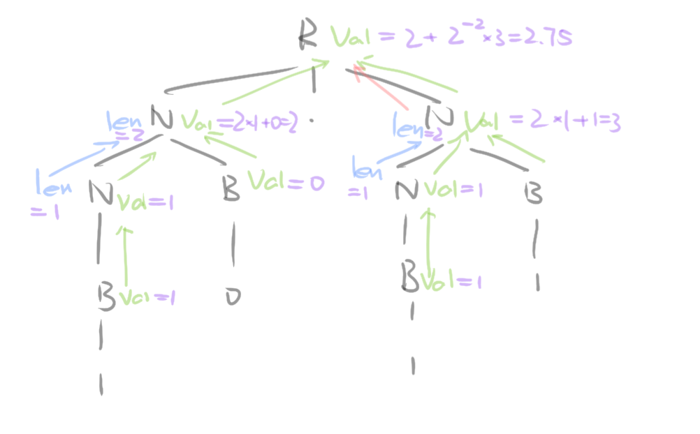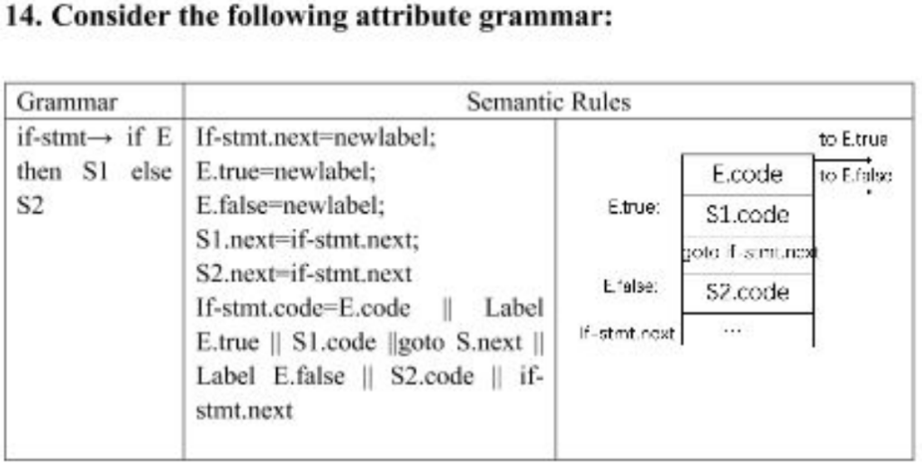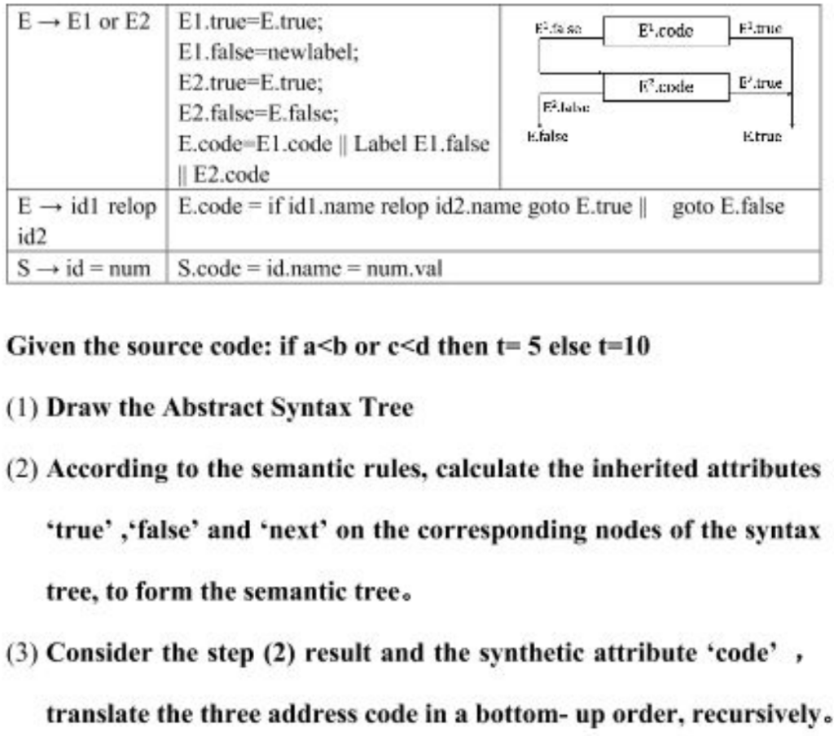

**画出语法树**（可以只表示非终结符，然后在最下面加括号表示值）

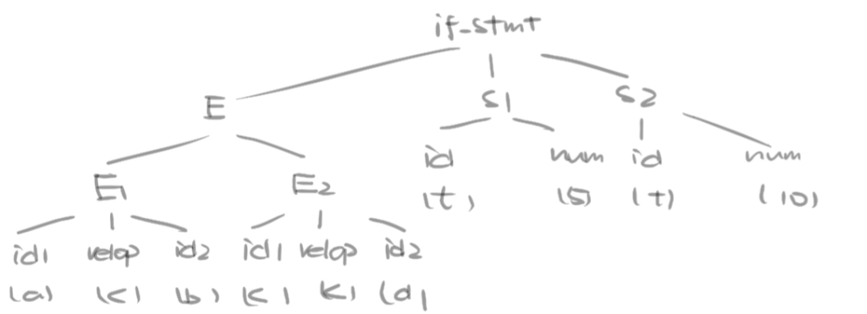

**由上至下计算继承属性**

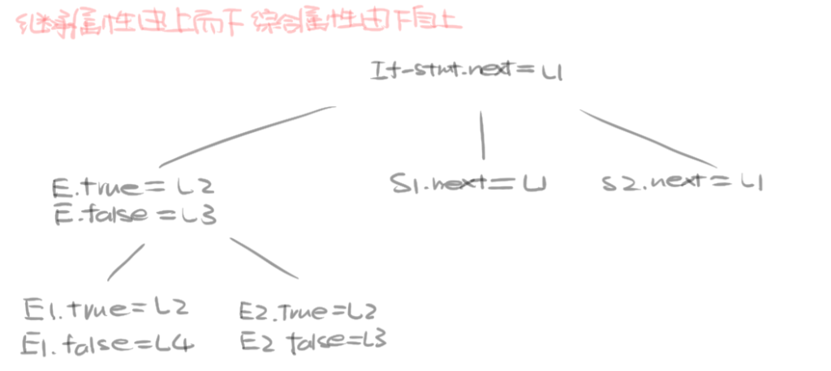

**由下至上计算综合属性**

