1. Which of the following is the feature of compiler?

A. The compiler may expand macros into source language statements.

B. The compiler translates the source program into target program.

C. The compiler directly executes the operations specified in the source program on inputs.

D. The compiler put together all of the executable object files into memory for execution.

2. The regular expression which has all strings of 0's and l's with no two consecutive 0's is ()

A. (00 | 11) B. (0|1) *

C. (0|ε) (1 | 10) * D. (0|ε) *011

3. Which is the regular expression for the following NFA?

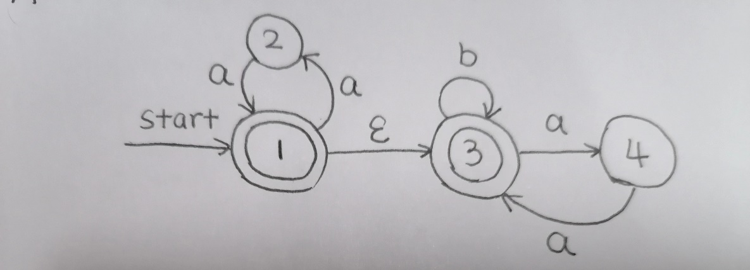

A. (aa)*(b|aa)*

B. aa(b|aa)*

C. (aa)*(b|aa)

D. aabaa

4. Which of the following is LL(1) grammar?

A. G(A): A →bAb | b

B. G(A): A →bAb | ε

C. G(A): A →bAc | ε

D. None of the above.

5. Which one of the following is true about parsing stack in LR parsing?

A. Handles for reduction can be found at the bottom of parsing stack.

B. Only non-terminals can be found in parsing stack.

C. Only terminals can be found at the top of parsing stack.

D. None.

6. A top-down predictive parser generates ()?

A. Rightmost Derivation

B. Rightmost Derivation in reverse

C. Leftmost Derivation

D. Leftmost Derivation in reverse

7. Which of the following is intermediate representation form?

A. Source Code.

B. Symbol Table.

C. Three Address Code.

D. All of the above.

8. Which of the following is an error recovery strategy for Syntax Analysis?

A. Maximal Munch Rule

B. Rewriting the grammar

C. Adding priority rules

D. Panic Mode

9. Which is NOT correct?

A. A grammar is called S-attributed if all attributes are Synthesized.

B. A grammar is called LL (1) grammar if the parse tree is unique for any string for corresponding language.

C. A grammar is context-free grammar if the grammar is LL (1) Grammar.

D. A grammar is context-free grammar if the grammar is SLR (1) Grammar.

10. What data structure in a compiler is used for managing information about variables and their attributes?

A. Abstract syntax tree B. Symbol table

C. Parse stack D. Parse table

**Solution:**

1. B

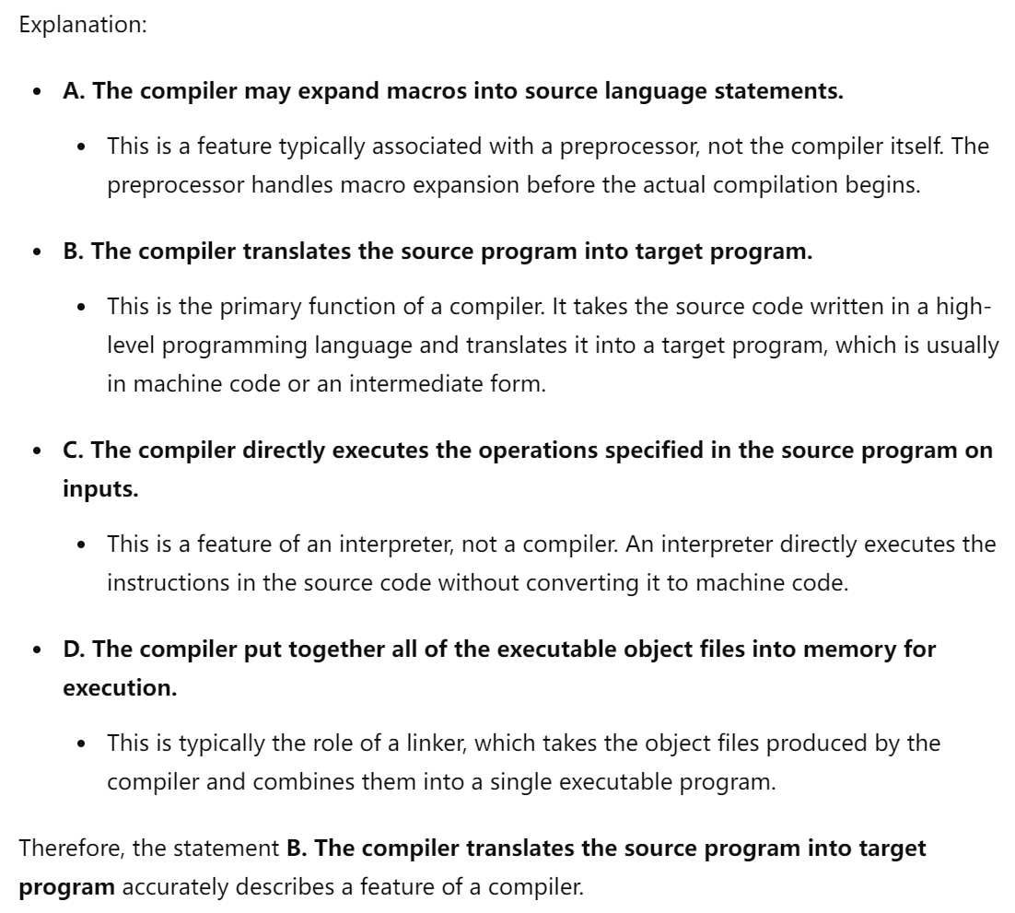

2. C

举出反例即可 A. 00 B. 00 D. 0011

3. A

先排除 B 和 D，因为第一个输入的字符甚至可能是 b

然后排除 C，因为输入b或aa后仍然可以继续输入

4. C

A选项 —— 公共左因子

B 选项 —— 间接左递归

5. D

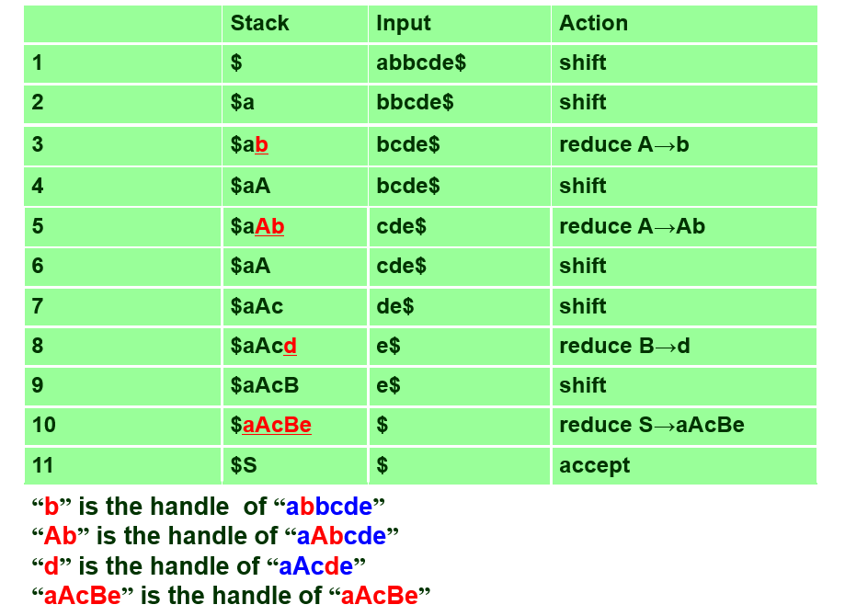

6. C

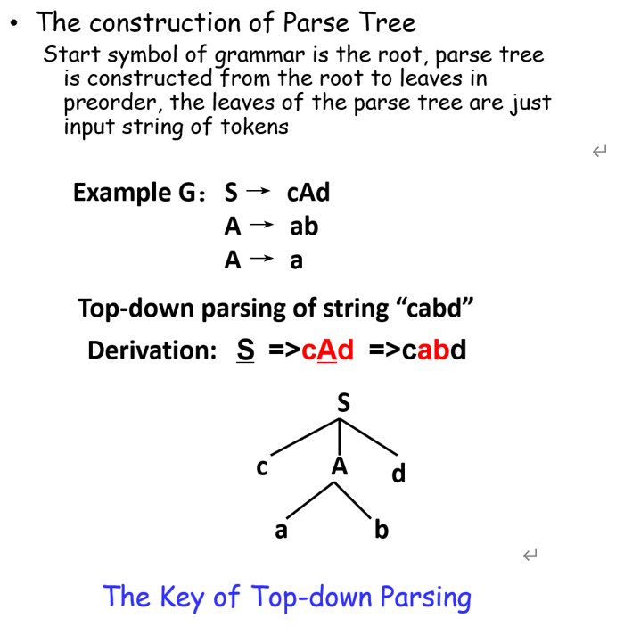

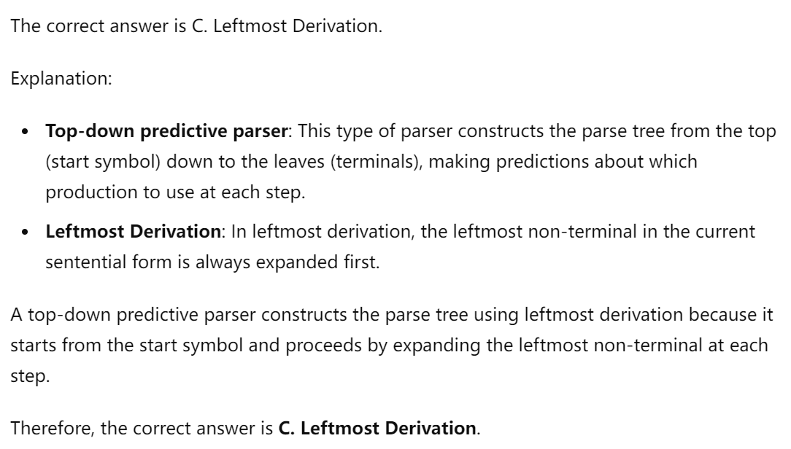

7. C

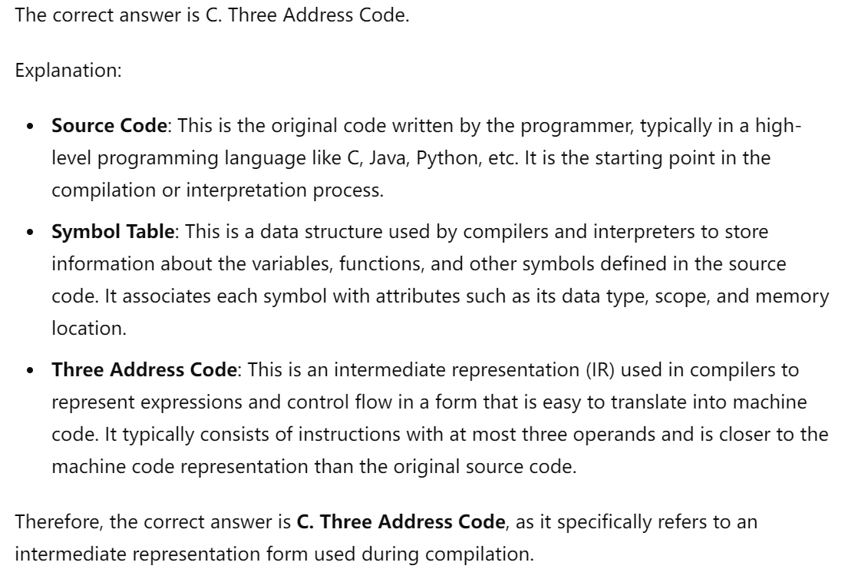

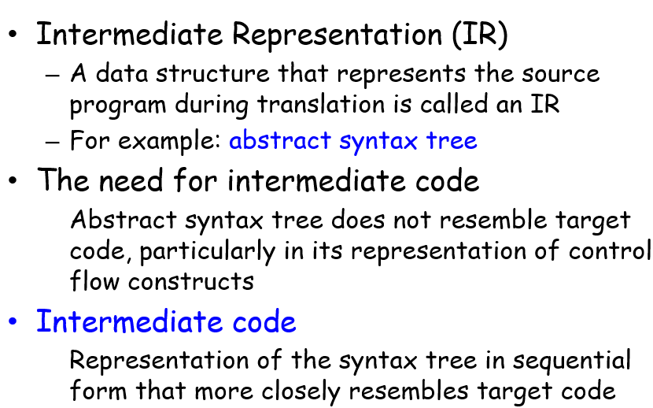

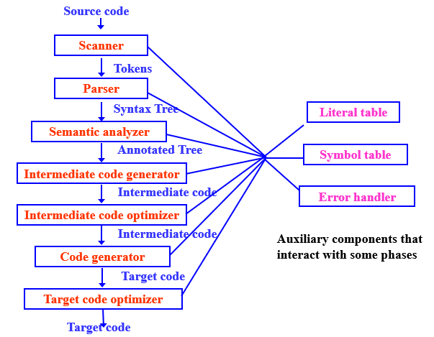

8. D

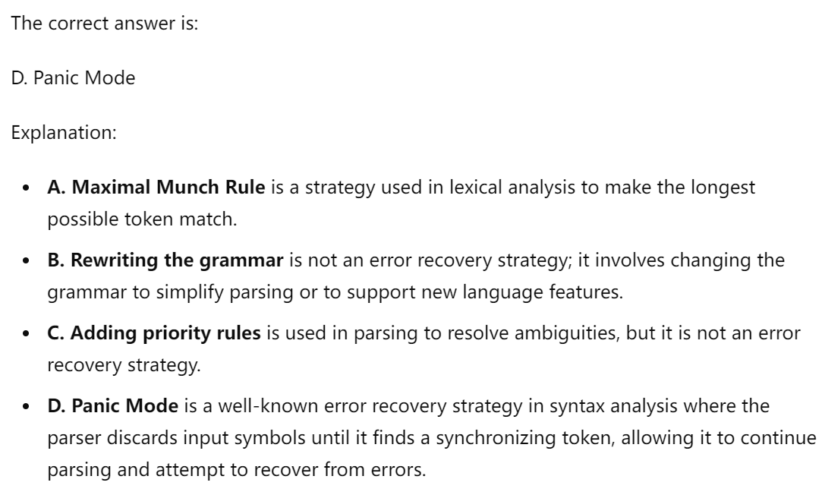

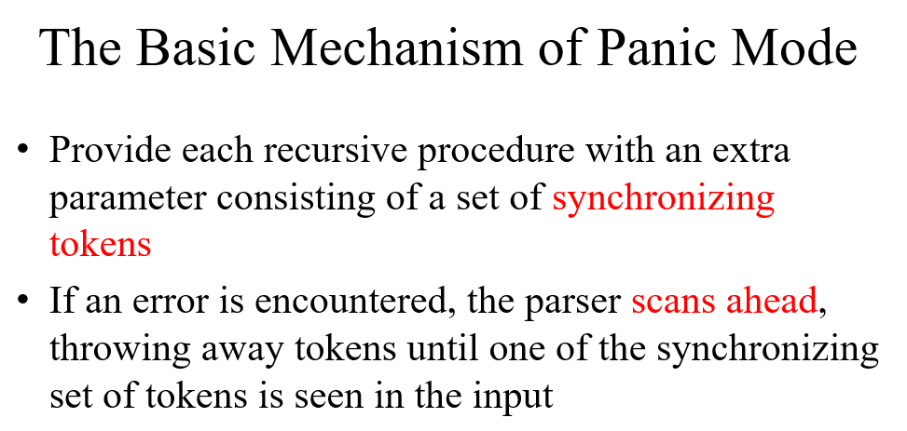

9. B

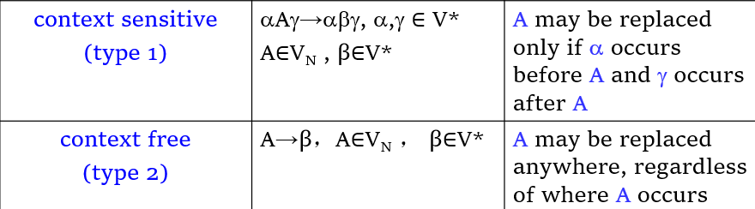

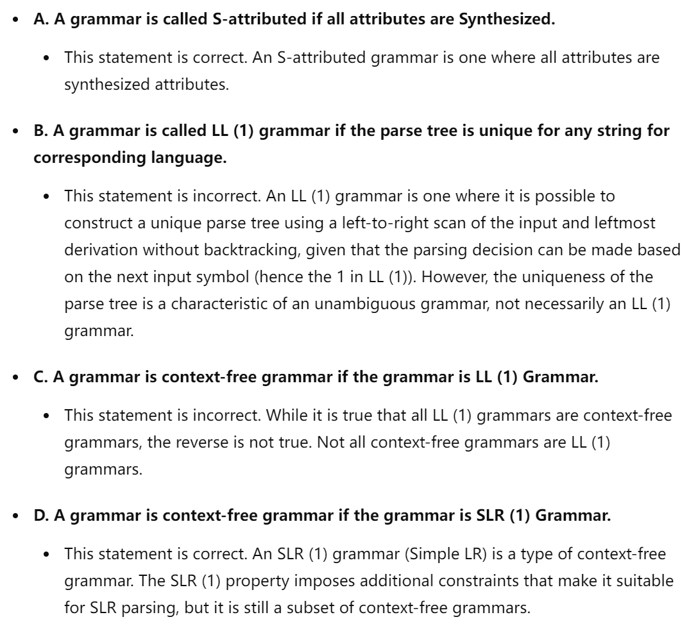

10. B

