Informe

Aplicación para resolver el área de figuras 2 capas diseño de interface

**Nombre: David Toro**

**Fecha:18/1/2024**

**Diseño:**

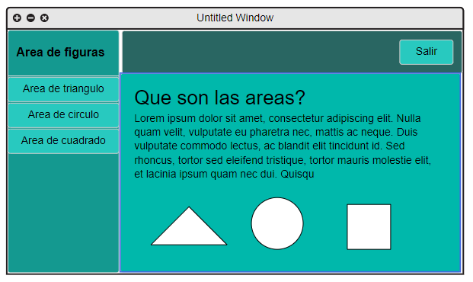

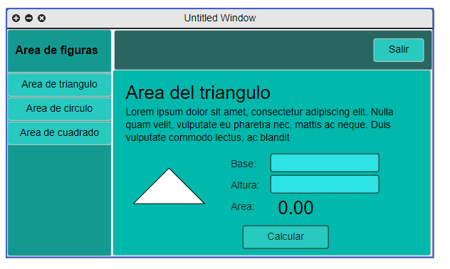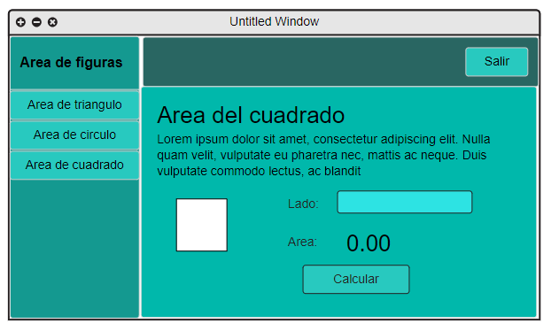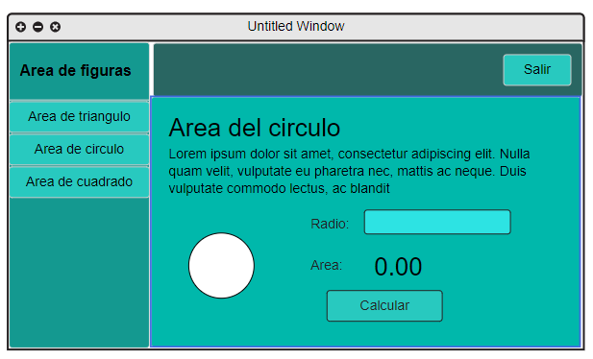

**Codigo:**

**MenuJFrame:**

/*

* Click nbfs://nbhost/SystemFileSystem/Templates/Licenses/license-default.txt to change this license

* Click nbfs://nbhost/SystemFileSystem/Templates/GUIForms/JFrame.java to edit this template

*/

package frontend;

/**

*

* @author david

*/

public class MenuJFrame extends javax.swing.JFrame {

/**

* Creates new form MenuJFrame

*/

public MenuJFrame() {

initComponents();

jLabelTitulo.putClientProperty( "FlatLaf.styleClass", "h2" );

jButtonTriangulo.putClientProperty("FlatLaf.styleClass", "h3");

jButtonCuadrado.putClientProperty("FlatLaf.styleClass", "h3");

jButtonCirculo.putClientProperty("FlatLaf.styleClass", "h3");

jButtonSalir.putClientProperty("FlatLaf.styleClass", "h3");

MenuJPanel menu =new MenuJPanel();

menu.setSize(jPanelContenido.getWidth(),jPanelContenido.getHeight());

menu.setLocation(0, 0);

jPanelContenido.removeAll();

jPanelContenido.add(menu);

jPanelContenido.revalidate();

jPanelContenido.repaint();

}

/**

* This method is called from within the constructor to initialize the form.

* WARNING: Do NOT modify this code. The content of this method is always

* regenerated by the Form Editor.

*/

@SuppressWarnings("unchecked")

// <editor-fold defaultstate="collapsed" desc="Generated Code">

private void initComponents() {

jPanelLateral = new javax.swing.JPanel();

jLabelTitulo = new javax.swing.JLabel();

jButtonTriangulo = new javax.swing.JButton();

jButtonCirculo = new javax.swing.JButton();

jButtonCuadrado = new javax.swing.JButton();

jPanelSuperior = new javax.swing.JPanel();

jButtonSalir = new javax.swing.JButton();

jPanelContenido = new javax.swing.JPanel();

setDefaultCloseOperation(javax.swing.WindowConstants.EXIT_ON_CLOSE);

setPreferredSize(new java.awt.Dimension(600, 350));

jPanelLateral.setBackground(new java.awt.Color(20, 153, 144));

jLabelTitulo.setHorizontalAlignment(javax.swing.SwingConstants.CENTER);

jLabelTitulo.setText("Areas de figuras");

jLabelTitulo.setToolTipText("");

jButtonTriangulo.setText("Area del triangulo");

jButtonTriangulo.addActionListener(new java.awt.event.ActionListener() {

public void actionPerformed(java.awt.event.ActionEvent evt) {

jButtonTrianguloActionPerformed(evt);

}

});

jButtonCirculo.setText("Area del circulo");

jButtonCirculo.addActionListener(new java.awt.event.ActionListener() {

public void actionPerformed(java.awt.event.ActionEvent evt) {

jButtonCirculoActionPerformed(evt);

}

});

jButtonCuadrado.setText("Area del cuadrado");

jButtonCuadrado.addActionListener(new java.awt.event.ActionListener() {

public void actionPerformed(java.awt.event.ActionEvent evt) {

jButtonCuadradoActionPerformed(evt);

}

});

javax.swing.GroupLayout jPanelLateralLayout = new javax.swing.GroupLayout(jPanelLateral);

jPanelLateral.setLayout(jPanelLateralLayout);

jPanelLateralLayout.setHorizontalGroup(

jPanelLateralLayout.createParallelGroup(javax.swing.GroupLayout.Alignment.LEADING)

.addComponent(jButtonTriangulo, javax.swing.GroupLayout.PREFERRED_SIZE, 160, javax.swing.GroupLayout.PREFERRED_SIZE)

.addComponent(jButtonCirculo, javax.swing.GroupLayout.PREFERRED_SIZE, 160, javax.swing.GroupLayout.PREFERRED_SIZE)

.addComponent(jButtonCuadrado, javax.swing.GroupLayout.PREFERRED_SIZE, 160, javax.swing.GroupLayout.PREFERRED_SIZE)

.addGroup(jPanelLateralLayout.createSequentialGroup()

.addGap(19, 19, 19)

.addComponent(jLabelTitulo))

);

jPanelLateralLayout.setVerticalGroup(

jPanelLateralLayout.createParallelGroup(javax.swing.GroupLayout.Alignment.LEADING)

.addGroup(jPanelLateralLayout.createSequentialGroup()

.addGap(26, 26, 26)

.addComponent(jLabelTitulo)

.addGap(18, 18, 18)

.addComponent(jButtonTriangulo, javax.swing.GroupLayout.PREFERRED_SIZE, 40, javax.swing.GroupLayout.PREFERRED_SIZE)

.addGap(0, 0, 0)

.addComponent(jButtonCirculo, javax.swing.GroupLayout.PREFERRED_SIZE, 40, javax.swing.GroupLayout.PREFERRED_SIZE)

.addGap(0, 0, 0)

.addComponent(jButtonCuadrado, javax.swing.GroupLayout.PREFERRED_SIZE, 40, javax.swing.GroupLayout.PREFERRED_SIZE))

);

jPanelSuperior.setBackground(new java.awt.Color(41, 102, 98));

jPanelSuperior.setPreferredSize(new java.awt.Dimension(440, 60));

jButtonSalir.setText("Salir");

jButtonSalir.addActionListener(new java.awt.event.ActionListener() {

public void actionPerformed(java.awt.event.ActionEvent evt) {

jButtonSalirActionPerformed(evt);

}

});

javax.swing.GroupLayout jPanelSuperiorLayout = new javax.swing.GroupLayout(jPanelSuperior);

jPanelSuperior.setLayout(jPanelSuperiorLayout);

jPanelSuperiorLayout.setHorizontalGroup(

jPanelSuperiorLayout.createParallelGroup(javax.swing.GroupLayout.Alignment.LEADING)

.addGroup(javax.swing.GroupLayout.Alignment.TRAILING, jPanelSuperiorLayout.createSequentialGroup()

.addContainerGap(351, Short.MAX_VALUE)

.addComponent(jButtonSalir)

.addGap(17, 17, 17))

);

jPanelSuperiorLayout.setVerticalGroup(

jPanelSuperiorLayout.createParallelGroup(javax.swing.GroupLayout.Alignment.LEADING)

.addGroup(jPanelSuperiorLayout.createSequentialGroup()

.addGap(16, 16, 16)

.addComponent(jButtonSalir)

.addContainerGap(21, Short.MAX_VALUE))

);

javax.swing.GroupLayout jPanelContenidoLayout = new javax.swing.GroupLayout(jPanelContenido);

jPanelContenido.setLayout(jPanelContenidoLayout);

jPanelContenidoLayout.setHorizontalGroup(

jPanelContenidoLayout.createParallelGroup(javax.swing.GroupLayout.Alignment.LEADING)

.addGap(0, 0, Short.MAX_VALUE)

);

jPanelContenidoLayout.setVerticalGroup(

jPanelContenidoLayout.createParallelGroup(javax.swing.GroupLayout.Alignment.LEADING)

.addGap(0, 0, Short.MAX_VALUE)

);

javax.swing.GroupLayout layout = new javax.swing.GroupLayout(getContentPane());

getContentPane().setLayout(layout);

layout.setHorizontalGroup(

layout.createParallelGroup(javax.swing.GroupLayout.Alignment.LEADING)

.addGroup(layout.createSequentialGroup()

.addComponent(jPanelLateral, javax.swing.GroupLayout.PREFERRED_SIZE, javax.swing.GroupLayout.DEFAULT_SIZE, javax.swing.GroupLayout.PREFERRED_SIZE)

.addGroup(layout.createParallelGroup(javax.swing.GroupLayout.Alignment.LEADING)

.addComponent(jPanelContenido, javax.swing.GroupLayout.DEFAULT_SIZE, javax.swing.GroupLayout.DEFAULT_SIZE, Short.MAX_VALUE)

.addComponent(jPanelSuperior, javax.swing.GroupLayout.DEFAULT_SIZE, javax.swing.GroupLayout.DEFAULT_SIZE, Short.MAX_VALUE)))

);

layout.setVerticalGroup(

layout.createParallelGroup(javax.swing.GroupLayout.Alignment.LEADING)

.addComponent(jPanelLateral, javax.swing.GroupLayout.DEFAULT_SIZE, javax.swing.GroupLayout.DEFAULT_SIZE, Short.MAX_VALUE)

.addGroup(layout.createSequentialGroup()

.addGap(60, 60, 60)

.addComponent(jPanelContenido, javax.swing.GroupLayout.DEFAULT_SIZE, javax.swing.GroupLayout.DEFAULT_SIZE, Short.MAX_VALUE))

.addComponent(jPanelSuperior, javax.swing.GroupLayout.PREFERRED_SIZE, javax.swing.GroupLayout.DEFAULT_SIZE, javax.swing.GroupLayout.PREFERRED_SIZE)

);

pack();

}// </editor-fold>

private void jButtonCirculoActionPerformed(java.awt.event.ActionEvent evt) {

CirculoJPanel cir =new CirculoJPanel();

cir.setSize(jPanelContenido.getWidth(),jPanelContenido.getHeight());

cir.setLocation(0, 0);

jPanelContenido.removeAll();

jPanelContenido.add(cir);

jPanelContenido.revalidate();

jPanelContenido.repaint();

}

private void jButtonTrianguloActionPerformed(java.awt.event.ActionEvent evt) {

TrianguloJPanel tri =new TrianguloJPanel();

tri.setSize(jPanelContenido.getWidth(),jPanelContenido.getHeight());

tri.setLocation(0, 0);

jPanelContenido.removeAll();

jPanelContenido.add(tri);

jPanelContenido.revalidate();

jPanelContenido.repaint();

}

private void jButtonSalirActionPerformed(java.awt.event.ActionEvent evt) {

dispose();

}

private void jButtonCuadradoActionPerformed(java.awt.event.ActionEvent evt) {

CuadradoJPanel cua =new CuadradoJPanel();

cua.setSize(jPanelContenido.getWidth(),jPanelContenido.getHeight());

cua.setLocation(0, 0);

jPanelContenido.removeAll();

jPanelContenido.add(cua);

jPanelContenido.revalidate();

jPanelContenido.repaint();

}

/**

* @param args the command line arguments

*/

public static void main(String args[]) {

/* Set the Nimbus look and feel */

//<editor-fold defaultstate="collapsed" desc=" Look and feel setting code (optional) ">

/* If Nimbus (introduced in Java SE 6) is not available, stay with the default look and feel.

* For details see http://download.oracle.com/javase/tutorial/uiswing/lookandfeel/plaf.html

*/

try {

for (javax.swing.UIManager.LookAndFeelInfo info : javax.swing.UIManager.getInstalledLookAndFeels()) {

if ("Nimbus".equals(info.getName())) {

javax.swing.UIManager.setLookAndFeel(info.getClassName());

break;

}

}

} catch (ClassNotFoundException ex) {

java.util.logging.Logger.getLogger(MenuJFrame.class.getName()).log(java.util.logging.Level.SEVERE, null, ex);

} catch (InstantiationException ex) {

java.util.logging.Logger.getLogger(MenuJFrame.class.getName()).log(java.util.logging.Level.SEVERE, null, ex);

} catch (IllegalAccessException ex) {

java.util.logging.Logger.getLogger(MenuJFrame.class.getName()).log(java.util.logging.Level.SEVERE, null, ex);

} catch (javax.swing.UnsupportedLookAndFeelException ex) {

java.util.logging.Logger.getLogger(MenuJFrame.class.getName()).log(java.util.logging.Level.SEVERE, null, ex);

}

//</editor-fold>

/* Create and display the form */

java.awt.EventQueue.invokeLater(new Runnable() {

public void run() {

new MenuJFrame().setVisible(true);

}

});

}

// Variables declaration - do not modify

private javax.swing.JButton jButtonCirculo;

private javax.swing.JButton jButtonCuadrado;

private javax.swing.JButton jButtonSalir;

private javax.swing.JButton jButtonTriangulo;

private javax.swing.JLabel jLabelTitulo;

private javax.swing.JPanel jPanelContenido;

private javax.swing.JPanel jPanelLateral;

private javax.swing.JPanel jPanelSuperior;

// End of variables declaration

}

**MenuJPanel:**

/*

* Click nbfs://nbhost/SystemFileSystem/Templates/Licenses/license-default.txt to change this license

* Click nbfs://nbhost/SystemFileSystem/Templates/GUIForms/JPanel.java to edit this template

*/

package frontend;

import javax.swing.ImageIcon;

/**

*

* @author david

*/

public class MenuJPanel extends javax.swing.JPanel {

/**

* Creates new form MenuJPanel

*/

public MenuJPanel() {

initComponents();

jLabelTitulo.putClientProperty( "FlatLaf.styleClass", "h2" );

jLabelParrafo.putClientProperty( "FlatLaf.styleClass", "h4" );

}

/**

* This method is called from within the constructor to initialize the form.

* WARNING: Do NOT modify this code. The content of this method is always

* regenerated by the Form Editor.

*/

@SuppressWarnings("unchecked")

// <editor-fold defaultstate="collapsed" desc="Generated Code">

private void initComponents() {

jToggleButton1 = new javax.swing.JToggleButton();

jLabelTitulo = new javax.swing.JLabel();

jLabelParrafo = new javax.swing.JLabel();

jLabel3 = new javax.swing.JLabel();

jLabel1 = new javax.swing.JLabel();

jLabel2 = new javax.swing.JLabel();

jToggleButton1.setText("jToggleButton1");

setPreferredSize(new java.awt.Dimension(424, 251));

jLabelTitulo.setHorizontalAlignment(javax.swing.SwingConstants.CENTER);

jLabelTitulo.setText("¿Que son las areas?");

jLabelTitulo.setToolTipText("");

jLabelParrafo.setText("<html>Se utiliza para medir la extensión de una superficie bidimensional. El cálculo del área implica la multiplicación de dos dimensiones, como la longitud y el ancho, en el caso de figuras como cuadrados y rectángulos. Para figuras complejas, como triángulos o círculos, se aplican fórmulas.</html>");

jLabel3.setIcon(new javax.swing.ImageIcon("F:/poo/areasFigurasGrafico/src/main/java/resourses/circulo.png"));

jLabel1.setIcon(new javax.swing.ImageIcon("F:/poo/areasFigurasGrafico/src/main/java/resourses/cuadrado.png"));

jLabel1.setPreferredSize(new java.awt.Dimension(75, 75));

jLabel2.setIcon(new javax.swing.ImageIcon("F:/poo/areasFigurasGrafico/src/main/java/resourses/triangulo.png"));

jLabel2.setPreferredSize(new java.awt.Dimension(75, 75));

javax.swing.GroupLayout layout = new javax.swing.GroupLayout(this);

this.setLayout(layout);

layout.setHorizontalGroup(

layout.createParallelGroup(javax.swing.GroupLayout.Alignment.LEADING)

.addGroup(layout.createSequentialGroup()

.addGroup(layout.createParallelGroup(javax.swing.GroupLayout.Alignment.LEADING)

.addGroup(layout.createSequentialGroup()

.addContainerGap()

.addComponent(jLabelParrafo, javax.swing.GroupLayout.PREFERRED_SIZE, 395, javax.swing.GroupLayout.PREFERRED_SIZE))

.addGroup(layout.createSequentialGroup()

.addGap(17, 17, 17)

.addComponent(jLabelTitulo))

.addGroup(layout.createSequentialGroup()

.addGap(33, 33, 33)

.addComponent(jLabel3, javax.swing.GroupLayout.PREFERRED_SIZE, 75, javax.swing.GroupLayout.PREFERRED_SIZE)

.addGap(43, 43, 43)

.addComponent(jLabel1, javax.swing.GroupLayout.PREFERRED_SIZE, javax.swing.GroupLayout.DEFAULT_SIZE, javax.swing.GroupLayout.PREFERRED_SIZE)

.addGap(42, 42, 42)

.addComponent(jLabel2, javax.swing.GroupLayout.PREFERRED_SIZE, javax.swing.GroupLayout.DEFAULT_SIZE, javax.swing.GroupLayout.PREFERRED_SIZE)))

.addContainerGap(23, Short.MAX_VALUE))

);

layout.setVerticalGroup(

layout.createParallelGroup(javax.swing.GroupLayout.Alignment.LEADING)

.addGroup(layout.createSequentialGroup()

.addGap(25, 25, 25)

.addComponent(jLabelTitulo)

.addPreferredGap(javax.swing.LayoutStyle.ComponentPlacement.UNRELATED)

.addComponent(jLabelParrafo, javax.swing.GroupLayout.PREFERRED_SIZE, 88, javax.swing.GroupLayout.PREFERRED_SIZE)

.addGap(18, 18, 18)

.addGroup(layout.createParallelGroup(javax.swing.GroupLayout.Alignment.TRAILING, false)

.addComponent(jLabel1, javax.swing.GroupLayout.PREFERRED_SIZE, javax.swing.GroupLayout.DEFAULT_SIZE, javax.swing.GroupLayout.PREFERRED_SIZE)

.addComponent(jLabel2, javax.swing.GroupLayout.PREFERRED_SIZE, javax.swing.GroupLayout.DEFAULT_SIZE, javax.swing.GroupLayout.PREFERRED_SIZE)

.addComponent(jLabel3, javax.swing.GroupLayout.PREFERRED_SIZE, 75, javax.swing.GroupLayout.PREFERRED_SIZE))

.addContainerGap(17, Short.MAX_VALUE))

);

}// </editor-fold>

// Variables declaration - do not modify

private javax.swing.JLabel jLabel1;

private javax.swing.JLabel jLabel2;

private javax.swing.JLabel jLabel3;

private javax.swing.JLabel jLabelParrafo;

private javax.swing.JLabel jLabelTitulo;

private javax.swing.JToggleButton jToggleButton1;

// End of variables declaration

}

**Main:**

/*

* Click nbfs://nbhost/SystemFileSystem/Templates/Licenses/license-default.txt to change this license

*/

package com.mycompany.areasfigurasgrafico;

import com.formdev.flatlaf.FlatLaf;

import com.formdev.flatlaf.FlatLightLaf;

import com.formdev.flatlaf.intellijthemes.FlatCyanLightIJTheme;

import com.formdev.flatlaf.intellijthemes.FlatDarkFlatIJTheme;

import frontend.MenuJFrame;

import java.awt.Color;

import java.util.Collections;

import javax.swing.UIManager;

/**

*

* @author david

*/

public class AreasFigurasGrafico {

public static void main(String[] args) {

FlatLaf.setGlobalExtraDefaults( Collections.singletonMap( "@accentColor", "#31524F" ) );

FlatLaf.setGlobalExtraDefaults( Collections.singletonMap( "@foreground", "#000000" ) );

FlatLightLaf.setup();

UIManager.put("Button.background", Color.decode("#28C9BF"));

UIManager.put("TextField.background", Color.decode("#2DE3E3"));

UIManager.put("Panel.background",Color.decode("#00B8AB"));

MenuJFrame menu = new MenuJFrame();

menu.setVisible(true);

}

}

**Proyecto:**

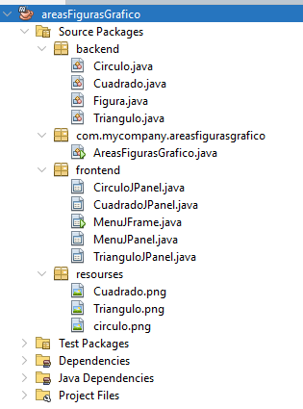

**Caso de prueba:**

