**Assign proper naming on all nodes in the diagram.**

**(Snapshot1: Topology Diagram)**

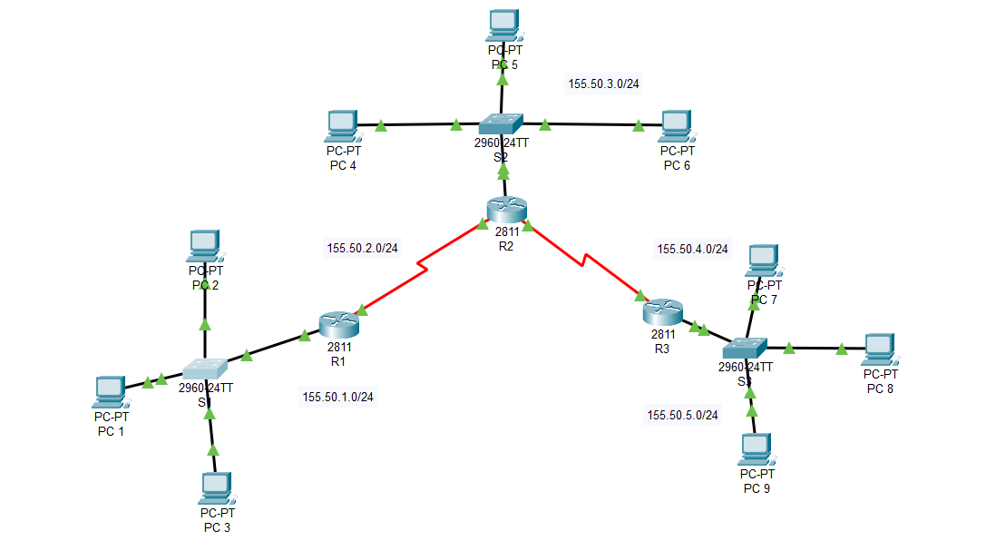

**Assign IP address, subnet mask and gateway on all PCs.**

**(Snapshot2-4: IP configuration of all PC1 on each site)**

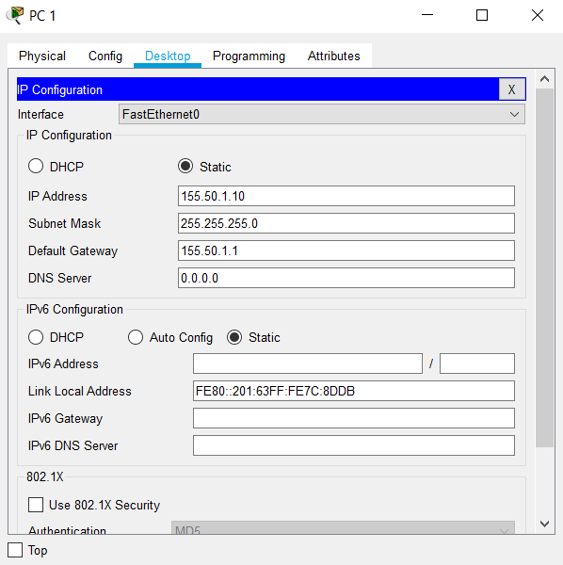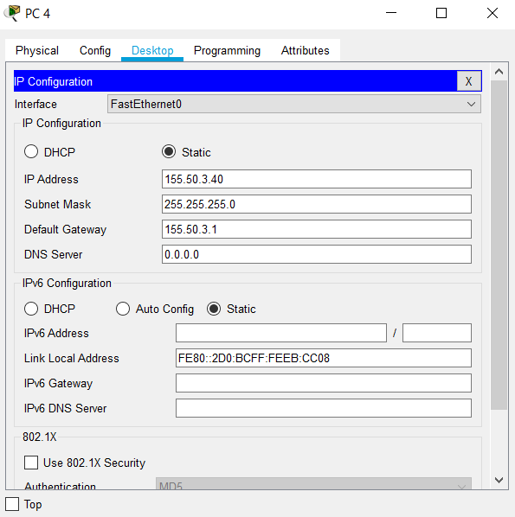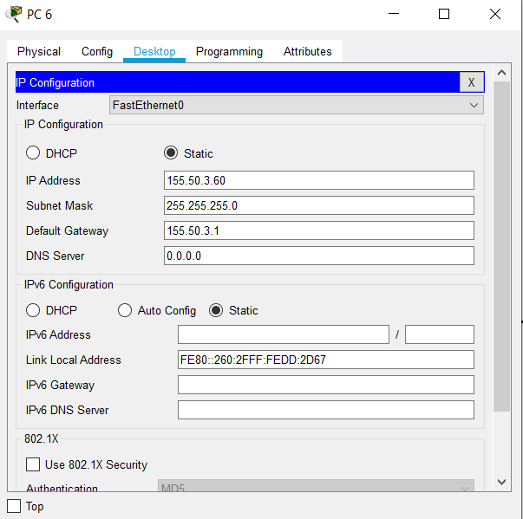

**Assign hostname of all routers and switches. (E.g; G1-R1)**

**(Snapshot5-10: Hostnames of all routers and switches)**

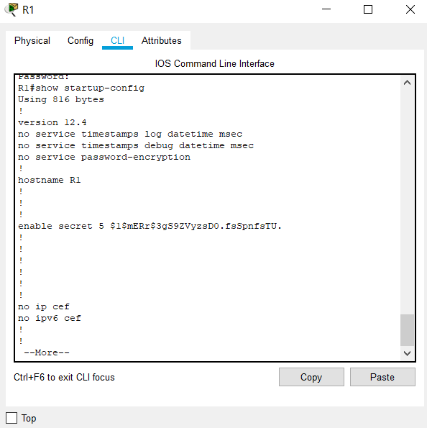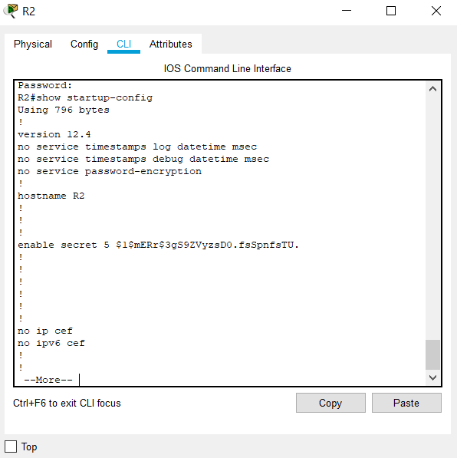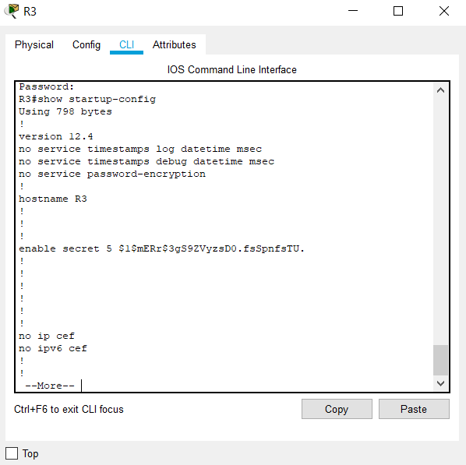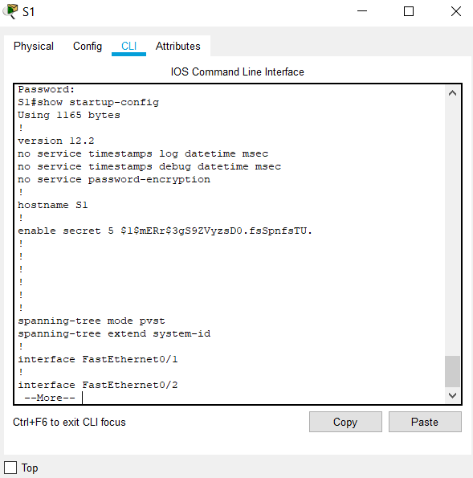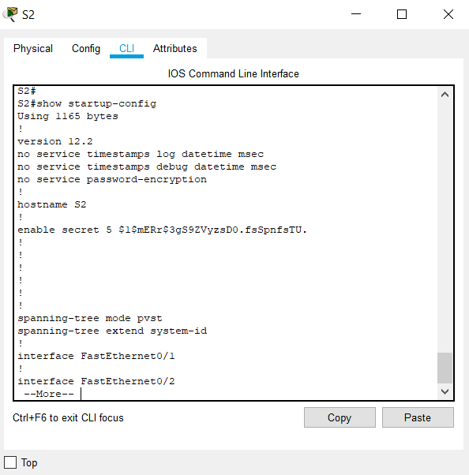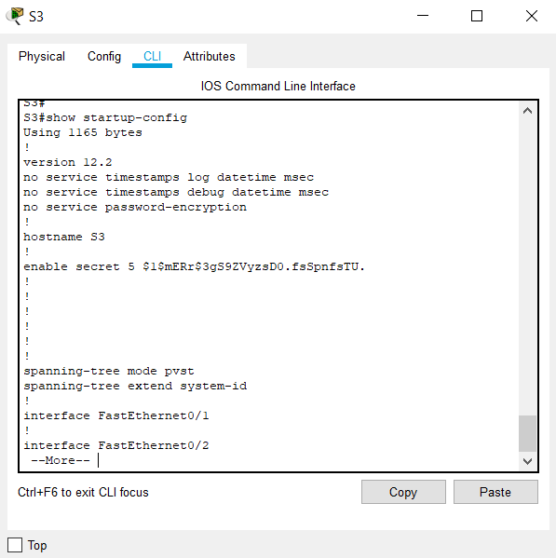

**Assign three types of passwords on all routers.**

**(Snapshot11-16: Passwords of all routers with “show startup-config”)**

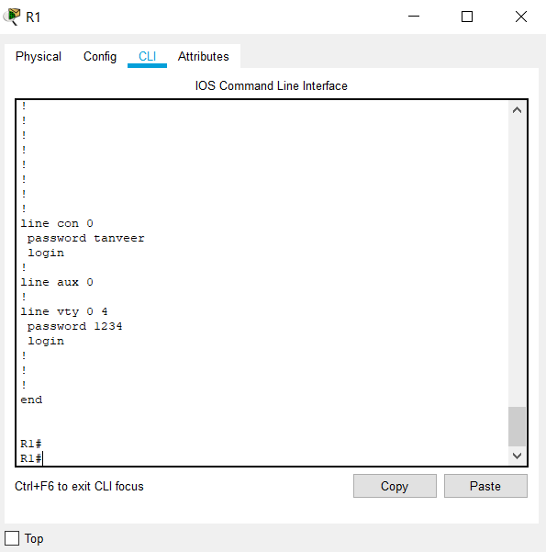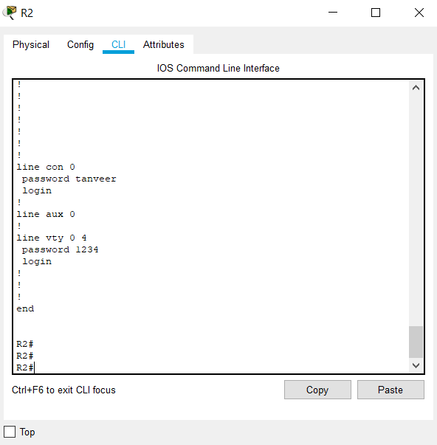

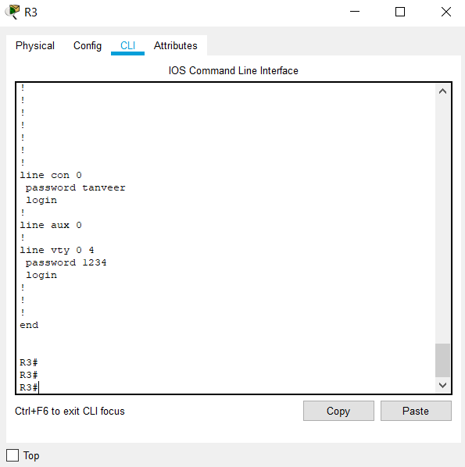

**Assign IP address and subnet mask on all interfaces according to the given below**

**addressing table.**

**(Snapshot17-19: IP addresses of all routers with “show ip interface brief”)**

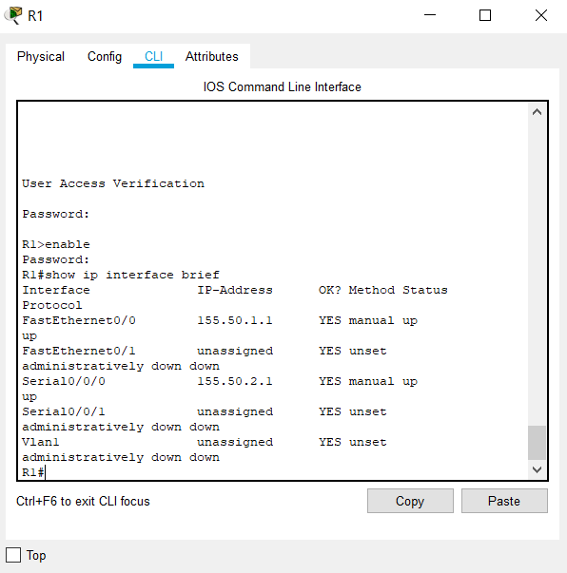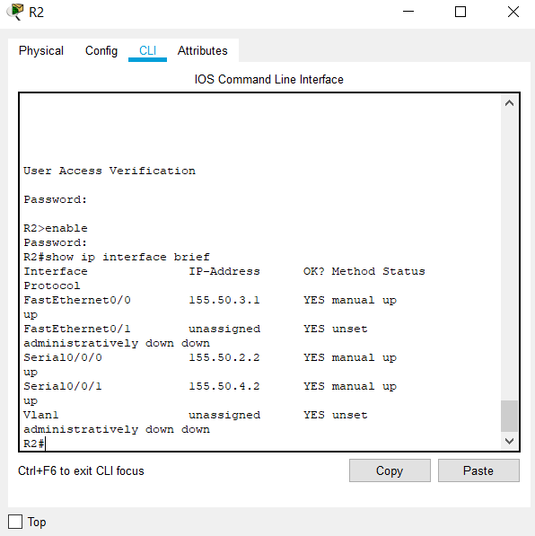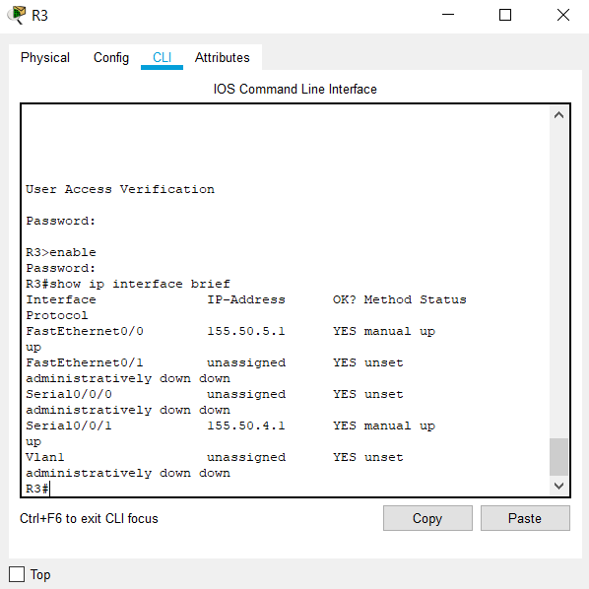

**Implement static routing on all routers and confirm the networks in the routing table.**

**(Snapshot20-22):Networks of all routers with “show ip route”**

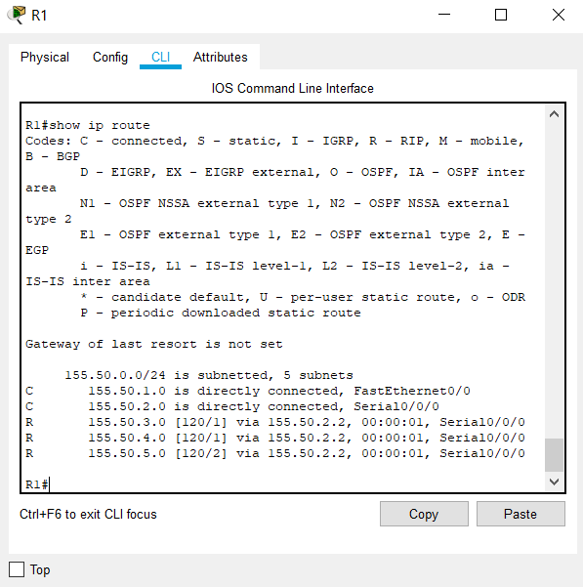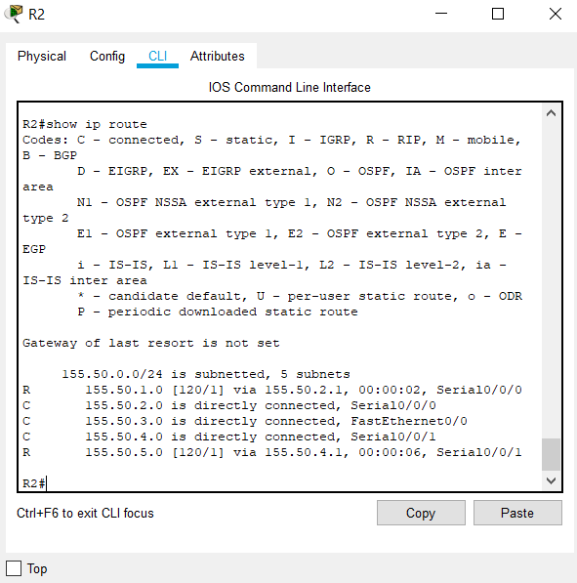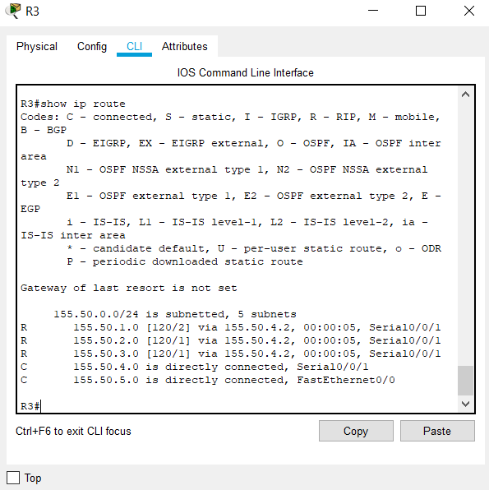

**Finally, perform the given below testing from all nodes.**

**ping PC1 of Site1 to PC4 of Site2,**

**ping PC1 of Site1 to PC7 of Site3,**

**ping PC5 of Site2 to PC2 of Site1,**

**ping PC5 of Site2 to PC8 of Site3,**

**ping PC9 of Site3 to PC3 of Site1,**

**ping PC9 of Site3 to PC6 of Site2,**

**(Snapshot23-28: Ping result of all given above commands from cmd**

**ping PC1 of Site1 to PC4 of Site2 ping PC1 of Site1 to PC7 of Site3**

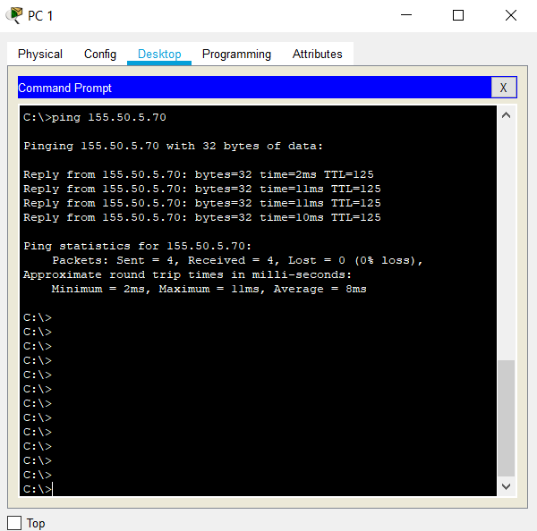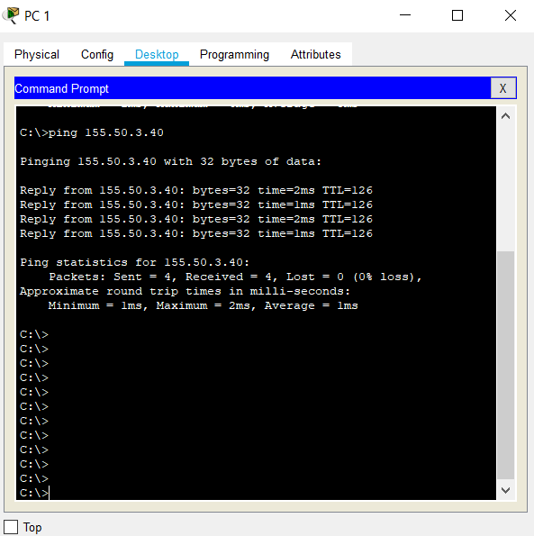

**ping PC5 of Site2 to PC2 of Site1 ping PC5 of Site2 to PC8 of Site3**

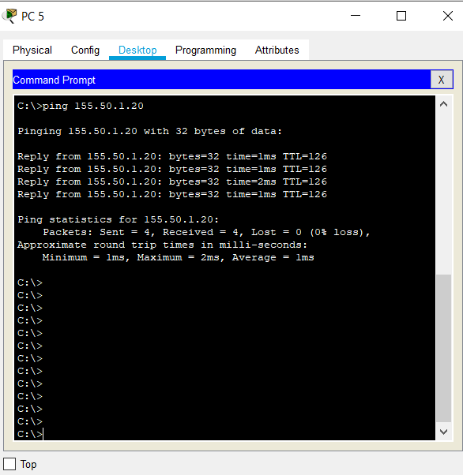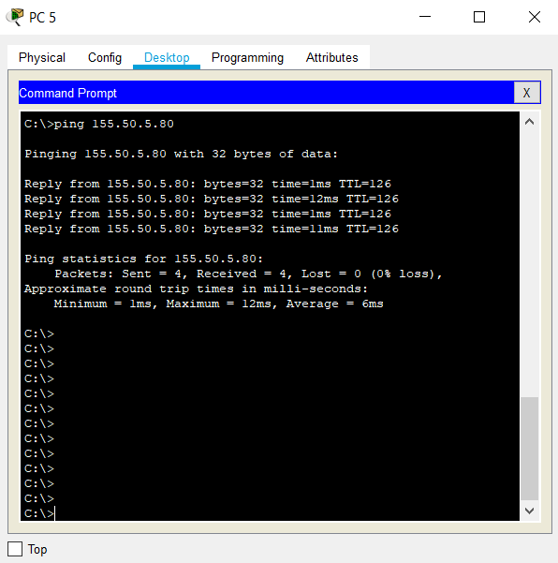

**ping PC9 of Site3 to PC3 of Site1 ping PC9 of Site3 to PC6 of Site2**

