**Q No.1- Describe the health organization with the assumptions of structural functional approach. Also describe its manifest and latent functions.**

**Health Organization:**

A sociological understanding emphasizes the influence of people’s social backgrounds on the quality of their health and health care. A society’s culture and social structure also affect health and health care.

According to the World Health Organization (WHO) we have control over all the world so (WHO) organization about corona viruses to protect yourself and others against COVID-19, clean your hands frequently and thoroughly. Use alcohol-based hand sanitizer or wash your hands with soap and water. If you use an alcohol-based hand sanitizer, make sure you use and store it carefully**. Globally difference between health in high income nation and low income nation .**

**Health in High-Income Nations:**

Obesity, that's on the upward push in high-profits nations, has been linked to many diseases, such as cardiovascular problems, musculoskeletal problems, diabetes, and respiratory issues. According to the Organisation for Economic Co-operation and Development (2013), weight problems fees are growing in all countries .several factors are contributing to the rise in obesity in developed countries:

* Improvements in era and reduced circle of relatives length have led to a discount of labour to be accomplished in family production.
* Unhealthy market goods, including processed foods, sweetened drinks, and sweet and salty snacks are changing home-produced goods.
* Leisure sports are growing extra sedentary; for example, laptop games, net surfing, and television viewing.
* More employees are shifting from lively work (agriculture and manufacturing) to carrier industries.
* Increased get admission to to passive transportation has led to greater riding and much less walking**.**

**Health in Low-Income Nations:**

It is not the cost of fitness care that is the most urgent concern. Rather, low-earnings nations should control such issues as infectious disease, high infant mortality charges, scarce medical personnel, and inadequate water and sewer systems. Such issues, which excessive-profits nations hardly ever even suppose about, are important to the lives of maximum people in low-income nations. Due to such fitness concerns, low-profits nations have higher costs of infant mortality and lower common lifestyles spans.

One of the most important participants to clinical troubles in low-income international locations is the shortage of get entry to to clean water and basic sanitation resources. According to a 2011 UNICEF report, almost 1/2 of the growing world’s population lacks improved sanitation facilities. The World Health Organization (WHO) tracks fitness-related facts for 193 nations. In their 2011 World Health Statistics report, they record the

**following statistics:**

* Globally, the rate of mortality for youngsters under five was 60 per 1,000 stay births. In low-earnings nations, however, that price is sort of double at 117 in keeping with 1,000 stay births. In excessive-earnings countries, that charge is extensively lower than 7 in line with 1,000 live births.
* The maximum frequent causes of demise for youngsters underneath five were pneumonia and diarrheal diseases, accounting for 18 percent and 15 percentage, respectively. These deaths could easily be avoidable with cleanser water and more insurance of to be had medical care.
* The availability of medical doctors and nurses in low-profits international locations is one-tenth that of nations with a excessive earnings. Challenges in get admission to to clinical schooling and get admission to to sufferers exacerbate this difficulty for would-be clinical specialists in low-profits nations (World Health Organization 2011).

**Functionalism :**

Good fitness best for health and powerful medical care are critical for the clean functioning of society. Patients must perform the “ill role” that allows you to be perceived as legitimately ill and to be exempt from their everyday obligations. The physician-affected person dating is hierarchical: The doctor gives instructions, and the patient wishes to follow them.

**Key words of Structure Approach of health organization**

* health disparities
* health education ethics
* health policy
* public health education
* public health interventions
* social ecological model
* structural approaches
* Hospitals
* Doctors
* Patients

**Conflict theory:**

Social inequality characterizes the fine of fitness and the best of fitness care. People from deprived social backgrounds are more likely to come to be sick and to receive inadequate health care. Partly to growth their incomes, physicians have tried to control the practice of medicine and to outline social troubles as medical issues.

**Symbolic interactions:**

Health and illness are social constructions: Physical and mental situations have little or no objective truth however alternatively is considered wholesome or ill conditions simplest if they may be described as such by a society. Physicians “manipulate the situation” to display their authority and medical knowledge

**Manifest functions:**

Manifest functions are generally expected from the institutions to be fulfilled. For example, hospitals are expected to provide better healthcare to the people or treat the patients going through any kinds of diseases, or those who met with an accident, etc.

**Latent function:**

example of latent function can be that in a hospital the doctors while treating a patient suffering from a certain kind of incurable disease somehow saves the patient, thus, discovering a new method of treating that particular disease. This distinction between the latent function and the manifest function is the reason sociologists tend to study beyond the reasons the individuals, institutions, etc normally offer for their actions.

They tend to search for the **social consequences** that lead to the various practices of society.In case of manifest functions, the actor is aware of the consequences of his action while in the latent functions, the actor is not aware of his actions. For instance, if a rule is made, the manifest function will be the intended function for the fulfilment of which the rule is made. On the contrary, the unintended function is the latent function, e.g. if the rule is made in order to maintain peace, but it harms the public, that harm will be the latent function.

**Complete chart Health organization**

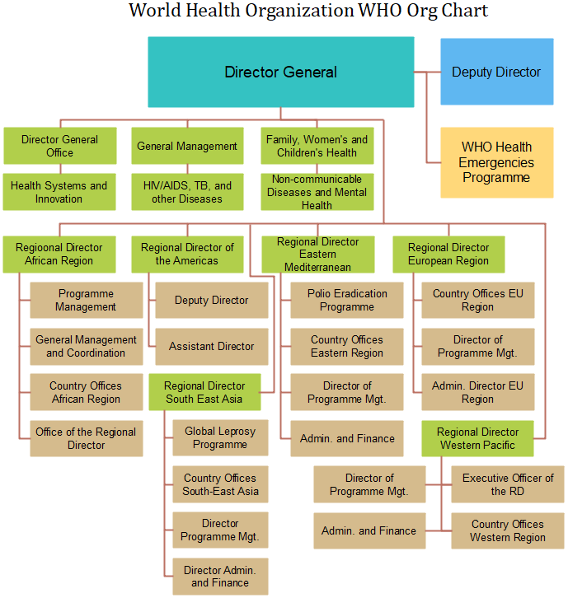

**Q No.2- Describe conflict theory with the perspective of Covid-19. Also describe its social, economic and political conflict**

**Describe conflict theory with the perspective of Covid-19**

The outbreak of COVID-19 has prompted concerns globally. On 30 January WHO has declared it as a global health emergency. The easy unfold of this virus made human beings to wear a masks as precautionary route, use gloves and hand sanitizer on a each day foundation that resulted in technology of a huge amount of clinical wastes within the environment. Millions of people have been put on lockdown for you to lessen the transmission of the virus. This epidemic has also changed the people's existence style; triggered enormous job losses and threatened the sustenance of millions of humans, as companies have close down to manipulate the spread of virus. All over the world, flights had been cancelled and transport structures were closed. Overall, the economic activities had been stopped and stock markets dropped at the side of the falling carbon emission. However, the lock down of the COVID-19 pandemic brought about the air best in many cities throughout the globe to enhance and drop in water pollutions in a few components of the world we not follow these statics then increases diseases. **Many person** not believe corona virus in Pakistan and other countries and they due to increases our diseases and its good any nation so we follow some Daily ruler rules are there:

**Several Highlights COVID-19 :**

•COVID-19 has been declared as a global health emergency due to unfold of corona virus.  
  
•To save you the transmission mask, surgical gloves and sanitizer have been used.  
  
•It has led to generation of big amount of clinical wastes within the environment.  
  
•Millions of people have been positioned below lockdown to lessen the transmission.  
  
•Reduction in economic activities and improved air and water pleasant across the globe.

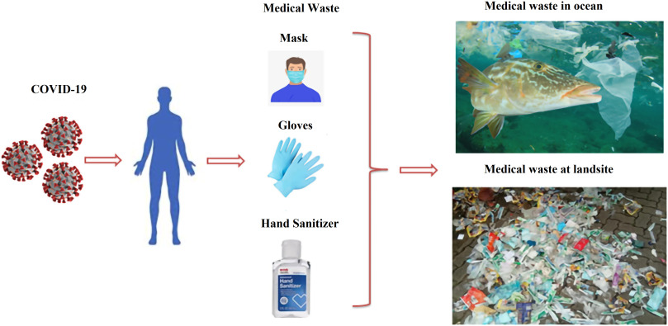

**Socially :**

Each person's thoughts and feelings approximately the coronavirus rely on the thoughts and feelings of every body else. The emotional valence, as well as the actual content, of a person's beliefs had been pulled one manner or another by way of the weight (and increasingly the lightness) of normal interactions. It's a collective concept we've made together, in conversation and over looks throughout distances, in group chats and on video-calls because social distance is must but few peoples are not follow so that why increase day by day our disease.

**Economic:**

The June 2020 Global Economic Prospects describes each the immediate and near-term outlook for the effect of the pandemic and the long-term harm it has dealt to potentialities for growth. The baseline forecast envisions a 5.2 percent contraction in worldwide GDP in 2020, using marketplace exchange price weights—the deepest international recession in decades, notwithstanding the extremely good efforts of governments to counter the downturn with fiscal and financial policy support.

**Polictal conflict:**

The worldwide outbreak has the potential to wreak havoc in fragile states, trigger enormous unrest and severely test global crisis control systems. Its implications are in particular severe for those caught inside the midst of battle if, as seems probable, the ailment disrupts humanitarian aid flows, limits peace operations and postpones or distracts warfare events from nascent in addition to ongoing efforts at diplomacy. Unscrupulous leaders may exploit the pandemic to strengthen their objectives in approaches that exacerbate domestic or worldwide crises – cracking down on dissent at domestic or escalating conflicts with rival states – on the belief that they'll break out with it while the world is in any other case occupied. COVID-19 has fuelled geopolitical friction, with the U.S. Blaming China for the disease even as Beijing attempts to win pals by supplying aid to affected countries, exacerbating current great-strength tensions that complicate cooperation on crisis management.

It isn't yet clear when and wherein the virus will hit hardest, and how economic, social and political elements may additionally converge to spark or irritate crises. Nor is it guaranteed that the pandemic’s consequences can be entirely or uniformly bad for peace and security. Natural screw ups have on occasion resulted within the diminution of conflicts, as rival events have had to paintings together, or at least preserve calm, to attention on preserving and rebuilding their societies. There were a few signs of governments looking to ease political tensions in the shadow of COVID-19 with, for example, the United Arab Emirates (UAE) and Kuwait supplying Iran – centre of one of the worst preliminary outbreaks outside China – humanitarian assistance. If the pandemic is probably to worsen some crises internationally, it may also create windows to improve others