**Assignment – 5**

**Q1. Write a program to encrypt the message "Are you Ready for class" using shift cipher with any key value. Then decrypt the message back to plain text.**

**A:**

*Pseudocode and Explanation –*

Input – a message string and a key value

First for loop converts all the character values into their respective number notations. Those are then further converted to cypher numbers using (x + key)mod26. All these numbers are stored in the vector – c_text.

Each number of this vector is then converted to their respective alphabetic notations. This is encrypted string which is stored in variable encrypted_text.

This encrypted text is then converted to decrypt numbers using (y-k)mod26. These numbers are then converted to their respective alphabet notation. This is decrypted string which is stored in variable decrypted_text.

*Code –*

#include<bits/stdc++.h>

using *namespace* std;

*int* main()

{

*int* key;

    string s;

    cout<<"Enter the message: "<<endl;

    cin>>s;

    cout<<"Enter the key value: "<<endl;

    cin>>key;

    // cout<<s;

    vector<*int*> c_text;

    for(*int* i=0;i<s.length();i++){

        if(*int*(s[i])>=65 && *int*(s[i])<=90){

*int* val = *int*(s[i]) - 'A';

*int* x = (val+key)%26;

            c_text.push_back(x);

        }else{

*int* val = *int*(s[i]) - 'a';

*int* x = (val+key)%26;

            c_text.push_back(x);

        }

    }

    // for(int i=0;i<c_text.size();i++){

    //     cout<<c_text[i]<<" ";

    // }

    string encrypted_text="";

    for(*int* i=0;i<c_text.size();i++){

        encrypted_text+=*char*(c_text[i]+65);

    }

    cout<<"The encrypted text is: "<<encrypted_text<<endl;

    string decryted_text="";

    for(*int* i=0;i<c_text.size();i++){

*int* val = c_text[i] - key;

*int* x;

        if(val<0){

            x = val+26;

        }else{

            x = val;

        }

        decryted_text+=*char*(x+65);

    }

    cout<<"The decrypted text is: "<<decryted_text<<endl;

}

*Output –*

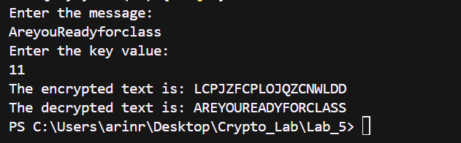

**Q2. Write a program to find the key value of the given cipher text (JBCRCLQRWCRVNBJENBWRWN).**

**A:**

*Pseudocode and Explanation –*

We check for all the values of key from 1 to 25. As we get all the decrypted string, We try to extract the most meaningful string.

*Code –*

#include<bits/stdc++.h>

using *namespace* std;

*int* main()

{

    string cipher_text = "JBCRCLQRWCRVNBJENBWRWN";

    // string cipher_text = "HPHTWWXPPELXTOYTRSE";

    vector<*int*> c_text;

    for(*int* i=0;i<cipher_text.length();i++){

*int* val = *int*(cipher_text[i] - 65);

        cout<<val<<" ";

        c_text.push_back(val);

    }

    for(*int* i=1;i<=25;i++){

*int* key = i;

        string decryted_text="";

        for(*int* i=0;i<c_text.size();i++){

*int* val = c_text[i] - key;

*int* x;

            if(val<0){

                x = val+26;

            }else{

                x = val;

            }

            decryted_text+=*char*(x+65);

        }

        cout<<"The decrypted text for key "<<key<<" is: "<<decryted_text<<endl;

    }

    // key = 9

// A stich in nine saves time

}

*Output –*

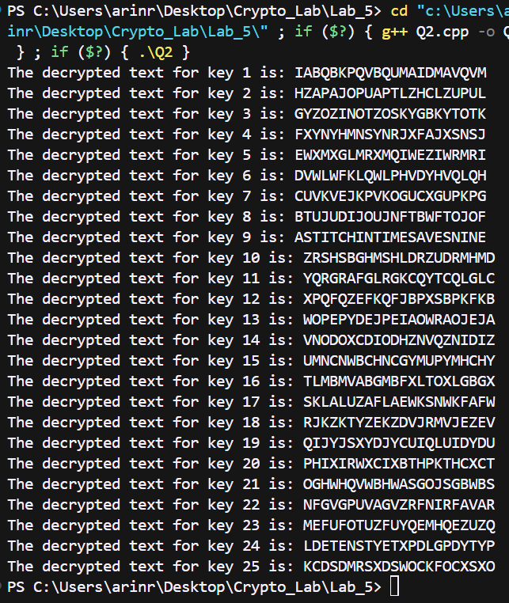

The string that is most meaningful is for key value 9 i.e. “A stich in nine saves time”.

**Q3. Implement Substitution Cipher.**

**A:** *Pseudocode and Explanation –*

Firstly, we took the user input of the characters that he wants to replace with. The string is encrypted now using that vector of replaced characters.

*Code –*

#include<bits/stdc++.h>

using *namespace* std;

*int* main()

{

    string s;

    cout<<"Enter the string: "<<endl;

    cin>>s;

    vector<*char*> subst;

    for(*int* i=0;i<26;i++){

*char* ch;

        cout<<"Enter the letter that will be replaced with "<<*char*(65+i)<<endl;

        cin>>ch;

        subst.push_back(ch);

    }

    // B C D E F G H I J K L M N O P Q R S T U V W X Y Z A

    string encrypted;

    for(*int* i=0;i<s.length();i++){

*int* val = *int*(s[i]-65);

        encrypted+=subst[val];

    }

    cout<<encrypted;

}

*Output –*

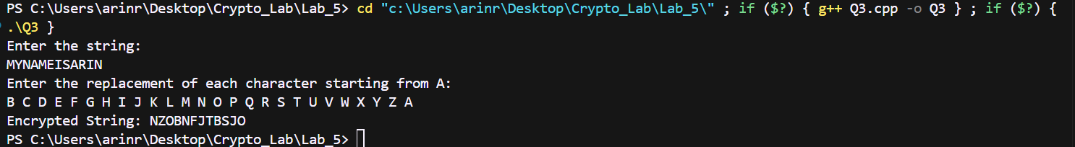

**Q4. Implement the first question for input: “I TRANSFERRED RS2034 TO YOU”**

**A:** *Pseudocode and Explanation –*

Firstly, I made a vector c_text that includes all the numbers and characters. In the next loop, using the same concept we will encrypt it using (x+key)modn.

*Code –*

#include<bits/stdc++.h>

using *namespace* std;

*int* main()

{

*int* key;

    string s;

    cout<<"Enter the message: "<<endl;

    cin>>s;

    cout<<"Enter the key value: "<<endl;

    cin>>key;

    // cout<<s;

    vector<*char*> c_text={'0','1','2','3','4','5','6','7','8','9','A','B','C', 'D', 'E', 'F', 'G', 'H', 'I', 'J', 'K', 'L', 'M', 'N', 'O', 'P', 'Q', 'R', 'S', 'T', 'U' ,'V', 'W', 'X', 'Y', 'Z'};

    string encrypted_text="";

    for(*int* i=0;i<s.length();i++){

*char* ch = s[i];

*int* val;

        for(*int* j=0;j<c_text.size();j++){

            if(ch == c_text[j]){

                val = j;

            }

        }

*int* x = (val+key)%36;

*char* cp = c_text[x];

        encrypted_text.push_back(cp);

    }

    cout<<encrypted_text;

}

*Output –*

