Hunger pizzas

Introduction
Hunger Pizzas is a pizza company that offers multiple pizza types, categories, and sizes. This sales analysis uses the company’s 2015 transaction data to examine how customers ordered and what they purchased. The data includes order dates and times, the pizzas in each order, quantities, sizes, listed prices, pizza categories, and ingredient descriptions.
The four tables work together to provide a view of sales. The orders table contains the date and time of each order. The order_details table lists the pizza items included in each order and the quantity ordered. The pizzas table links each pizza ID to a size and price. The pizza_types table provides the pizza’s name, category, and ingredients.
By joining these tables, the analysis can examine sales volume and estimated sales revenue by pizza, size, category, month, weekday, and hour. The dataset records 21,350 orders and 49,574 pizzas sold during 2015. Revenue is estimated using the listed pizza price multiplied by the quantity sold. This is sales revenue before costs; the data does not include expenses, discounts, taxes, or profit

2. Objectives of the Sales Analysis
The main objective is to understand Hunger Pizzas’ sales performance and identify patterns that may help the company make informed business decisions.
Specifically, the analysis aims to:
- Measure overall sales activity.
Count orders and pizzas sold during the year, and calculate revenue based on the listed prices. This provides a high-level view of business performance.
- Identify popular and less popular pizzas.
Compare the quantities sold for each pizza type. This can help identify customer favorites and products that may need further review.
- Compare pizza categories.
Examine the sales of Classic, Supreme, Veggie, and Chicken pizzas. Category-level results can help the business understand which broad product groups attract the most orders.
- Understand demand by pizza size.
Compare sales across sizes, such as Small, Medium, Large, XL, and XXL. This can support decisions about ingredient preparation and size availability.
- Review sales patterns over time.
Compare performance by month, weekday, and hour. This can help identify busy periods for scheduling staff, preparing ingredients, and managing stock.
- Provide practical findings for planning.
Summarize the patterns in a way that can guide menu reviews, promotions, and operational planning. Any decisions about profit or product costs would require additional cost data.

DataSet Description
The dataset consists of four CSV tables. Together, they describe orders, the items within each order, pizza sizes and prices, and information about each pizza type.
3.1 orders
The orders table contains 21,350 rows, with one row for each order. Its columns are:
- order_id — a unique identifier for an order.
- date — the date the order was placed.
- time — the time the order was placed.
This table is used to analyze the number and timing of orders. The recorded dates run from January 1, 2015, through December 31, 2015.
3.2 order_details
The order_details table contains 48,620 rows. Each row represents a pizza item on an order. Its columns are:
- order_details_id — a unique identifier for the order-detail row.
- order_id — the order containing the item.
- pizza_id — the specific pizza and size ordered.
- quantity — the number of units of that pizza included in the order.
An order can contain multiple detail rows, which is why there are more rows in order_details than in orders. Summing the quantity column gives 49,574 pizzas sold during the year.
3.3 pizzas
The pizzas table contains 96 rows. It describes the available size and listed price for each pizza ID. Its columns are:
- pizza_id — a unique identifier for a pizza in a particular size.
- pizza_type_id — the identifier for the pizza type.
- size — the size, such as S, M, L, XL, or XXL.
- price — the listed price for that pizza and size.
A single pizza type can have multiple rows in this table because it is offered in more than one size. The listed price is used with quantity to estimate sales revenue.
3.4 pizza_types
The pizza_types table contains 32 rows, one for each pizza type. Its columns are:
- pizza_type_id — a unique identifier for a pizza type.
- name — the full name of the pizza.
- category — the category, such as Classic, Supreme, Veggie, or Chicken.
- ingredients — a text description of the ingredients used.
This table supplies the names and categories used to make the sales results easier to interpret.
3.5 How the tables connect
The tables are joined using their ID columns:
- orders.order_id connects to order_details.order_id.
- order_details.pizza_id connects to pizzas.pizza_id.
- pizzas.pizza_type_id connects to pizza_types.pizza_type_id.
After the tables are joined, sales can be grouped by pizza name, category, size, date, or time. Estimated revenue is calculated as:
Revenue = Quantity sold × Listed price
This is an estimate of revenue based on the prices in the dataset. Because the tables do not include ingredient costs, labor, delivery expenses, discounts, or taxes, they cannot establish the company’s profit
Insights
- Retrieve the total number of orders placed
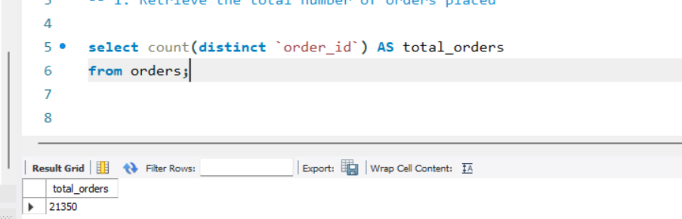
- Calculate the total revenue generated from pizza sales.

- Identify the highest-priced pizza.
- Identify the most common pizza size ordered.
- List the top 5 most ordered pizza types along with their quantities.
- Join the necessary tables to find the total quantity of each pizza category ordered.
- Determine the distribution of orders by hour of the day.
- Join relevant tables to find the category-wise distribution of pizzas.
- Group the orders by date and calculate the average number of pizzas ordered per day.

- Determine the top 3 most ordered pizza types based on revenue
Conclusion
The 2015 data shows substantial sales activity for Hunger Pizzas: 21,350 orders containing 49,574 pizzas. Using the listed prices, estimated total sales revenue was approximately $817,860. This gives the company a useful baseline for comparing product and time-period performance.
Product and category performance
The Classic category had the highest sales volume, with 14,888 pizzas sold, and also produced the highest category revenue at approximately $220,053. This suggests that Classic pizzas were an important part of the company’s sales in 2015. The Supreme category sold 11,987 pizzas, Veggie sold 11,649, and Chicken sold 11,050. All four categories contributed meaningfully to sales.
At the individual pizza level, the Classic Deluxe had the highest quantity sold, at 2,453 pizzas. The Barbecue Chicken, Hawaiian, and Pepperoni pizzas were also among the most popular by quantity. The Thai Chicken Pizza generated the most revenue among pizza types, at approximately $43,434. Its leading revenue result, despite not being the top pizza by quantity, indicates that unit volume alone does not determine revenue; listed prices and sizes also affect the total.
The Brie Carre Pizza had the lowest quantity sold, at 490 pizzas. This result may be useful when reviewing menu performance, but sales volume alone does not show whether a product is profitable or strategically valuable. The company could consider examining its costs, customer feedback, and sales trends before making menu changes.
Size performance
Large pizzas were the most frequently sold size, with 18,956 units. Medium pizzas accounted for 15,635 units, while Small pizzas accounted for 14,403. XL and XXL pizzas had much lower sales volumes, with 552 and 28 units, respectively.
These results may help Hunger Pizzas plan ingredient preparation and assess demand for each size. The low XL and XXL quantities could be reviewed alongside their prices, costs, and customer demand before the company decides whether to change their availability.
Timing patterns
July was the strongest month by both sales revenue and quantity, with approximately $72,558 in revenue and 4,392 pizzas sold. October had the lowest revenue, at approximately $64,028, and also had the lowest monthly quantity, with 3,883 pizzas sold. These differences suggest that sales varied across the year. The dataset can identify the variation, but it does not explain its causes.
By weekday, Friday had the highest sales revenue, at approximately $136,074. Sunday had the lowest, at approximately $99,204. By hour, the busiest period was lunchtime: 12 p.m. had the highest quantity at 6,776 pizzas, followed by 1 p.m. at 6,413. The early evening hours, especially 5 p.m. and 6 p.m., also had high sales.
Business use of the findings
Hunger Pizzas can use these patterns as a starting point for operational planning. Higher sales around lunchtime and on Fridays may help the company plan staffing and ingredient preparation. The leading pizzas and categories may be useful when considering menu placement or promotions. Lower-volume products can be reviewed using additional information before decisions are made.
These conclusions describe sales activity, not profitability. To determine which pizzas earn the most profit, the company would need cost data such as ingredient, packaging, labor, and delivery costs. Further analysis could also examine customer location, discounts, payment method, and repeat purchases if those data become available.

