OPEN ENDED SIMULATIONS

Modelling and Simulation of a PV Fed Regenerative Fuel Cell DC Microgrid for Hydrogen Energy Storage
Project Report
Drives and Modelling Lab 2026
Submitted by
Group 25
Syed Mohammad Naqvi — 240929250
Devang Rathi — 240929222
Divyansh Badola — 240929278
Under the guidance of
[Faculty guide name and designation]
School of Mechanical Engineering
Manipal Institute of Technology, Manipal
In partial fulfilment of the requirements for the award of the degree of
BACHELOR OF TECHNOLOGY
IN
MECHATRONICS

SCHOOL OF MECHANICAL ENGINEERING
MANIPAL INSTITUTE OF TECHNOLOGY
(A Constituent Unit of Manipal Academy of Higher Education)
MANIPAL 576104, KARNATAKA, INDIA
OCTOBER 2026


SCHOOL OF MECHANICAL ENGINEERING
Manipal
Date: __________________

CERTIFICATE
This is to certify that the project titled “Modelling and Simulation of a PV-Fed Regenerative Fuel Cell DC Microgrid for Hydrogen Energy Storage” is a record of the work submitted by Syed Mohammad Naqvi (240929250), Devang Rathi (240929222), and Divyansh Badola (240929278), Group 25, towards the requirements of the Drives and Modelling Lab in the Bachelor of Technology programme in Mechatronics, School of Mechanical Engineering, Manipal Institute of Technology, Manipal.
Academic year: __________________
The work is based on an acknowledged open-source MATLAB/Simulink implementation, with the group’s configuration, model corrections and simulation study described in this report.

____________________________ ____________________________
Faculty guide Head of Department
[Name and designation] [Name and designation]
Institutional approval and signatures to be completed by the authorised faculty.

ACKNOWLEDGMENTS
We thank the School of Mechanical Engineering, Manipal Institute of Technology, for the learning environment and facilities supporting this Drives and Modelling Lab project. We acknowledge the course faculty and laboratory staff for their guidance in modelling, simulation and interpretation of electrical systems.
We acknowledge Michael Barbosa and Gustavo de Andrade for the open-source hydrogen-energy-storage project, which provides the reference microgrid implementation. Its availability enabled us to examine the interaction between renewable generation, converter interfaces and hydrogen storage rather than treating the system as an unexplained simulation block.
We also acknowledge the MathWorks documentation used to understand Simscape physical signals, converter interfaces, sensors and solver configuration. The group’s work focuses on adapting the model, checking operating modes, correcting the hydrogen mass balance and connecting the study to the supply requirements of electric drives.
Group 25

ABSTRACT
This project studies a photovoltaic (PV) and unitized regenerative fuel cell (URFC) DC microgrid in MATLAB/Simulink. The aim is to examine hydrogen as an energy-storage medium and relate the source and converter system to the DC-link supply used in electric drives. The model combines a PV source, average-value DC–DC converters, an electrolyzer/fuel-cell representation, a hydrogen inventory model, a DC load and grid support. The reference implementation is adapted from the acknowledged hydrogen-energy-storage repository.
The study first checks the URFC in electrolyzer, fuel-cell and OFF modes using constant current commands. The tank-flow summation is corrected so that hydrogen consumption reduces stored mass, and the current-to-hydrogen conversion includes the two-electron factor in Faraday’s law. A smaller local solver step is used to investigate the apparent startup delay. Five exported MATLAB R2025b runs reached 600 s on 24 October 2026. The corrected checks show 6.236619 g of hydrogen accumulation at a 100 A electrolyzer command and 12.494131 g of depletion at a 200 A fuel-cell command. Separate PV checks show calculated maximum-power-point power of 3.487874 kW and 1.641069 kW at normalized irradiances of 1 and 0.5 respectively.
These checks establish subsystem behaviour; they do not establish islanded DC-bus regulation, full-day energy autonomy or superiority of an optimal control strategy. The report defines the measurement and scenario-comparison procedure needed to extend the study. Its connection to electric drives lies in converter-fed DC supply, current control, source–load power balance and energy management. A controlled motor load and speed-control loop are identified as a future extension.
Keywords: photovoltaic generation, regenerative fuel cell, hydrogen storage, DC microgrid, electric drives, Simscape, energy management.

TABLE OF CONTENTS
Report contents and page numbers
Acknowledgments i
Abstract ii
Table of Contents iii
List of Tables iv
List of Figures v
List of Abbreviations vi
Chapter 1 INTRODUCTION 1
Chapter 2 LITERATURE REVIEW AND OBJECTIVES 2
Chapter 3 METHODOLOGY 3
Chapter 4 CONTRIBUTION OF EACH STUDENT 10
Chapter 5 RESULTS AND DISCUSSION 11
Chapter 6 CONCLUSION AND FUTURE SCOPE 17
REFERENCES 18
Annexure A PROJECT DETAILS 19
Annexure B MATLAB AND SIMSCAPE CODE 20
Annexure C PLAGIARISM REPORT 22
Annexure D AI PLAGIARISM REPORT 23

LIST OF TABLES
Table captions and page numbers
Table 3.1 Software and project files 5
Table 3.2 Parameters used for subsystem checks 5
Table 3.3 Signed current-reference convention 6
Table 4.1 Technical responsibility of each member 10
Table 5.1 Hydrogen inventory results 11
Table 5.2 Hydrogen slope comparison 12
Table 5.3 Completed run settings 13
Table 5.4 Calculated PV power at constant irradiance 14
Table 5.5 Evidence available for the present report 16
Table A.1 Project record 19

LIST OF FIGURES
Figure captions and page numbers
Figure 3.1 Overall PV URFC DC microgrid architecture 3
Figure 3.2 Main Simulink microgrid model 4
Figure 3.3 URFC controller and corrected hydrogen flow paths 7
Figure 3.4 Stateflow operating mode controller 8
Figure 3.5 Hydrogen mass flow integration 8
Figure 3.6 PV converter and calculated power logging 9
Figure 5.1 Hydrogen mass during electrolyzer operation 11
Figure 5.2 Hydrogen mass during fuel cell operation 12
Figure 5.3 Hydrogen inventory during OFF mode 13
Figure 5.4 Calculated PV power at two irradiances 14
Figure 5.5 Measured stack currents and startup detail 15

LIST OF ABBREVIATIONS
Abbreviations
Term | Meaning
DC | Direct current
PV | Photovoltaic
URFC | Unitized regenerative fuel cell
PEM | Proton exchange membrane
EL | Electrolyzer mode
FC | Fuel-cell mode
MPP | Maximum power point
MPPT | Maximum power point tracking
PWM | Pulse-width modulation
PI | Proportional–integral
SOC | State of charge
SDI | Simulation Data Inspector

CHAPTER 1

INTRODUCTION

1.1 Introduction
Electric drives require an electrical source, a power converter, a motor and a control system. The source must provide the voltage and power demanded by the converter while tolerating changing operating conditions. This project examines the source and energy-storage side of that chain through a PV–hydrogen DC microgrid. The present load is an electrical demand model; a motor and speed controller are not part of the demonstrated implementation.
A URFC stores electrical energy indirectly: electrolyzer operation produces hydrogen, and fuel-cell operation uses hydrogen to generate electricity. A common DC bus allows renewable generation, storage interfaces and consumer demand to exchange power. Grid support is retained in the reference arrangement and must be included when interpreting power balance.

1.2 Motivation
PV generation changes with irradiance, whereas electrical demand follows the application. Hydrogen storage provides a way to study energy transfer across different time periods. A simulation environment makes it possible to inspect current references, converter action and hydrogen inventory without constructing a pressurised hydrogen system.

1.3 Relevance to the Drives and Modelling Lab
The work applies circuit modelling, power conversion, current-reference control, voltage and current measurement, numerical simulation and energy accounting. These are directly relevant to the DC-link supply of a converter-fed drive. Storage operation can support a drive supply, but hydrogen regeneration and regenerative motor braking are different processes. Recovering braking energy would require a reversible drive interface and a suitable energy-absorption path.

1.4 Environmental and practical impact
Hydrogen can store renewable electricity, but its environmental value depends on the electricity source and the complete conversion chain. Electrolyzer power drawn from grid support cannot automatically be described as solar-derived green hydrogen. Compression, thermal management, auxiliaries and practical conversion losses are outside the present simplified model. Consequently, no lifecycle-emissions or economic advantage is quantified here.

CHAPTER 2

LITERATURE REVIEW AND OBJECTIVES

2.1 Literature review
The reference repository [1] provides a starting implementation for a PV–URFC microgrid. Its value for this lab is the opportunity to inspect component equations and interfaces, reproduce subsystem tests and document adaptations. It is a development project and therefore requires engineering checks before its outputs are accepted as validated results.
The submitted synopsis identifies three related works: Ogbonnaya et al. [2] on modelling a unitized regenerative PEM fuel-cell system; De Andrade et al. [3] on optimal control and hybrid MPC for a grid-assisted PV–hydrogen system; and Batzelis et al. [4] on Lambert W evaluation in photovoltaic modelling. These works frame the electrochemical, supervisory-control and PV-model aspects of the project. Their reported performance is not treated as a result of this student implementation.
MathWorks documentation provides implementation guidance on the electrolysis reaction [5], the DC motor model and its control examples [6], and Simscape solver and measurement interfaces [7–9]. The motor documentation supports the future-drive connection, rather than a claim that speed control has already been demonstrated.

2.2 Aim
To model and simulate a DC microgrid integrating PV generation and a URFC, and to study hydrogen storage under changing source and load conditions with reference to electric-drive supply requirements.

2.3 Objectives
• Configure the PV subsystem and normalized irradiance input.
• Study electrolyzer, fuel-cell and OFF operation and validate the direction and units of hydrogen flow.
• Integrate source, converters, DC bus, demand and hydrogen inventory measurements.
• Define comparisons for constant-current, single-mode and supplied optimal-trajectory scenarios.
• Evaluate the effect of irradiance and demand on power exchange and hydrogen inventory.
• Relate DC-bus power availability to a future converter-fed motor drive.

2.4 Scope of the present report
Completed evidence covers constant-current URFC checks and constant-irradiance calculated PV power. Full-day operation, closed-loop power-based dispatch, measured PV delivery and motor speed control require additional results. The exported model diagrams, logged results and executed code excerpts are included. Uncompleted measurements are identified in the results discussion.

CHAPTER 3

METHODOLOGY

3.1 System architecture and workflow
The PV branch and the URFC branch connect to a common DC bus through converter interfaces. The consumer represents electrical demand, while the grid branch supplies or absorbs the residual power permitted by its configuration. The hydrogen tank is represented by integrated mass flow, not by a detailed pressure-vessel or thermal model.
The workflow is to initialise parameters, check individual operating modes, verify hydrogen conversion and signs, enable PV, add electrical measurements, and then compare source/load scenarios. A 600-second test is used for subsystem debugging. The supplied daily input profile is reserved for the longer energy-management study.
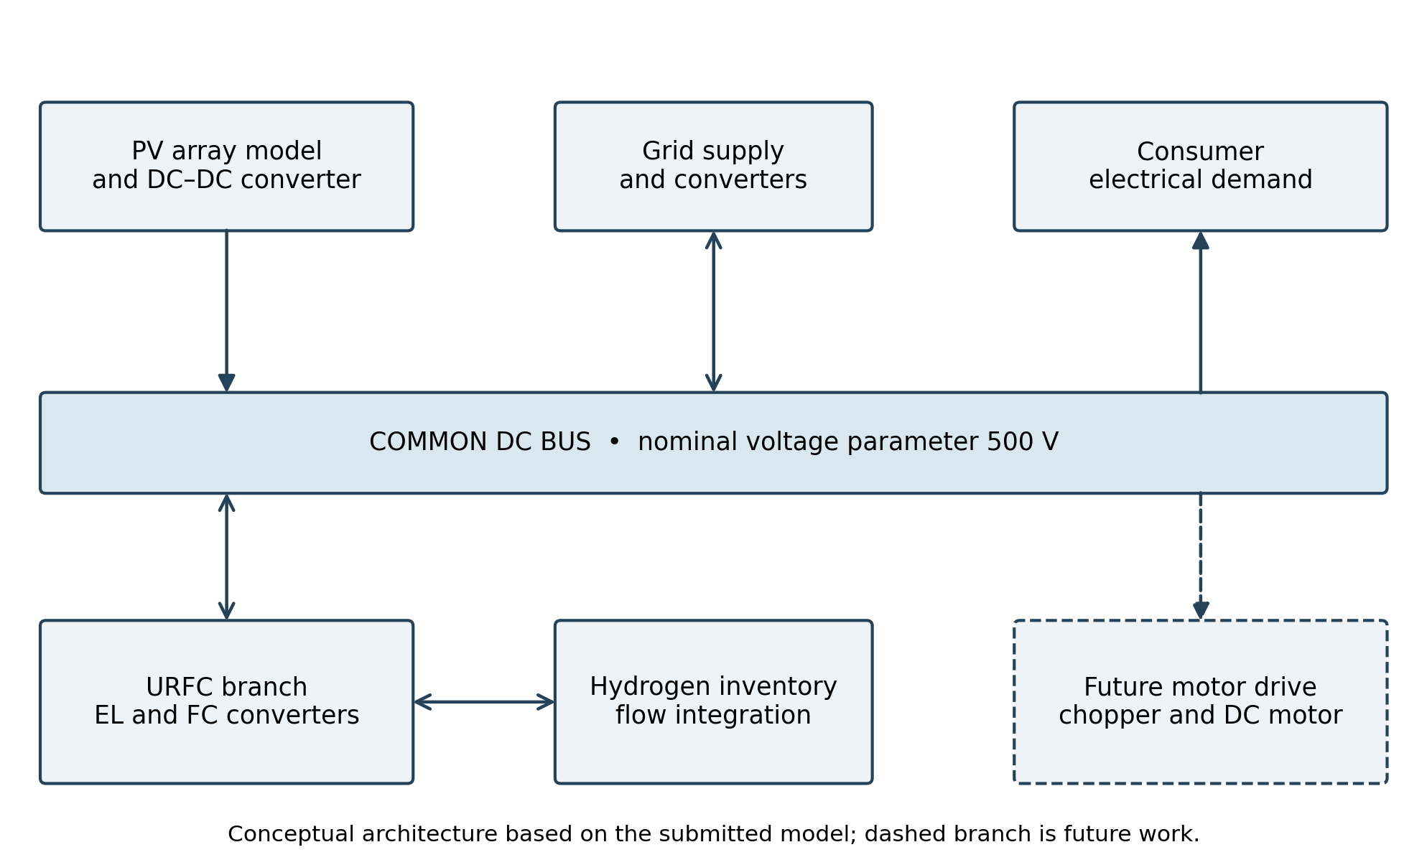
Figure 3.1 Overall PV URFC DC microgrid architecture

3.2 Model representation
The PV component calculates an approximate maximum-power operating point. Its physical-signal power output is an available-power calculation and must be distinguished from measured converter output power. The URFC is represented using separate electrolyzer and fuel-cell component equations selected by operating-mode logic. This is a system-level representation of a reversible device, not a spatially resolved electrochemical model.
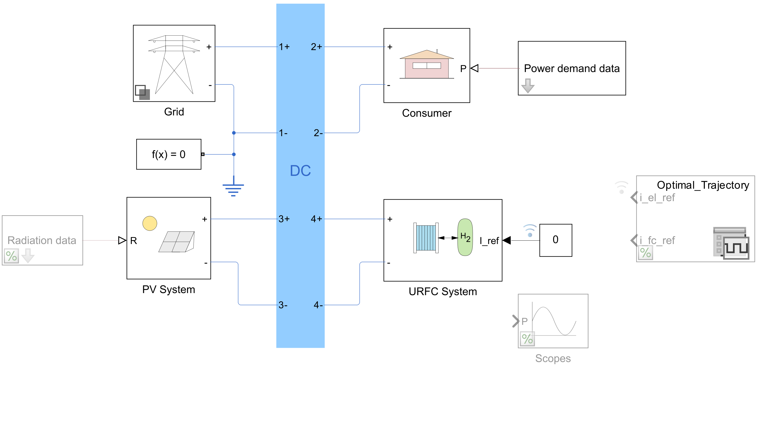
Figure 3.2 Main Simulink microgrid model
Actual exported model. Greyed blocks are commented out. Each short test overrides the signed current reference and internal PV irradiance constant; the saved diagram shows the baseline values. The consumer demand profile and grid connection remain active.

3.3 Software and model files
Table 3.1 Software and project files
Item | Purpose
MATLAB R2025b and Simulink | Parameter setup, model execution and plotted results
Simscape and Simscape Electrical | Physical networks, converter interfaces and sensors
Stateflow | URFC operating-mode chart
microgrid.slx | Reference system model; retain a separate edited copy
microgrid_parameters.m | Input loading, nominal bus voltage and tank settings
photovoltaic_parameters.m; urfc_parameters.m | PV and electrochemical parameter definitions
pv_panel.ssc; urfc_electrolyzer.ssc; urfc_fuel_cell.ssc | Custom physical component equations
input_data_24h.mat; op_mode_siginal.mat | Daily inputs and supplied operating scenarios

3.4 Baseline parameters
Table 3.2 Parameters used for subsystem checks
Parameter | Value
Nominal bus-voltage parameter | 500 V
Initial / minimum / maximum hydrogen mass | 700 g / 200 g / 1000 g
URFC cells / active cell area | 10 / 100 cm²
URFC temperature | 353.15 K
Electrons per hydrogen molecule | 2
Faraday constant / hydrogen molar mass | 96485 C/mol / 2.01588 g/mol
Test duration / local solver step | 600 s / 1 s
EL / FC / OFF reference commands | +100 A / −200 A / 0 A
Normalized irradiance tests | 1 and 0.5, representing 1000 and 500 W/m²
The 500 V entry is a model parameter, not proof that the measured bus remains at exactly 500 V under all conditions. A 1 s local solver step is a diagnostic setting for this averaged energy model; it is not suitable for resolving PWM switching or fast motor-current transients.

3.5 Governing relationships
The normalized irradiance input is λ = G / 1000, where G is in W/m². The PV implementation uses temperature-dependent photocurrent and a Lambert W approximation to estimate an operating voltage and associated power [1]. The operating-point calculation does not, by itself, demonstrate a dynamic MPPT controller.
The basic hydrogen conversion follows Faraday’s law. With ideal Faradaic conversion and N series cells:
ṁH₂ = M H₂ N I / (2F)
Here ṁH₂ is in g/s when M H₂ is in g/mol, I is in A and F is in C/mol. For the fuel-cell branch this is the ideal hydrogen-consumption rate associated with current; purge losses and imperfect utilisation are not represented.
Stored hydrogen follows the mass balance:
mH₂(t) = mH₂(0) + ∫ [ṁEL(τ) − ṁFC(τ)] dτ
The minus sign is essential: positive fuel-cell consumption must decrease the tank mass. A capacity-normalized inventory may be plotted as 100 mH₂/mmax, but the usable operating window remains bounded by the configured minimum and maximum masses.
Electrical delivery is measured from simultaneous voltage and current signals:
PPV→bus = Vbus IPV→bus
Using positive magnitudes for source delivery and electrolyzer/load absorption, a general DC-bus balance is:
PPV + PFC + Pgrid = Pload + PEL + Ploss + dEbus/dt
Pgrid is signed positive for import. The bus-energy term is included only when corresponding storage is modelled. If an ideal source fixes bus voltage, it supplies the residual balance and must not be mistaken for autonomous regulation by the URFC.

3.6 Operating-mode selection
Table 3.3 Signed current-reference convention
Reference | Mode | Hydrogen trend
Iref > 0 | Electrolyzer | Increasing mass
Iref < 0 | Fuel cell | Decreasing mass
Iref = 0 | OFF | Constant mass in the ideal model

3.7 Adaptations and numerical checks
The model was checked through isolated mode tests before restoring the complete PV branch. The tank-input PS Add was replaced with PS Subtract, keeping electrolyzer production at the positive input and fuel-cell consumption at the negative input. The positive hydrogen feed required by the fuel-cell component was retained.
The two-electron factor was introduced consistently in three places: electrolyzer hydrogen generation, the fuel-cell current-to-flow Gain, and the fuel-cell flow-to-current-density equation. Applying only one change would leave the electrical and hydrogen interpretations inconsistent. The edited component files must be refreshed in their Simscape Component blocks.
Reducing the local solver sample time from 30 s to 1 s substantially reduced the apparent startup plateau. This supports a numerical/controller-update explanation for the earlier delay; it does not identify a physical fuel-cell startup time. Further step-size comparison is needed before making transient-accuracy claims.
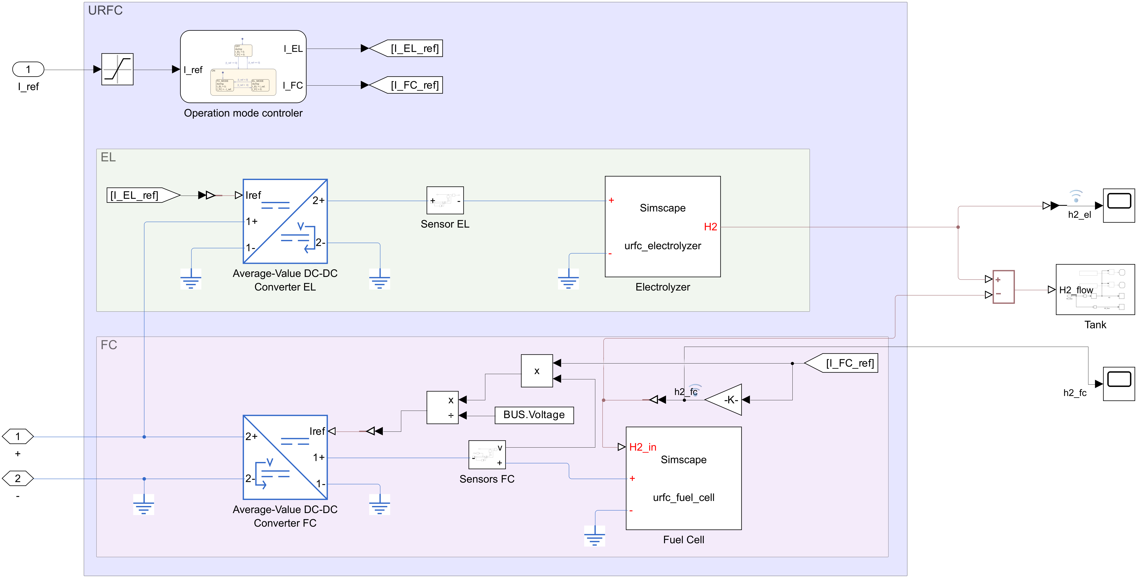
Figure 3.3 URFC controller and corrected hydrogen flow paths

3.8 Simulation procedure and scenario comparisons
For each independent run, initialise the same tank mass, record the reference command and input profile, and log time, current, voltage, power and hydrogen mass. Verify single-mode behaviour before comparing the daily scenarios. Restore the daily irradiance connection after the constant-irradiance checks; its unused physical-signal network must not remain active and disconnected.
The synopsis includes optimal-trajectory, constant-current, electrolyzer-only and fuel-cell-only scenarios. The supplied trajectory should be described as replayed reference data unless the optimisation is independently implemented. Its two current signals require a checked interface to the signed reference. No simultaneous electrolyzer/fuel-cell operation should be commanded.
Tank bounds require active logic: inhibit electrolysis at the upper limit and fuel-cell operation at the lower limit. The reference model’s disabled stop checks do not enforce these bounds. A mass limiter alone would conceal continued, physically impossible energy exchange.
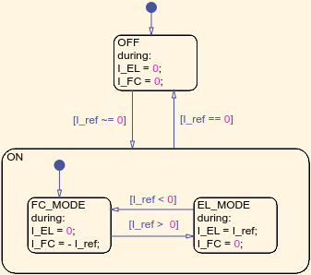
Figure 3.4 Stateflow operating mode controller
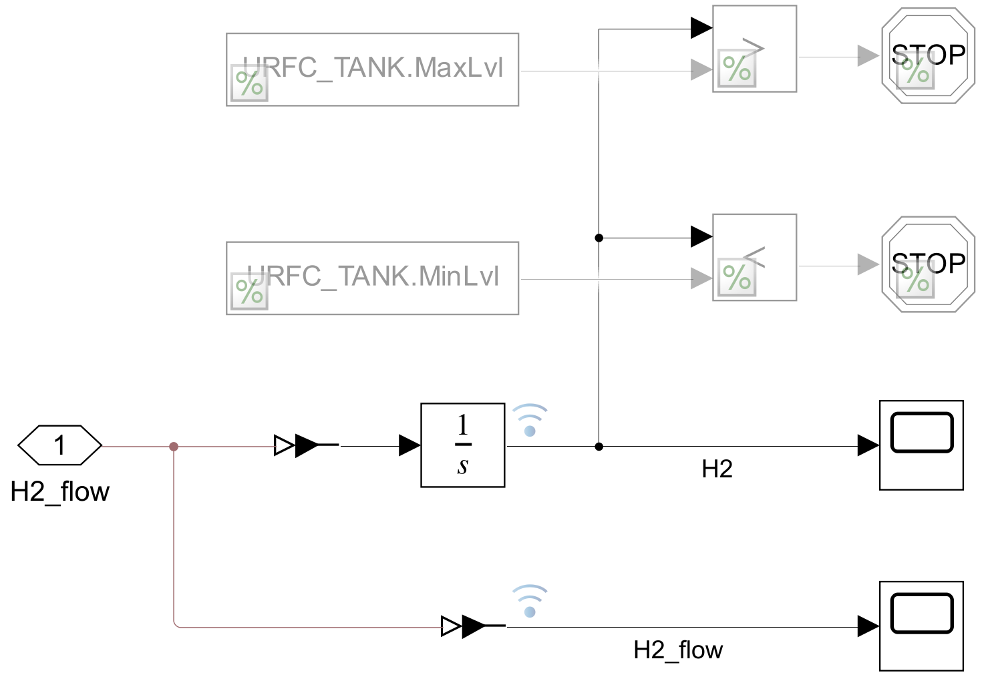
Figure 3.5 Hydrogen mass flow integration

3.9 Measurement of converter delivery
The completed PV measurements use the component’s physical-signal power output, converted to watts. The attempted automatic insertion of current and voltage sensors failed at deletion of an existing physical connection; the script restored the baseline PV subsystem and completed all five runs. The exported circuit below therefore contains calculated PV power logging, not successful measurement of converter output power.
To complete bus-delivery measurement, insert a Current Sensor in series with the positive converter output and a Voltage Sensor across the output terminals. Convert their signals to amperes and volts and multiply them [8, 9]. This remains a separate verification task.
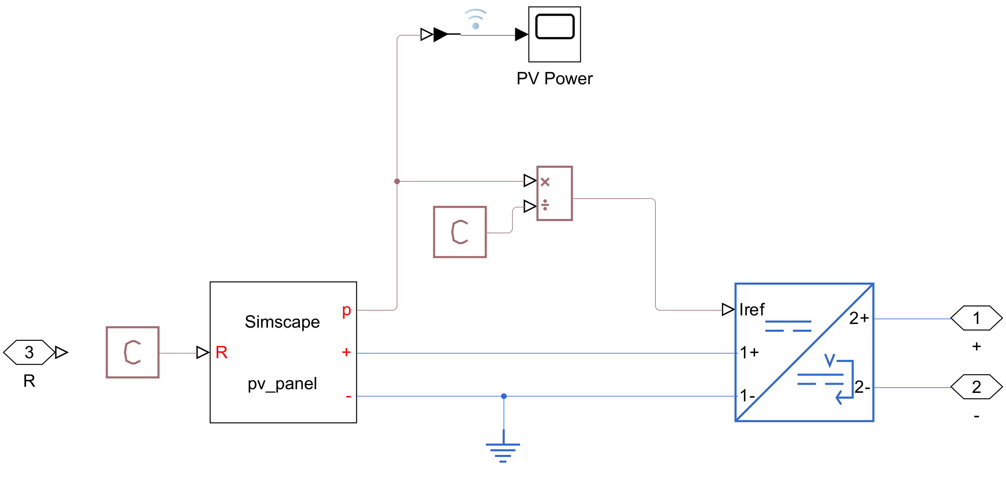
Figure 3.6 PV converter and calculated power logging

3.10 Connection to electric-drive modelling
A motor drive supplied by this bus would use a DC chopper or an inverter between the bus and the motor. For a DC motor, the electrical and mechanical relationships are:
Va = Ra ia + La dia/dt + Ke ω and J dω/dt = Kt ia − TL − Bω
These equations show how supply voltage affects armature current, torque and speed. A speed controller could generate a bounded current reference for an inner current loop, while energy management determines how much power the PV–hydrogen source can deliver. Motor and converter ratings must be compatible with the bus voltage [6].
The existing consumer demand is suitable for a supply-side study but cannot produce motor-speed, torque or acceleration results. A future motor load should replace or supplement it explicitly. Regenerative braking additionally requires reverse power capability, a regulated DC bus and a destination for recovered energy; reversible hydrogen chemistry alone does not establish that capability.

CHAPTER 4

CONTRIBUTION OF EACH STUDENT

4.1 Individual technical responsibilities
The technical work allocation follows the submitted synopsis. Each member owns a subsystem or integration task that contributes to the project’s engineering outcome. The entries below describe responsibilities; completion of any pending scenario must be confirmed before final submission.
Table 4.1 Technical responsibility of each member
Member | Technical responsibility
Syed Mohammad Naqvi  240929250 | PV subsystem configuration; normalized irradiance and demand inputs; constant-irradiance comparisons; PV available-power and converter-delivery measurements.
Devang Rathi  240929222 | URFC mode modelling; electrolyzer and fuel-cell hydrogen conversion; tank mass-balance sign correction; assessment of hydrogen inventory and operating limits.
Divyansh Badola  240929278 | DC microgrid assembly and interface checks; operating-scenario configuration; solver setup; integration of power measurements and cross-scenario analysis.

4.2 Collaborative activities
Shared work includes reviewing the source model, checking units and sign conventions across subsystem boundaries, interpreting numerical behaviour, comparing source and load power, and relating the supply system to electric-drive requirements. Integration decisions require coordination: PV power must reach the correct converter reference, URFC current commands must use the agreed sign convention, and tank limits must be reflected in dispatch logic.
The group’s contribution is the adaptation, correction, instrumentation and analysis of an acknowledged reference implementation. The original repository authors retain credit for the baseline model and component development. All members should be able to explain the system-level power and hydrogen balances during the demonstration.

CHAPTER 5

RESULTS AND DISCUSSION

5.1 Exported simulation record
The results in this chapter were exported from MATLAB R2025b Update 7 on 24 October 2026. All five cases reached 600 s. Each started at 700 g of hydrogen and produced 601 logged samples at 1 s intervals. Reported values are taken from the uploaded CSV files and run summary; the four principal graphs are the original MATLAB image exports. The archive identifier is report_outputs_20261024_052034_911.
Table 5.1 Hydrogen inventory results
Mode | Reference | Initial mass | Final mass
Electrolyzer | +100 A | 700 g | 706.236619 g
Fuel cell | −200 A | 700 g | 687.505869 g
OFF | 0 A | 700 g | 700.000000 g

5.2 Electrolyzer operation
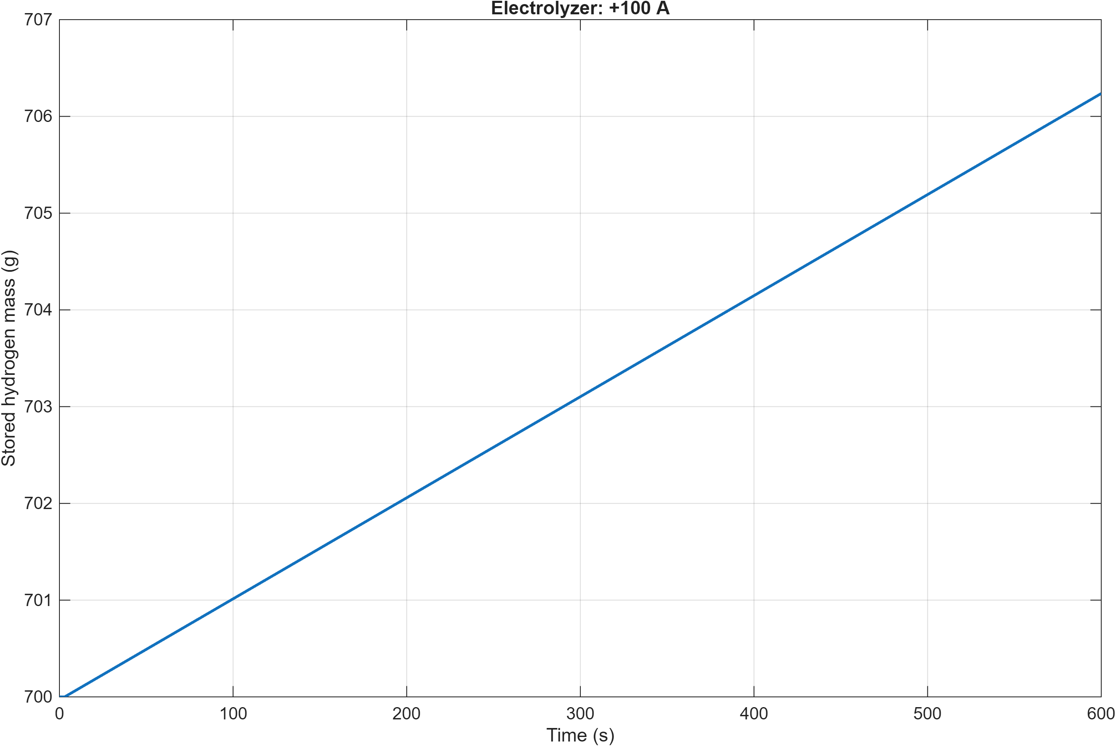
Figure 5.1 Hydrogen mass during electrolyzer operation
The +100 A run increases hydrogen inventory by 6.236619 g. The fitted slope over 60–600 s is +0.010446598 g/s, agreeing with the ideal 10-cell Faraday conversion at 100 A. The brief numerical startup explains why the total increase is slightly below the constant-rate value over the full 600 s.

5.3 Fuel cell operation
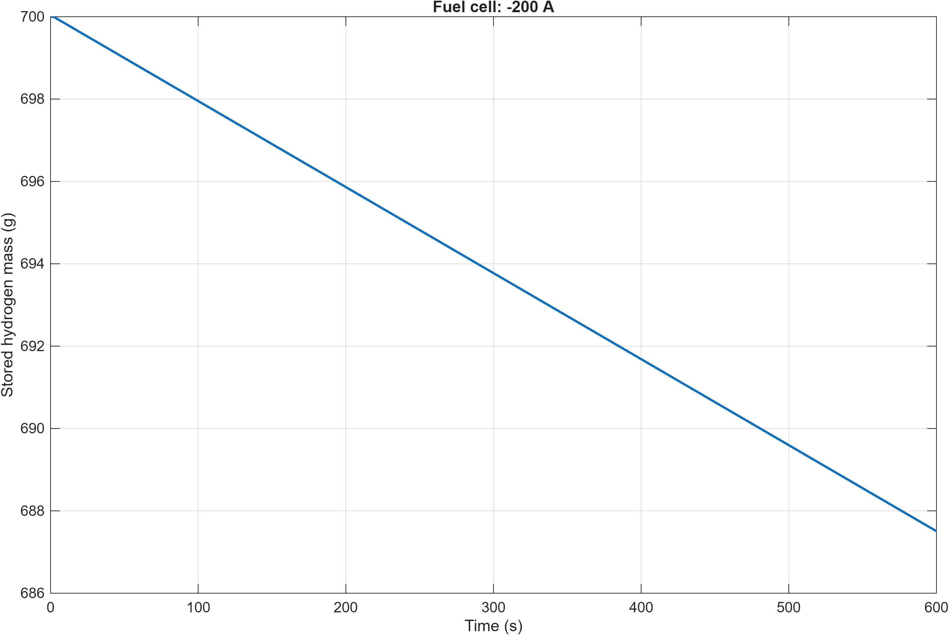
Figure 5.2 Hydrogen mass during fuel cell operation
The −200 A reference selects fuel-cell operation and gives a final mass of 687.505869 g, a decrease of 12.494131 g. The fitted 60–600 s slope is −0.020893196 g/s. Positive fuel-cell hydrogen consumption is subtracted from electrolyzer production at the tank input, so the mass decreases with the correct sign.
The corresponding ideal rate is −2.01588 × 10 × 200 / (2 × 96485) = −0.020893196 g/s. Agreement verifies the implemented current-to-hydrogen conversion at this operating point. It does not establish fuel utilisation, converter efficiency or the physical accuracy of the startup transient.
Table 5.2 Hydrogen slope comparison
Mode | Logged fit in g/s | Ideal rate in g/s
Electrolyzer | +0.010446598 | +0.010446598
Fuel cell | −0.020893196 | −0.020893196
OFF | Approximately zero | 0
The fit excludes the first 60 s. The very small OFF slope returned by numerical fitting (about −1.67 × 10⁻¹⁷ g/s) is floating-point roundoff; the logged mass samples are all 700 g.

5.4 OFF mode and tank range
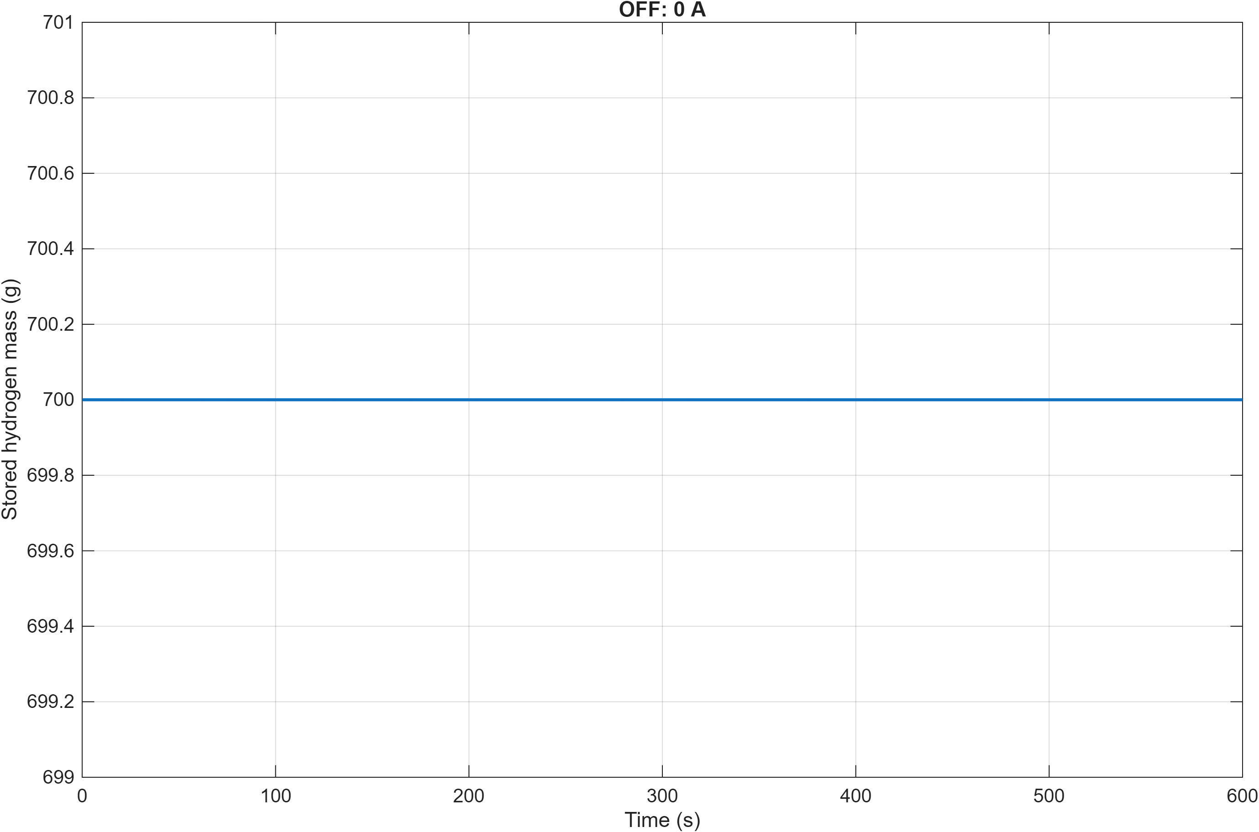
Figure 5.3 Hydrogen inventory during OFF mode
At zero reference, the measured electrolyzer and fuel-cell currents are zero, net tank flow is zero, and hydrogen mass remains exactly 700 g in the exported data. This is consistent with the ideal inventory model and is not a measurement of real tank leakage.
No test left the configured 200–1000 g tank window. This is a post-processing range check, not evidence of active protection: the tank-limit stop blocks are commented out in the submitted model. The two PV-only runs also retain 700 g because their URFC reference is zero.
Table 5.3 Completed run settings
Case | Current reference | Irradiance | End time
EL_100A | +100 A | 1000 W/m² | 600 s
FC_200A | −200 A | 1000 W/m² | 600 s
OFF | 0 A | 1000 W/m² | 600 s
PV_1000 | 0 A | 1000 W/m² | 600 s
PV_500 | 0 A | 500 W/m² | 600 s

5.5 Irradiance sensitivity of calculated PV power
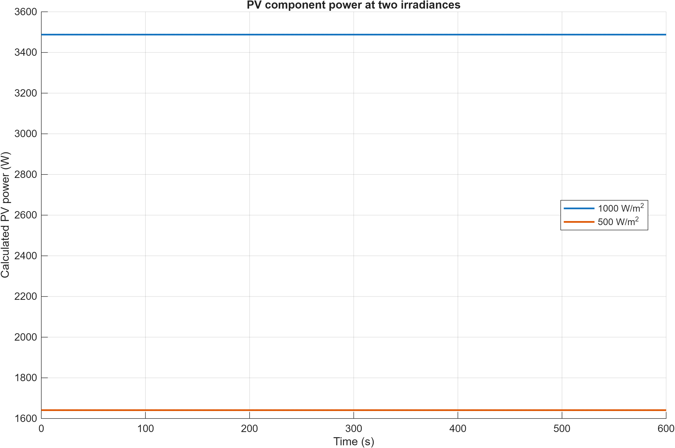
Figure 5.4 Calculated PV power at two irradiances
Table 5.4 Calculated PV power at constant irradiance
Normalized input | Irradiance | Calculated PV power
1.0 | 1000 W/m² | 3487.873606 W
0.5 | 500 W/m² | 1641.068502 W
Both calculated power traces are constant over the test interval because irradiance and temperature are fixed. Reducing irradiance by 50% reduces calculated power to 47.05% of its higher-irradiance value. The operating voltage also changes, so power need not scale in direct proportion to irradiance.
These traces are the PV component’s calculated operating-point output. They do not measure power delivered through the converter to the DC bus. The failed measurement insertion was rolled back before the five simulations, and no measured PV-delivery or DC-bus-voltage trace is claimed.

5.6 Measured stack current and startup behaviour
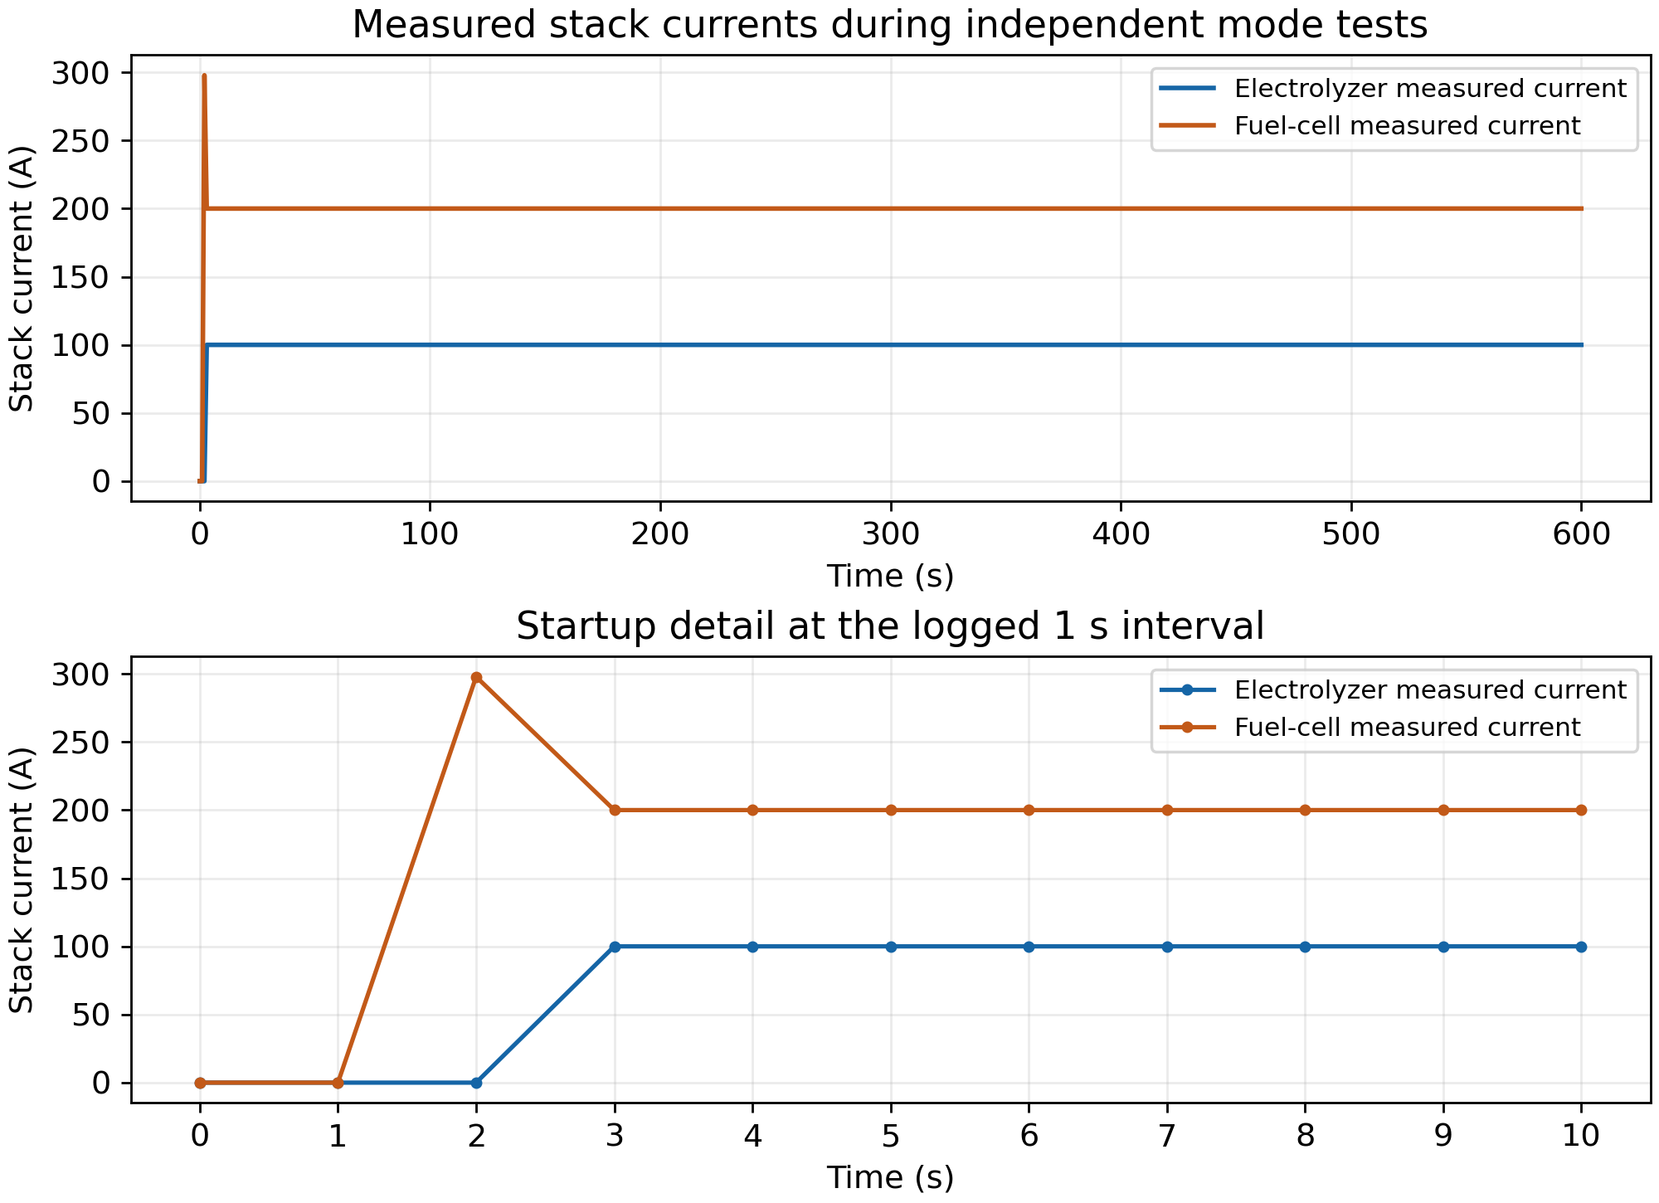
Figure 5.5 Measured stack currents and startup detail
Figure 5.5 is replotted directly from the exported MATLAB current logs without smoothing. The electrolyzer current reaches 100 A. In the fuel-cell test, the measured stack current reaches 297.816 A at t = 2 s, then settles to 200 A by the t = 3 s sample. The peak is approximately 48.91% above the 200 A command.
This sampled startup overshoot deserves further investigation with a smaller solver step and consistent converter dynamics. The tank consumption is calculated from the fuel-cell command, not from the measured transient current. Consequently, agreement of hydrogen slope with Faraday’s law does not independently validate the instantaneous electrical-to-hydrogen balance during startup.
The 1 s logging interval and local solver setting are suitable for these preliminary energy checks but cannot establish fast current-loop performance. No motor speed or torque response is present in the model.

5.7 Measurement status and limitations
Table 5.5 Evidence available for the present report
Result | Status
Hydrogen mass and net flow | Complete for all five 600 s runs
Calculated PV power | Complete at normalized irradiance 1 and 0.5
EL and FC stack voltage and current | Logged; startup current shown in Figure 5.5
Measured PV power delivered to the DC bus | Not available; sensor insertion rolled back
Measured DC-bus voltage and full branch balance | Not available in the exported dataset
24-hour dispatch and optimal-strategy comparison | Not executed
DC motor speed control | Future extension
The measurement script failed at its delete_line call while inserting a current sensor into the PV converter output connection. The error was “Invalid line specifier”. Its recovery path discarded the attempted edits and reloaded the saved baseline model. All five cases then completed. This is an instrumentation issue and does not invalidate the separately logged baseline signals, but it prevents a claim about measured PV delivery.

5.8 Interpretation for electric drives
The completed tests establish the expected direction and magnitude of hydrogen inventory change and the sensitivity of calculated PV power to irradiance. The grid remains connected, so the results do not demonstrate autonomous DC-link regulation. The fuel-cell startup current peak also shows why electrical measurements must accompany storage accounting.
A fair strategy comparison needs equal initial storage, consistent source/load profiles, measured grid exchange and final-storage accounting. Electrical round-trip efficiency cannot be calculated from these independent +100 A and −200 A checks. Pressure, thermal dynamics, auxiliary loads and nonideal hydrogen utilisation are outside the current inventory model.
For the electric-drives extension, first verify bus voltage, branch power signs and converter current limits. A suitably rated chopper-fed motor and current/speed controllers can then be added with a solver step suited to their faster dynamics. The planned full-day and optimal-controller comparisons remain future work.

CHAPTER 6

CONCLUSION AND FUTURE SCOPE

6.1 Summary
The project adapts a PV–URFC DC microgrid for the Drives and Modelling Lab and examines the relation between current commands, hydrogen inventory and renewable-source power. Subsystem testing identified the need to subtract fuel-cell consumption from tank inflow and to include the two-electron factor in hydrogen conversion. Reducing the local solver step also removed most of the apparent long startup plateau.

6.2 Conclusion
The corrected constant-current tests show the expected storage trends: hydrogen increases in electrolyzer mode, decreases in fuel-cell mode and remains constant in OFF mode. The PV operating-point calculation decreases when irradiance is reduced. Together, these observations support the basic subsystem balances and provide a basis for the integrated energy-management study.
The principal connection to electric drives is the modelling of a converter-fed DC supply with multiple energy sources. This work addresses source availability, DC-bus interfaces, power measurement and storage accounting. It does not yet demonstrate motor-speed control, islanded bus regulation or an optimised full-day dispatch strategy. The missing measurements and remaining tests are identified in Chapter 5.

6.3 Future scope
• Complete measured PV delivery, grid exchange and daily power-balance plots.
• Implement tank-aware supervisory dispatch with current limits and a deadband between production and consumption modes.
• Compare predefined scenarios with equal initial conditions and final-storage accounting.
• Add nonideal efficiencies, auxiliary demand and a pressure-dependent hydrogen-storage model.
• Connect a suitably rated DC motor through a chopper, then implement inner current and outer speed control.
• Evaluate load-torque changes, source disturbances and regenerative braking only after bidirectional converter capability and DC-bus energy absorption are established.

REFERENCES
[1] M. Barbosa, with G. de Andrade, “Hydrogen Energy Storage,” GitHub repository, MIT License. https://github.com/michaelfsb/hydrogen-energy-storage. Reference source inspected: commit 41917034dadf1881c6f74708d2dfe52985ba601c. Accessed 21 October 2026.
[2] C. Ogbonnaya, C. Abeykoon, A. Nasser and A. Turan, “Unitized regenerative proton exchange membrane fuel cell system for renewable power and hydrogen generation: Modelling, simulation, and a case study,” Cleaner Engineering and Technology, vol. 4, 100241, 2021. doi:10.1016/j.clet.2021.100241.
[3] G. A. De Andrade, P. R. Da Costa Mendes, J. G. G. Clúa and J. E. Normey-Rico, “Control of a grid assisted PV-H2 production system: A comparative study between optimal control and hybrid MPC,” Journal of Process Control, vol. 92, pp. 220–233, 2020. doi:10.1016/j.jprocont.2020.06.008.
[4] E. Batzelis, G. Anagnostou, C. Chakraborty and B. Pal, “Computation of the Lambert W function in photovoltaic modeling,” Lecture Notes in Electrical Engineering, pp. 583–595, 2020. doi:10.1007/978-3-030-37161-6_44.
[5] MathWorks, “Electrolyzer.” https://www.mathworks.com/help/simscape-electrical/ref/electrolyzer.html.
[6] MathWorks, “DC Motor.” https://www.mathworks.com/help/simscape-electrical/ref/dcmotor.html.
[7] MathWorks, “Solver Configuration.” https://www.mathworks.com/help/simscape/ref/solverconfiguration.html.
[8] MathWorks, “Current Sensor” and “Voltage Sensor.” https://www.mathworks.com/help/simscape/ref/currentsensor.html and https://www.mathworks.com/help/simscape/ref/voltagesensor.html.
[9] MathWorks, “PS-Simulink Converter” and “Simscape Component.” https://www.mathworks.com/help/simscape/ref/pssimulinkconverter.html and https://www.mathworks.com/help/simscape/ref/simscapecomponent.html.

ANNEXURE A PROJECT DETAILS
Table A.1 Project record
Field | Details
Title | Modelling and Simulation of a PV-Fed Regenerative Fuel Cell DC Microgrid for Hydrogen Energy Storage
Course / group | Drives and Modelling Lab / Group 25
Institution | School of Mechanical Engineering, Manipal Institute of Technology
Members | Syed Mohammad Naqvi 240929250; Devang Rathi 240929222; Divyansh Badola 240929278
Faculty guide | [Enter confirmed name and designation]
Academic year | [Enter official academic year]
Software | MATLAB R2025b, Simulink, Simscape, Simscape Electrical and Stateflow
Hardware | Software simulation only
Working model and code version | microgrid_report_run.slx; run 20261024_052034_911

Final submission record
Attach the final model, all parameter and component files, input datasets and plotting scripts. Retain the original repository licence and identify edited files. The report includes the available exported figures and selected executed code. Retain the complete simulation archive with the submission. Confirm that plot legends, units, current commands and solver settings match the final simulations.
Only completed experiments should be described as results. Keep the supplied optimal trajectory attributed to its source and identify any independently developed controller separately.

ANNEXURE B MATLAB AND SIMSCAPE CODE

B.1 Executed initialization
The following listing is the initialization file archived with the completed MATLAB run. The model calls it during loading and initialization.
addpath("icons")
load("input_data_24h.mat")
URFC = urfc_parameters;
PV = photovoltaic_parameters;
BUS.Voltage = 500; % [V]
URFC_TANK.MaxLvl = 1000; % [g]
URFC_TANK.MinLvl = 0.2*URFC_TANK.MaxLvl; % [g]
URFC_TANK.IniLvl = 0.7*URFC_TANK.MaxLvl; % [g]

B.2 Corrected hydrogen conversion
These exact expressions are taken from the archived physical-component files and the model Gain block. The tank uses electrolyzer production minus positive fuel-cell consumption.
% urfc_electrolyzer.ssc — equations section
h2 == mmH2*N_cells*i/(n_electrons*F_constant);
% Fuel-cell Gain block in the Simulink model
2.01588*URFC.N_cells/(URFC.n_electrons*URFC.F_constant)
% urfc_fuel_cell.ssc — intermediates section
I = (h2_in*n_electrons*F_constant)/(mmH2*N_cells) / A_cell;
The Simscape expressions are component code fragments; they are not standalone MATLAB commands. The fuel-cell Gain is a block parameter expression. URFC.n_electrons = 2 and URFC.N_cells = 10.

B.3 Operating mode logic
The actual Stateflow chart is shown in Figure 3.4. OFF sets both references to zero; EL_MODE sets I_EL = I_ref and I_FC = 0; FC_MODE sets I_EL = 0 and I_FC = −I_ref. Chart transitions use the sign of I_ref. This description preserves the chart implementation rather than replacing it with an unexecuted controller.
Complete source files are retained in the code folder of report_outputs_20261024_052034_911.zip, including the parameter classes and PV, electrolyzer and fuel-cell component files.

B.4 Executed simulation and data export excerpts
Selected consecutive excerpts from run_report_simulations.m are reproduced below. The enclosing loop supplies each case name, current reference and normalized irradiance from Table 5.3.
in = Simulink.SimulationInput(mdl);
in = in.setBlockParameter(currentBlock,'Value',num2str(cases.Reference_A(k)));
in = in.setBlockParameter(radiationBlock,'constant',num2str(cases.NormalizedIrradiance(k)));
in = in.setModelParameter('StopTime','600','SignalLogging','on', ...
'SignalLoggingName','logsout','ReturnWorkspaceOutputs','on');
simulationOutput = sim(in);
save(fullfile(caseDir,'simulation_output.mat'),'simulationOutput','-v7.3');
logs = simulationOutput.logsout;
exportCSVs(logs,caseDir);

B.5 Executed plotting functions
function plotOne(logs,sig,yl,ttl,file)
ts=series(logs,sig); f=newFigure;
plot(ts.Time,ts.Data,'LineWidth',1.6); grid on;
xlabel('Time (s)'); ylabel(yl); title(ttl,'Interpreter','none');
saveFigure(f,file);
end
function f = newFigure
f=figure('Visible','off','Color','w','Position',[100 100 1050 650]);
end
function saveFigure(f,file)
finish = onCleanup(@() close(f)); %#ok<NASGU>
exportgraphics(f,[file '.png'],'Resolution',300);
savefig(f,[file '.fig']);
end
The measurement-insertion routine was attempted but failed at delete_line; its changes were rolled back. It is not presented as a successful PV measurement implementation. Figure 5.5 was subsequently plotted from the archived scalar CSV logs, using every original sample.

ANNEXURE C PLAGIARISM REPORT
[Insert the institution-approved similarity report here.]
Report date: __________________ Similarity result: __________________

Reserved for the actual issued report; no similarity score is assumed.

ANNEXURE D AI PLAGIARISM REPORT
[Insert the AI assessment report required by the institution here.]
Report date: __________________ Assessment result: __________________

Reserved for the actual issued report. Any declaration should follow the institution’s policy.

