Architecture & Design Document
Aetheria GameFi DAO Ecosystem
Full-Stack Decentralized Protocol
Field | Value
Course | Blockchain Technologies 2
Scenario | Option B - GameFi Economy with DeFi, DAO, Oracle, L2 and Indexing
Repository | Blockchain2_FinalProject
Primary Network | Arbitrum Sepolia / L2 testnet
Tooling | Foundry, OpenZeppelin, Chainlink-compatible aggregator, The Graph, frontend dApp
Document Purpose | Explain system architecture, contract relationships, storage layout, critical flows, trust assumptions, and design decisions.

Prepared as the project architecture document required by the final project specification. The document is written for review, audit, extension, and defense.

1. Executive Summary
Aetheria is a GameFi DAO protocol that combines in-game ERC-1155 items, a UUPS-upgradeable game engine, a token economy based on GOV and IRON, a constant-product AMM, an ERC-4626 yield vault, an oracle-powered token shop, DAO governance, L2 deployment, and subgraph-based indexing. The protocol is intended to demonstrate a complete full-stack decentralized system rather than a single isolated contract.
The project follows Option B of the final project scenarios: an ERC-1155 in-game item economy with crafting, a marketplace AMM for fungible resources, Chainlink-style oracle integration, DAO-governed parameters, and L2 deployment. The implementation also includes an ERC-4626 vault and reproducible deployment/testing infrastructure to satisfy broader course requirements.
Layer | Main Components | Purpose
User / dApp Layer | Frontend dApp, wallet connection, subgraph queries | Allows users to farm, craft, swap, deposit, buy IRON, and vote.
Game Layer | GameItems, GameEngineV1/V2 behind ERC1967Proxy | Handles loot farming, item minting, crafting and upgradeable gameplay parameters.
DeFi Layer | IronToken, GovToken, AMM, IronVault, IronShop | Provides fungible tokens, swaps, LP shares, yield shares and oracle-priced token purchase.
Governance Layer | GovToken, MyGovernor, Timelock | Provides proposal, voting and delayed execution path for protocol parameter changes.
Infrastructure Layer | Arbitrum Sepolia, Chainlink-compatible oracle, The Graph subgraph, RPC provider | Provides execution environment, external price data, historical indexing and frontend data access.

1.1 Scope of This Architecture Document
This document covers the following contracts and infrastructure artifacts:
- GovToken.sol
- IronToken.sol
- GameItems.sol
- GameEngineV1.sol
- GameEngineV2.sol
- AMM.sol
- AMMFactory.sol
- IronVault.sol
- IronShop.sol
- MockV3Aggregator.sol
- MyGovernor.sol
- Timelock.sol
- frontend dApp
- The Graph subgraph configuration

1.2 Main Architectural Principle
The protocol separates user-facing actions from authority-bearing actions. Normal users interact with gameplay, AMM, vault and shop contracts. Governance-owned or owner-restricted functions are isolated behind Ownable, Governor and Timelock patterns. The GameEngine is intentionally upgradeable, while token and AMM primitives are kept simpler and more stable.

2. System Context Diagram (C4 Level 1)
At the highest level, the system consists of wallet users, a frontend dApp, smart contracts deployed to an L2 testnet, a Chainlink-compatible price feed, a subgraph for indexed historical data, and standard RPC/block explorer infrastructure.
Figure 1. C4 level 1 system context diagram.

2.1 External Actors
Actor | Responsibility / Interaction
Player / Wallet User | Connects wallet, farms loot, crafts items, swaps tokens, deposits into the vault, buys IRON and votes.
Protocol Team / Deployer | Runs deployment scripts, configures initial system parameters and prepares the governance handoff.
DAO / Token Holders | Use GovToken voting power to approve protocol changes through MyGovernor and Timelock.
Subgraph Indexer | Reads emitted events and transforms them into queryable entities.
Oracle Provider | Provides ETH/USD price data through an AggregatorV3-compatible interface.
L2 Network | Executes transactions and stores contract state for the protocol.

2.2 High-Level Data Flow
- Users sign transactions in the frontend and submit them to Arbitrum Sepolia through an RPC provider.
- Protocol contracts update on-chain state and emit events such as LootFarmed, SwordCrafted, Swap, IronPurchased and VoteCast.
- The subgraph indexes these events and exposes them through GraphQL for historical UI pages.
- The IronShop reads a Chainlink-compatible price feed and rejects stale or invalid price data before selling IRON.
- Governance proposals move through Governor -> Timelock -> target contract execution.

3. Contract and Component Architecture
The following component diagram shows the deployed smart contract system and the main dependencies between contracts. It also highlights the proxy layout for the upgradeable GameEngine and the external infrastructure used by the dApp.
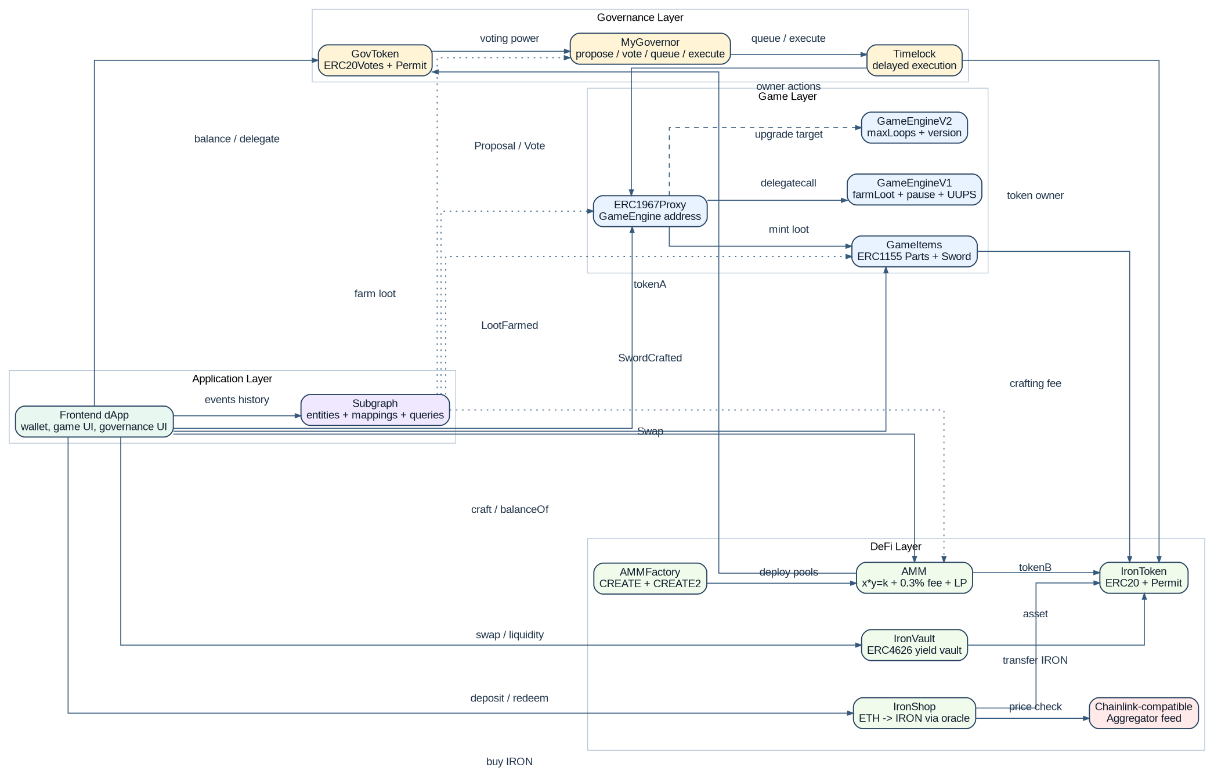
Figure 2. Component architecture and contract relationships.

3.1 Component Responsibilities
Component | Type | Responsibility
GovToken | ERC20Votes + ERC20Permit + Ownable | Governance token, voting power snapshots, delegation, and mint authority.
Timelock | TimelockController wrapper | Delayed executor for governance-approved actions.
MyGovernor | OpenZeppelin Governor stack | Proposal creation, voting, queueing and execution through Timelock.
IronToken | ERC20 + ERC20Permit + Ownable | Main in-game fungible resource used for crafting, shop purchases, AMM swaps and vault deposits.
GameItems | ERC1155 + Ownable | Stores Part A, Part B and Legendary Sword items; supports minting and crafting.
GameEngine Proxy | ERC1967Proxy | Stable public address for upgradeable game logic and gameplay state.
GameEngineV1/V2 | UUPS implementation | Loot farming, drop chance configuration, pause/unpause and upgrade path.
AMM | ERC20 LP token + ReentrancyGuard | Constant-product GOV/IRON swaps with 0.3% fee and LP mint/burn.
AMMFactory | Factory | Deploys AMM pools using CREATE and CREATE2 and records created pools.
IronVault | ERC4626 + Ownable + ReentrancyGuard | Tokenized vault for IRON deposits and vIRON shares; supports yield injection by owner.
IronShop | Ownable + ReentrancyGuard | Sells IRON for ETH after validating oracle freshness and price.
MockV3Aggregator / Chainlink feed | Oracle interface | Provides price data during tests and testnet-style integration.
Subgraph | The Graph | Indexes gameplay, AMM, shop and governance events for frontend history.

3.2 UUPS Proxy Layout
The GameEngine uses the UUPS pattern. The ERC1967Proxy is the address users and the frontend interact with. Calls are delegated to GameEngineV1 or a later implementation, while persistent state remains in the proxy storage. Upgrade authorization is protected by the Ownable/UUPS authorization path, intended to be controlled by Timelock after deployment.
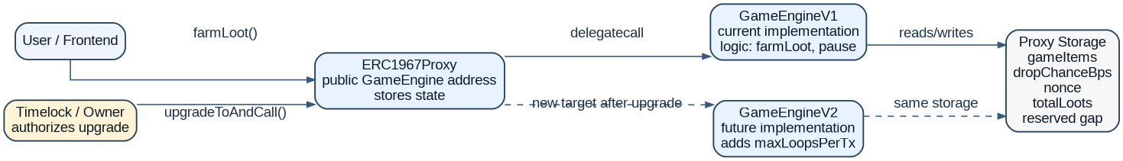
Figure 3. UUPS proxy layout for GameEngine.

3.3 Access Control Overview
Contract | Privileged role / owner | Privileged actions
GovToken | Ownable owner | Mint GOV. Should be transferred to Timelock for final deployment.
IronToken | Ownable owner | Mint IRON. Deployment script transfers ownership to Timelock.
GameItems | Ownable owner = GameEngine proxy | Mint item drops and receive crafting calls.
GameEngine proxy | Ownable owner, intended Timelock | Set drop chance, pause/unpause and authorize UUPS upgrade.
IronVault | Ownable owner | Add yield to the ERC4626 vault.
IronShop | Ownable owner | Withdraw ETH, update price feed, update IRON price.
AMMFactory | Owner address | Create pools through CREATE or CREATE2.
MyGovernor | Token holders voting through GovToken | Create, vote, queue and execute proposals.
Timelock | Proposer/Canceller/Executor roles | Schedules and executes governance-approved operations.

4. Critical User Flow Sequence Diagrams
This section documents the critical execution paths that reviewers should understand before auditing or extending the system.

4.1 Loot Farming and Sword Crafting
The gameplay loop starts with farming parts through the GameEngine proxy. The engine updates local state before minting ERC1155 items. Crafting then burns Part A and Part B, transfers the IRON crafting fee, and mints a Legendary Sword.
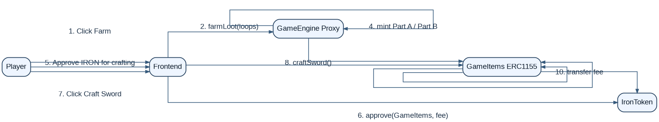
Figure 4. Loot farming and sword crafting sequence.

4.2 AMM Swap
The AMM uses the constant-product formula. The user first approves the input token. The pool calculates amountOut after the 0.3% fee, enforces minAmountOut slippage protection, updates reserves, and transfers tokens.
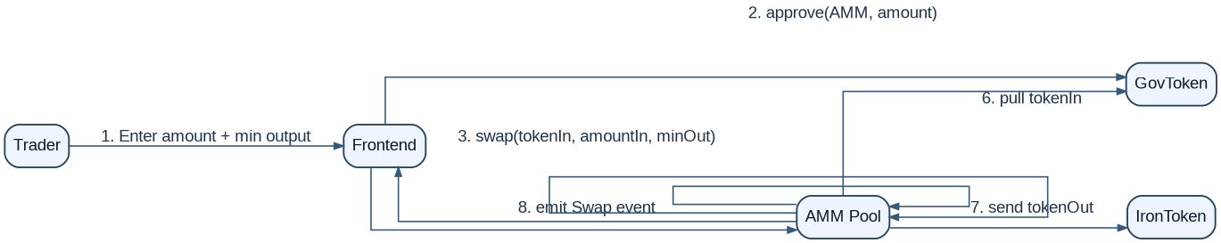
Figure 5. AMM swap sequence.

4.3 ERC4626 Vault Deposit and Yield
The vault follows the tokenized vault pattern. Users approve and deposit IRON to receive vIRON shares. When the owner injects yield, total assets increase and each share represents a larger claim on the underlying asset.
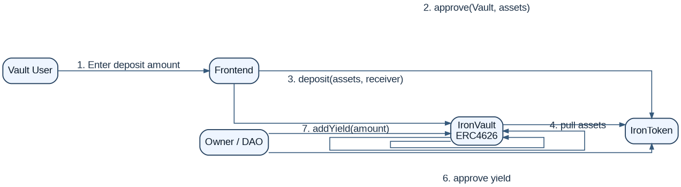
Figure 6. Vault deposit and yield sequence.

4.4 Governance Proposal Lifecycle
Governance follows a standard Governor and Timelock path. Token holders delegate votes, create or vote on proposals, and successful proposals are queued in Timelock before execution against target contracts.
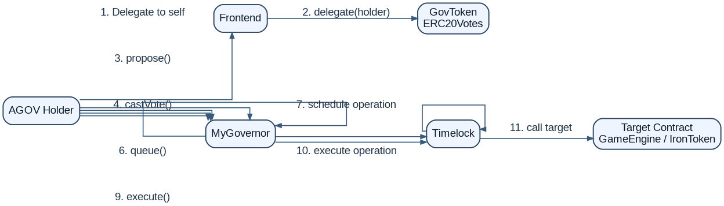
Figure 7. Governance proposal-vote-queue-execute sequence.

4.5 Oracle-Based IRON Purchase
IronShop reads the AggregatorV3-compatible feed before selling IRON. The contract validates positive price and staleness before transferring IRON to the buyer.
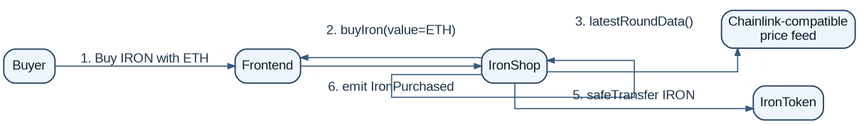
Figure 8. Oracle-based IRON purchase sequence.

5. Data Model and Storage Layout
The following storage layout summary documents the project data model. Constants and immutable variables are not normal mutable storage in the same way as state variables: constants are inlined in bytecode, and immutables are assigned at construction time and embedded in deployed code. Inherited OpenZeppelin storage is acknowledged where applicable.
Contract | Storage / Data Model | Design Notes
GovToken | OpenZeppelin ERC20, ERC20Permit, ERC20Votes, Ownable inherited storage | No custom mutable state variables beyond inherited token/governance state.
IronToken | OpenZeppelin ERC20, ERC20Permit, Ownable inherited storage | No custom mutable state variables beyond inherited token state.
GameItems | ironToken; craftingFee; inherited ERC1155 and Ownable storage | PART_A, PART_B and LEGENDARY_SWORD are constants. ironToken is used for crafting fees.
GameEngineV1 | gameItems; dropChanceBps; nonce; totalLoots; __gap[44]; inherited Initializable/UUPS/Ownable/Pausable/ReentrancyGuard storage | Upgradeable storage must never reorder or remove these variables.
GameEngineV2 | maxLoopsPerTx appended after V1 layout | V2 keeps V1 variables unchanged and adds new state after the existing layout. No storage collision is expected.
AMM | reserveA; reserveB; inherited ERC20 and ReentrancyGuard storage | tokenA and tokenB are immutable; fee constants are bytecode constants.
AMMFactory | owner; allPools; getPool[tokenA][tokenB] | Tracks deployed pools and supports deterministic pool deployment.
IronVault | Inherited ERC4626, ERC20, Ownable and ReentrancyGuard storage | No custom accounting state; relies on ERC4626 totalAssets/share conversion.
IronShop | priceFeed; ironToken; ironPriceUsd; stalenessThreshold; inherited Ownable/ReentrancyGuard storage | Stores oracle adapter, shop inventory token and pricing configuration.
MockV3Aggregator | decimals; latestAnswer; latestTimestamp; latestRound; answers; timestamps | Testing oracle that mimics Chainlink latestRoundData behavior.
MyGovernor | Inherited Governor, GovernorSettings, GovernorVotes, GovernorVotesQuorumFraction, GovernorTimelockControl storage | Governance parameters are configured in constructor/inheritance.
Timelock | Inherited TimelockController role and operation scheduling storage | Maintains role permissions, delay and queued operation metadata.

5.1 Upgradeable Storage Collision Analysis
Only GameEngine is designed as upgradeable. GameEngineV1 stores gameItems, dropChanceBps, nonce, totalLoots and a reserved __gap array. GameEngineV2 does not reorder or delete V1 state. It appends maxLoopsPerTx after the V1 storage layout. This preserves all existing storage slots used by V1. The ERC1967Proxy keeps the same proxy address and stores data in proxy storage, while implementation contracts provide code through delegatecall.
Upgrade Step | Storage Safety Statement
V1 deployment | Proxy is initialized once with gameItems and owner. State lives in the proxy, not in the implementation contract.
V1 to V2 upgrade | V2 preserves V1 state order and adds maxLoopsPerTx only after existing V1 state. Existing slots retain the same meaning.
Future upgrades | New variables must be appended only. No inherited state variable can be reordered, deleted, or have its type changed.

5.2 Event Data Model for Subgraph
Event Source | Events | Indexed Entities
GameEngine | LootFarmed, DropChanceUpdated, MaxLoopsUpdated | Player, LootFarm, ProtocolConfigChange
GameItems | ItemsMinted, SwordCrafted | Item, ItemBalance, Craft
AMM | LiquidityAdded, LiquidityRemoved, Swap | Swap, LiquidityEvent, Player
AMMFactory | PoolCreated | PoolCreation
IronShop | IronPurchased, PriceFeedUpdated, IronPriceUpdated | IronPurchase, ProtocolConfigChange
IronVault | YieldAdded | VaultYield
MyGovernor | ProposalCreated, VoteCast, ProposalExecuted | Proposal, VoteCastEvent, Player

6. Access Control and Trust Assumptions
This protocol intentionally uses centralized bootstrap powers during deployment, then moves core control toward governance. The exact powers and risk assumptions must be visible because governance, oracles and upgradeability are the main trust-sensitive areas of the system.
Role / Entity | Powers | Risk if compromised | Mitigation / Expected Control
Deployer EOA | Deploys contracts, initializes protocol, may own some contracts depending on deployment script. | Can retain excessive privileges if ownership is not handed off. | Final deployment checklist must transfer core ownership to Timelock and avoid EOA admin backdoors.
Timelock | Executes queued governance actions after delay. | If roles are misconfigured, malicious operations may be executed too quickly or without governance. | Delay, Governor-only proposer/canceller roles, post-deployment verification script.
Governor | Manages proposals and votes using GovToken voting power. | Governance capture, whale voting, proposal spam or flash-loan voting attacks. | Voting delay, voting period, quorum, proposal threshold and token vote snapshots.
GameEngine owner | Can pause/unpause, update drop chance and authorize upgrades. | Can change gameplay or upgrade to malicious implementation. | Should be Timelock-controlled in final deployment.
GameItems owner | Can mint ERC1155 items. | Unlimited item minting if owner is malicious. | Owner is GameEngine proxy; minting occurs through controlled game logic.
IronShop owner | Can update feed, price and withdraw ETH. | Can set malicious oracle feed or withdraw funds. | Should be governed or multisig-owned; frontend should display current feed and price.
Oracle feed | Provides ETH/USD price used by IronShop. | Stale or manipulated price may affect purchase calculations. | Positive price and staleness checks; production should use a real Chainlink feed.
Subgraph indexer | Serves historical data to frontend. | Can be stale or unavailable; does not affect contract state. | Frontend should use direct RPC for critical current state and subgraph only for history.

6.1 Current Deployment Notes
The codebase contains a deployment script that performs partial ownership handoff: IronToken and GameEngine are transferred to the Timelock and the deployer renounces Timelock admin. Some contracts, such as GovToken, IronVault, AMMFactory and IronShop, should be checked in final deployment and either transferred to Timelock or explicitly documented as trusted-admin components. This is not a UI issue; it is an operational governance requirement.

6.2 Failure Modes
- If the oracle feed becomes stale, IronShop.buyIron reverts and protects the system from using old price data.
- If the GameEngine implementation is maliciously upgraded, item minting and drop logic can be corrupted.
- If governance voting power is concentrated, protocol parameters can be changed by a whale or captured entity.
- If the subgraph is unavailable, the protocol remains usable through direct contract calls but historical frontend pages degrade.
- If the AMM reserves are shallow, swaps have high price impact even if the contract logic is correct.

7. Design Patterns and Justification
The project uses more than five documented design patterns. Each pattern below is tied to a real need in the protocol rather than added as a checkbox.
Pattern | Where Used | Why It Is Used
Factory Pattern | AMMFactory.createPool and createPoolDeterministic | Centralizes AMM pool creation and demonstrates both CREATE and CREATE2.
Proxy / UUPS | GameEngineV1/V2 behind ERC1967Proxy | Allows game logic to evolve without changing the public GameEngine address.
Checks-Effects-Interactions | AMM swap/remove liquidity, GameEngine farmLoot, IronShop purchase/withdraw | Reduces risk from external calls by updating state before interactions where applicable.
Reentrancy Guard | AMM, IronVault, IronShop, GameEngine | Protects functions that move funds or call external contracts.
Access Control / Ownable | GovToken, IronToken, GameItems, GameEngine, IronVault, IronShop, AMMFactory | Restricts minting, upgrades, oracle updates and sensitive parameter changes.
Pausable / Circuit Breaker | GameEngineV1 | Allows emergency stop of farming if gameplay minting or drop logic needs to be halted.
Oracle Adapter | IronShop with AggregatorV3Interface | Decouples purchase logic from a specific feed implementation and enables mocks in tests.
Timelock Governance | MyGovernor + Timelock | Adds a delay between successful vote and execution, giving users time to react.
Tokenized Vault | IronVault ERC4626 | Standardizes share accounting and yield-bearing deposits.
Event-Driven Indexing | All protocol event emissions + subgraph | Allows the frontend to retrieve protocol history without scanning logs manually.

8. Architecture Decision Records (ADR)
ADR | Context | Options Considered | Decision | Consequences
ADR-01: Use ERC1155 for game items | The game needs multiple item types: Parts A/B and a Legendary Sword. | Separate ERC20/ERC721 contracts, or ERC1155. | Use ERC1155 because it can represent multiple fungible/semi-fungible items in one contract. | Lower deployment overhead and simpler inventory indexing; item-specific logic must be handled carefully.
ADR-02: Use UUPS for GameEngine | Game mechanics may change after deployment but item balances must remain stable. | No upgradeability, Transparent Proxy, UUPS. | Use UUPS behind ERC1967Proxy for the GameEngine. | Upgradeable logic with stable address; upgrade authorization must be strictly governed.
ADR-03: Own GameItems by GameEngine proxy | Loot farming should mint items, but users should not mint directly. | User minting, EOA minter, GameEngine owner. | Transfer GameItems ownership to GameEngine proxy. | Only game logic can mint drops; a malicious engine upgrade would also control item minting.
ADR-04: Build AMM from scratch | The project requires a DeFi primitive and constant-product behavior. | Fork existing AMM or implement simple AMM. | Implement simple x*y=k AMM with 0.3% fee and LP tokens. | Meets learning goal and improves auditability; not production-complete like Uniswap.
ADR-05: Use ERC4626 for vault | Users need a standard way to deposit IRON and receive yield-bearing shares. | Custom vault accounting or ERC4626. | Use OpenZeppelin ERC4626 base. | Standard integrations and safer conversion logic; still requires yield source governance.
ADR-06: Use Chainlink-compatible oracle interface | IronShop needs external ETH/USD price validation. | Hardcoded price, off-chain API, AggregatorV3Interface. | Use AggregatorV3Interface and a mock aggregator for tests. | Supports production Chainlink feed replacement and test determinism.
ADR-07: Index events with The Graph | Frontend needs history of loot, crafts, swaps and votes. | Direct RPC log scanning, custom backend, The Graph. | Use subgraph with schema and mappings. | Improves query performance and decentralization; subgraph data can lag behind chain state.
ADR-08: Governance through Governor + Timelock | Parameter changes and upgrades should not be direct EOA actions. | EOA owner, multisig only, DAO Governor + Timelock. | Use OpenZeppelin Governor stack with Timelock. | Adds transparency and delay; requires correct vote delegation and role configuration.

9. Deployment, Indexing and Frontend Notes

9.1 Deployment Model
The protocol is deployed through Foundry scripts. DeployDAO.s.sol deploys the governance layer, token contracts, game layer, AMM, vault, factory, oracle mock and shop. The script should be parameterized through environment variables for real network deployments and should be extended with a post-deployment verification script before final submission.
Deployment Step | Contracts / Actions
Phase 1 - Governance | Deploy GovToken, Timelock and MyGovernor; grant Governor roles on Timelock.
Phase 2 - Game Economy | Deploy IronToken, GameItems, GameEngineV1 implementation and ERC1967Proxy; transfer GameItems ownership to proxy.
Phase 3 - DeFi | Deploy IronVault, AMM, AMMFactory, MockV3Aggregator and IronShop; seed liquidity and shop inventory.
Phase 4 - Handoff | Transfer selected owners to Timelock and renounce temporary Timelock admin.
Phase 5 - Verification | Verify source, check owners, governance parameters, Timelock delay, and lack of deployer backdoor.

9.2 Subgraph Design
The subgraph follows the standard manifest + schema + mapping design. It listens to events from the game, AMM, shop, vault and governance contracts. The frontend should use direct RPC for live balances and The Graph for historical pages such as latest farms, crafts, swaps, purchases and votes.
File | Purpose
subgraph.yaml | Defines networks, contract addresses, ABIs, start blocks and event handlers.
schema.graphql | Defines entities such as Player, Item, ItemBalance, LootFarm, Craft, Swap, Proposal and VoteCastEvent.
mapping.ts | Transforms raw event logs into saved entities and aggregate counters.
queries.md | Documents at least five GraphQL queries for frontend and review.

9.3 Frontend Data Sources
Data Need | Preferred Source | Reason
Current token balances | Direct RPC call to ERC20/ERC1155 balanceOf | Must be current and simple to read.
AMM reserves | Direct RPC call to AMM reserveA/reserveB | Used for immediate swap UI.
Vault shares | Direct RPC call to IronVault balanceOf | Current user position.
Proposal list and history | Subgraph | Historical proposal events and vote list are easier to query via GraphQL.
Latest crafts / farms / swaps | Subgraph | Event history is better indexed than fetched repeatedly through RPC logs.
Oracle price | On-chain oracle read through IronShop / Chainlink interface | DeFi-critical data should be validated on-chain, not from a frontend API.

10. Review Checklist
- Every public/external function has unit tests, including revert paths.
- GameEngine upgrade path V1 to V2 is demonstrated and storage layout is unchanged.
- Timelock owns final privileged actions where required by the specification.
- GovToken voting power requires delegation and proposal lifecycle is demonstrated end-to-end.
- AMM swap enforces slippage protection and k does not decrease after fee-adjusted swaps.
- IronVault ERC4626 rounding behavior and deposit/redeem invariants are tested.
- IronShop rejects stale and invalid oracle prices.
- Slither High and Medium findings are zero before submission, or explicitly fixed and re-run.
- Subgraph builds successfully and documents at least five GraphQL queries.
- Frontend handles wrong network, rejected transaction, insufficient balance and missing approvals with readable messages.
- Deployment addresses and verification links are recorded in README.
- Post-deployment verification script confirms owners, Timelock delay, Governor settings and admin handoff.

Appendix A - Contract Relationship Matrix
From | To | Relationship
Frontend | GovToken | Reads balances/votes and sends delegate transactions.
Frontend | GameEngine proxy | Calls farmLoot.
Frontend | GameItems | Reads balances and calls craftSword.
Frontend | AMM | Calls addLiquidity/removeLiquidity/swap and reads reserves.
Frontend | IronVault | Calls ERC4626 deposit/mint/withdraw/redeem and reads shares.
Frontend | IronShop | Calls buyIron and reads shop configuration if exposed.
GameEngine proxy | GameItems | Mints loot drops.
GameItems | IronToken | Transfers crafting fee and burns/mints game items.
AMM | GovToken and IronToken | Transfers swap inputs/outputs and holds reserves.
IronVault | IronToken | Holds assets and mints/burns vault shares.
IronShop | MockV3Aggregator / Chainlink feed | Reads price and updatedAt before purchase.
MyGovernor | Timelock | Queues and executes governance operations.
Timelock | Target contracts | Executes approved parameter changes and upgrades.
Subgraph | Protocol events | Indexes emitted events into queryable entities.

