Southampton Solent University

Computing
School of Technology and Maritime Industries

Computing
Oliver Myers
Developing Open Source Screenwriting Software

Progress Report
COM629 AE1

Supervisor: Nick Whitelegg
Date of submission: February 2026

Contents
1. Introduction 3
2. Project Evaluation (Methods) 4
2.1 Evaluation 4
2.2 Research 4
2.3 Ethics 5
3. Project Progress 7
3.1 Market Research 7
3.2 Technical Research 8
3.3 Survey 10
3.4 Qt Framework Test 10
3.5 Objectives and Requirements 10
3.6 Ethics 11
4. Project Management 12
4.1 Development Methodology 12
4.2 Risks and Contingencies 13
5. What next? 15
5.1 Proof of Concept Tests 15
5.2 Survey 15
5.3 Requirements Finalization and Feature Prioritisation 15
5.4 Project Design 15
5.5 Development & Testing 16
6. Reference list 17
Appendix A: Annotated Bibliography A
Appendix B: Artificial Intelligence (AI) Declaration H
Appendix C: Ethical Clearance C
Appendix D: Market Research Example D

List of Figures
Figure 1: Fade In Screenwriting Application (2026) 3
Figure 2: Script Elements (2026) 7
Figure 3: Market Features Comparison (2026) 8
Figure 4: Qt vs Electron Frameworks (2026) 9
Figure 5: Qt Creator Hello World Project (2026) 10
Figure 6: Phases of Incremental Design Methodology (2026) 12
Figure 7: Gantt Chart (2026) 13
Figure 8: Risk Assessment Table (2026) 13

Introduction

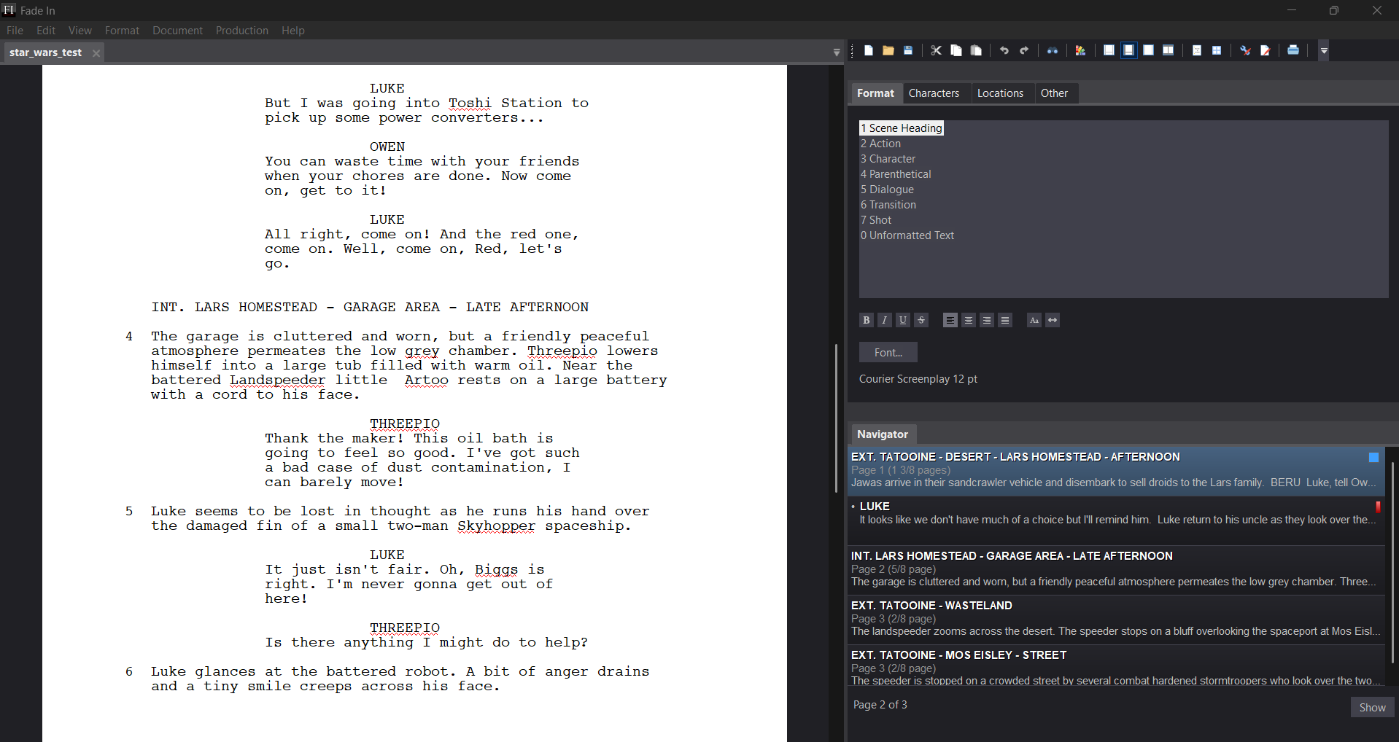
Through talking to peers who are interested in and produce screenplays, I understand that the screenwriting software market is heavily saturated but there is not a free product that meets the requirements of a screenwriter. The idea to provide a solution to this problem was the beginning of this project. This was followed by questions such as what features of a screenwriting application are critical to functionality and what other features does the market provide that screenwriters appreciate. From these questions the underlying idea was developed into: Creation of a professional pure screenwriting software application that follows industry standards, for free.
Figure 1: Fade In Screenwriting Application (2026)

2. Project Evaluation (Methods)

2.1 Evaluation

My project will be evaluated in three ways:

Feedback testing with a questionnaire
When the final software product is developed, a mixed-methods questionnaire will be used to gain feedback. The questionnaire will contain sections of quantitative and qualitative questions regarding features and other general software aspects. The quantitative data will be in the form of Likert scales while qualitative data will identify specific feature gaps. This data can then be processed, and meaningful insights will be derived.

Comparison against the project requirements
The final products features will be compared to the list of requirements and features that have been derived from market and technical research including the research survey.

Heuristic Evaluation
The final software will also be evaluated against Nielsen’s 10 Usability Heuristics (Nielsen, J., 1994). This is important as these are proven User Interface design principles.

By using these three sources, the project will have a wide range of evaluation.

2.2 Research

The research for this project is broken down into three categories:

General Screenwriting Research
This is research from the perspective of screenwriting professionals on what a screenwriting application should provide for them. It is important to understand how standard formatting (e.g. Courier 12pt, margin widths) impacts the ‘one page equals minute’ rule of thumb which is a critical professional requirement.

Market Research
Five popular professional screenwriting applications were selected for research: Final Draft, Fade In, Celtx, Scrivener, Arc Studio.

Project requirements and a list of potential features will be determined from:
- A list of features of the applications broken down into categories:
  - Writing Engine
  - Story Architecture & Planning
  - Production & Workflow
  - Collaboration & Data Management
  - Accessibility & Value
- External references regarding each application
- Conclusions drawn from testing each application as well as conclusions from comparative research between the applications.

The technical aspects of these five applications will also be researched this includes:
- The data formats used.
- The use of cloud storage.
- The format of the application itself (browser-based/desktop application).

Technical Research
Technical research can be further broken down into three categories:
- Cross platform frameworks:
  - The two frameworks to be researched for use are the Qt framework and Electron Framework. A comparison of features and use cases will be made.
- File formats and data serialization:
  - The possible viability of using the formats:
    - XML
    - Open Screenplay Format (XML based)
    - fdx Final Draft (Closed XML format)
    - Fountain (markdown based plain text format)
    - json
- Software Design Patterns
  - The design pattern chosen is critical to the development process. Patterns such as the Model View Controller (MVC) pattern and the Flyweight Pattern may prove insightful (GeeksForGeeks, 2023).

2.3 Ethics

The primary ethical consideration for the project revolves around the collection of data from human participants. The following measures will be implemented to address this:

Informed Consent
All participants will be presented a participation information sheet. Consent will be obtained via tick to consent boxes at the start of the survey.

Data Anonymity and GDPR Regulations
The survey is designed to be entirely anonymous. No identifiable information will be gathered.

Data Storage and Retention
Collected data will be stored on Solent University One Drive Servers. All raw data will be permanently deleted three months after the conclusion of the research project.

Ethical Clearance
Formal ethical approval will be sought through the Solent Ethics Portal and a record of this provided.

3. Project Progress

3.1 Market Research

General screenwriting research has been conducted and provided results on the industry standard for scripts for example (Trottier, D. 2014):
Typeface: Courier 12-point font must be used.
Margin measurements:
Left margin at 15 spaces (1.5 inches)
Dialogue at 25 spaces (2.5 inches)
Actors’ instructions at 31 spaces (3.1 inches)
Character’s name at 37 spaces (3.7 inches)
Page numbers upper right flush to margin.

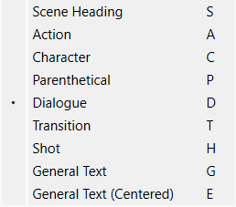
Industry standard scripts consist of the following elements
Figure 2: Script Elements (2026)

Each element requires unique indentation and capitalization logic that should be automated within the application writing engine. This ensures professional compliance.

A list of features of each application has been derived as well as references providing thought out critiques and insights. From these along with first-hand experience with the applications, conclusions have been drawn about each individual application. An example of Scrivener research can be found in appendix D
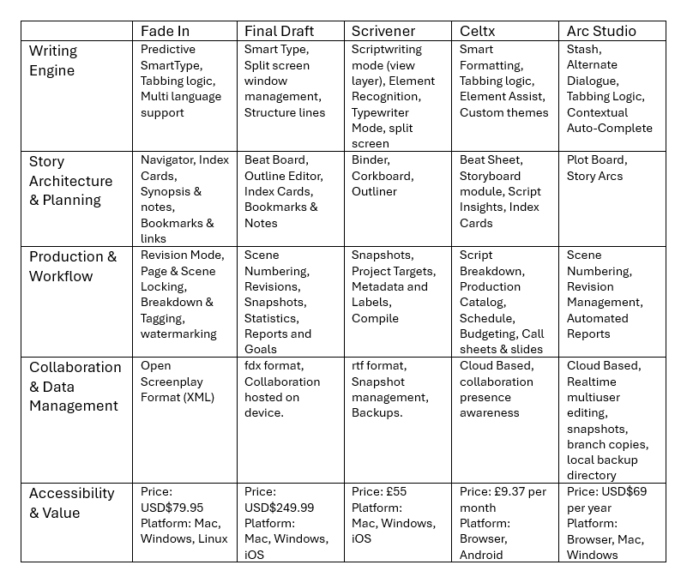
Figure 3: Market Features Comparison (2026)
(Industrial Scripts, 2024)

This information will be used in the construction of the research survey along with informing the requirements for the project.

3.2 Technical Research

Two frameworks were researched: Electron and Qt. Figure 4 was produced with the sources: (Williams, E, 2023) (Kur, K, 2025) (Winbuzzer, 2024) (StackShare, 2025)
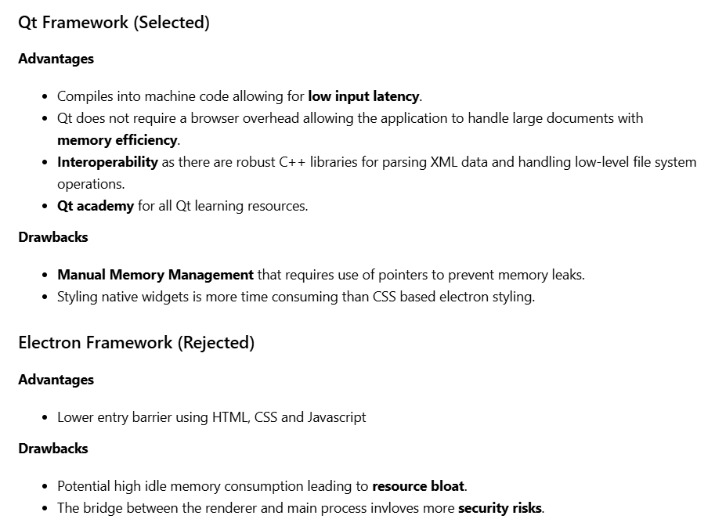
Figure 4: Qt vs Electron Frameworks (2026)

Qt was selected over Electron primarily due to resource efficiency and low latency handling. Qt allows direct memory management and high-performance text rendering which is crucial in long form documents. Qt’s capabilities align with the project goal of providing a robust lightweight alternative compared with resource intensive Electron applications. (Kubara, 2023) highlights that Qt’s signal and slot mechanism is ideal for real time UI updates required in a text engine.

Market research found that many file formats that are used across applications. One critical use case is the ability to export scripts into the pdf format which is industry standard as well as fdx (Final Draft) and fountain formats which are used in a professional capacity in the production phase of a screenplay.

For my project it makes sense to store users’ files on their local devices as the introduction of the usage of cloud servers would provide added complexity.

3.3 Survey

The production of a research survey has been started and the process of ethical clearance from the university is ongoing.

3.4 Qt Framework Test

Using Qt Academy and the Qt Creator, tests have begun on proof-of-concept examples that Qt can be used for the project.
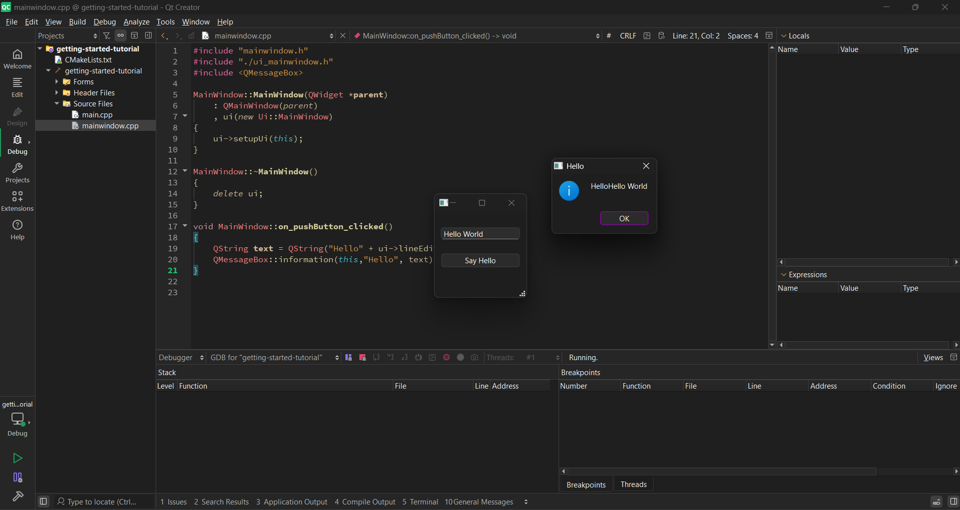
Figure 5: Qt Creator Hello World Project (2026)

The proof-of-concept projects to be completed are:
- A text file viewer
- A simple to do list application using xml

3.5 Objectives and Requirements

Based on the current market research and technical evaluation of Qt the following provisional requirements have been established:

Functional Requirements
- Industry Standard Formatting: The engine must apply industry standards such as margins, font and script elements.
- Tabbing Functionality: The tab and enter keys must trigger element transitions.
- PDF Export: The application must have the ability to export the script into a submission ready PDF.
- File Persistence: The application must save and load scripts in an open format (Open Screenplay Format, XML)
- Navigator: Functionality for navigating the script through scenes.
- Character Autocomplete: A SmartType feature that suggests character names based on previous entries.

Non-Functional Requirements
- Latency: The keystroke to screen latency must remain under 50ms.
- Cross Platform: The application must be capable of running on Windows, Mac and Linux desktop environments.
- Resource Efficiency: The software should use less than 100MB of Ram during idle operation.
- Robustness: The application must be able to handle files exceeding 120 pages without drop in performance.
- Accessibility: The interface must comply with WCAG 2.1 standards.

3.6 Ethics

Data Protection
The users’ files will not be stored on any cloud service and will be stored exclusively on local storage on their devices. This reduces any security risks and ensures data sovereignty.

Accessibility
Technical research is ongoing into WCAG 2.1 standards for GUIs

Intellectual Property
To ensure that the project remains open source and free it will be released under the MIT License. This fulfils the aim of the project being a free alternative to current market products.

4. Project Management

4.1 Development Methodology

The Incremental Development Methodology has been selected for this project. Using this a usable version of the software is delivered early and the ability to add new features later provides flexibility.

When the list of requirements is finalized, each requirement will go through the following process:
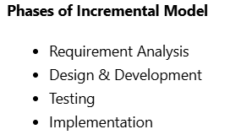
Figure 6: Phases of Incremental Design Methodology (2026)

Git version control will be utilized to manage the code base. This also provides feature branching for each new increment keeping the main codebase safe.

A Gantt Chart is also in operation to track progress of the project and increments. The adding of increments to the development phase is in progress.

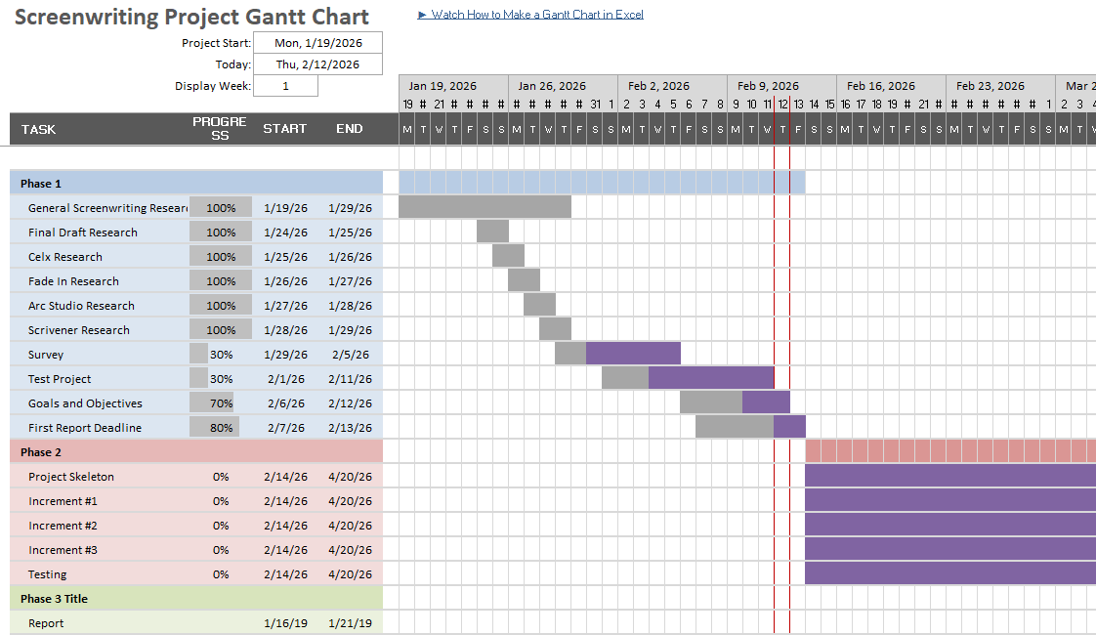
Figure 7: Gantt Chart (2026)

The number of hours to be spent on the project are 400. Currently 75 – 100 has been spent on the research phase of the project. The remaining hours will be divided up and spent over the next phases of the project,

4.2 Risks and Contingencies

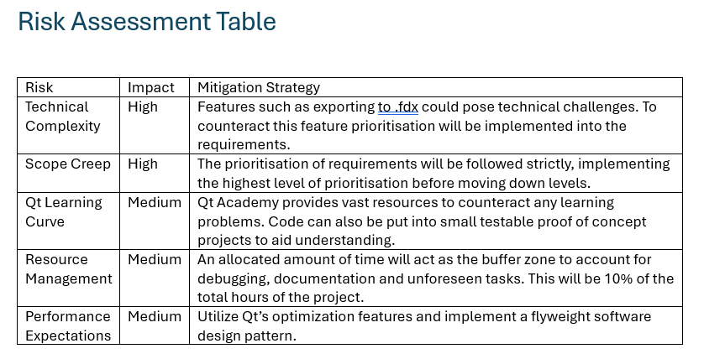
Five aspects of this project were identified as being risks and are seen in the table below:
Figure 8: Risk Assessment Table (2026)

5. What next?
5.1 Proof of Concept Tests
The two proof of concept test in progress to test viability are:

Text File Viewer
This will involve implementing a syntax highlighter class in Qt. This can be adapted in the final project to identify screenplay elements. QTextDocument performance will also be tested in this proof-of-concept project.

To Do List XML Application
The functionality used here can be utilized in the final project regarding the correct mapping of elements to an open data format. XML serialization testing will also be completed here.

5.2 Survey

The research survey is in development using university approved Jisc Online Surveys. The survey will be released to university students studying media related degrees, personally known screenwriters and online via the Reddit r/Screenwriting community.

The data gathered from the survey will be processed and go on to inform the project requirements regarding feature prioritisation.

5.3 Requirements Finalization and Feature Prioritisation

Drawing on conclusions from market research, technical research, proof of concepts and the survey; the provisional requirements will be changed into the final requirements for the project including feature prioritisation.

5.4 Project Design

Production of wireframes will commence using Figma and will be checked against the WCAG 2.1 accessibility requirements.

Software Architecture design will commence involving the use of software design patterns, UML diagrams, an XML schema diagram and use case diagrams. (Refactoring Guru, 2014) outlines widely used software development patterns.

5.5 Development & Testing

In the 11 weeks between this report and the final deadline a Sprint plan will be implemented. Smaller incremental sprints will encompass these overall sprints.
- Sprint 1: The core engine features
- Sprint 2: Navigation features
- Sprint 3: Data Serialization
- Sprint 4: Lower Priority Features

Testing will be linked to the development of increments as laid out in the development methodology section.

6. Reference list

GEEKSFORGEEKS, 2023. Software Design Patterns Tutorial Available from: https://www.geeksforgeeks.org/system-design/software-design-patterns/

INDUSTRIAL SCRIPTS, 2024. The Best Script Writing Programs for Aspiring Screenwriters Available from: https://industrialscripts.com/best-script-writing-programs/#h-final-draft-the-industry-standard-for-professional-screenwriters

KUR, K., 2025. Is Electron.js Better Than Qt for Modern UI Development? Available from: https://softwarelogic.co/en/blog/is-electronjs-better-than-qt-for-modern-ui-development

NIELSEN, J., 1994. 10 Heuristics for User Interface Design Available from: https://www.nngroup.com/articles/ten-usability-heuristics/

NIKITIN, V., 2024. Software Development Methodologies: Types and Comparison Available from: https://www.itransition.com/software-development/methodologies

OPENSCREENPLAYFORMAT, 2025. GitHub - OpenScreenplayFormat/osf-sdk: Open Screenplay Format SDK Available from: https://github.com/OpenScreenplayFormat/osf-sdk

REFACTORING GURU, 2014. Design Patterns Available from: https://refactoring.guru/design-patterns

STACKSHARE, 2025. StackShare Available from: https://stackshare.io/stackups/electron-vs-qt

TROTTIER, D., 2014. The screenwriter’s bible : a complete guide to writing, formatting, and selling your script. Los Angeles: Silman-James Press

WILLIAMS, E., 2023. Pros and Cons of Electron Js Development — Should You Use It? Available from: https://medium.com/@emmaw4430/pros-and-cons-of-electron-js-development-should-you-use-it-407f67dae310

WINBUZZER, 2024. Why Choose Qt? The Qt Advantage in Software Development Available from: https://winbuzzer.com/2024/05/08/why-choose-qt-the-qt-advantage-in-software-development-xcxwgp/

Appendix A: Annotated Bibliography

Reference list

ARTIS, K., 2025. C++ Qt for Desktop GUIs: Building Cross-Platform Interfaces for User-Friendly Applications. Independent
Summary: Artis’s book on Qt for Desktop GUIs is a technical guide that explores implementation using the Qt framework and all relevant tools that come with the Qt Creator.

Evaluation: As a 2025 publication, this source provides up to date technical information regarding Qt 6 which is valuable for research and development.

Relevance: This source is relevant to the technical research and provides learning opportunities for using the Qt framework.

CHESSON, D., 2025. Scrivener Review: A Great 20% Discount (But Why I Don’t Use It) Available from: https://kindlepreneur.com/scrivener-review/
Summary: A review of Scrivener from a professional writer’s perspective. It highlights the strength of organisation along with the weakness of appealing to all types of creative writers.

Evaluation: Kindleprenur is regarded as a recognised authority in publishing technology.

Relevance: This helped identify feature bloat in Scrivener and competitors adding weight to the requirements of this project.

DUFFY, J., 2021a. Fade In Available from: https://www.pcmag.com/reviews/fade-in?test_uuid=04IpBmWGZleS0I0J3epvMrC&test_variant=A
Summary: A technical review of the Fade In screenwriting software that focuses on compatibility with industry standard file formats among other topics.

Evaluation: PCMag is a highly regarded technology publication. Their testing makes for reliable research.

Relevance: This source is very useful in market research, providing a pain point of high-performance rendering in desktop apps.

DUFFY, J., 2021b. Final Draft (for Mac) Available from: https://www.pcmag.com/reviews/final-draft?test_uuid=04IpBmWGZleS0I0J3epvMrC&test_variant=A
Summary: An analysis of the Final Draft software and outline some of the core features that make Final Draft the industry standard application.

Evaluation: This provides a professional standard of testing and is backed up by PCMag which is a reputable source.

Relevance: This source is relevant in market research which informs the functional requirements of the project and ensures the project includes critical features found in industry standard software.

FECHTER, J., 2024. Celtx Review: Is it Worth it? [Insider Review] Available from: https://www.squibler.io/learn/software/celtx-review/
Summary: A review of the browser based Celtx software including critiques of the performance lag and subscription-based model.

Evaluation: Written by a professional and provides an insight as to why users may be seeking offline alternatives.

Relevance: This source supports the decision for using the Qt framework for a desktop experience as opposed to a web-based cloud solution.

GEEKSFORGEEKS, 2018. Incremental Process Model Software Engineering Available from: https://www.geeksforgeeks.org/software-engineering/software-engineering-incremental-process-model/
Summary: This source is an educational article that outlines the definitions and processes of an Incremental approach to software engineering.

Evaluation: GeeksforGeeks is a reputable academic resource for computer science students and provides clear insightful facts.

Relevance: Research from this source led to the Incremental Methodology being chosen over alternatives such as a waterfall approach.

GEEKSFORGEEKS, 2023a. Software Design Patterns Tutorial Available from: https://www.geeksforgeeks.org/system-design/software-design-patterns/
Summary: This source provides educational material on design patterns used in modern software architecture.

Evaluation: GeeksforGeeks is a reputable academic resource for computer science students that provides clear insightful facts on relevant topics.

Relevance: This source provides material for the Project Design Phase of the project, more specifically for the use of software design patterns.

GEEKSFORGEEKS, 2023b. Software Risk Analysis Available from: https://www.geeksforgeeks.org/software-engineering/software-risk-analysis/
Summary: This source provides educational material on the general risks that software faces and why.

Evaluation: GeeksforGeeks is a reputable academic resource for computer science students that provides clear insightful facts on relevant topics.

Relevance: This source was used in the production of the risk assessment table found in this document.

INDUSTRIAL SCRIPTS, 2024. The Best Script Writing Programs for Aspiring Screenwriters Available from: https://industrialscripts.com/best-script-writing-programs/#h-final-draft-the-industry-standard-for-professional-screenwriters
Summary: This source is an updated 2024 list comparison of the top screenwriting tools on the market.

Evaluation: Industrial Scripts is a leading script consultancy; therefore, their data and evaluations of applications reflect what professionals in the industry require from their software.

Relevance: This source is relevant in market research along with the development of requirements for the project.

KUBARA, I., 2023. What Is Qt Framework, Why to Use It, and How? | Lemberg Solutions Available from: https://lembergsolutions.com/blog/why-use-qt-framework
Summary: An engineering focused blog that details the benefits of the Qt framework such as efficient memory management.

Evaluation: This source was published by a software development firm providing a professional perspective on framework selection.

Relevance: This source directly contributed to the technical research portion of this project and specifically the framework selection portion of Qt vs Electron.

KUR, K., 2025. Is Electron.js Better Than Qt for Modern UI Development? Available from: https://softwarelogic.co/en/blog/is-electronjs-better-than-qt-for-modern-ui-development
Summary: A comparative study from 2025 focusing on the performance gap between Chromium based apps and C++ Qt applications.

Evaluation: This is a recent source that outlines the trend away from resource heavy electron apps.

Relevance: This provided insights for the comparison between Qt and Electron and the framework selection portion of the project.

NIELSEN, J., 1994. 10 Heuristics for User Interface Design Available from: https://www.nngroup.com/articles/ten-usability-heuristics/
Summary: This source establishes and outlines ten principles that ensure a software interface is intuitive for the end users.

Evaluation: Jakob Nielsen is a reputable source and leading authority on web and software usability. This source is also very academically inclined.

Relevance: This provided context for some of the requirements and therefore provides guidance for the design process of the final product.

NIKITIN, V., 2024. Software Development Methodologies: Types and Comparison Available from: https://www.itransition.com/software-development/methodologies
Summary: This is a comparison of different methodologies including Agile, Waterfall and incremental methodologies that outlines the use cases and benefits of each.

Evaluation: This source is published by Itransistion which is a software company and therefore provides content relevant to current commercial practices.

Relevance: This source helped justify the decision to use the Incremental approach in the project which informs how the project requirements are set up and the project management is handled.

OPENSCREENPLAYFORMAT, 2025. GitHub - OpenScreenplayFormat/osf-sdk: Open Screenplay Format SDK Available from: https://github.com/OpenScreenplayFormat/osf-sdk
Summary: This is a technical documentation and SDK for an open-source XML based screenplay data standard.

Evaluation: A source that is used by one of the market research applications (fade in), this also represents data transparency regarding screenwriting applications.

Relevance: This source is critical for the file persistence requirement and ensures the project does not rely on proprietary file formats.

REFACTORING GURU, 2014. Design Patterns Available from: https://refactoring.guru/design-patterns
Summary: A guide to software architecture problems, specifically software design patterns.

Evaluation: The design patterns are used to make code more maintainable and testable. This source is also regarded as reputable about guides to design patterns.

Relevance: This has a direct impact on the Project Design portion of the project and the Software Architecture aspect as well. Specifically the strategy pattern.

SCRIPT SLUG, n.d. Star Wars: Episode IV - A New Hope (1977) Available from: https://www.scriptslug.com/script/star-wars-episode-iv-a-new-hope-1977
Summary: This is a professional screenplay database where scripts can be viewed as PDFs for professional formatting and creative insights. The specific file is the Star Wars IV: A New Hope script.

Evaluation: This is a reputable repository of scripts for screenwriters to draw on to study. It can also serve as a source for formatting benchmarks.

Relevance: This script was used in the market research part of the project as a test case that was written out using each application. This could also be used as a test for the final project.

STACKSHARE, 2025. StackShare Available from: https://stackshare.io/stackups/electron-vs-qt
Summary: This is a data driven platform that compares the frameworks of Electron and Qt. These data points are based on developer usage, performance benchmarks and community size.

Evaluation: This source provides technical metrics from thousands of verified software companies.

Relevance: This source provided direct technical information that led to the decision to use Qt as a framework for this project as the information provided led to the conclusion that Qt is a time-tested technology.

TROTTIER, D., 2014. The screenwriter’s bible: a complete guide to writing, formatting, and selling your script. Los Angeles: Silman-James Press
Summary: This book is a guide on all aspects of the profession of screenwriting and details instructional information for formatting.

Evaluation: Dave Trottier is an educational professional and a global authority on formatting. This book is used as a textbook in film schools worldwide.

Relevance: This source provided direct information for the technical research such as margin size, font, and element spacing in the script.

WILLIAMS, E., 2023. Pros and Cons of Electron Js Development — Should You Use It? Available from: https://medium.com/@emmaw4430/pros-and-cons-of-electron-js-development-should-you-use-it-407f67dae310
Summary: This source is an article detailing the benefits and technical limitations of Electron, in particular its high RAM usage and security vulnerabilities in desktop environments.

Evaluation: This is a researched developer’s perspective into the consequences of choosing a web stack for desktop applications.

Relevance: This was used in a critical manner in the technical research section when comparing the Qt framework to the Electron Framework.

WINBUZZER, 2024. Why Choose Qt? The Qt Advantage in Software Development Available from: https://winbuzzer.com/2024/05/08/why-choose-qt-the-qt-advantage-in-software-development-xcxwgp/
Summary: This article explains why C++ Qt is used for high performance applications that require cross platform consistency.

Evaluation: This is reliable tech news website that focuses on performance software development.

Relevance: This supports some of the non-functional requirements for the project and provided evidence for the decision to use the Qt framework over the Electron framework.

Appendix B: Artificial Intelligence (AI) Declaration

Student Name: Oliver Myers

Project Title: Developing Open Source Screenwriting Software

AI Tool Used: Microsoft Copilot

- Nature of Assistance

I acknowledge the use of Microsoft Copilot to assist in the structuring of this progress report. This tool was used in an assistive and consultative capacity rather than for the generation of primary academic content.

- Specific Applications
I have used AI during the production of this document and intend to use Ai as follows:
- Structural Planning: To help organize the hierarchy of sections to ensure a logical flow and professional tone.
- Technical Refinement: To clarify terms and definitions of relevant technologies and methodologies.
- Drafting Support: To help refine my own drafted text for clarity.

- Human Oversight and Responsibility
- Verification: All technical and theoretical insights provided by AI were/are going to be manually verified against primary sources.
- Originality: No Ai-generated content has been presented as my own research or thought. All critical aspects of the project including framework selection and project methodology were made by me based on technical research.
- Final Edits: I have reviewed, edited and taken full responsibility for the entire content of this report and will do for the final report.

- Typical Prompts Used
- “How can I structure a ‘What Next’ section for a 400 hour computing project?”
- “Can you help me remove some sources from my 28 annotated bibliography based on which areas in which I have other sources covering the knowledge to get down to between 15 – 20.”

Appendix C: Ethical Clearance
At the time of writing Ethical Clearance for this project has been sought via the Solent Ethics Portal however some aspects of the survey informed consent form have been returned for review. The resubmission for the application can be seen in the screenshot below.
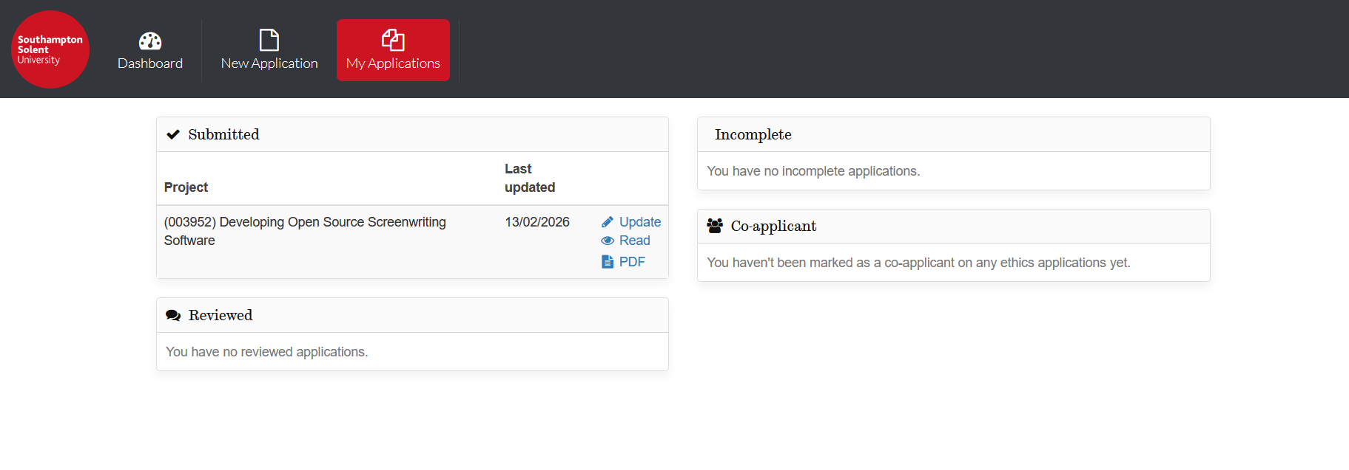

Appendix D: Market Research Example

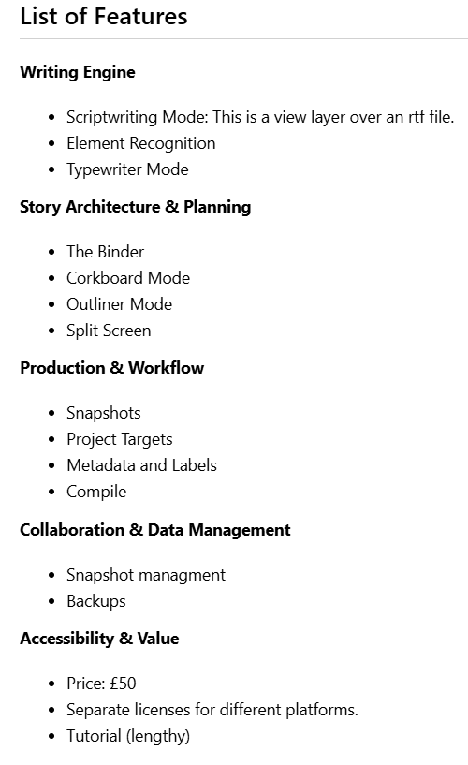
Example of list of features, external references and conclusions drawn for Scrivener

