The corkboard shows the immediate subdocuments of the selected document. To see this in action:
<$Scr_Ps::0>1. Split the editor again by going to <$Scr_Cs::1>View > Editor Layout > Split Horizontally<!$Scr_Cs::1> (or using the button in the editor header view).
2. Click on the “Draft” folder in the binder to load it in the top editor.
3. Make sure the corkboard is selected in the view mode control in the toolbar.<!$Scr_Ps::0>
Note how the corkboard in the top editor now shows the three folders, “The Basics”, “Going Further” and “Tips”, represented as index cards. If you look in the binder, you will notice that these three folders are the immediate subdocuments of the Draft folder—that is, they are only indented one level deeper than the Draft folder.
<$Scr_Cs::3><$Scr_Ps::2>Note<!$Scr_Cs::3>: Index cards on the corkboard show the title and synopsis of each document. If a document does not have a synopsis associated with it, the first lines of its text will be displayed in grey instead. <!$Scr_Ps::2>
Next, in the corkboard, double-click on the yellow book icon in the second card. This will drill down to show the contents of the “Going Further” folder on the corkboard.
You can edit the synopsis or title in a card by double-clicking into it, and you can drag the cards around (and into the binder) to reorder your documents. (If you try this out in the tutorial, be sure to put them back into their original order afterwards!)
Now click on the “Research” folder in the binder. Note how media files such as images are displayed as photographs on the corkboard rather than as index cards (although you can change this behaviour via the Options).
<$Scr_Cs::3><$Scr_Ps::2>Tip<!$Scr_Cs::3>: If the inspector is open, it will show information for the currently selected document in the corkboard (or outliner). If nothing is selected, information will be shown for the container document. <!$Scr_Ps::2><$Scr_Ps::4>
Corkboard Options<!$Scr_Ps::4>
Now click on the Get Organised folder to return to a corkboard with standard text documents. You can change settings such as the number of cards in a row and their width by clicking on the button showing an icon of four index cards in the right of the footer bar:
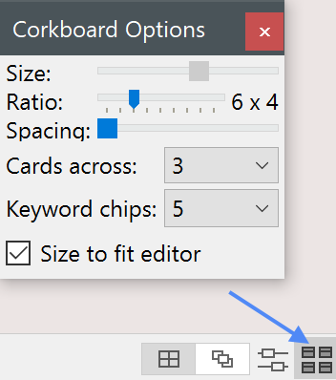
<$Scr_Ps::0>• Other view options are available from the <$Scr_Cs::1>View > Corkboard Options<!$Scr_Cs::1> menu.
• Show status stamps on cards (diagonal stamps indicating the status of each document) by going to <$Scr_Cs::1>View > Corkboard Options > Status Stamps<!$Scr_Cs::1>.
• Tint cards with label colours by going to <$Scr_Cs::1>View > Use Label Color In > Index Cards<!$Scr_Cs::1>.
• Right-clicking on selected cards brings up a contextual menu, allowing you to change the label and status of the documents associated with those cards.<!$Scr_Ps::0>
There’s a whole lot more you can do with the corkboard, so once you feel at home in Scrivener, be sure to come back and check out the corkboard section in “Going Further” (or have a look at the full user manual available from the <$Scr_Cs::1>Help<!$Scr_Cs::1> menu).
For now, though (after a stretch of the legs, a glass of wine, a good curse at the prolixity of this tutorial’s author, whichever helps), let’s move on to the outliner. To do so, make sure the focus is in the bottom editor (by clicking into it if necessary), and then select “The Outliner” in the binder.

